**Fact Sheet: Long-Acting Injectable Buprenorphine (LAIB) – Information for Pharmacists**

**Q: How is depot buprenorphine different to vaccinations that I give now?**

Most vaccinations currently administered by pharmacists are intramuscular (IM) injections of small amounts of vaccine.

The depot buprenorphine medications (Buvidal and Sublocade) are administered subcutaneously. The volume ranges from 0.16ml – 0.45ml for the Buvidal products, and 0.5ml – 1.5ml for the Sublocade products. The depot buprenorphine products are more viscous than most vaccines, especially the Sublocade products. The higher viscosity means that when administrating the injection, you may feel more resistance than when administering a vaccine – this could mean that the injection takes longer to administer, and that the client feels some discomfort / pain when the injection is administered.

Due to the location of injection sites for the depot buprenorphine medications and the potential for the client to feel discomfort / pain, it is recommended that administration occurs with the client laying down.

**Q: I’ve only ever supplied oral opioid replacement therapy (ORT), am I allowed to administer depot buprenorphine?**

You can administer depot buprenorphine if:

· you’re an authorised pharmacist immuniser with the Tasmanian Department of Health

· you work in a pharmacy that is approved to administer vaccinations under the Tasmanian Pharmacy Immunisation Program

· you’re an accredited Tasmanian Opioid Pharmacotherapy Program (TOPP) provider

· you work in a pharmacy that is approved to administer opioid replacement therapy (ORT) under the TOPP

· you’ve completed your online learning and practical

· you have received notification from the Alcohol and Drug Service (ADS) that you are accredited to administer.

The legislative framework supports pharmacists to administer depot buprenorphine. The *Poisons Act 1971* allows a pharmacist to supply narcotic (Schedule 8) substances to a person in accordance with a valid prescription, and the interpretation of the term ‘supply’ in the *Poisons Act 1971* includes administration. The relevant parts of the *Poisons Act 1971* include:

· Section 3(1) - Interpretation of ‘supply’

· Section 47(1)(c) – Sale and supply of narcotic substances

Relevant parts of the *Poisons Regulations 2018* include:

· Regulation 16(2) – Supply of narcotic substances



**Alcohol and Drug Service**

**September 2023**

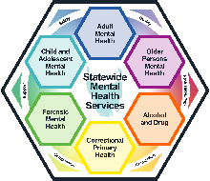

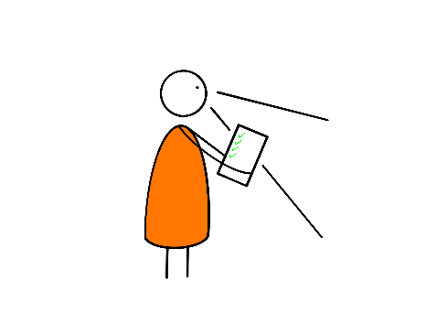

**Step 1:** Complete one of the online learning packages listed on [Opioid pharmacotherapy program | Tasmanian Department of Health](https://www.health.tas.gov.au/health-topics/alcohol-and-drugs/alcohol-and-drug-services/opioid-pharmacotherapy-program).

**Step 2:** To undertake the practical component of the training **you** must be a current Authorised Pharmacist Immuniser with the Tasmanian Department of Health and an accredited Tasmanian Opioid Pharmacotherapy Program (TOPP) provider. The **pharmacy** you intend to administer LAIB in must be approved to provide ORT under the TOPP and approved to provide vaccinations under the Tasmanian Pharmacy Immunisation Program.

**Step 4:** Undertake practical. Your practicum supervisor will use the Skills Assessment Record to assess your competency in two administrations of depot buprenorphine.

**Step 3:** Arrange to undertake your practical with either a private prescriber, an authorised pharmacist who has experience in the administration of depot buprenorphine, or the Alcohol and Drug Service (ADS). Training requests to the ADS can be sent to [adspharmacy@ths.tas.gov.au](mailto:adspharmacy@ths.tas.gov.au)

**Q: How do I become authorised to administer depot buprenorphine?**

The below summarises the process for authorisation, further information, along with clinical guidelines and policy, can be found online at [Opioid pharmacotherapy program | Tasmanian Department of Health](https://www.health.tas.gov.au/health-topics/alcohol-and-drugs/alcohol-and-drug-services/opioid-pharmacotherapy-program)



**Alcohol and Drug Service**

**September 2023**



**Step 5:** Once you’ve received your confirmation from the ADS you can administer depot buprenorphine in your pharmacy. Once you feel you have had enough experience, you can supervise other pharmacist’s practical training sessions. You can access the online learning package at any time to refresh your knowledge. You can contact the ADS for clinical questions and the Pharmaceutical Services Branch (PSB) for regulatory questions.