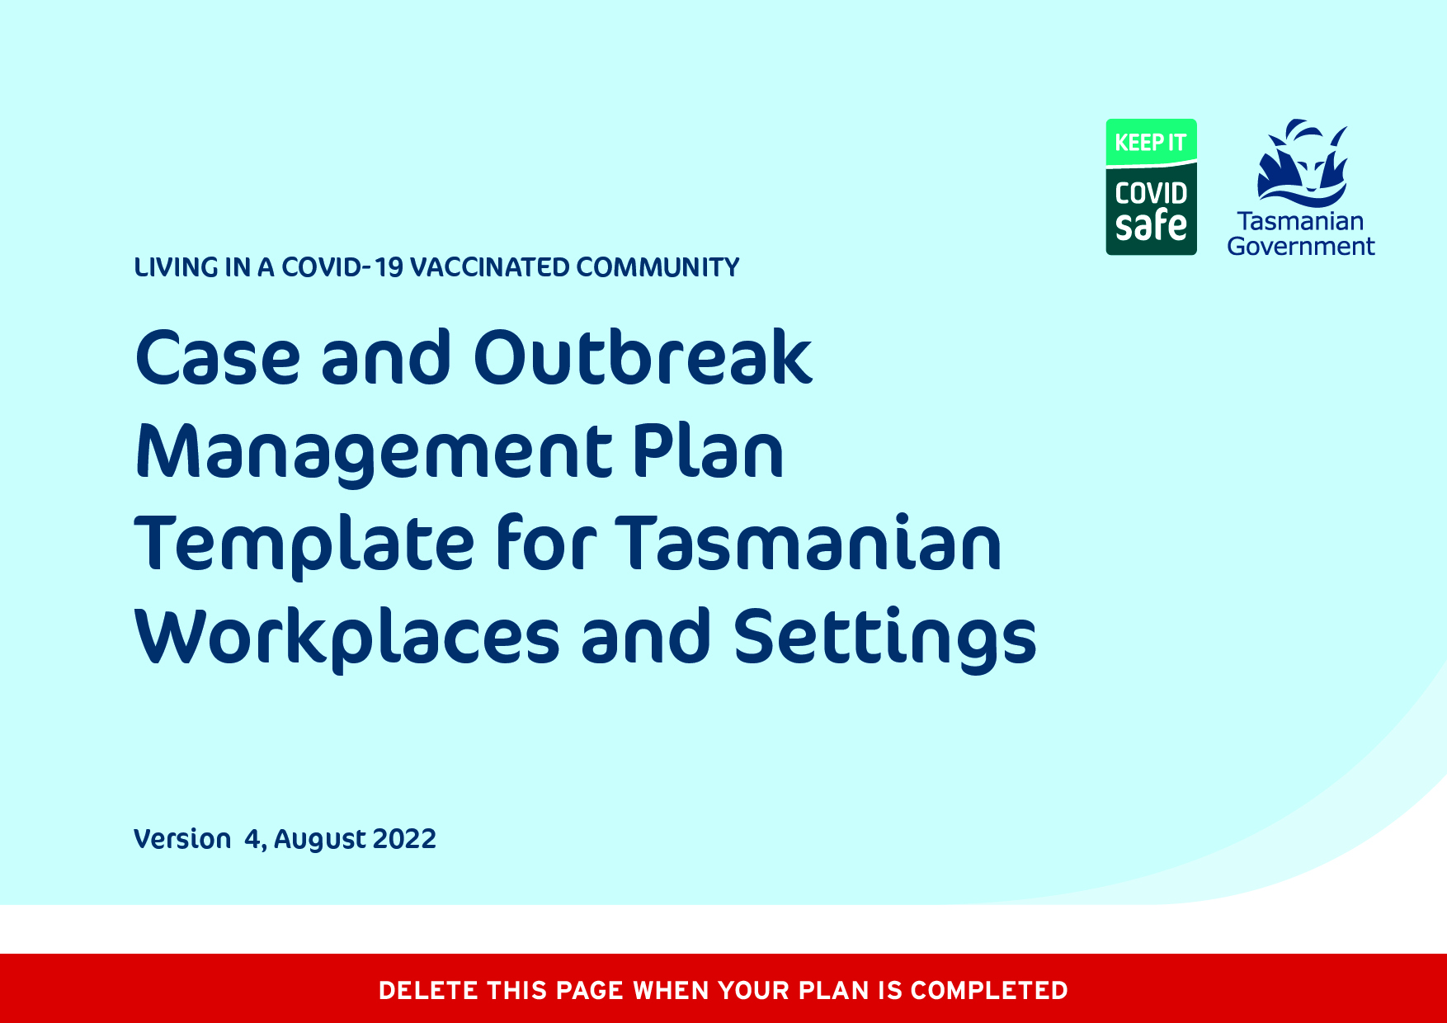

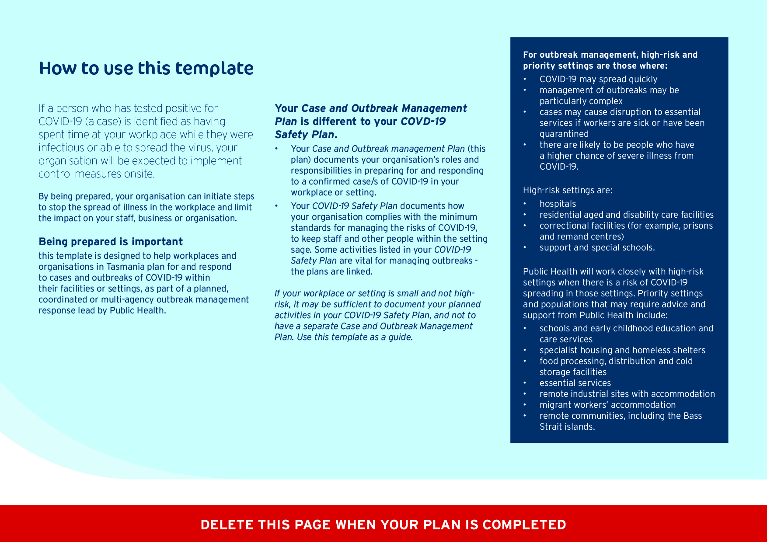
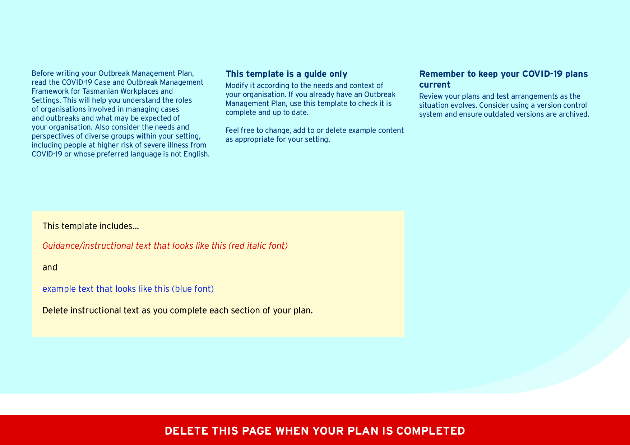
COVID-19 Case and Outbreak Management Plan
for [organisation name]
Version | Status | Date | Revised by | Comments
 | ☐ Draft  ☐ Endorsed |  | [Name, job title] | [List main changes since previous version]

Contents
Context 6
Aim of COVID-19 case and outbreak management 6
Scope 7
Governance 8
Related resources 8
Main case and outbreak management roles of key organisations 9
Communications 10
Stage 1: Prevent and Prepare 12
Stage 2: Respond 13
Stage 3: Stand-down 14
Appendices 15
Appendix 1: Internal Outbreak Response Team 16
Appendix 2: Key contacts 18
Appendix 3: Cleaning and disinfection following a confirmed case 19

Acknowledgement of Country
We acknowledge Tasmanian Aboriginal people as the traditional owners and ongoing custodians of the land on which we work and live, and pay respect to Elders past and present. For around 40 000 years, Aboriginal people have lived on lutruwita/Tasmania, within strong and resilient communities. We acknowledge and learn from that as we work to strengthen resilience against COVID-19 across Tasmania.
Document Authorisation
This document and subsequent versions are draft until endorsed by [insert title authorising officer within the organisation]
Approval
This document is approved by [insert name and title of authorising officer and date of approval]

Context
When there are cases of COVID-19 in our workplace or setting, our organisation will be expected to implement control measures onsite.
Public Health guidelines on slowing the spread of illness in workplaces and settings is provided in the Case and Outbreak Management Framework for Tasmanian Settings and Public Health best practice workplace guidance.
Public Health may scale the response in close collaboration with our organisation (including staff ‘on the ground’ at the setting) and other stakeholders, including relevant government agencies.
The purpose of this plan is to document the activities we will undertake to prepare for and respond to cases and outbreaks of COVID-19 in our workplace or setting.
Good preparation will enable us to enact this Plan immediately, on notification of a case in our setting.

Aim of COVID-19 case and outbreak management
The aim of COVID-19 case and outbreak management is to minimise the spread of COVID-19 and minimise the impact on staff, others within the workplace/setting, stakeholders, and our business/organisation.

Scope
Outline what is in and out of scope for this document. For example:
- some organisations may have multiple sites included within the scope of this plan
- some organisations may provide or support accommodation (for workers and or customers) that should be included in the scope of the plan
- clinical management of cases (while vital) is not an outbreak management activity and is out of scope.
In scope of this Plan | Out of scope of this Plan
Management of a COVID-19 case or cases at any of the following facilities:
- [name of facility]

Governance
Outline the decision-making and coordination arrangements for your organisation when responding to a case or outbreak of COVID-19 in your setting. These arrangements should align with other governance and/or emergency management structures/arrangements in place for your organisation, if possible.
Consider:
- Who will lead the organisation’s response and be the ultimate decision-maker within the organisation?
- Who will be the main contact person for Public Health, if necessary, and coordinate the organisation’s response?
- What committees/forums are in place to support the organisation’s response?
- Who will undertake activities ‘on the ground’ in the setting to help stop the spread of illness? Will you have an internal outbreak response team? If yes, who will participate on it?

Related resources
List any relevant legislation, emergency plans and documents that are specific to this setting/sector.
- COVID-19 Safety Plan for [your organisation]
- Other related documents

Main case and outbreak management roles of key organisations
Stakeholder | Role for case and outbreak management
Public Health | - Coordinates COVID-19 outbreak management  - Provides instructions about isolation requirements to each case notified and sends a survey by SMS to assess the risk to that person and determine if they are in high-risk or priority settings  - May notify us when a confirmed case is identified as having spent time in our facility, depending on the circumstances (or the case may inform us)  - Advises of the number of cases required in our setting to meet the definition of an outbreak  - Advises our organisation on outbreak control measures (for example, use of facemasks, cleaning, and disinfection) to implement to protect others and slow the spread of illness in the setting  - Advises our organisation on ways to keep track of the number of active cases  - Advises on broader public health control measures and monitors their effectiveness  - Liaises with relevant agencies about targeted testing and vaccination services  - Determines when the outbreak is over
WorkSafe Tasmania | - Advises safe work practices  - Must be informed if a staff member is confirmed as having COVID-19 and may have been infected while at work
Our organisation | - Conducts workplace risk assessments as the situation changes over time, and implements COVID-19 risk controls as per the level of risk at that time and as per Public Health best practice guidelines  - Implements public health case and outbreak control measures onsite, as outlined in this plan or requested by Public Health  - Provides advice to cases associated with the setting (workers, residents, clients) about isolation requirements  - Reminds staff and supports residents/clients who are cases to notify Public Health of positive RAT results  - Supports residents/clients to complete the Public Health case survey  - Monitors the number of cases in our setting and reports outbreaks to Public Health  - Monitors the COVID-19 impact on staffing and activates our business continuity plan if necessary  - Informs WorkSafe Tasmania if a worker contracts COVID-19, if there is a possibility they contracted the virus at work  - Advises any close contacts we identify, to check www.coronavirus.tas.gov.au for instructions  - Has a workplace policy outlining arrangements and requirements for workers who are close contacts.  - Provides suitable accommodation for cases to isolate in (if accommodation is usually provided or supported by the workplace/organisation for that person).

Communications
List the key stakeholders that you will communicate with as part of your response to COVID-19 infections. Change or add groups and details in the table below as needed or refer to a more detailed communication plan (as an appendix or separate document). Include the information you will provide and how, and the contact information — or where to find contact information — for each stakeholder.
Key stakeholder | What they need to know | How we’ll communicate | Contact information
Workers (includes employees, consultants, students and volunteers) | - Level of risk, number of cases linked to the setting (while maintaining staff privacy.  - The importance of staying away and getting tested if unwell, hand hygiene, respiratory etiquette and physical distancing.  - The usefulness of facemasks to help slow the spread of illness  - Outbreak control measures being implemented, for example changed arrangements for accessing the setting, use of facemasks.  - Membership of the internal outbreak response team (if relevant) or staff involved in managing the response.  - Arrangements for accessing leave for isolation.  - Arrangements for staff who are close contacts, including under what circumstances they can attend the workplace and the measures they must take to protect other people in the workplace.  - Expectations about getting tested and not attending work if staff have any COVID-19 symptoms.  - Changes to staffing/rostering arrangements.  - Working from home arrangements (if relevant).  - Arrangements to support staff health and wellbeing.  - Arrangements for isolation of cases (if accommodation is normally provided or supported by the workplace). | - All-staff email  - Meetings  - Text messages  - Staff Intranet  - Signage
Visitors, contractors and delivery personnel | - The importance of hand hygiene, respiratory etiquette, physical distancing and not entering if they have any symptoms of COVID-19.  - Outbreak control measures being implemented, for example changed arrangements for accessing the setting, use of facemasks. | - Email  - Text messages  - Signage
Public Health | - Name and contact details of the main contact person(s) for Public Health, including out-of-hours.  - Outbreak management risks specific to the setting. | - Email  - Telephone  - Meetings
WorkSafe Tasmania | - Cases in staff where incident notification is required under Work Health and Safety Regulations 2012 – Reg 699 | - Phone | 1300 366 322

Stage 1: Prevent and Prepare
In the table below, list the prevention and preparedness activities that are relevant to your workplace/setting.
For guidance on activities to include see Case and Outbreak Management Plans resources:
- COVID-19 Case and Outbreak Management Framework for Tasmanian Settings
- Case and Outbreak Management for Settings: Preparedness Checklist
If you have a COVID-19 Safety Plan and all the prevention and preparedness activities your organisation needs to undertake are detailed and up to date in that Plan consider referring to that plan rather than duplicating the content here.
What do we need to do? | How will we do this? | Who will do it? | When will it happen? | What resources will we need? | Other considerations

Stage 2: Respond
The response stage is triggered by an outbreak linked to the workplace/setting. The goal is to slow the virus spreading and protect people at greater risk of severe illness from COVID-19.
To notify Public Health of outbreaks, email: respiratory.outbreaks@health.tas.gov.au
In the table below, list the response activities that are relevant to your sector/organisation. For guidance on activities to include see:
- COVID-19 Case and Outbreak Management Framework in Tasmanian Settings
- Case and Outbreak Management for Settings: Response Checklist
Consider activities and consequences that are specific to your sector/organisation and actions potentially needed if the case notification is outside normal hours or where many or key staff are absent. Also consider worker accommodation if this is provided or supported by your workplace.
What do we need to do? | How will we do this? | Who will do it? | When will it happen? | What resources will we need? | Other considerations

Stage 3: Stand-down
The stand-down stage is triggered when Public Health confirms the outbreak is over, usually 14 days after isolation of the last case. After standing down, our organisation will continue Stage 1 activities for prevention of and preparedness for further outbreaks.
An important activity during the stand-down phase is to evaluate the response and update this plan.
In the table below, list the stand-down activities that are relevant to your sector/organisation. An example is provided. For guidance on activities to include see:
- COVID-19 Case and Outbreak Management Framework in Tasmanian settings
What do we need to do? | How will we do this? | Who will do it? | When will it happen? | What resources will we need? | Other considerations
Evaluate the response | By a formal debrief, with reference to key progress reports developed during the response | Outbreak response team | Within one month of the end of the outbreak | Funding for a facilitator, if deemed necessary

Appendices
The following templates are included in the appendices:
- Appendix 1: Internal outbreak response team
- Appendix 2: Key contacts
- Appendix 3: Procedure for cleaning following a confirmed case

Add other appendices to support your organisation in outbreak management, for example:
- template email to staff to inform them of the outbreak, and control measures being implemented

- procedures or checklists of actions for likely scenarios.

Appendix 1: Internal Outbreak Response Team
Customise the table below to suit your organisation and facility/site. Some roles may be performed by the same person, and some roles may need two or more people, especially if your organisation provides 24/7 services. All roles/functions should be undertaken by people within your own organisation, with expertise and guidance sought from external stakeholders as needed.
Role/function | Person | Responsibilities
Case/Outbreak response coordination | This is generally, a person with authority to coordinate the response within the setting. | - Lead the Internal Outbreak Response Team.  - Coordinate activities required within the setting to slow the spread of illness.  - Liaise with key stakeholders.  - Identify risks specific to the outbreak.
Infection prevention and control coordination |  | - Liaise with Public Health about infection prevention and control measures, if necessary.  - Ensure adequate supplies of facemasks, other relevant personal protective equipment and cleaning and disinfection products.  - Ensure staff are trained in infection prevention and control precautions, as relevant for the setting.  - Maximise ventilation in the setting. Refer to Safe Work Australia website.  - Ensure cleaning staff are kept informed about enhanced cleaning and infection prevention and control measures.  - Oversee cleaning activities – hire additional cleaners as required.  - Identify places for cases to isolate while they are onsite.  - Identify close contacts in the setting and instruct them to follow the steps for close contacts, as outlined at www.coronavirus.tas.gov.au/contacts or as advised by Public Health.  - Ensure suitable accommodation for isolation and quarantine is available.
Information management |  | Collect and provide data to Public Health to assist with risk assessment and formulation of public health case and outbreak control measures.
Communications |  | Liaise with Public Health about:  - internal communications  - stakeholder communications  - media and public communications.
Administration support |  | - Organise Internal Outbreak Response Team meetings.  - Record and distribute minutes of meetings.  - Monitor and maintain resources, for example, hand sanitiser and disposable tissues.

Appendix 2: Key contacts
Use this table to list the organisation’s key stakeholders to communicate with during an outbreak.
Organisation | Name and position | Contact phone | Contact email
Public Health |  | 1800 671 738 | respiratory.outbreaks@health.tas.gov.au
WorkSafe Tasmania |  | 1300 366 322
Unions

Appendix 3: Cleaning and disinfection
following a confirmed case
Background
COVID-19 is spread through respiratory droplets produced when an infected person coughs or sneezes. A person can get COVID-19 by breathing in these droplets or, less commonly, by touching a surface or object that has the virus on it and then touching their own mouth, nose or eyes.
Following a confirmed case of COVID-19, thorough cleaning and disinfection of contaminated areas is needed as per our COVID-19 Safety Plan, to remove the virus from surfaces.
There is no need to close a facility/setting while cleaning and disinfection is underway, particularly if the confirmed case only spent time parts of the facility/setting.
Information about cleaning and disinfection following a confirmed case of COVID-19 is online at www.coronavirus.tas.gov.au.
Cleaning and disinfection for non-health care settings follows the same principles as routine cleaning and disinfection, except:
- cleaning staff should wear disposable gloves, a long-sleeved gown and a surgical mask plus eye protection or a face shield while cleaning and disinfecting
- cleaners should be trained in putting on and removing personal protective equipment (PPE)
- areas may need to be prepared to ensure proper cleaning and disinfection (eg removing personal effects)
- soft or porous surfaces may need attention (eg steam-cleaning or laundering of fabrics).
For instructions for cleaning and disinfection generally, refer to COVID-19 Information for workplaces — cleaning (Safe Work Australia) and Information about routine environmental cleaning and disinfection in the community (Australian Government Department of Health).
For instructions for cleaning in health and residential care settings, refer to COVID-19 Environmental cleaning and disinfection principles for health and residential care facilities (Australian Government Department of Health).
Procedure
Detail the key steps in arranging, or conducting cleaning for your facility/setting

