Tobacco use in Tasmania 2017-18

Published May 2019

Tobacco smoking is the leading cause of preventable disease and death in Australia. In 2011, it was responsible for nine per cent of the total burden of ill-health and premature death in Australia.
This report summarises results from the National Health Survey (NHS) 2017-18. To maintain consistency with the results of previous surveys, crude (non-age standardised) rates have been used in this report unless specified

General Population
In 2017-18, Tasmania and the Northern Territory had the highest proportion of current smokers of all jurisdictions, significantly higher than Australia as a whole.
Current smokers*, 18 years and over by jurisdiction, 2017/18
Jurisdiction | Percentage
NSW | 15.4%
Vic | 15.2%
Qld | 15.9%
SA | 14.3%
WA | 13.3%
Tas | 17.6%
NT | 21.1%
ACT | 11.8%
Aus | 15.1%
NHS 2017/18 First Results 2019; *Daily and occasional smokers combined
All jurisdictions experienced a decline in the proportion of daily smokers between 2014-15 and 2017-18. The Tasmanian decline was the second highest at 1.9 per cent.
Daily smokers 18+ years by Jurisdiction, age-standardised
Jurisdiction | 2014-15 | 2017-18 | % change
NSW | 14.4% | 14.2% | -0.2%
Vic | 13.9% | 13.7% | -0.2%
Qld | 16.3% | 15.1% | -1.2%
SA | 13.5% | 13.3% | -0.2%
WA | 14.2% | 11.9% | -2.3%
Tas | 19.3% | 17.4% | -1.9%
NT | 19.9% | 18.9% | -1.0%
ACT | 12.2% | 10.6% | -1.6%
Aus | 14.7% | 14.0% | -0.7%
NHS 2017-18 First Results 2019
The graph below shows Tasmania’s smoking prevalence of 17.6% for 2017-18 is lower than for 2014-15 but remains statistically significantly higher than the Australian prevalence of 15.1%.
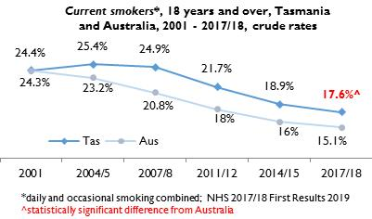

Gender
Trend data below show a gradual decline in both male and female smokers since 1989-90 but the proportion of male smokers (19.3%) remains higher than females (15.7%). The gap between males and females of 3.6 per cent in 2017-18 is the smallest it has been since 2007-08.
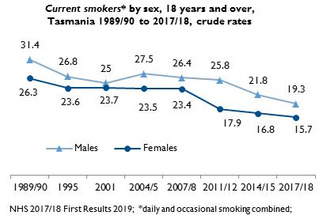

Age Groups
The graph below shows that the age distribution of current smokers in Tasmania has remained relatively stable, with the exception of a decline of about seven per cent in the 35-44 year age group.
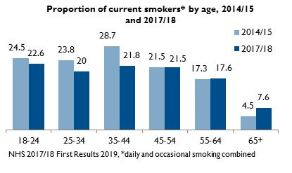
Males are more likely to be current smokers than females in all age groups in Tasmania and nationally. The greatest difference is in the 25-34 year and 35-44 year age groups. Marked differences also exist between Tasmanian females and Australian females, particularly in younger age groups
Proportion of current smokers* by age and sex, Tasmania and
Australia, 2017-18
Age (years) | Males  Tas | Males  Aus | Females  Tas | Females  Aus
18-24 | 23.7 | 20.9 | 21.2 | 11.5
25-34 | 25.2 | 21.7 | 17.6 | 11.6
35-44 | 26.2 | 21.5 | 17.6 | 13.8
45-54 | 22.8 | 20.5 | 21.4 | 16.0
55-64 | 17.3 | 17.5 | 17.7 | 14.7
65+ | 8.2 | 8.5 | 7.0 | 6.3
NHS 2017-18 First Results, 2019; *daily and occasional smokers combined

Ex-Smokers and Never Smoked
More males than females reported they were ex-smokers in 2017-18. This pattern is also reflected at the national level for all age groups.
Ex-smokers by age and sex, Tasmania 2017/18
Age | Males % | Females %
18-24 | 10.3 | 6.7
25-34 | 25.5 | 19.2
35-44 | 32.5 | 30.4
45-54 | 38.3 | 34.1
55-64 | 43.6 | 35.7
65+ | 57.8 | 38.2
NHS 2017-18 First Results, 2019
Within Tasmania, across all age groups, females were more likely to have never smoked than males.
The proportion of young males who never smoked has increased from 58.6 per cent in 2014-15 to 66.1 per cent, but there were more modest increases for females and older age groups.
Never smoked by age and sex, Tasmania 2017/18
Age | Males % | Females %
18-24 | 66.1 | 72.1
25-34 | 51.3 | 64.8
35-44 | 41.6 | 52.9
45-54 | 38.9 | 44.5
55-64 | 38.0 | 46.9
65+ | 34.2 | 55.5
NHS 2017-18 First Results, 2019
The proportion of Tasmanians aged 18 years and over who have never smoked has remained relatively stable since 1989-90.
The proportion of ex-smokers has increased by more than 10 per cent since 1989-90 but with almost no change since 2011-12.
Trends in quitting and never smoked, 18 years and over, Tasmania 1989-90 to 2017-18
Year | ex-smoker % | never smoked %
1989/90 | 23.3 | 47.9
1995 | 31.8 | 42.7
2001 | 26.5 | 49.1
2004/5 | 32.3 | 42.2
2007/8 | 30.1 | 45.0
2011/12 | 33.4 | 44.9
2014/15 | 33.8 | 46.8
2017/18 | 33.6 | 48.9
NHS 2017-18 First Results 2019

Socio-Economic Status
Smoking continues to be much more common among Tasmanians residing in areas experiencing the greatest socio-economic disadvantage.
Of all Tasmanians aged 18 years and over who live in the most disadvantaged geographic areas (quintile 1) about one in four (24.2%) are daily smokers.
Of those who live in the least disadvantaged area (quintile 5) about one in 13 (7.6%) are daily smokers.

The difference between the proportions of smokers in these two quintiles is statistically significant.
This distribution is similar at the national level, with significantly more smokers living in the most disadvantaged areas compared with the least disadvantaged fifth quintile.
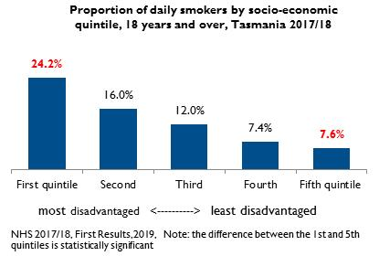
Smoking is more than twice as common among unemployed than employed Tasmanians. Of all Tasmanians aged 18 years and over employed in 2017-18, 16.5% were daily smokers, compared to 38.1% of Tasmanians who reported they were unemployed.
Proportion of daily smokers by workforce status, 18 years and over, Tasmania 2014-15 and 2017-18

Status | 2014-15 | 2017-18
Employed | 19.5 | 16.5
Unemployed | 31.5 | 38.1
Not in workforce | 13.8 | 14.5
NHS 2017-18 First Results, 2019

Prepared May 2019
Email rosie.hippel@health.tas.gov.au

