This leaflet gives you important information about the general use and care of a swivel bather.

The information describes how to install, use and care for the swivel bather.

It does not replace specific instructions given to you by the equipment prescriber.

Swivel Bather – Use and Care

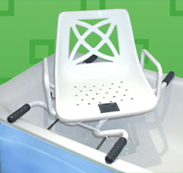

Positioning Screws

Non-slip handles



**Installing the swivel bather:**

**Base**

1. Place the base on the bath. Make sure the four non-slip handles have at least 25mm resting on the edge of the bath.
2. Adjust the positioning screws until the rubber ends are within 6mm of the sides of the bath but not quite touching the sides.

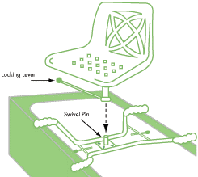

1. Place the seat on the base.

**Seat**

1. There is a lever on the right hand side of the seat that locks the  
   seat into place. To lock the seat into position, push the lever down until it fits into the slot in the base.

To unlock the seat, lift the lever.

**Using the Swivel Bather:**

1. Turn the seat so that it faces the side of the bath, and lock   
   it into position.
2. Stand close to the bath, so you can feel the bath against the back   
   of your legs.
3. Reach behind you and hold both of the armrests for support.
4. 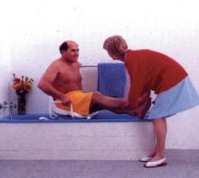Lower yourself slowly into the chair using the armrests.
5. Unlock the seat by pulling up the lever on the right hand side.
6. Turn the seat and lift your legs into the bath.
7. Lock the seat in place by pushing the lever down.

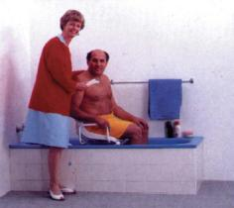

1. Shower while sitting over the bath on the swivel bather.
2. To get out of the bath, reverse the process.

**Care of the swivel bather**

* Wipe any soiling immediately with hot, soapy water.
* Dry the seat with a towel after each use.
* Clean the swivel bather regularly with hot, soapy water. Check for rust and signs of wear to the  
  plastic seat.

**Repairs to your Equipment:**

If your equipment breaks, is broken, damaged, rusted or worn; please contact your local TasEquip warehouse  
to arrange for a repair or replacement:

Contact TasEquip on:  1300 827 378 or directly to the regional warehouse below:

|  |  |  |
| --- | --- | --- |
| Hobart  Repat Centre,  90 Davey Street,  Hobart  Tel: 03 6166 7393,  [SouthTasEquip@ths.tas.gov.au](mailto:SouthTasEquip@ths.tas.gov.au)  Fax: 03 6173 0413 | Launceston  3/213 Wellington Street,  Launceston  Tel: 03 6777 4336  [NthTasEquip@ths.tas.gov.au](mailto:NthTasEquip@ths.tas.gov.au)  Fax: 03 6777 5142 | Latrobe  Mersey Community Hospital,  Moriarty Rd, Latrobe  Tel: 03 6478 5599  [NWTasEquip@ths.tas.gov.au](mailto:NWTasEquip@ths.tas.gov.au)  Fax: 03 6441 5949 |