This leaflet gives you important information about the general use and care of a shower chair or stool.
The information describes how to install, use and care for the shower chair or stool.
It does not replace specific instructions given to you by the equipment prescriber.

Shower Chair/Stool – Use and Care

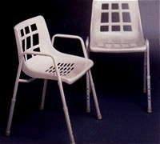 | Adjustable Legs | 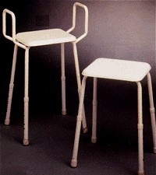

Installing the shower chair or stool:
- Use the height adjusting buttons on the legs to adjust the leg height so it is comfortable for the person using the shower chair or stool. Feet should be flat on the floor when sitting on the shower chair or stool.
- On some shower chair or stools, one of the legs of the chair or stool has more holes to enable extra adjustability for use on uneven shower bases. This leg is interchangeable with any other leg of the chair or stool if required.
- Make sure that the height adjusting buttons on the legs are ‘popped out fully’ before sitting on the shower chair or stool.
- Place the shower chair or stool in the shower cubicle.

Using the shower chair or stool:
- Step into the shower cubicle. Use a grab rail or both armrests of the shower chair or stool for support if needed.
- Sit on the shower chair or stool safely. Stand with your back to the shower chair or stool so that you can feel the chair or stool against the back of your legs. For chairs or stools with armrests, reach behind you and hold both of the armrests for support while you sit.
- Shower sitting down. If you need to stand and require support, hold a grab rail.

CAUTION:
Push weight through both armrests when standing up, sitting down or using the armrests as a support. Putting weight through only one armrest may cause the shower chair or stool to tip.

Routine care of the shower chair or stool:
- Dry the chair or stool after each use with a towel, including the adjustable legs to prevent any damage.
- If the shower chair or stool becomes soiled, clean the chair or stool immediately with warm, soapy water.
- Regularly check the rubber stoppers on each leg are not cracked or worn.
- Routinely inspect for rust, that the frame is straight and the plastic is not cracked.

Repairs to your equipment:
If your equipment is broken, damaged, rusted or worn contact your local TasEquip warehouse to arrange for repair or replacement.
Contact TasEquip on: 1300 827 378 or directly to the regional warehouse below:

Hobart  Repat Centre,  90 Davey Street,  Hobart  Tel: 03 6166 7393,  SouthTasEquip@ths.tas.gov.au  Fax: 03 6173 0413 | Launceston  3/213 Wellington Street,  Launceston  Tel: 03 6777 4336  NthTasEquip@ths.tas.gov.au  Fax: 03 6777 5142 | Latrobe  Mersey Community Hospital,  Moriarty Rd, Latrobe  Tel: 03 6478 5599  NWTasEquip@ths.tas.gov.au  Fax: 03 6441 5949

TasEquip – Bedside Commodes – 20190502 Date: May 2019 Review Date: May 2021

