This leaflet gives you important information about the general use and care of a bedside commode.
The information describes how to install, use and care for the bedside commode.
It does not replace specific instructions given to you by the equipment prescriber.

Bedside Commode – Use and Care
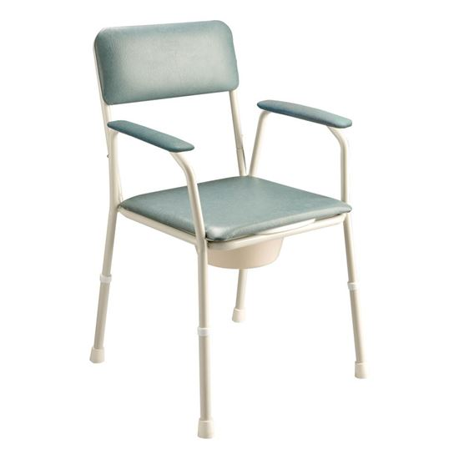
Adjustable legs
Bedside commodes come with a chair frame with padded armrests and seat back, removable padded seat, toilet seat and a removable bucket with lid.

Installing the bedside commode:
- Use the height adjusting buttons on the legs to adjust the height so it is comfortable for the person using the bedside commode. Feet should be flat on the floor when sitting on the bedside commode.
- Make sure that the height adjusting buttons on the legs are ‘popped out fully’ before sitting on the commode.
- Before using the commode for toileting remove the padded seat and the bucket lid.

Using the bedside commode:
- Stand in front of the bedside commode so the frame is touching the back of your legs.
- Reach behind you and place your hands on both armrests for support.
- Lower yourself onto the toilet seat, using the armrests for support.
- Empty the commode bucket after each use and clean thoroughly with warm soapy water.
- Always use the lid when carrying the bucket to prevent spills and splashes.

CAUTION:
Push weight through both armrests when standing up, sitting down or using the armrests as a support.
Putting weight through only one armrest may cause the bedside commode to tip.
Care of the bedside commode:
- If the bedside commode becomes soiled, clean immediately with warm, soapy water. The toilet seat on the frame lifts up to make cleaning easier.
- Regularly check the rubber stoppers on each leg are not cracked or worn.
- Routinely inspect for rust and the frame is straight
- Routinely inspect the plastic is not cracked and the vinyl is intact.

Repairs to your equipment:
If your equipment is broken, damaged, rusted or worn contact your local TasEquip warehouse to arrange for repair or replacement.

Contact TasEquip on: 1300 827 378 or directly to the regional warehouse below:

Hobart  Repat Centre,  90 Davey Street,  Hobart  Tel: 03 6166 7393,  SouthTasEquip@ths.tas.gov.au  Fax: 03 6173 0413 | Launceston  3/213 Wellington Street,  Launceston  Tel: 03 6777 4336  NthTasEquip@ths.tas.gov.au  Fax: 03 6777 5142 | Latrobe  Mersey Community Hospital,  Moriarty Rd, Latrobe  Tel: 03 6478 5599  NWTasEquip@ths.tas.gov.au  Fax: 03 6441 5949

TasEquip – Bedside Commodes – 20190502 Date: May 2019 Review Date: May 2021

