Bath Transfer Bench – Use and Care
This leaflet gives you important information about the general use and care of a bath transfer bench.
The information describes how to install, use and care for the bath transfer bench.
It does not replace specific instructions given to you by the equipment prescriber.

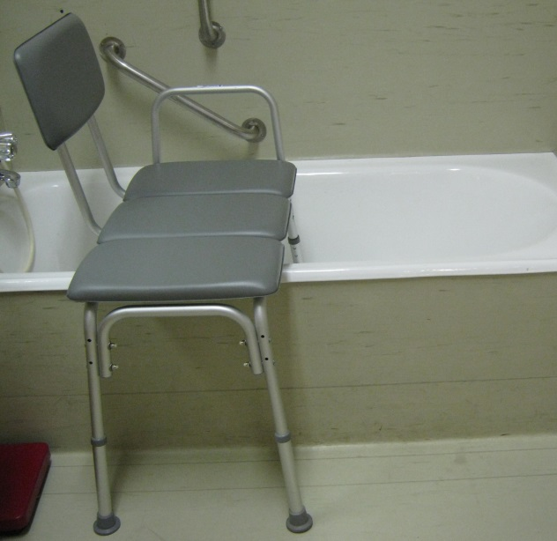
Adjustable legs

Installing the transfer bench
- Place the two legs of the transfer bench with the suction pads inside the bath or shower and the other two legs outside the bath or shower.
- Place the transfer bench so you are facing the taps and shower when sitting on the transfer bench. The armrest should be inside the bath or shower. The backrest can be changed from side to side so you can face the taps and have the armrest in the correct position.
- Use the height adjusting buttons on the legs to adjust the legs so the seat is level. The legs inside the bath may need to be shorter as the bath base is often higher than the floor level.
- Make sure that the height adjusting buttons on the legs are ‘popped out fully’ before sitting on the transfer bench.
Using the transfer bench
A transfer bench allows you to move into a bath or shower without stepping or standing.
- Sit on the end of the bench.
- While facing toward the taps slide your bottom across until over the bath.
- Swing legs into the bath while remaining seated.
- Remain sitting, or then stand to shower, as recommended by the prescriber.
- If standing when shower completed, return to the seated position.
- Slide your bottom across the bench towards the outer edge or the bath.
- While seated lift your legs out of, and over, the side of the bath.
- Stand carefully.

Care of the transfer bench:
- Dry the transfer bench after each use with a towel, including the adjustable legs, to prevent any damage.
- If the transfer bench becomes soiled, clean the bench immediately with warm, soapy water.
- Regularly check the rubber stoppers on each leg are not cracked or worn.
- Routinely inspect for rust, that the frame is straight and the vinyl or plastic are intact.

Repairs to your equipment:
If your equipment is broken, damaged, rusted or worn contact your local TasEquip warehouse to arrange for repair
or replacement.

Contact TasEquip on: 1300 827 378 or directly to the regional warehouse below:

Hobart  Repat Centre,  90 Davey Street,  Hobart  Tel: 03 6166 7393,  SouthTasEquip@ths.tas.gov.au  Fax: 03 6173 0413 | Launceston  3/213 Wellington Street,  Launceston  Tel: 03 6777 4336  NthTasEquip@ths.tas.gov.au  Fax: 03 6777 5142 | Latrobe  Mersey Community Hospital,  Moriarty Rd, Latrobe  Tel: 03 6478 5599  NWTasEquip@ths.tas.gov.au  Fax: 03 6441 5949

TasEquip – Tub Transfer Bench Date: May 2019 Review Date: May 2021

