This leaflet gives you important information about the general use and care of an adjustable height chair.
The information describes how to install, use and care for the adjustable height chair.
It does not replace specific instructions given to you by the equipment prescriber.

Adjustable Height Chair – Use and Care

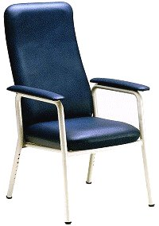 High Backed Chair 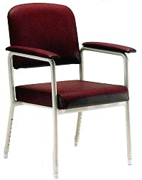 Bridge Chair
Adjustable legs

Installing the chair:
- Use the height adjusting buttons on the legs to adjust the height so it is comfortable for the person using the chair. When seated your hips should be slightly higher than your knees, with your feet flat on the floor. The equipment prescriber can advise you of the best height for the chair.
- Make sure that the height adjusting buttons on the legs are ‘popped out fully’ before sitting on the chair.

Using the chair:
- Stand with your back to the chair with the seat touching the back of your legs.
- Reach behind you and place your hands on both armrests for support.
- Lower yourself slowly into the chair using the armrests for support.
- Push up on both armrests to help you to stand.
CAUTION:
Push weight through both armrests when standing up, sitting down or using the armrests as a support.
Putting weight through only one armrest may cause the chair to tip.
Routine care of the chair:
- If soiled, clean the chair immediately with warm, soapy water.
- Regularly check the rubber stoppers on each leg are not cracked or worn.
- Routinely inspect for rust, that the frame is straight, and the vinyl is intact.

Repairs to your Equipment:
If your equipment is broken, damaged, rusted or worn contact your local TasEquip warehouse to arrange for repair or replacement:

Contact TasEquip on: 1300 827 378 or directly to the regional warehouse below:

Hobart  Repat Centre,  90 Davey Street,  Hobart  Tel: 03 6166 7393,  SouthTasEquip@ths.tas.gov.au  Fax: 03 6173 0413 | Launceston  3/213 Wellington Street,  Launceston  Tel: 03 6777 4336  NthTasEquip@ths.tas.gov.au  Fax: 03 6777 5142 | Latrobe  Mersey Community Hospital,  Moriarty Rd, Latrobe  Tel: 03 6478 5599  NWTasEquip@ths.tas.gov.au  Fax: 03 6441 5949

TasEquip – Adjustable Height Chair – 20190502 Date: May 2019 Review Date: May 2021

