
HACC DATA REPOSITORY
User Guide

JANUARY 2013


HACC Data Repository

How to use guide – version 1

The purpose of this guide is to provide a simple step-by-step set of instructions for first-time users of the HACC Data Repository. Clear instructions are provided together with real screen-shots from the application.

How it is different
Before April 2008, services that receive HACC funding had to email their information to the National Data Repository. This data would then be processed and you would be emailed of the results of this.
The above mentioned process is now redundant. Services that receive HACC funding are now required to log-on to the new State HACC DR and import their data. These instructions tell you how to do that.

Data are to be submitted to the HACC DR by close of business on the 25th day of the submission month.

Submission months are: October, January, April and July. These are respectively for data from Quarter’s 1-4 of each financial year.

Benefits of using the HACC DR
- Services can now run reports, giving agencies timely access to critical performance information and statistics.

- Data are available in a more timely fashion for further analysis by DHHS.

Index

- Log-on
- Log-off
- Changing your password (recommended on first log-on)
- What you can see and what it means
- Reports
- Importing (uploading) your quarterly MDS data
- Import Logs
1. Log-on

Step 1

Cut and Paste, or type, the following URL (internet address) into Internet Explorer:

https://haccdr.dhhs.tas.gov.au

Step 2

You will see the following screen. Type in your user name and password. These have been supplied to your email.

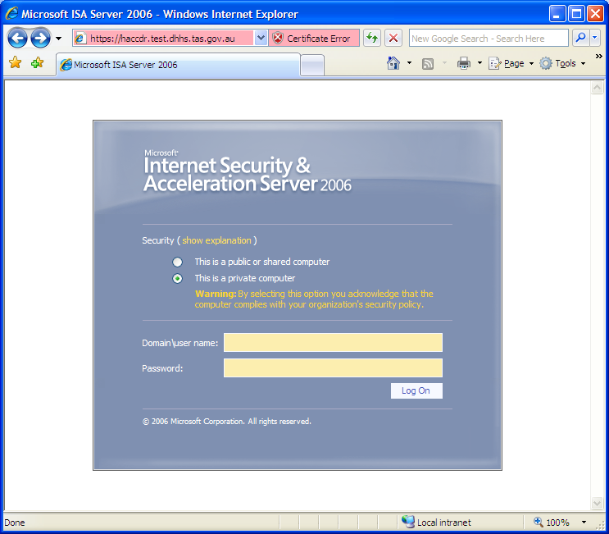

Step 3
The following page will then appear. Click on HERE.

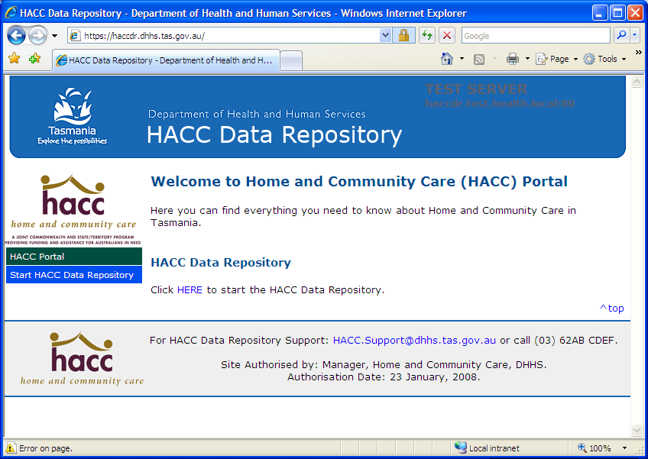

Another screen appears, enter your second user name and password, and then click on LOGIN.
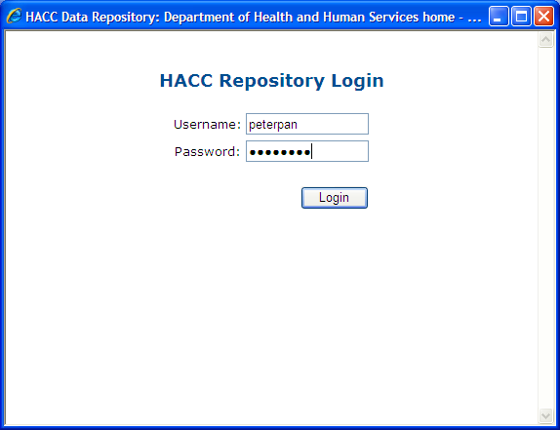

You will see to following screen and have completed the log-in process. The reports screen is the default entry screen.

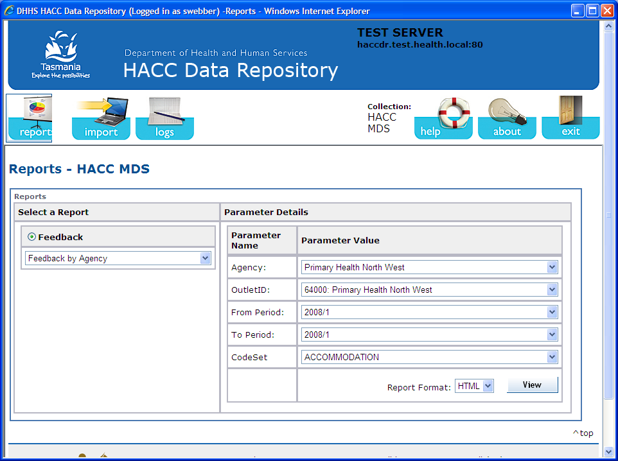

2. Log-off

From the main screen, click on the Exit icon.

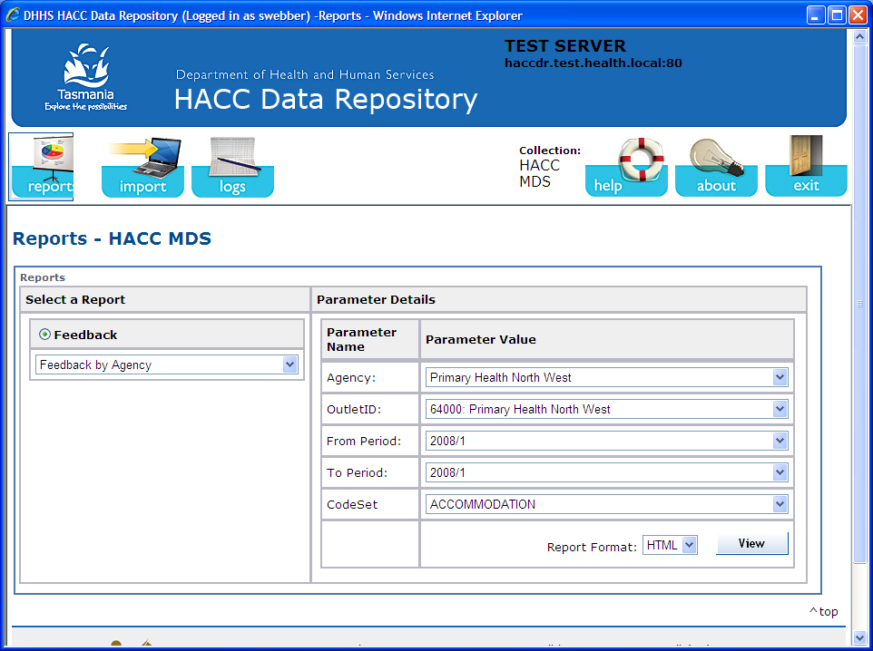

Then press OK, when prompted. You are now logged-off.

3. Changing your password

Please note, it is recommended you change your password on first log-in. This is to ensure the highest possible level of system security. If you have forgotten your password please call Tasmanian HACC Program on 6233 6493.

STEP 1

Log in as per normal.

STEP 2

On the second log in screen, enter your username and password, and then click-on here.

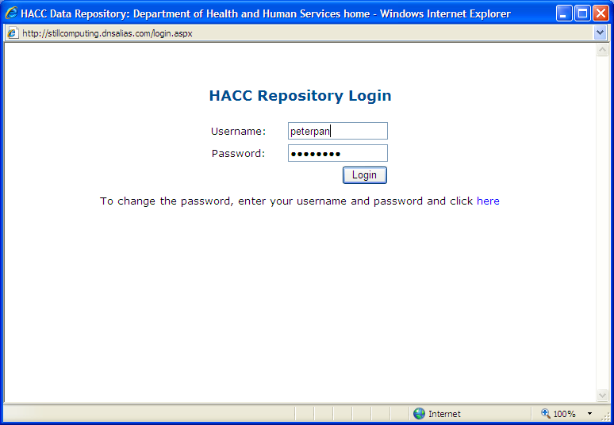

STEP 3

Change your password, confirm it by typing it again and then press OK.

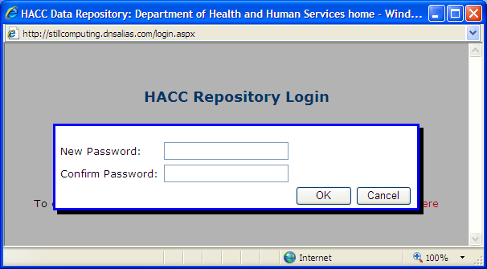

4. What you can see and what it means

The screen below is what you will see after you have logged-on.

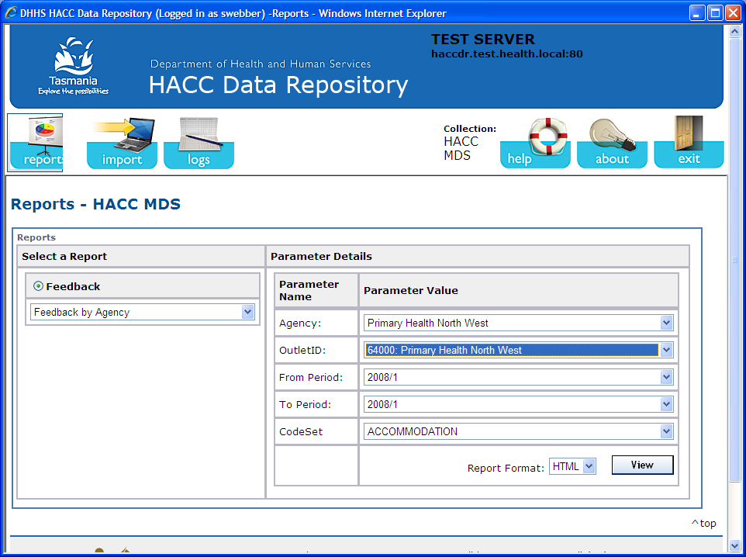

The DR has a number of icons which you can click-on. A brief explanation of what they do is provided below:

 | Includes a list of reports available for your service. Please note these may not be active until after the collection period.
 | This is used to upload your data to the repository.
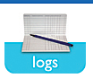 | This provides you with a log of all data uploads you have done. It gives you feedback in much the same as the NDR did previously.

 | Click on for a searchable Help function (not available yet)
 | Ignore this, it includes the software developers details do not contact.
 | To exit the system

5. Reports

The Tas HACC DR contains a number of reports available for agencies.

STEP 1
i) Select the type of report. ii) Determine the Agency, OuletID, From Period and To Period. iii) Work out what format you want your report in (PDF, HTML, EXCEL or CSV), then press View.

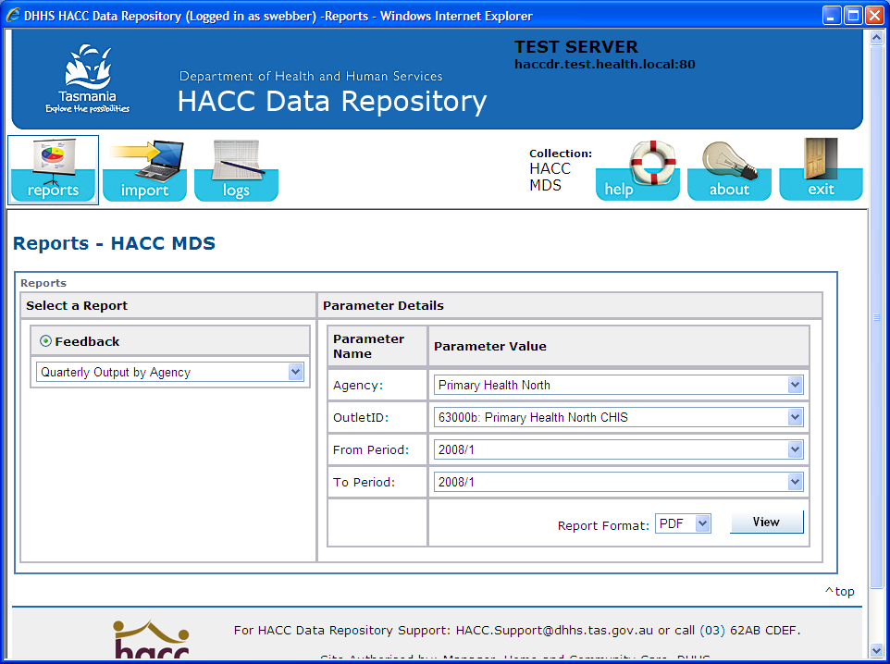

Your report will be created. You can save the report for future use.

6. Importing (uploading) your quarterly MDS data

STEP 1
Service Providers are required to upload files in .csv or xml format.

Click on the Import icon

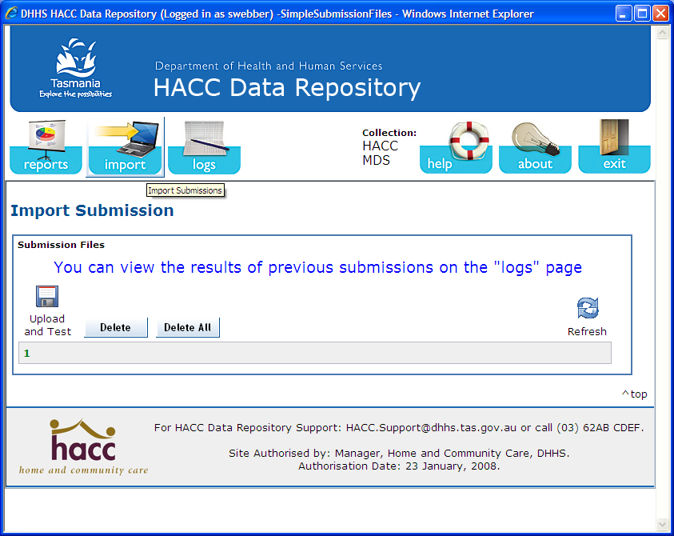

STEP 2

Click on the Upload and Test icon

A Load File box will appear, select Browse, find your data file on your computer system, press OK, then press Upload (see picture below).

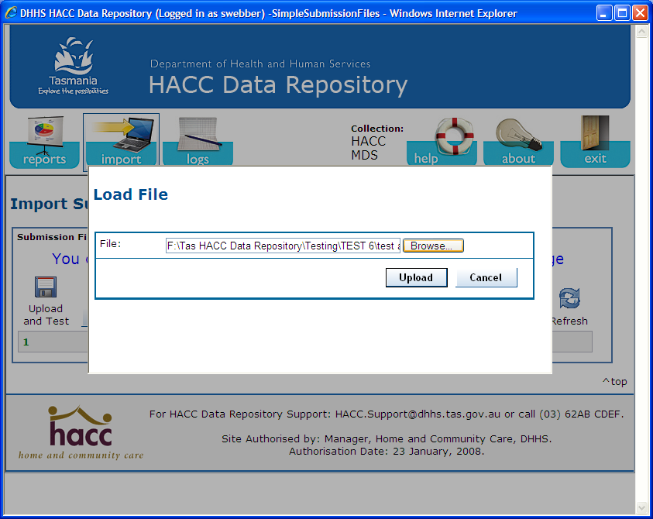

The following message indicates a successful upload:

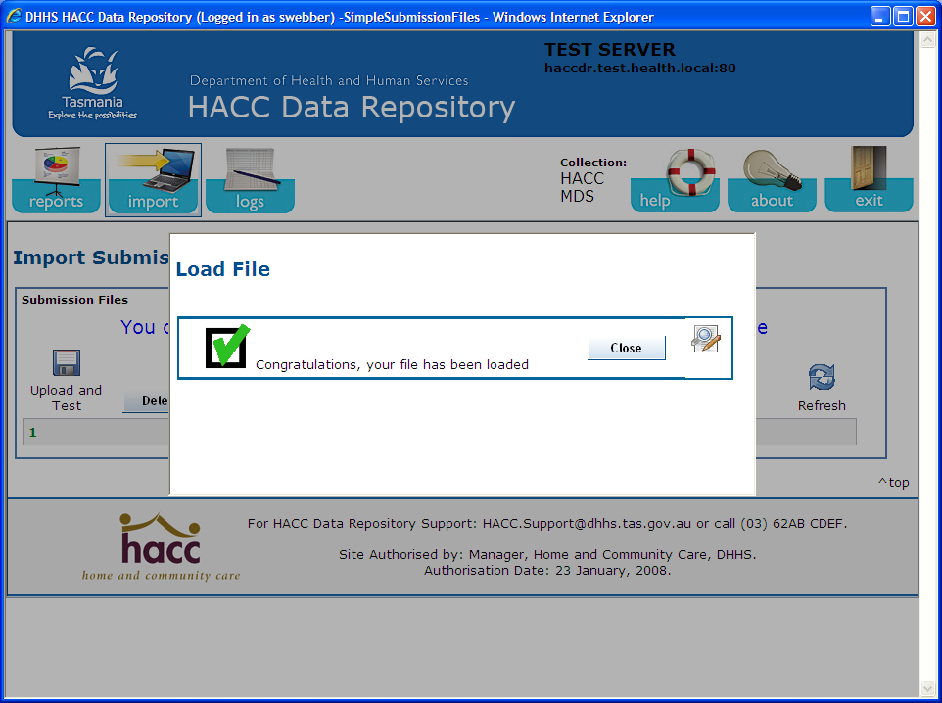

STEP 3
Click on the Logs icon to see how your upload went. This is important when you get messages mentioning Critical Errors or Warnings. These logs help you trouble shoot any issues you may have. Information in these logs is expanded on in Appendix A.
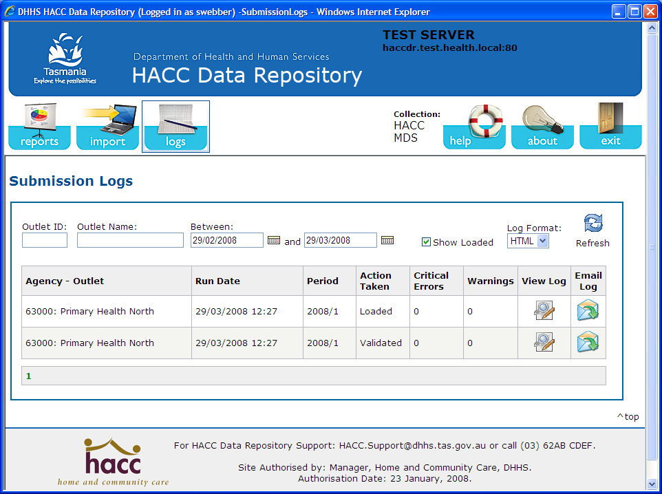

The submission log looks like this: Use the scroll-bar to move up and down the log.

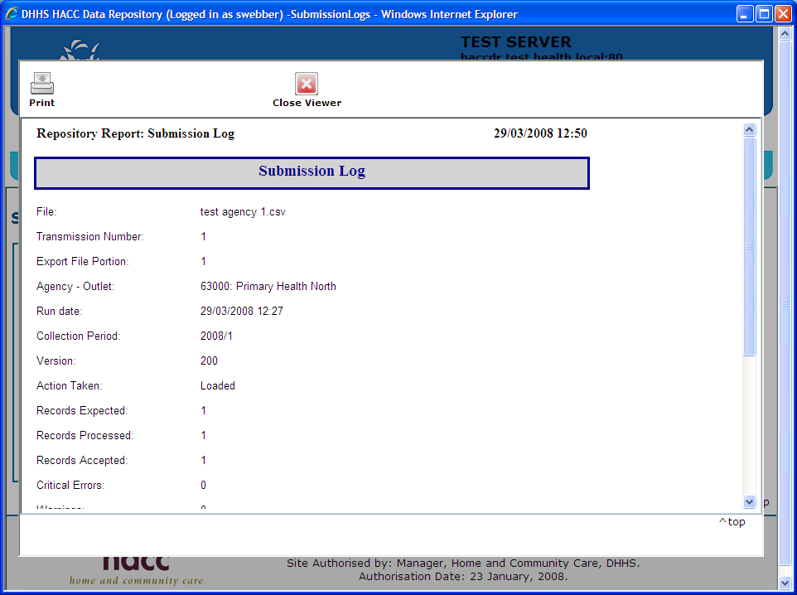

It is good practice to get into the habit of checking log files. This not only helps you understand any problems you may be having, but helps improve data quality over time.

The log is a confirmation on your submission; please print this out for your own files.

You have finished importing your file.

Please call 6233 6493 if you are having trouble importing your file.

7. Import Logs

Issue: Wrong file type

The HACC DR accepts only CSV and XML files, and will produce the error message below when it does not recognise either format. Firstly, check to ensure you have loaded the correct file. Please save as either a CSV or XML and try again.

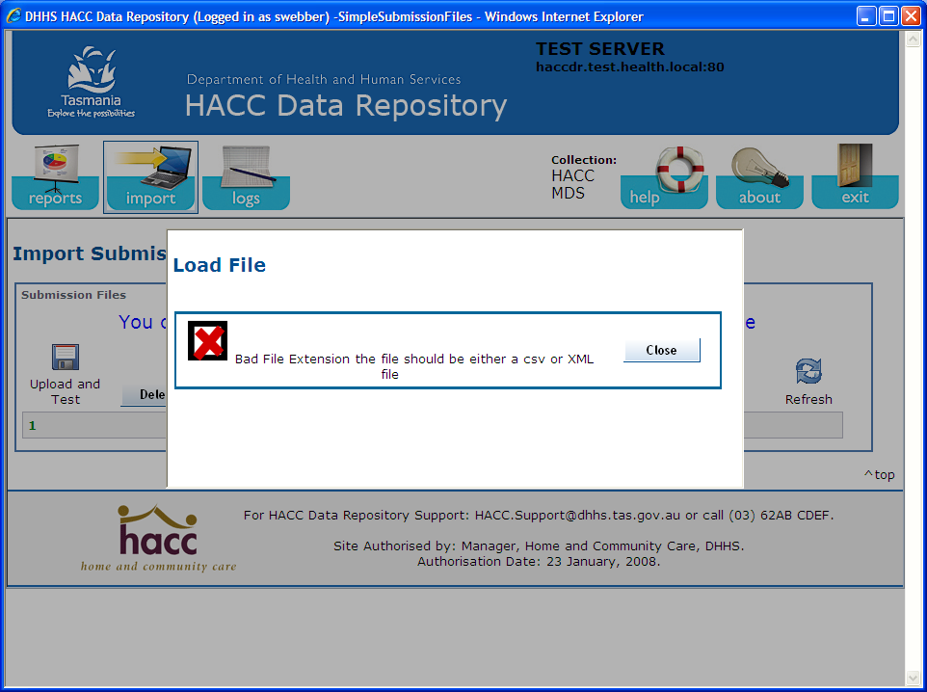

A successful load is shown below:
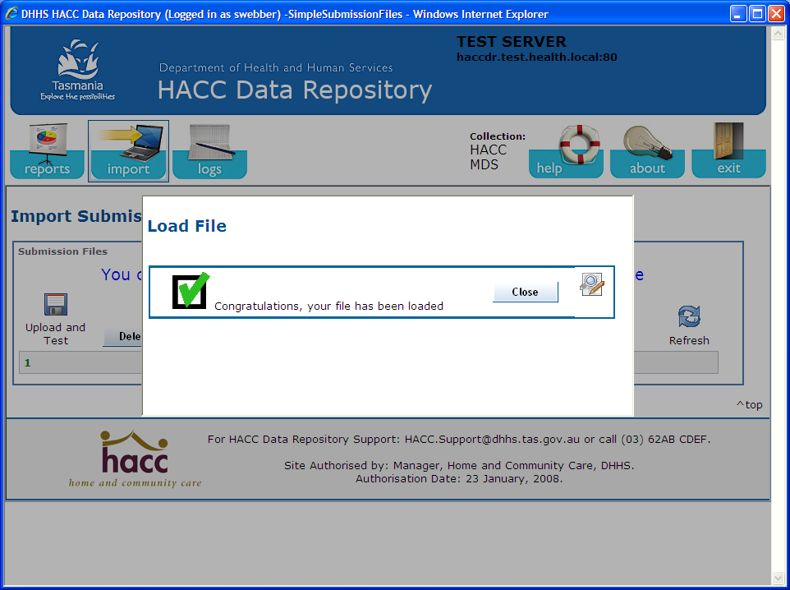:

Issue: Wrong Agency (Organisation) code

Each file you upload will have an agency code. You can only load files with your agency code. An agency code is made up of 5 digits, starting with a 6. Some agencies will have ‘portions’ (different service delivery areas within the same organisation). Example of agency codes are shown below
- 60000
- 60001
- 60000A
- 60000B

60000A and 6000B are different portions of the same agency. For example, 60000A may be a service in the North of the State and 60000B may be in the South.

Attempting to load a file with the wrong agency code will reject the load with the following message:

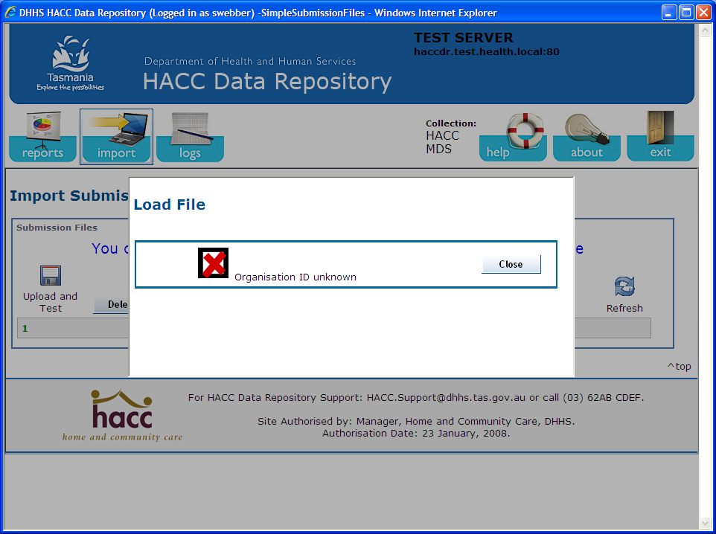

Issue: Data quality issues – EXAMPLE 1 – Incorrect Date of Birth

In this example, one of the clients had a birth date of 01/01/1860. It rejected the file with the following message:

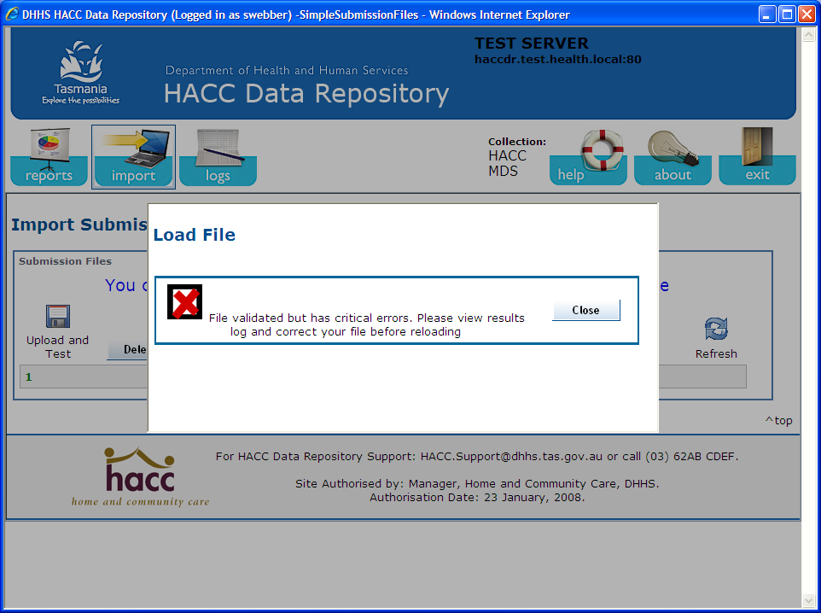

Opening the log will describe the problem, so you can then correct your data for another load:

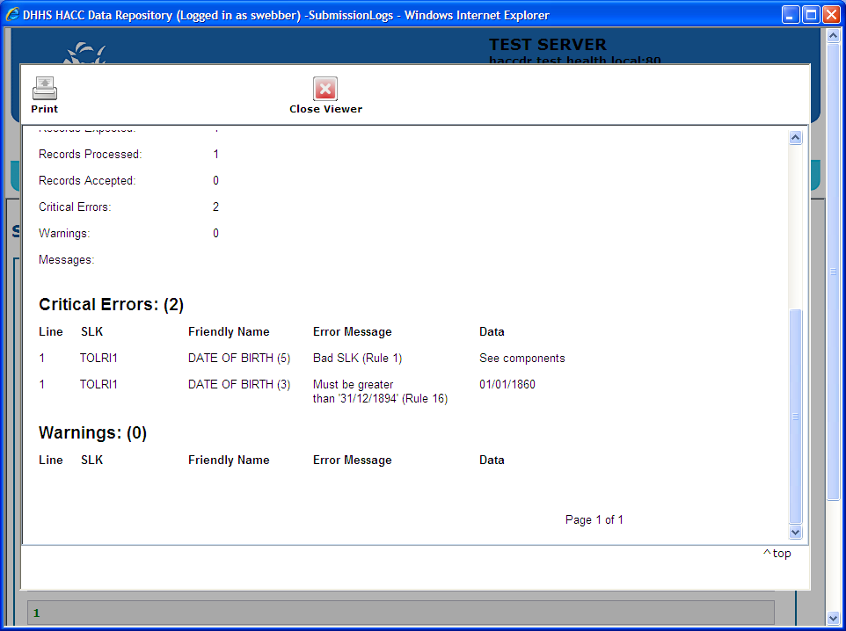

Issue: Data quality issues – EXAMPLE 2 – Incorrect Postcode

In this example, a dataset was loaded. One of the clients had an unrecognisable postcode. It accepted the file with the following message:

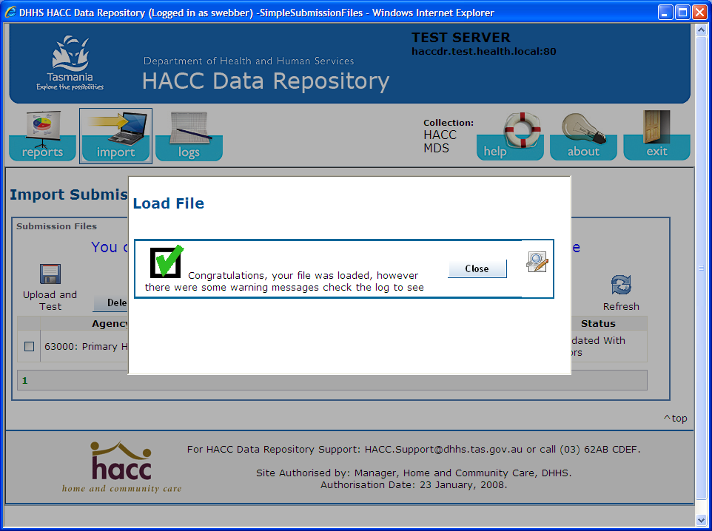

In the above situation, please amended the postcode and re-import the file.

If you are having trouble, please call 6233 6493.

