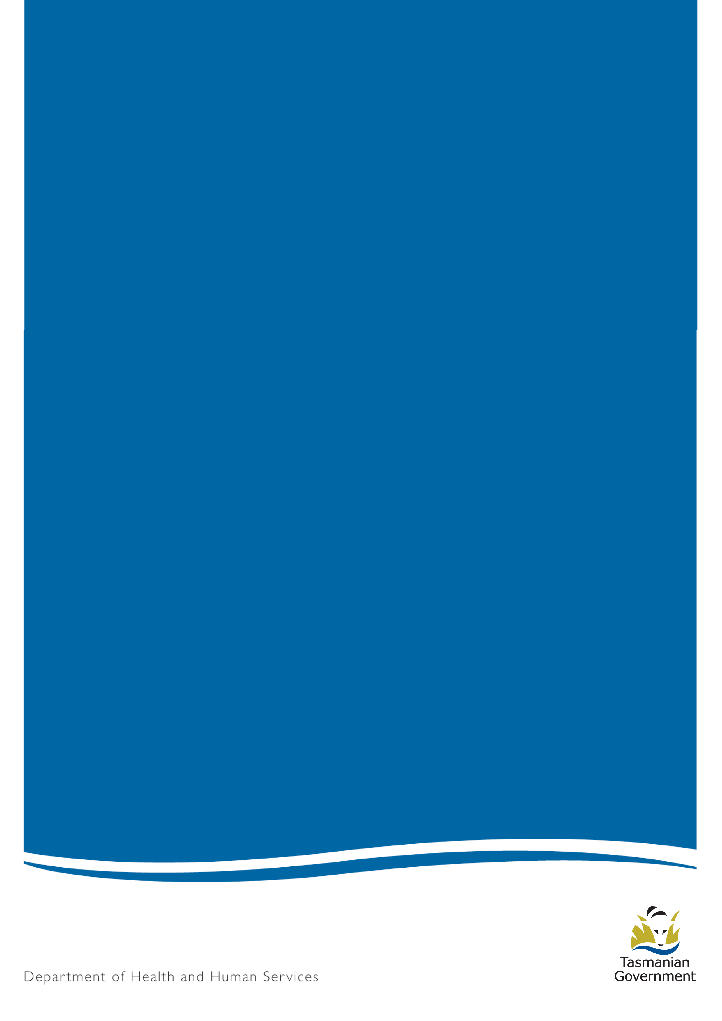

Smoking Laws in Tasmania

A Guide for Licenced and Dining Premises
July 2018

Message from the Director of Public Health
If you own or run a licenced premises or dining premises in Tasmania, this guide is for you. This guide explains Tasmania’s laws about smoke-free areas and what owners and operators of licenced premises and dining premises need to know.
Please read this guide carefully.
Smoking is a leading cause of illness and early death in Australia. It kills more than 500 Tasmanians every year. These harms ripple through families and communities.
Nearly one in five Tasmanian adults smoke daily or occasionally. This is the second highest rate in Australia and compares unfavourably with the national rate of fewer than one in six.
Fortunately, most young Tasmanians don’t smoke, but some still take it up. That is why many of Tasmania’s smoking control laws aim to reduce the appeal and visibility of smoking products to young people, and make it harder for people to smoke.
The laws also help protect Tasmanians from second-hand smoke. There is no safe level of exposure second-hand smoke.
Owners and occupiers of licensed and dining premises: your actions can help younger generations of Tasmanians grow up to enjoy being adults, unaffected by the harms of smoking or the loss of friends and family from cancers or lung and heart diseases caused by smoking. Thank you for trading legally and responsibly.
If you need help with any matters in this booklet, please contact your local tobacco control officer.
Yours sincerely

Dr Mark Veitch
Director of Public Health

Contents
1. Introduction 4
2. What is ‘smoking’? 5
Exemptions 5
3. Smoke-free areas 6
Dining and licenced premises 6
4. Outdoor Smoking Areas 7
What are the requirements of outdoor smoking areas? 7
The location and design of outdoor smoking areas 7
5. Responsibilities of occupiers 9
What happens if someone smokes in a smoke-free area? 9
6. More Information 10
For more information contact: 10
7. Glossary 11

Introduction
This guide describes what people running licenced premises and dining premises need to do to comply with laws about smoke-free areas in Tasmania.
It outlines the responsibilities of:
- occupiers of licenced premises, including pubs, clubs, nightclubs
- occupiers of places where people eat, including restaurants and cafes

If this is you, please read the guide in full to make sure you understand your legal responsibilities.

What is ‘smoking’?
In this guide and under Tasmanian laws, the term ‘smoking’ or ‘smoke’ covers the use of any smoking product and any non-tobacco cigarette, cigar, pipe or device.

For more definitions from the Public Health Act 1997, see the Glossary.

Figure 1: Smoking covered by Tasmania’s Public Health Act 1997.

Exemptions
Under the Public Health Act 1997 (the Act) and in these guidelines, smoking products do not include:
- Devices used for delivering oxygen in to a person
- Devices used to deliver controlled substances within the meaning of the Misuse of Drugs Act 2001, to a person
Any goods or devices included in the Australian Register of Therapeutic Goods Act 1989

Smoke-free areas
Under the Act, the following areas are automatically required to be smoke-free:
- enclosed public places or workplaces
- indoor areas of dining areas and licenced premises, including pubs, clubs, nightclubs
- outside dining areas, when the kitchen is open or food is being eaten
- outside licensed areas, except in designated outside smoking areas
- any vehicle with a child (person under the age of 18 years) in it
- any work vehicle with another person in it
- bus shelters and bus malls
- pedestrian malls
- public swimming pools and between the flags at beaches
- within three metres of the entrance/exit to public buildings
- within three metres of outdoor dining areas
- within 10 metres of a building’s air intake for ventilation equipment
- within 20 metres of outdoor sporting events
- mass outdoor public events, including festivals
- any area designated to be smoke-free by the local council, for example Salamanca Market.

Dining and licenced premises
Under Tasmanian law, smoking is illegal in enclosed public places.
Smoking is illegal:
- in and within three metres of outdoor dining areas during meal times – that is, when food may be eaten
- in outdoor areas of premises that have a licence or permit under the Liquor Licensing Act 1990 (such as pubs, clubs and night clubs), where the provision of beverages rather than food is the primary function, except in designated smoking areas that meet certain requirements. See information under the heading Outside Smoking Areas.
Signs are mandatory to communicate this to customers and assist staff.

Outdoor Smoking Areas
Smoking is permitted in designated outdoor smoking areas of dining and licenced premises, if the designated areas meet certain requirements.

What are the requirements of outdoor smoking areas?
Outdoor smoking areas must not be serviced by staff.
Customers may drink, but not eat, in outdoor smoking areas; signs are recommended to make this clear to customers and assist staff.
A premises may have a separate outdoor dining and smoking area, however an outdoor dining area must not be of inferior facility to any outdoor smoking area.

The location and design of outdoor smoking areas
Outdoor smoking areas:
- must not be located within 10 metres of air intake equipment for ventilation
- must not be within three metres of a building entrance or exit.
Outdoor smoking areas must either:
- not have a roof: an outdoor smoking area will generally be considered to not have a roof if at least two-thirds of the roof space is uncovered; OR
- have a roof but a perimeter consisting of no more than 50 per cent walls or windows (whether open or closed); less restrictive consideration may be given if the roof is angled or pitched upwards.
A greater proportion of roof space must be uncovered in small areas where:
- the ceiling height in the outdoor smoking area is less than three metres; and/or
- the area is less than 10 metres squared.
The following factors may be taken into account when considering whether an area has a roof or a perimeter consisting of more than 50 percent walls and windows:
- the purpose of the wall (whether it encloses, divides, supports or protects)
- the height of any walls
- the size of the outdoor smoking area
- the distance of the outdoor smoking area from any adjacent buildings
- the density or permeability of the walls or roof material
- the proportion of the outdoor smoking area covered by a roof
- the angle (pitch) of the roof and the extent to which its construction inhibits the upward movement and egress of air.
Examples of outdoor smoking areas that comply and don’t comply with these requirements are provided below. These examples provide general guidance only on the interpretation of the outdoor smoking area requirements.
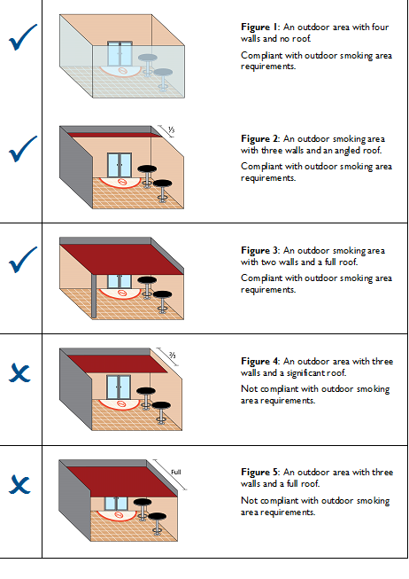
If you are designing an outdoor smoking area, check the specific requirements of the Public Health Act 1997, and seek advice from a Tobacco Control Officer.
While the Department does not formally ‘approve’ plans for outdoor smoking areas, staff may provide advice. Failure to comply with legislation may cost you a fine and expensive alterations after your building work is complete.
Note: if your local council approves plans for building an outdoor smoking area, this does not necessarily mean the plans comply with the outdoor smoking area requirements of the Public Health Act 1997.

Responsibilities of occupiers
Occupiers have a legal responsibility to protect others from exposure to second-hand smoke.
You must:
- make sure your customers do not smoke in a smoke-free area
- make sure your customers do not eat in a designated smoking area
- display signs as required by the Director of Public Health, so your customers know where they can and cannot smoke
- maintain the amenity (quality) of smoke-free areas to at least the standard of any outdoor smoking areas you provide.

What happens if someone smokes in a smoke-free area?
People who smoke in a smoke-free area risk on-the-spot fines or prosecution.
Occupiers risk on-the-spot fines or prosecution if smoking occurs in a smoke-free area they are responsible for. Some defences apply, for example if the occupier:
- couldn’t have reasonably be expected to have known the person was smoking
- requested the person to stop smoking, informed them it was an offence and requested they leave if they continue smoking.

More Information
You can access the Public Health Act 1997 and regulations at Tasmanian Law Website.

For more information contact:
Tobacco Control Team
Department of Health
Level 3/25 Argyle Street
HOBART Tas 7000
Phone (toll free) 1800 671 738
Fax (03) 6222 7692
Email tobacco.control@dhhs.tas.gov.au
Website
Tobacco Control officers can provide more information about the smoke-free areas laws and the operation of outdoor smoking areas.
Tobacco Control Officer– South:
Phone (03) 6166 0656
Tobacco Control Officer – North and North West
Telephone (03) 6777 1979
Tobacco Licensing State wide
Phone (03) 6166 6665
Fax (03) 6222 7692

Glossary
Act: the Public Health Act 1997
Department: the Tasmanian Government department responsible for tobacco control – the Department of Health and Humans Services at the time of publication of this guide.
Occupier: someone who has the legal right to use or carry on operations at a place.
Outdoor dining: an outside area (not enclosed) where customers eat solid food and which has tables or seating that you provide for customers to use while eating. People may smoke in outdoor dining areas outside meal times, that is, when the kitchen is closed and food is not being eaten, IF the area meets the minimum requirements of outside smoking areas.
Outdoor smoking area: an outdoor area that:
- is not serviced; and
- either
- does not have a roof; or –
- has a roof but does not have a perimeter consisting of more than 50 per cent walls or windows (whether open or closed).
Penalty units: set by the Penalties Units and other Penalties Act 1987. For more information, go to the Department of Justice website.
Roof: any structure or device, whether fixed or moveable, that prevents or impedes upward airflow. What constitutes a roof can depend on a number of factors and may include canvas awnings, market umbrellas or sails. The issue is whether the structure or device impedes upward airflow, thereby increasing the risk to health.
Serviced: the delivery of beverages and snacks or other food delivered to Customers by staff
Smoke free area: Enclosed public places and workplaces, within three metres of the entrance/exit to a public building, within 10 metres of a building’s air intake and other areas as listed in Section 3.
Smoking: Smoking any substance (including tobacco, herbs, e-juice), including vaping.
Wall: can include material such as glass, plastic, bistro blinds and canvas. The issue is whether the material or structure impedes airflow.

DISCLAIMER: This information is for guidance only and is not to be taken as an expression of the law. It should be read in conjunction with the Public Health Act 1997. Owners, licensees and occupiers should also consult their relevant industry associations for advice and assistance and may choose to seek legal advice. The Crown in the right of the State of Tasmania, its officers, employees and agents do not accept liability, however arising, including liability for negligence, for any loss resulting from the use of, or reliance on, this information.

