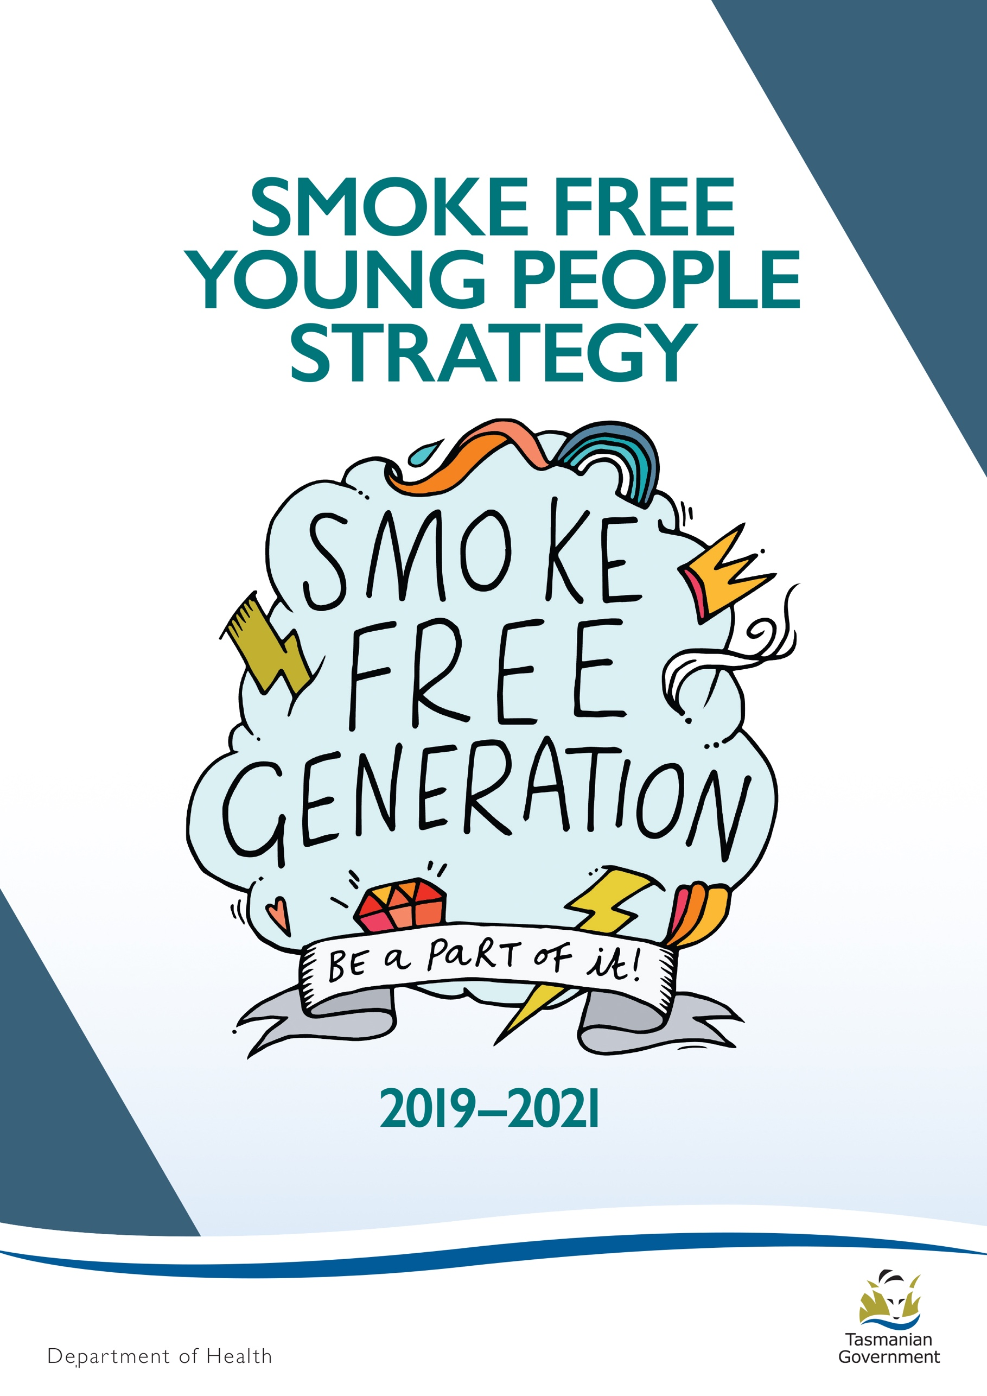

Prepared by Public Health Services, Department of Health for the
Smoke Free Young People Working Group

Endorsed by the Tasmanian Tobacco Control Coalition
www.smokefree.den.org.au
November 2019

Introduction

Smoking by young people is an important health issue.
2
This Strategy outlines how we can work together to protect young Tasmanians from the harmful effects of tobacco use.
It builds on outcomes from the Smoke Free Young People Strategy 2013-2017 which showed that positive collaboration between partners can be achieved and that there is great energy and interest in this issue. It also demonstrated that social media works and is a good option to disseminate health messages to young Tasmanians.
Ongoing downward trends for smoking prevalence by young people in Tasmania suggest the social acceptability of smoking is changing, however continued action is needed to prevent its uptake and to continue to help those who have already started smoking to quit. In doing so, current and future generations of young Tasmanians will grow up to be smoke free.
For this updated Strategy, young people will be engaged wherever possible to improve outcomes and existing resources such as the Smoke Free Generation – Be a Part of It! branding and website will continue to be used.
There are a range of measures being implemented through state and national plans that are linked to the prevention of smoking uptake.

At the state level, the Tasmanian Tobacco Control Plan 2017-2021 recommends continued action to influence young people to be smoke free with population health approaches that impact on smoking uptake, as well as those that focus on the individual.
Actions to reduce the retail availability of tobacco and the removal of flavourings from cigarettes to make them less palatable for new smokers are important contributors to smoking prevention. These are actions that sit with the broader Tobacco Control Plan and will not be addressed directly through this Strategy.
The Healthy Tasmania Five Year Strategic Plan also addresses smoking uptake by young people through additional compliance and education activities including action to reduce the supply of tobacco by family and friends.
Healthy Tasmania has established targets to halve the gap between Tasmanian and national smoking rates by 2020 for Tasmanians under the age of 25 and to better the national average by 2025.
At the national level, population wide measures that impact on smoking uptake include plain packaging of tobacco and regular increases in tobacco prices.

Partners

This Strategy has been developed by the Smoke Free Young People Working Group established by the Tobacco Control Coalition, a group of stakeholders from government and non-government sectors with a commitment to reducing smoking prevalence in Tasmania.
The Coalition advises the Tasmanian Government on tobacco policy issues and supports implementation and monitoring of the Tobacco Control Plan.
Partners in the Smoke Free Young People Working Group include representatives from the youth sector (The Link Youth Health Service, Drug Education Network), the Department of Health, Department of Education and Tasmanian Health Service; Tasmanian Independent Schools and health organisations such as Cancer Council Tasmania and Flinders Island Aboriginal Association Inc.
To help implement the Tobacco Control Plan, a working group for smoke free priority populations has also been established.
It has developed No One Left Behind: An Action Plan to Achieve a Smoke Free Tasmania 2018-2021 which targets certain population groups with high smoking rates to quit.
These are:
- pregnant women
- young people
- middle-aged men
- Aboriginal people
- people with mental ill-health
- people from low socio economic areas.
No One Left Behind complements actions identified in this Strategy, particularly relating to the link between tobacco use and disadvantage, disengagement with schools and unemployment.

Young People and Smoking in Tasmania

Most young Tasmanians are smoke free.
The Australian Secondary Students’ Alcohol and Drug (ASSAD) survey is conducted every three years. Although the survey doesn’t capture current smoking by teenagers that work or who are no longer at school, it provides a reliable insight into the smoking behaviour of young Tasmanians most of whom are at school.
ASSAD surveys continue to show ongoing declines in current smokers since a high in the mid 1990’s. The most recent survey was conducted in 2017 with Tasmanian students between the ages of 12 and 17. It showed 5 per cent of students were current smokers meaning they had smoked within seven days of the survey. This is a decrease from 9 per cent in 2011 and equates to around 1800 students (Cancer Council Victoria, ASSAD 2017 Tasmania, Statistics and Trends).
For young students aged 12 to 15 years, current smokers is at a low of 4 per cent. For older students aged 16 to 17 years, 8 per cent are current smokers, a significant decline from 16 per cent in 2011. The 18 to 24 age group has the highest current smokers at 22.6 per cent (National Health Survey 2017/18).
By gender, there are no notable differences in smoking overall.
For students who identify as current smokers, an average of 13 cigarettes per week are smoked.
The most common brand used is JPS (27 per cent) and the most common pack size is 20s (37 per cent). Significantly, most source cigarettes from their friends (60 per cent) or ask someone else to buy them (15 per cent). Very few students buy cigarettes themselves from a shop.
Questions on electronic cigarette use were included in the ASSAD survey for the first time in 2014 where 12 per cent reported having ever vaped. This was similar in 2017 at 13 per cent. Having ever vaped was more common among males (17 per cent) than females (8 per cent).
An emerging concern is the substantial use of roll-your-own tobacco with 73 per cent of students that had smoked in the past month using it.
Another concern is that maternal smoking continues to be alarmingly high among women under 20 years of age at around 40 per cent (Tasmanian Perinatal Data Collection 2017).
78 per cent of Tasmanian students had never smoked in 2017, an increase from 70 per cent in 2011.
A priority is to prevent smoking uptake for longer in age groups that are already in decline. With less established smokers in the 16 to 17 age group, the timing is ideal to take strong action to prevent smoking uptake.

Why do young people smoke?
4
Smoking habits develop differently for young people. Some will experiment and never increase their use, while others will move quickly from experimentation to dependence.

The combined effect of a range of issues can lead to smoking uptake by young people. These can include:

Environmental
    - Exposure to tobacco industry influence, marketing and promotion that creates a positive image of smokers and smoking such as movies, magazines, television, sport and cultural events, video games and social media.
    - Price and ease of access to tobacco.
    - Socio economic status or coming from a disadvantaged background.
    - Geographic location.
    - Engagement with and by schools.
    - Unemployment.

Social
- Family, particularly parents. Young people are more likely to see tobacco use as a normal behaviour if their parents, siblings or other family members smoke.
- Peer groups. Young people are more likely to smoke if their friends smoke. They also tend to overestimate smoking prevalence by their peers.

Individual
- Beliefs about smoking that are image related.
- Beliefs about smoking as a means of coping with stress.
- Beliefs that the negative effects or health impacts of smoking are not relevant.
- Addiction. Young people can become addicted to cigarettes very rapidly, even at low levels of consumption.
- Low self-esteem due to poor social skills, connectedness to school or home or not fitting in and being part of a group.
- Risk taking behaviour. Brain development continues until about the age of 25 years resulting in less than optimal capacity for planning and judgement by younger people.

5

The Solutions
Nearly all smokers start before the age of 18 and one-third of people who have ever tried smoking go on to become daily smokers (US Department of Health and Human Services, 2010).
Prevention is not just stopping those who have never smoked from trying or starting smoking. It also means discouraging those who have tried smoking once or twice from continuing, deterring continuation among those who have ‘taken up’ smoking and encouraging and assisting established young smokers to quit.
To increase effectiveness, interventions need to be coordinated and seek to achieve a balanced mix over time to:

Create a world where seeing people smoke is the exception, not the norm
Smoke free lifestyles should be considered normal. This can be achieved through actions such as laws to restrict where people can smoke, particularly in public places that young people are likely to be. Encouragement and support for adults to set an example by quitting smoking themselves can also positively impact on young people.

Limit tobacco marketing and promotion that is likely to be seen by young people
The removal of tobacco product displays in shops and other measures such as plain packaging has significantly reduced exposure to product branding, marketing and promotion. However, tobacco products are still located behind a counter and price boards displayed in some shops show product and price information that can be easily seen by young people.

Make it harder to smoke
Regular increases in tobacco prices over recent years have made tobacco difficult for young people to afford. How tobacco is sold is also regulated with age-based laws that restrict sale and supply to people under 18 years of age. However, there is more that can be done to strengthen laws that influence and determine how and where tobacco is sold.

Educate young people to help them make healthy choices
School based and community education programs and promotions, complemented by social marketing campaigns, can be used to provide young people with the information they need to be informed about their health.

Provide support to quit smoking
Access to youth friendly cessation support and services requires ongoing resourcing.

Moving Forward
Key factors to enable implementation are to:

Work together
Strong collaboration was a feature of the previous Strategy and will need to continue in the future.

Consult
The voice of young people needs to be heard. Talking with young people is an integral part of developing and measuring the success of this Strategy.

Resources
Implementation will be coordinated by Public Health Services, Department of Health in collaboration with members of the Smoke Free Young People Working Group, subject to resourcing and funding.

Evaluation
Long term outcomes include reduced prevalence of current smokers aged 12 to 17 years and more that have never smoked. The ASSAD survey in 2020 will be used to measure this.
Smoking by 18 to 24 year olds to be reported in the National Health Survey 2020 will also be an important indicator of progress.

Action Areas
Five areas for action are recommended:
- Youth Campaign
Target 10-17 years

- School Based Support
Target 10-17 years

- Normalise Smoke Free
Target 10-24 years

- Cessation Support
Target 15-24 years

- Adult Role Modelling
Target 10-24 years
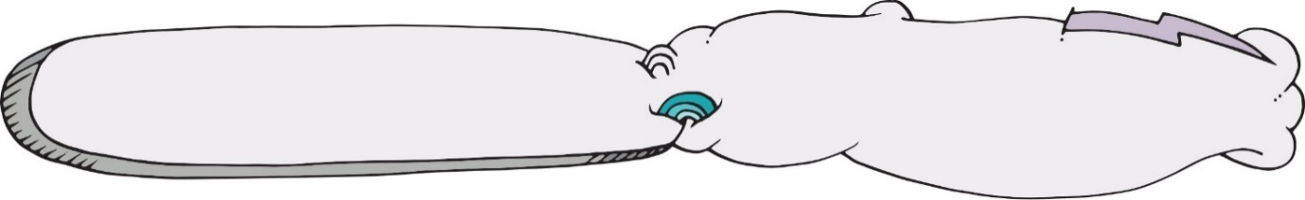

Action One

Youth Campaign

Objective
To develop and implement a Smoke Free Generation campaign to shift attitudes, intentions and behaviours about smoking by young Tasmanians, particularly those aged 10-17 years with a focus on five campaign messages: (1) the benefits of being smoke free, (2) the negative short-term and immediate effects of smoking, (3) the reality that a majority of young Tasmanians are smoke free, (4) the addictiveness of nicotine and (5) how not to smoke (dealing with peer pressure and saying no).

Rationale
Young people who receive anti-smoking information from a variety of sources – such as family, friends, school, social media, television, internet and events as opposed to only a few, are more likely to refuse tobacco.

Actions
  - Deliver campaign messages and promote the Smoke Free Generation website through targeted online and social media using a combination of organic and paid promotions.
  - Link young people to adult focussed campaigns using digital and social media with tagging.
1.3 Encourage partners to extend the reach of campaign messages through promotion at community, school, sport and youth events with merchandise and promotional items such as postcards.

Outcomes
Increased knowledge and awareness by young Tasmanians of the five campaign messages.

Monitoring
- Smoke Free Generation Facebook and Instagram reach and insight reports.
- Smoke Free Generation website Google analytic reports including page views, new users and number of sessions.
- Number and type of events attended by partners, such as school visits and youth events.

School Support

Action Two

Objective
To support schools to access evidence-based and up-to-date information on smoking prevention and cessation to assist in the implementation of the Personal, Social and Community Health strand of the Australian Health and Physical Education curriculum.

Rationale
Smoke free messages are best delivered and promoted by people who young people trust. Schools are well placed to do this and, by ensuring access to the right information, teachers can be better supported to implement smoke free messages through the curriculum.

Actions
2.1 Review teacher access to information to support them to deliver the curriculum, including if Pinterest is a suitable platform to access information.
2.2 Review information and resources available to teachers to ensure it is evidence-based.
2.3 Investigate a smoking prevention program that can be delivered to students in person.
2.4 Promote existing programs and activities such as World No Tobacco Day, National Youth Week and The Critics’ Choice.

Outcomes
Teachers will have access to current resources that reflect best practice and are evidence informed that is coordinated through a central point of contact that includes both content knowledge and pedagogy.

Monitoring
- Number of teachers accessing Pinterest (via the Drug Education Network website).
- Smoke Free Generation website Google analytic reports on use by staff from the Department of Education and other schools.
- Teacher survey.
10

Normalise Smoke Free

Action Three

Objective
To ensure being smoke free is the norm.

Rationale
Young people form attitudes to smoking through the experience and observations of adults close to them, particularly parents. Actions that seek to encourage parents to quit smoking, restrict where people can smoke in public places and reduce tobacco promotion can help to change social norms and the mindset that it is ok for young people to smoke. This can prevent uptake.

Actions
3.1 Strengthen laws that influence how and where tobacco is sold and places where it is used, including increasing the minimum age for the sale of tobacco from 18 to 21 years.
3.2 Acknowledge and encourage smoke free workplaces, particularly those that people up to the age of 24 are likely to visit or be employed at.
3.3 Support the Smoke Free Environments project which seeks to extend and implement smoke free areas in and around Tasmanian health care facilities and schools.
3.4 Consult with young Tasmanians about their awareness and use of electronic cigarettes.

Outcomes
Access and availability of tobacco and its promotion to young people will be reduced. Exposure to the act of smoking, particularly in public areas and to second-hand smoke will also be reduced.

Monitoring
- Percentage of students that access tobacco from retail outlets and from family or friends.
- Percentage of retailers compliant with laws that ban the sale of tobacco to a child.
- Percentage of students exposed to second hand smoke in the home.
- Number and proportion of smoke free workplaces.
- Number and proportion of smoke free public events.
- Increased smoke free areas in health care facilities and schools.

Cessation Support

Action Four

Objective
12
To provide and promote information on options for young people to quit smoking that are evidence-based and up-to-date. The evidence on specific interventions that work best for young smokers is lacking but it is generally recommended that some interventions for adults may also be effective for young people, such as the Quitline, which has protocols in place for counselling younger smokers.

Rationale
Feedback from some schools and youth health workers is that students want and need support to quit smoking.

Actions
  - Conduct a literature review of what works best to help young people quit smoking.
  - Promote the Quitline to young people and service providers as an appropriate and accessible service, particularly for young adults between 18 and 24 years of age.
  - Pilot new ways to provide smoking cessation counselling to young people such as texting or online chat in real time.
  - Ensure the content on the Smoke Free Generation website is evidence-based and up-to-date.
  - Develop messaging to target cannabis users who do not see themselves as tobacco users addicted to nicotine.

Outcomes
Awareness by service providers of and access to self-help resources and programs will be improved. There will also be a better understanding of how to assist young Tasmanians to quit smoking.

Monitoring
- Increased Quitline contacts from smokers up until the age of 24 years.
- Smoke Free Generation website Google analytic reports on page views for information on how to quit smoking.

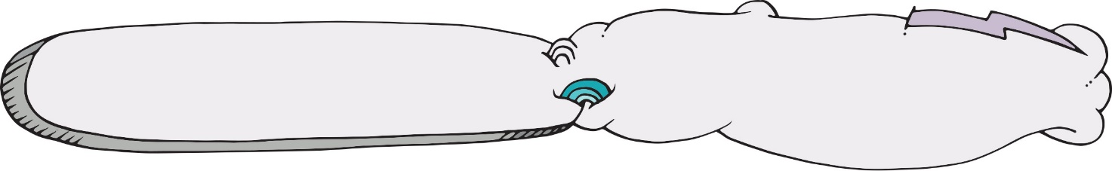

Adult role modelling

Action Five
13

Objective
To increase awareness of adults in positions of influence over young people, particularly youth workers and teachers, of the key role they have to prevent or delay smoking uptake. This is particularly important for those who are experimenting with tobacco to ensure they do not progress to becoming a dependent smoker. Adults can also encourage and assist young smokers to reduce or quit smoking and create and support smoke free and healthy environments.

Rationale
Research shows that consistent messages and support around smoking from schools and parents can prevent smoking uptake and assist with quitting.

Actions
5.1 Promote ‘Don’t give a lifetime of addiction. Kids and smokes. Count the costs’ resources to reduce the supply of tobacco to young people by family and friends.
5.2 Update and promote the ‘Smoking but it’s the least of their problems…’ guide for youth workers and youth service managers in Tasmania.
5.3 Promote training available through the Smoking Cessation Program for youth workers and schools that can assist young smokers to reduce or quit smoking.
5.4 Deliver Smoke Free Generation information sessions targeting youth health workers, teachers and school support staff at least once a year that provides brief information on prevention, cessation and other topical tobacco control issues.

Outcomes
Adult role models have increased knowledge and awareness of smoking as an issue of importance and options to quit smoking.

Monitoring
- Number of ‘Don’t give a lifetime of addiction’ resources distributed.
- Number of youth worker guides distributed.
- Number and type of training delivered by the Smoking Cessation Program to youth workers and schools.
- Number of Smoke Free Generation information sessions and feedback provided by youth workers, teachers and school support staff.

