Smoke Free Public Events

A Guide for Event Organisers

June 2018

Introduction
This guide is to help event organisers complete a Smoke Free Management Plan for public events.
Most public events require a Place of Assembly licence which is issued by local councils. A Smoke Free Management Plan approved by the Department of Health and Human Services is also required before a local council can issue a Place of Assembly licence for a public event. This applies to events declared by the Director as smoke free or events that voluntarily choose to be smoke-free or have a designated smoking area.
A Smoke Free Management Plan is an additional requirement that event organisers will need to allow time for when making a Place of Assembly submission to local council.
There are no additional costs for event organisers, other than the time needed to complete a Smoke Free Management Plan.
Under section 67I of the Public Health Act 1997 (the Act) the Director may receive applications to designate a smoking area at an event that has been declared smoke free. The intention is for smoking to only occur if areas are designated for smoking. There are restrictions on designated smoking areas which are outlined in this guide.
Smoke free laws aim to reduce smoking rates by:
- Protecting the health of non-smokers, including staff and patrons from exposure to environmental tobacco smoke.
- Reducing uptake by young people by making smoking less likely to be considered the norm when it is removed from busy public areas, particularly where there are young people.
- Supporting smokers by making it easier to quit or remain quit.
Smoke-free public event laws were passed by the Tasmanian Parliament in November 2011 and took effect on 1 March 2012. Over a number of years, classes of events i.e. carols by candlelight, then markets and festivals, and more recently agricultural shows, were designated as smoke-free by the Director of Public Health by public notices. A separate public notice was issued to declare all mass outdoor events smoke-free in 2016. In 2017 the Act was strengthened to prohibit the use of electronic cigarettes (personal vaporiser products) or other herbal cigarettes in smoke free areas. Using an electronic cigarette is sometimes called vaping. In Tasmania, the law refers to this as smoking.
For more information or help completing a Smoke Free Management Plan contact:
Phone: 1800 671 738 (free call)
(03) 61660656 south
(03) 67771979 north
Email: public.health@dhhs.tas.gov.au
Website: http://www.dhhs.tas.gov.au/publichealth/tobacco_control
Version notes
This version of the Guide, effective 1 June 2018, amends the previous guide by:
- reformatting
- updating website references
- updating contact details
- the definition of smoking includes e-cigarettes, personal vaporisers and herbal cigarettes

Completing a Smoke Free Management Plan
All event organisers are required to complete questions 1 to 5 on the Smoke Free Management Plan. Answers to questions 1, 2 and 3 are compulsory and 4 and 5 are optional. You only need to answer question six if your event plans to have a designated smoking area.
Q1. Signage (compulsory answer)
The Act requires signage approved by the Director of Public Health to be displayed in smoke free areas. You must indicate where these signs will be located.
This is to ensure that signs are placed where patrons can see them. This will ensure the smoke-free requirements of your event are communicated, which may also help with compliance.
Examples of suitable areas where signage could be located include entrances or areas where smokers are likely to gather.
Only signage approved by the Director can be displayed. Copies of approved signs can be downloaded from www.dhhs.tas.gov.au/publichealth/tobacco_control or you can contact Tobacco Control for copies, including laminated versions or banners.
You can use alternative signs but you will need to seek permission from the Director of Public Health. For further information on this contact Public Health Services.
Q2. Event Promotion Materials (compulsory answer)
You must provide information on the event promotion materials that will be used to inform patrons of the smoke-free requirements that apply. This can include ticketing, advertising on posters, websites or broadcasting at the event.
This is to ensure patrons are aware the event is completely smoke-free or that designated smoking areas are available.
An example of wording for a smoke free event is “This is a smoke-free event”.
An example of wording for an event with designated smoking areas is “Designated areas for smoking apply”.
If no promotion materials are used for an event then tick the no box and provide a reason.

Q3. Staff Communication (compulsory answer)
You must provide information on how you will communicate your event’s smoke-free requirements to staff. This can be verbally or in writing. The key point is to ensure your staff are aware patrons cannot just smoke anywhere and that the event is either completely smoke-free or has designated smoking areas.
Enforcement
Smoke-free public events are not commonly visited by tobacco control officers which is why awareness by staff of the requirements is important so can tell patrons.
Enforcement needs will vary according to the type of event and numbers of people that attend. You will have to make your own judgement on the best approach to take.
Experience suggests communities are help to enforce the law when they are aware an event being smoke-free. Smokers themselves are used to looking for signs to ensure they know where they can and cannot smoke.
The general expectation on ensuring compliance is for public event staff to be readily able to tell patrons about smoke-free requirements.
Signs are particularly important so staff can point to them. Another option is to have Information Cards available that can be handed to people smoking.
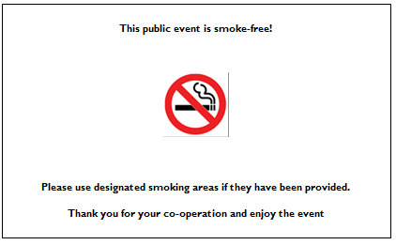
These are available from Public Health Services or can be downloaded from: www.dhhs.tas.gov.au/publichealth/tobacco_control

For large events (tens of thousands of people), you may wish to have more specific procedures in place to deal with non-compliance and complaints.
Issues for consideration and communication to staff include:
- What is an offence under the Act and that offenders risk an on-the-spot fine or if they smoke in a smoke-free area.
- The need to be fair and consistent in their approach, such as by first asking a person smoking in a smoke-free area to stop or to move to a designated smoking area (if available) before taking stronger action if their behaviour does not change.
- What to do if a patron complains about smoke-free requirements.
- Keeping a log or record of offences observed and action taken.
- Appoint nominated officers under the Act who have the authority to issue warnings and on-the-spot fines. Event organisers can write to the Director and request certain staff be authorised as nominated officers to assist with enforcement at an event.
Public Health Services may also be able to help monitor large events. Contact Public Health Services for more information or help to develop specific procedures for enforcement.
Q4. Cessation Support (optional answer)
You may wish to provide cessation support for staff such as nicotine patches or gum, especially for long running events that are completely smoke-free.
Q5. Health Promotion (optional answer)
Event organisers may wish to promote a health message at smoke free events. Quit Tasmania can provide free resources such as flags, banners and other promotional materials to help encourage

people to quit smoking.

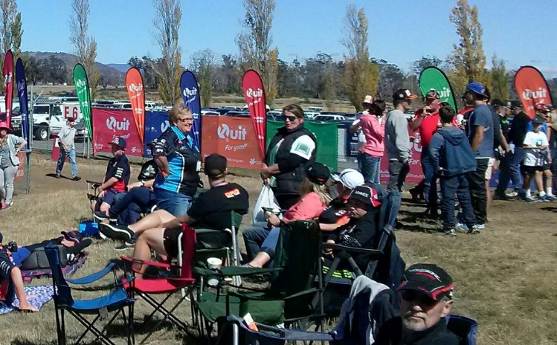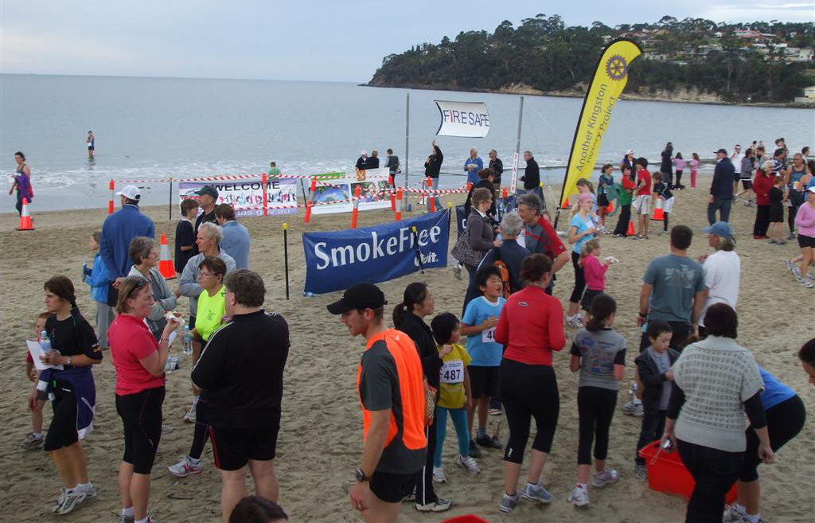

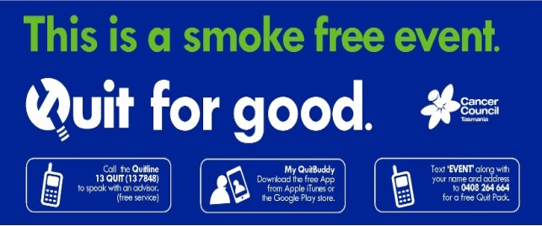

For further information contact Quit Tasmania on 6169 1943or email admin@quittas.org.au

Q6. Designated Smoking Areas (compulsory answer if applicable)
This section of the Smoke Free Management Plan may act as an application to the Director of Public Health for designated smoking area at a Public Event that has been declared smoke-free under the Act. Designated smoking areas were introduced to help organisers transition towards an entirely smoke-free event. A single designated smoking area should provide for smoking including the use of personal vaporisers e-cigarettes or herbal cigarettes.
Events with designated smoking area or areas must provide a site plan clearly showing:
- number
- size – maximum of 10m x 10m permitted
- location (towards the outermost edge of the entire area used for the event or for patrons to view a staged performance)
- not within 20 metres of food outlets
- not within 20 metres of children’s activities
- where approved signs are located.
An example of a site plan is provided below where the designated smoking area is highlighted in red:

Other designated smoking areas requirements include:
- no broadcasting equipment positioned within a designated smoking area, although any broadcasting outside the area may be heard within it
- no children permitted within the area
- no food (including drinks other than water)
- no servicing by staff of any food or beverages
- no seating.

All structures must comply with the requirements for outdoor smoking areas under the Act.
This means it must not have a roof, or if it has a roof, does not have a perimeter consisting of more than 50 per cent walls and windows.
Butt bins can be located in designated smoking areas to reduce litter.
Under section 67I of the Act you must take steps to endure that the condition imposed on the designated smoking areas are maintained.
Therefore, if during the event seating is provided or it nears activities for children or food, you could be penalised.
A letter from Public Health Services will be issued to you stating these requirements, the date of your event and the number of designated smoking areas that you are allowed.

