Issued by the Director of Public Health  
under the *Public Health Act 1997*

Effective 29 November 2017

Guidelines for the Sale of   
Smoking Products

Containing legal requirements for  
retailers, manufacturers, and distributors of   
tobacco products and personal vaporiser products   
(including electronic cigarettes)

Public Health Services

Department of Health and Human Services

# Issuing Statement and Commencement Date

I, Dr Mark Veitch, being and as the Director of Public Health, acting pursuant to the *Public Health Act 1997* hereby:

1. revoke, effective 29 November 2017, guidelines previously issued under the Act relating to the sale of tobacco products in Tasmania; and
2. issue these guidelines, being the *Guidelines for the Sale of Smoking Products;* and
3. determine that these guidelines come into effect on and from 29 November 2017.

Dated this 28 November 2017

**Dr Mark Veitch**

**Director of Public Health**

# Version notes

These Guidelines amend the *Guidelines for the Sale of Tobacco Products in Tasmania* (version 18 January 2016) by:

* adopting a new name for the guidelines
* incorporating personal vaporiser products into the operation of the guidelines (as these are now regulated by the *Public Health Act 1997* as a result of the changes contained in the *Public Health Amendment (Healthy Tasmania) Act 2017)*
* approving the form and manner of notices to be displayed (previously in a separate instrument issued under the Act)
* removing the example ‘acknowledgement of information’ form
* changing some formatting and language.

# Table of Contents

PART A Introduction and Definitions 4

Clause 1. Introduction 4

Clause 2. Definitions 5

PART B Product and Pricing Information 9

Clause 1. Introduction 9

Clause 2. Information that can be displayed 9

Clause 3. Product availability notice 11

Clause 4. Price board 12

Clause 5. Price tickets 13

PART C Notices that must be displayed 15

Clause 1. Introduction 15

Clause 2. Notices that must be displayed 15

Clause 3. How to display the notices 18

PART D Information to employees 19

PART E Proof of Age 20

PART F Packaging and Labelling requirements 21

# PART A Introduction and Definitions

## Introduction

* 1. These Guidelines are about the sale of *smoking products* in Tasmania.
  2. A smoking product is any *tobacco product* or *personal vaporiser product* (including electronic cigarettes or e-cigarettes).
  3. The Guidelines contain requirements for retailers, manufacturers, and distributors of those products.
  4. The Guidelines are issued by the *Director of Public Health* under the *Public Health Act 1997.* It is a legal requirement to comply with the Guidelines. Failure to do so is a breach of the *Act* and can result in fines.
  5. The Guidelines are set out as follows:
     1. This Part A includes definitions for certain words and phrases used in the Guidelines.
     2. Part B sets out the product and pricing information that *licence holders* may display in *retail premises* (section 70(2)(b)(ii) of the *Act*)*.*
     3. Part C sets out the notices that *licence holders* must display and how to display them (section 69A(2) of the *Act)*.
     4. Part D sets out the information that *licence holders* must provide employees (section 64(6) of the *Act*).
     5. Part E specifies the additional classes of documents that are acceptable forms of *proof of age* (section 3 of the *Act)*.
     6. Part F sets out the packaging and labelling requirements for *tobacco products* (section 73 of the *Act).*

## Definitions

A word or phrase appearing in *italics* in these Guidelines has the meaning given to it in the table below. If there is an asterisk (*) next to the word or phrase, its meaning is taken from the *Public Health Act 1997* as at 29 November 2017. If the definition in the *Act* changes, that new definition replaces the one below.

|  |  |
| --- | --- |
| Act * | means the *Public Health Act 1997* |
| approved * | means approved by the *Director of Public Health* |
| ancillary tobacco product * | means a *tobacco product* other than –  (a) tobacco in any form; or  (b) a product of which tobacco is an ingredient; or  (c) a package or cigarette shipper containing a thing referred to in paragraph (a) or (b) of this definition |
| concealed storage facility * | means –  (a) a storeroom, cellar or other enclosed place; or  (b) a cupboard, locker or drawer –  that –  (c) is inaccessible to the public; and  (d) is kept closed, except when there is an immediate need to put things in it or take things from it; and  (e) when closed, cannot be seen into by the public |
| Director of Public Health * | means the Director of Public Health appointed under section 6 of the *Public Health Act 1997* |
| electronic dispensing unit * | means a machine that is designed to dispense *smoking products* and be operated by means of an electronic keypad, whether or not, at a given time, the machine is in working order |
| exempt device * | means –  (a) a device designed to be used for the purpose of delivering oxygen into a person’s body; and  (b) a device, object or product used, or designed to be used, to deliver a controlled substance, within the meaning of the *Misuse of Drugs Act 2001*, into a person’s body; and  (c) any of the following goods, or devices, included in the Australian Register of Therapeutic Goods maintained under section 9A of the *Therapeutic Goods Act 1989* of the Commonwealth:  (i) therapeutic goods within the meaning of that Act;  (ii) a medical device within the meaning of that Act;  (iii) a therapeutic device within the meaning of that Act; and  (d) a device or object prescribed by the regulations to be an exempt device |
| licence holder | means the holder of a *smoking product licence* that authorises the sale of *tobacco products* and/or *personal vaporiser products* or an employee of the holder of such a licence |
| personal vaporiser product * | means any of the following, other than an *exempt device:*  (a) an electronic cigarette, or a device, object or product, that –  (i) with or without modification, is capable of heating any substance into an aerosol, mist or vapour which is inhaled into a person’s body; and  (ii) has one or more of the following parts:   1. a battery; 2. an electronic heating element; 3. a cartridge or container capable of holding a substance;   (b) each part of an electronic cigarette, or a device, object or product, referred to in paragraph (a);  (c) a substance or item apparently intended, with or without modification, to be used in connection with an electronic cigarette, or a device, object or product, referred to in paragraph (a);  (d) a device, object, or product, that is prescribed by the regulations to be a personal vaporiser product |
| plain sales unit * | means a *sales unit t*hat –  (a) is not displaying any wording or imagery that contravenes the guidelines; and  (b) does not have any mirror or other reflective device; and  (c) does not have any interior or exterior lighting; and  (d) does not have any lighting directed specifically at it, whether from a spotlight, down light or otherwise or whether the illumination is constant or intermittent; and  (e) is not fitted with or connected to any device capable of causing the sales unit (or any part of it) or its contents (or any of its contents) to move in a way that is visible to the public; and  (f) is not displaying any wording, trademarks or colour schemes usually used in the packaging of any *smoking product* held in it; and  (g) is not displaying any partial wording or imagery of any packaging of *smoking product* held in it; and  (h) has no lines, borders or other visual design effects that make it stand out; and  (i) is not linked to any hologram |
| product line * | in relation to a *smoking product*, means a kind of *smoking product* distinguishable from another kind of *smoking product* by any one or more of the following characteristics:  (a) its length, mass or volume;  (b) its content;  (c) its brand name or trade mark;  (d) in the case of a packet of cigarettes or cigars, the number of cigarettes or cigars in the packet; |
| proof of age * | means  (a) a driver licence; or  (b) a passport; or  (c) a class of document specified in the guidelines for the purpose of this definition |
| retail premises | means premises on a *smoking product licence*  from which *tobacco products* or *personal vaporiser products* (or both) are authorised to be sold |
| sale / sell * | includes –  (a) dispose by any method for valuable consideration; and  (b) barter or exchange; and  (c) dispose to an agent for sale on consignment; and  (d) offer or expose for sale; and  (e) keep or have in possession for sale; and  (f) agree to sell; and  (g) send, forward or deliver for sale; and  (h) dispose by way of raffle, lottery or other game of chance; and  (i) provide a sample |
| sales unit * | means –  (a) in the case of *specialist tobacconist premises*, a receptacle, area of shelving, electronic dispensing unit or other thing from which *tobacco* *products* are dispensed when sold; or  *(b)* in the case of retail premises other than *specialist tobacconist premises*, a receptacle, area of shelving, vending machine, electronic dispensing unit or other thing from which *smoking products* are dispensed when sold |
| service area * | means an area of the premises –  (a) from where *sales* of *smoking products* are ordinarily effected; and  (b) to which the public does not normally have access |
| smoking product * | means a *tobacco product* or *personal vaporiser product* or both |
| smoking product licence * | means a licence to sell *smoking products* in force under the *Act* |
| specialist tobacconist premises * | premises that are operated independently and apart from any other retail business and where only tobacco, *tobacco products*, matches and cigarette or pipe lighters are sold |
| tobacco product * | means any of the following:  (a) tobacco in any form;  (b) any product of which tobacco is an ingredient;  (c) any device or article designed or intended only for use in connection with tobacco;  (d) any prescribed product;  (e) any package, or cigarette shipper, containing a thing referred to in [paragraph (a)](http://www.thelaw.tas.gov.au/tocview/content.w3p;cond=;doc_id=86%2B%2B1997%2BGS3%40Nd35817396342593%40Hpa%40EN%2B20150806000000;histon=;inforequest=;pdfauthverid=;prompt=;rec=4;rtfauthverid=;term=;webauthverid=#GS3@Nd35817396342593@Hpa@EN), [(b)](http://www.thelaw.tas.gov.au/tocview/content.w3p;cond=;doc_id=86%2B%2B1997%2BGS3%40Nd35817396342593%40Hpb%40EN%2B20150806000000;histon=;inforequest=;pdfauthverid=;prompt=;rec=4;rtfauthverid=;term=;webauthverid=#GS3@Nd35817396342593@Hpb@EN), [(c)](http://www.thelaw.tas.gov.au/tocview/content.w3p;cond=;doc_id=86%2B%2B1997%2BGS3%40Nd35817396342593%40Hpc%40EN%2B20150806000000;histon=;inforequest=;pdfauthverid=;prompt=;rec=4;rtfauthverid=;term=;webauthverid=#GS3@Nd35817396342593@Hpc@EN) or [(d)](http://www.thelaw.tas.gov.au/tocview/content.w3p;cond=;doc_id=86%2B%2B1997%2BGS3%40Nd35817396342593%40Hpd%40EN%2B20150806000000;histon=;inforequest=;pdfauthverid=;prompt=;rec=4;rtfauthverid=;term=;webauthverid=#GS3@Nd35817396342593@Hpd@EN) of this definition |
| vending machine * | means a machine, other than an *electronic dispensing unit*, that is designed to dispense *smoking products*, whether or not, at a given time, the machine is in working order |

# PART B Product and Pricing Information

## Introduction

* 1. Under section 70 of the *Act* a person must not advertise *smoking products* unless guidelines issued under the *Act* allow it.
  2. These Guidelines allow *licence holders* to display certain product and pricing information on a *plain sales unit.*
  3. *Licence holders* do not have to display any product or pricing   
     information, but if they choose to do so, the information must comply with this Part B.

## Information that can be displayed

*General retail premises without a vending machine*

* 1. In *retail premises* that are not *specialist tobacconist premises* or premises with a *vending machine:* 
     1. a *licence holder* may only display the following product and pricing information for *smoking products* held for *sale:*
        1. up to one square metre of related **price tickets** that comply with Part B, clause 5 of these Guidelines, displayed only during the fleeting incidental display of *smoking products* as permitted under the *Act*; **and**
        2. one **product availability notice** that complies with Part B, clause 3ofthese Guidelines; **or**
        3. one **price board** that complies with Part B, clause 4 of these Guidelines;
     2. Product and pricing information under subclause (a) above may only be displayed on a *plain sales unit* or a *concealed storage facility* or, if the *concealed storage facility* is not in publicview, in the *service area* of the premises.

*General retail premises with a vending machine*

* 1. In *retail premises* with a *plain sales unit* that is a *vending machine:*
     1. a *licence holder* may only display the following product and pricing information for *smoking products* held for *sale* in that *vending machine*:
        1. up to 40 related **price tickets** that comply with Part B, clause 5 of these Guidelines;
     2. Product and pricing information under subclause (a) above may only be displayed on the front surface of the *vending machine.*

*Specialist tobacconists*

* 1. In *specialist tobacconist premises:*
     1. a *licence holder* may only display the following product and pricing information:
        1. for *tobacco products* held for *sale* - one **price board** that complies with Part B, clause 4 of these Guidelines; **and**
        2. for *ancillary tobacco products* displayed in the premises - up to four square metres of related **price tickets** that comply with Part B, clause 5 of these Guidelines; **and**
        3. for *tobacco products* held for *sale* that are not *ancillary tobacco products* - up to one square metre of related **price tickets** that comply with Part B, clause 5 of these Guidelines, displayed only during the fleeting incidental display of the related *tobacco products* as permitted under the *Act*;
     2. Product and pricing information under subclause (a) above may only be displayed on a *plain sales unit* or a *concealed storage facility* or, if the *concealed storage facility* is not in publicview, in the *service area* of the premises.

## Product availability notice

* 1. A product availability notice must:
     1. not contain any writing other than “Smoking Products Sold Here” (once occurring);
     2. use only black text in the typeface known as Arial, in maximum 160 point size (4 cm), in normal weight (not bold, italic or underlined), in lowercase or as shown in subclause (a) above, on white background;
     3. not use any colours;
     4. contain text only on one side; and
     5. not contain any writing, lines, images or other markings not permitted by this clause 3.

## Price board

* 1. A price board must:
     1. not be greater than 100 cm x 75 cm in size;
     2. contain only the following writing:
        1. subject to subclause (b)(ii), for each *product line* of *smoking product* held for *sale*:
           1. the brand name (once occurring); and/or
           2. the price; and/or
           3. the number of cigarettes or cigars in a *packet*; and/or
           4. the number of *packets* in a *carton*; and/or
           5. headings referencing the items above;
        2. no part of a brand name may appear on a price board more than once;
     3. use only black text in the typeface known as Arial, in maximum 80 point size (2 cm), in normal weight (not bold, italic or underlined), in lowercase or with the beginning letter of each word capitalised, on white background;
     4. not use any colours;
     5. contain text on one side only; and
     6. not contain any writing, lines, images or other markings not permitted by this clause 4.

## Price tickets

* 1. Only one price ticket per *product line* of *smoking product* held for *sale* is permitted.
  2. Each price ticket must:
     1. contain only the following writing for the related *smoking product*:
        1. the *product line;* and/or
        2. the price; and/or
        3. the number of *packets* in a *carton*; and/or
        4. a barcode or other identifying numeric, alphabetic, or alphanumeric code; and/or
        5. one symbol identifying the country of origin; and/or
        6. headings referencing the items above;
     2. contain text on one side only;
     3. when displayed in accordance with Part B, clause 2(1) of these Guidelines (relating to *retail premises* without a *vending machine*) or clause 2(3) of these Guidelines (relating to *specialist tobacconist premises)* use only text that is in the typeface known as Arial, in maximum 80 point size (2 centimetres), in normal weight (not bold, italic or underlined);
     4. when displayed in accordance with Part B, clause 2(2) of these Guidelines (relating to *vending machines*)*,* use only text that is in the typeface known as Arial, in maximum 20 point size (5 millimetres), in normal weight (not bold, italic or underlined);
     5. use only:
        1. black text on white background; or
        2. where price tickets are displayed in accordance with Part B, clause 2(1) or clause 2(3) of these Guidelines, if all other price ticketing in the premises is in a dual colour scheme, a single colour on another single-coloured background consistent with that dual colour scheme;
     6. not use any colours unless permitted by this clause 5;
     7. not contain any writing, lines, images or other markings not permitted by this clause 5;
     8. for a *plain sales unit* that is not a *vending machine*, not be positioned:
        1. so that it is visible to the public, except during the fleeting incidental display (as permitted under the *Act)* of the *smoking product* to which it relates; and
        2. anywhere other than immediately adjacent to the *smoking product* to which it relates; and
     9. for a *plain sales unit* that is a *vending machine,* not be positioned anywhere other than on the front surface of the *vending machine*.

# PART C Notices that must be displayed

## Introduction

* 1. Under section 69A(2) of the *Act,* a person who *sells* *smoking products* must display notices approved by the *Director of Public Health*.
  2. This Part C sets out the notices to display and how to display them.

## Notices that must be displayed

* 1. For the purposes of section 69A(2) of the *Act,* for a person who sells *smoking products*:
     1. the form of ‘**Notice A**’ as set out in subclause 4 below, in A4 size (297 mm x 210 mm), is hereby *approved.*
  2. For the purposes of section 69A(2) of the *Act,* for a person who *sells* *smoking products* from a *sales unit* that is a *vending machine* and for a person who *sells* *tobacco products* from *specialist tobacconist premises*:
     1. the form of ‘**Notice B**’ as set out in subclause 4 below, in A4 size (297 mm x 210 mm), is hereby *approved.*
  3. For the purposes of section 69A(2) of the *Act,* for a person who sells *tobacco products* and displays a price board as permitted under these Guidelines:
     1. the form of ‘**Notice C**’ as set out in subclause 4 below, in 300 mm x 100 mm size, is hereby *approved;* and
     2. the form of ‘**Notice D**’and the form of ‘**Notice E**‘ as set out in subclause 4 below, each in 280 mm x 100mm size, are hereby *approved* as alternatives to ‘**Notice C**’.
  4. The following are the *approved* notices referred to in subclauses (1), (2) and (3) above:

Notice A

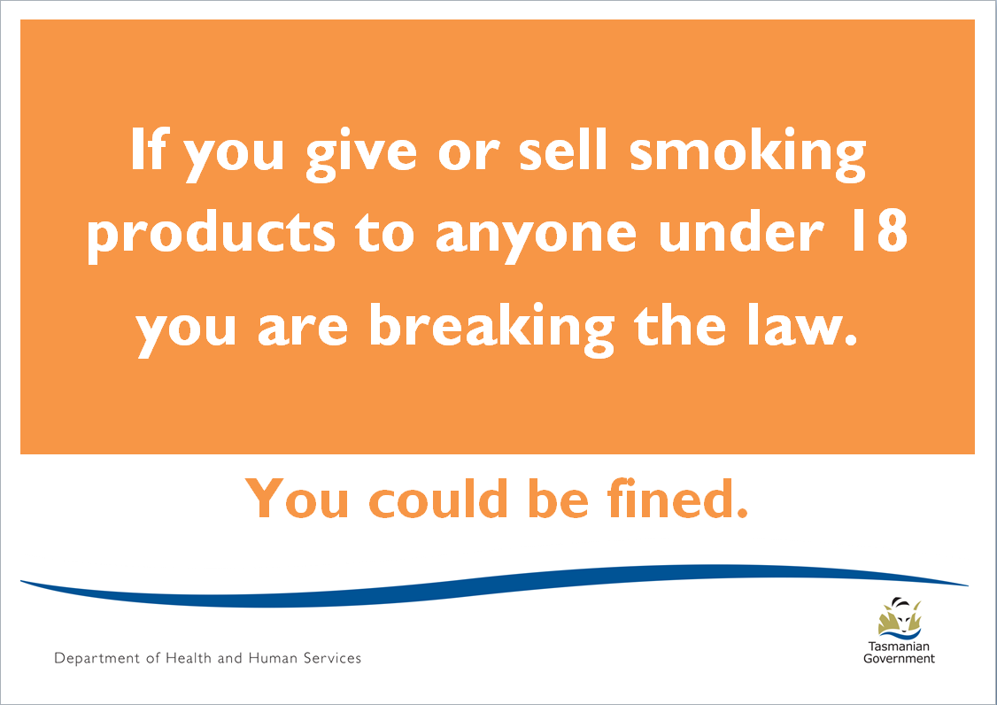

Notice B

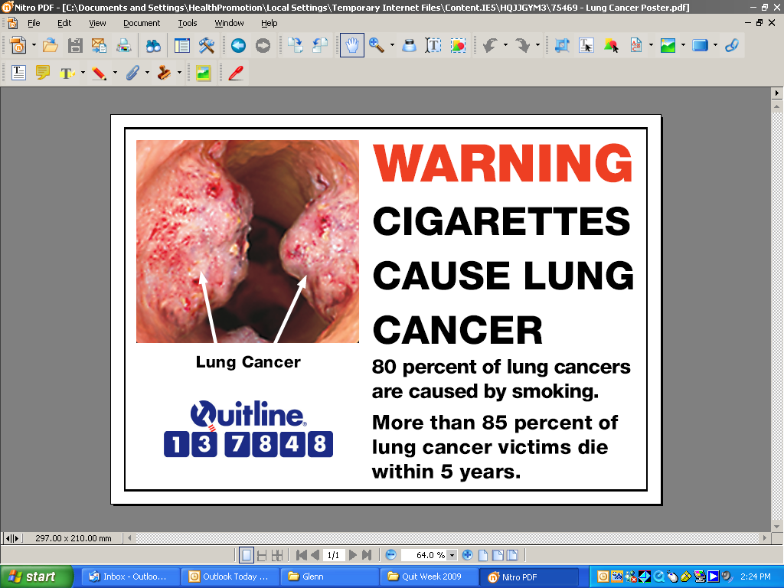

Notice C

This is a health warning from Quit Tasmania - Smoking Takes Lives.

Notice D

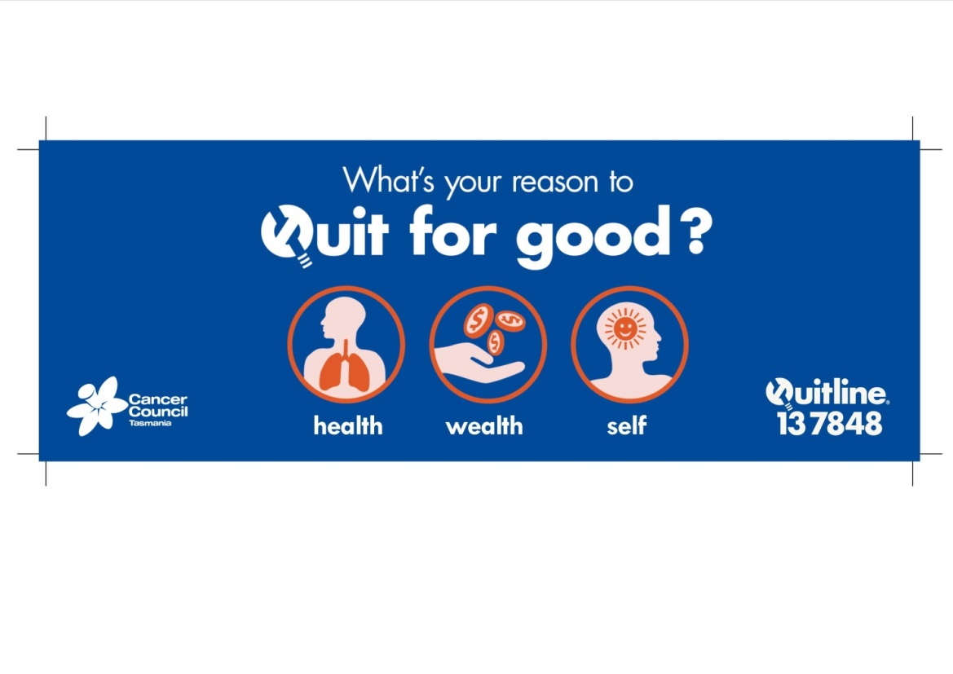

Notice E



*The above notices can be downloaded from the Department of Health and Human Services website at www.dhhs.tas.gov.au/publichealth/tobacco_control. Printed copies are available from the Department’s Tobacco Control Team – telephone: 1800 671 738 or email: tobacco.control@dhhs.tas.gov.au*

## How to display the notices

* 1. For the purposes of section 69A(2) of the Act, the above *approved* notices must be displayed by the personin the following manner:
     1. Notice A must be displayed:
        1. where *smoking products* are *sold* from a *plain sales unit* that is not a *concealed storage facility* or a *vending machine,* directly on the front surface of the *plain sales unit,* so that the notice is visible to staff and the public and can be easily seen and read;
        2. where *smoking products* are *sold* from a *concealed storage facility,* directly on the front surface of the *concealed storage facility* or, if the *concealed storage facility* is not in public view, in the *service area* of the premises, so that the notice is visible to staff and the public and can be easily seen and read;
        3. where *smoking products* are *sold* from a *plain sales unit* that is a *vending machine,* directly on the front surface of the *vending machine*, so that the notice is visible to staff and the public and can be easily seen and read;
     2. Notice B must be displayed:
        1. where *smoking products* are *sold* from a *plain sales unit* that is a *vending machine,* directly on the front surface of the *vending machine*, so that the notice is visible to staff and the public and can be easily seen and read;
        2. where *tobacco products* are sold from *specialist tobacconist premises*, directly on the front surface of a *plain sales unit* or *concealed storage facility* or, if the *concealed storage facility* is not in public view, in the *service area* of the premises, so that the notice is visible to staff and the public and can be easily seen and read;
     3. Notices C, D, or E must be displayed directly on the front surface of a *plain sales unit* or *concealed storage facility* or, if the *concealed storage facility* is not in public view, in the *service area* of the premises, so that the notice is visible to staff and the public and can be easily seen and read.

# PART D Information to employees

* 1. For the purpose of section 64(6) of the *Act*, a *licence holder* must provide to persons employed at the premises the following information about the *sale* and supply of *smoking products* to children:
     1. You must not *sell*, lend, give or supply any *tobacco product* or *personal vaporiser product* (including e-cigarettes) to, or for the use of, a person under 18 years of age.
     2. You must not offer to do those things.
     3. If you do those things, you have broken the law. Enforcement action can be taken against you. You can receive a large fine. Your employer may also be fined.
     4. You have broken the law even if the under-age customer says the product is for a person over 18 years of age.
     5. If you are unsure whether or not a customer is over 18 years of age, you should ask to see their ‘*proof of age’* identification. The only acceptable *proof of age* identification is:
        1. a driver licence;
        2. a passport;
        3. a photographic Keypass identification card;
        4. a firearms licence issued under the *Firearms Act 1996*; or
        5. a Tasmanian Government Personal Information Card.
  2. The information in clause (1) must be provided before a person commences employment with the *licence holder*.
  3. The information in clause (1) should be provided to staff every six months.

# PART E Proof of Age

* 1. The following classes of documents are specified for the purpose of the definition of *proof of age* under section 3 the *Act*:
     1. a photographic Keypass identification card;
     2. a firearms licence issued under the *Firearms Act 1996;*
     3. a Tasmanian Government Personal Information Card.

# PART F Packaging and Labelling requirements

* 1. For the purposes of section 73 of the *Act*, the manufacturer or distributor of any *tobacco product* must ensure that the *tobacco product* is packaged and labelled in accordance with the relevant Commonwealth legislation.



Contact Details:

Public Health Services

GPO Box 125

Hobart TAS 7001

1800 671 738

tobacco.control@dhhs.tas.gov.au

www.[dhhs.tas.gov.au](http://www.dhhs.tas.gov.au/publichealth/tobacco_control)