Designating Smoke-free Areas
A Guide for Occupiers

Introduction
This guide is to help occupiers including local councils to declare public streets and other areas smoke-free. A number of public places including bus and pedestrian malls, workplaces, children’s playgrounds, sporting venues and swimming pools have already been declared smoke-free by the Tasmanian Government under section 67B of the Public Health Act (1997).
Smoke-free laws aim to:
- Protect people from exposure to second hand smoke
- De-normalise smoking behaviour in public places, particularly for young people
- Support people who have quit or are trying to quit smoking
In smoke free areas, the use of tobacco products, electronic cigarettes, personal vaporisers, herbal and non-tobacco cigarettes are all banned.
Tobacco smoking kills more than 15 000 Australians every year. It is the single largest preventable cause of early death and disease in Australia.
Passive smoking or involuntary exposure to environmental tobacco smoke (ETS) can harm human health, by increasing heart disease, cancer, a variety of respiratory ailments and other adverse medical conditions. There is no safe level of exposure to ETS.
By declaring additional areas smoke-free, occupiers like local councils are contributing to the health and wellbeing of our community and the promotion of this very important public health initiative.

Implementation
This guide is to help occupiers including councils, to declare new smoke-free areas in public streets and other areas.
Occupiers are urged to use this guide when considering declaring smoke-free areas under the Act.
Population Health Services would like to work closely with you during the proposed declaration process to enable both parties to have a shared understanding of the area to become smoke-free. A template declaration has been included in Appendix A of this guide.
This guide sets out the roles that you, as occupiers and our tobacco control team will take in declaring new smoke-free areas and explains the need for smoke-free signs, monitoring and enforcement strategies for these smoke-free areas.
Occupiers should return a completed declaration to our tobacco control team to ensure that Government is aware of your plans to declare new smoke-free areas under the Act.

Legal Support and Advice
Occupiers are encouraged to seek their own legal advice to ensure that any existing and proposed new smoke-free areas have been declared with legal certainty and in accordance with the Act.
This guide provides recommendations based on steps taken from councils, other occupiers and Government when they have designated smoke-free areas in the past.

Consultation and Selection
You should consider where smokers may relocate to if a new area is declared smoke-free. The introduction of a new smoke-free area may create other issues if smokers move to a nearby area that could give rise to ongoing complaints or exposure to second hand smoke by a number of passers-by or adjacent businesses.
If you had designated smoke-free areas in the past, take steps to engage and consult with local businesses and stakeholders before introducing new smoke-free areas.
This process of consultation should be conducted in the early stages and should be considered when selecting a new smoke-free area.
For example councils have surveyed local businesses and users of the area to determine their views, or contact businesses with an explanatory letter or information sheet.
This consultation process should include stakeholders adjacent to areas where existing smokers will likely relocate or move.

Maps and Declarations
Occupiers should use maps and clear descriptions when declaring areas smoke-free to avoid any uncertainty.
Several smoke-free pedestrian and bus malls were declared by the State Government under the Public Health (Smoke-free Areas) Regulations 2014. For more information visit the Tasmanian Government Law Website.
The regulations describe the areas that were selected to be smoke-free and depict them with the use of marked maps. An accurate map of the area to be designated smoke-free should be consulted and used to designate the boundary. This may be used as a reference for enforcement, public awareness rising or when responding to complaints.
A template declaration instrument smoke-free can be found in Appendix A and is based on the regulations.

Public Awareness
Signs must be used to improve public awareness of smoke-free areas and in order to meet the legislative requirements. The Act requires you as the occupier to provide smoke-free signs in existing and new smoke-free areas within their municipality.
Section 67E Signs of the Act states:
The occupier of a smoke-free area must display within that area any sign approved by the Director or containing wording or images approved by the Director for display in a smoke-free area or class of area.
In addition, occupiers particularly councils should raise public awareness of a new smoke-free area by public notice in a local newspaper or by forming a working group to focus on promoting the new smoke-free areas and the benefits to the users. These benefits may include decreased litter, improved air quality and a supportive environment for smokers to quit for good.

Enforcement
Experience indicates that smoke-free areas are largely self-enforcing. However, you as occupier should take primary responsibility for enforcement of public streets and areas you designate as smoke-free. However, our tobacco control officers may provide some additional enforcement if needed.
When local council is planning to designate a smoke-free area, consideration should be taken to which officers within council will enforce the smoke-free laws. All environmental health officers are authorised under the Act to enforce the tobacco laws.
Nominated officers can also be designated by the Director of Public Health. Nominated officers can be any individual employed by the occupier or council or class of individuals (such as bylaw officers or city inspectors) who could enforce the tobacco laws.
For example the Tasmanian Health Service has authorised security guards to enforce smoke-free areas.
Nominated officers can be supported by our Department’s tobacco control officers.
It is an offence Under Section 67C of the Act to smoke in a smoke-free area.
Enforcement of smoke-free areas may involve monitoring and surveillance, issuing verbal and written warnings and infringement notices, and court proceedings.

Population Health Services Tobacco Control Team
The tobacco control team implements the tobacco provisions of the Act and the associated guidelines.
The team is primarily focused on regulation of tobacco sellers in Tasmania. The team’s experience of monitoring and enforcing smoke-free areas suggest that these places are largely self-enforcing when adequate signs are displayed and consultation has taken place.
Smokers are used to looking for signs indicating where they can smoke.
If local councils declare new areas to be smoke-free Department’s tobacco control team can provide:
- enforcement guides for nominated officers
- advice on enforcement, monitoring and surveillance
- when available, enforcement to a smoke-free area.

For more information contact:
Tobacco Control
Department of Health
Level 3/25 Argyle Street
HOBART Tasmania 7000
Phone (toll free) 1800 671 738
Email: public.health@health.tas.gov.au
Department of Health Tobacco Control website

Tobacco Control Officer North/North West Tasmania
Telephone (03) 6777 1979
Fax (03) 6334 3057

Tobacco Control Officer Southern Tasmania
Phone (03) 6166 0656
Fax (03) 6222 7692

Revenue
When local council serves the infringement notice for smoking in a designated smoke-free area, council retains the funds.
Section 174 (Infringement Notices) of the Act states:
Any payments made in respect of an infringement notice
- are playable to the council if the notice was served by the council
- in any other case, are payable into the Consolidated Fund.

Further information
- Public Health Act 1997 Tasmanian Legislation WebSite
- Public Heath (Smoke-free Areas) Regulations 2014 Tasmanian Legislation WebSite
- Public Health (Infringement Notices) Regulations 2012 Tasmanian Legislation WebSite
- Smoke-free Tour of Tasmania Department of Health and Human Services website

Appendix A – Template
The wording in this template declaration is taken from the Public Health (Smoke-free Areas) Regulations 2014.
Using this template is not mandatory but it is provided as a guide. Occupiers including councils should seek legal advice to declare any additional smoke-free areas.
Please complete this declaration and return it to public.health@dhhs.tas.gov.au with a marked map of the area (as in Appendix B) that council declares smoke-free and a cover letter (as in Appendix C).
Insert Logo here

Declaration of Smoke-free Area

I [Insert name] ___________________ General Manager of [name of Council/ Organisation] __________ declare the following public areas to be smoke-free in accordance with Section 67B of the Public Health Act 1997. This declaration takes effect from [insert date] ___________
(a) ___________________________ comprising all areas of land of about _________ square meters shown on the attached map bounded by a heavy black line and shaded.
(b) ___________________________ comprising all areas of land of about _________ square meters shown on the attached map bounded by a heavy black line and shaded.
It is an offence under Section 67C of the Public Health Act 1997 to smoke within the perimeter of the smoke-free areas listed above. The maximum penalty is 20 penalty units.

Signed Date
_______________ _______________

Appendix B – Example map of a smoke-free area
When an occupier declares a new area smoke-free, an accurate map of the area is recommended. Include a marked map of the smoke-free area to the completed declaration (Appendix A) and cover letter (Appendix C) and return them to public.health@dhhs.tas.gov.au.

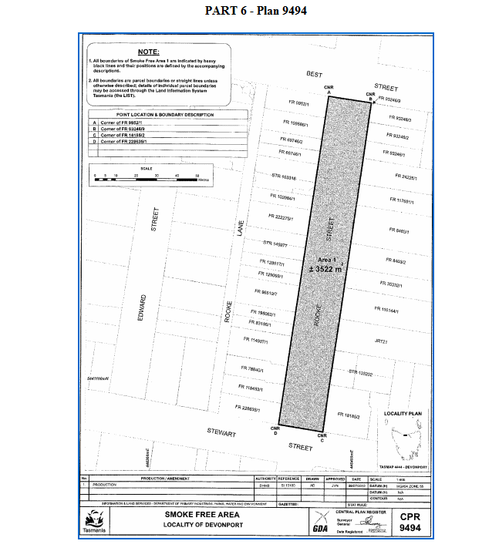
Source: Part 6 – Plan 9494, Public Health (Smoke-free Areas) Regulations 2014. For more information visit the Tasmanian Government Laws website.

Appendix C – Template Cover Letter or Email
A cover letter or email from the general manager stating that council or other occupier undertakes to provide signs, public awareness, education and enforcement of the smoke-free area should accompany completed document based on a smoke-free area declaration (Appendix A) and an accurate map of the area (Appendix B).

To Director of Public Health Admin email address
<Insert date>
Director of Public Health

I enclose the declaration and marked map of <Address of street or area> within <Insert local council> that has been declared smoke-free.
<Insert local council name> undertakes to provide signs, enforcement and public awareness of this area.

Regards

General Manager / Occupier
<Insert signature>

