Tasmanian Acute Public Hospitals
Healthcare Associated Infection Surveillance Report 40 – Quarter 4 2018
Tasmanian Acute public Hospital Healthcare Associated Infection Surveillance Report 40 – Quarter 4 2018
Department of Health, Tasmania
Published 2019
Copyright—Department of Health, Tasmania
Permission to copy is granted provided the source is acknowledged
Authors
- Ms Fiona Wilson, Clinical Nurse Consultant, TIPCU
- Dr Tara Anderson, Specialist Medical Advisor, TIPCU
- Ms Anne Wells, Assistant Director of Nursing, TIPCU
Suggested reference: Wilson, F., Anderson, T., Wells, A. (2019). Tasmanian Acute Public Hospitals Healthcare Associated Infection Report No 40 - Quarter 4, 2018. Hobart: Department of Health.
Reviewed and approved by the:
- Tasmanian Health Service - Executive Director of Nursing North, Executive Director of Nursing North West, Nursing Director South – Critical Care, Clinical Support and Investigations
- Tasmanian Department of Health - Director of Public Health
Notes
Data are subject to ongoing revision so data from previous reports should not be relied upon. Use the most up to date report when citing data.

Contents
Index of figures and tables 4
Executive summary 5
Staphylococcus aureus bacteraemia 6
Tasmanian rates 6
Hospital rates 7
Clostridium difficile infection 8
Tasmanian rates 8
Hospital rates – by quarter 9
Vancomycin resistant enterococci 10
VRE genotypes 11
Carbapenemase-producing Enterobacteriaceae 12
Acknowledgements 13
Appendix 1 14
Explanatory notes 14
Appendix 2 17
Healthcare associated Staphylococcus aureus bacteraemia (SAB) 17
Clostridium difficile infection (CDI) 19
Vancomycin resistant enterococci (VRE) 21

Index of figures and tables
Figure 1 Healthcare associated Staphylococcus aureus bacteraemia - Tasmanian rate by quarter 6
Figure 2 Healthcare associated Staphylococcus aureus bacteraemia - rate by quarter 7
Figure 3 Acute public hospital identified CDI and HCA-HCF CDI – rates by quarter 8
Figure 4 Hospital identified CDI by quarter 9
Figure 5 HCA-HCF by quarter 9
Figure 6 First VRE isolates – classification by quarter 10
Figure 7 First VRE isolates - genotype by quarter 11

Table 1 Tasmanian public hospital numbers and rate per 10 000 patient days of HCA-SAB. 17
Table 2 Royal Hobart Hospital numbers and rates per10 000 patient days of HCA-SAB 17
Table 3 Launceston General Hospital numbers and rates per10 000 patient days of HCA-SAB 18
Table 4 Mersey Community Hospital numbers and rates per10 000 patient days of HCA-SAB 18
Table 5 North West Regional Hospital numbers and rates per10 000 patient days of HCA-SAB. 19
Table 6 Tasmanian numbers and rates per10 000 patient days of CDI 19
Table 7 Hospital numbers and rates per10 000 patient days of hospital identified CDI 20
Table 8 Hospital numbers and rates per10 000 patient days of HCA-HCF CDI 20
Table 9 First VRE isolates identified per quarter. 21
Table 10 Classification of first VRE isolates – colonisation and infection 21
Table 11 First VRE isolates by genotype by quarter 22

Executive summary
This report provides an overview of the Tasmanian acute public hospitals’ healthcare associated infection (HAI) surveillance for the fourth quarter (Q4) of 2018.
Details of the surveillance program, including the rationale for the indicators measured and the methodologies used in data collection, validation and analysis are available at the TIPCU website.
Any form of comparison between hospitals should be done with caution because data are not adjusted for patient characteristics that vary between hospitals. Further, the relatively small Tasmanian population and small number of events can result in volatility of rates from time to time. The raw data in the appendices illustrate this.
This report contains the following findings:
- The Tasmanian rate of healthcare associated Staphylococcus aureus bacteraemia (SAB) remains low and below the National Benchmark.
- The rate of ‘hospital identified Clostridium difficile infection (CDI)’ and ‘hospital identified, healthcare associated-healthcare facility onset (HCA-HCF) CDI’ decreased this quarter.
- The number of new isolates of vancomycin resistant enterococcus (VRE) decreased during Q4 2018 compared with Q3 2018 with vanA the most common genotype identified.
- There were two cases of Carbapenemase-producing Enterobacteriaceae (CPE) notified, neither of which were locally acquired.
Please note that the quarterly HAI reports will change in 2019. They will continue to be produced quarterly with each issue concentrating on a particular topic. The reports planned for 2019 are:
- Staphylococcus aureus bacteraemia (SAB).
- Vancomycin resistant enterococcus (VRE).
- Hand hygiene compliance.
- Clostridium difficile infection (CDI) and antibiotic use.
Routine HAI data will continue to be supplied to hospitals upon request.

Staphylococcus aureus bacteraemia
Staphylococcus aureus, a common cause of serious healthcare associated bloodstream infection (bacteraemia), may cause significant patient morbidity and mortality.
Many healthcare associated Staphylococcus aureus bacteraemias (SAB) are preventable. SAB was made notifiable in Tasmania in 2008 pursuant to the Public Health Act 1997. Tasmania was the first Australian jurisdiction to introduce this measure to capture SAB data.
SAB surveillance is carried out in Tasmania using the national surveillance definitions published by the Australian Commission on Safety and Quality in Health Care (ACSQHC).
Under this definition a SAB is defined as healthcare associated (HCA) if the patient’s first SAB positive blood culture was collected either >48 hours after hospital admission or <48 hours after discharge (Criterion A) OR ≤48 hours after hospital admission and one or more of four key clinical healthcare related criteria was met (Criterion B).
The National Healthcare Agreement (2011) target is no more than two HCA SAB per10 000 patient days for each public hospital.

Tasmanian rates
Figure 1 presents the combined Tasmanian acute public hospital rates of HCA SAB by quarter.
Figure 1 Healthcare associated Staphylococcus aureus bacteraemia - Tasmanian rate by quarter
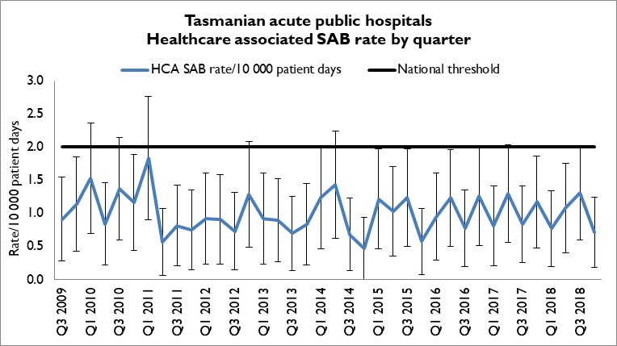
There were 7 cases of HCA SAB in all Tasmanian public hospitals in Q4 2018. This corresponded to a combined Tasmanian public hospital rate of HCA SAB for Q4 2018 of 0.7 per 10 000 patient days (95% CI 0.2 – 1.2).

Hospital rates
Figure 2 presents the individual acute public hospitals rates of HCA SAB by quarter.
Figure 2 Healthcare associated Staphylococcus aureus bacteraemia - rate by quarter
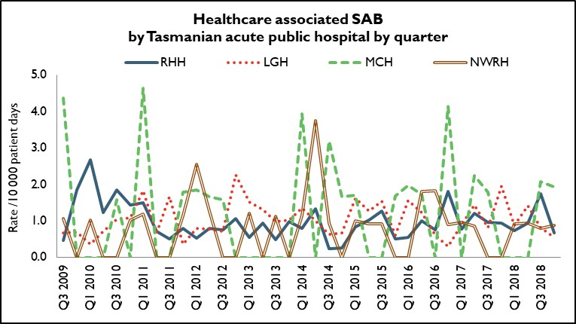
In Q4 2018, the rate of HCA SAB for RHH, LGH, MCH and NWRH met the National Healthcare Agreement target of no more than two HCA SAB per10 000 patient days.

Clostridium difficile infection
Clostridium difficile infection (CDI) is a bowel infection caused by the bacterium Clostridium difficile and is a common cause of healthcare associated diarrhoea. CDI causes significant patient morbidity and mortality and can result in increased hospital stays and costs. Factors that may contribute to higher CDI rates include the overuse of antibiotics and ineffective infection control processes including suboptimal environmental cleanliness.
Surveillance of CDI in Tasmania uses the ACSQHC’s national surveillance definitions. There is no National benchmark for CDI and it is not a notifiable condition in Tasmania.
Hospital identified CDI are CDI infections identified in a hospital irrespective of attribution of infection.
Healthcare associated – healthcare facility onset (HCA-HCF) CDI are a sub-group of hospital identified cases. This category only includes infections that occurred 48 hours or more after a patient was admitted to hospital. The HCA – HCF rate excludes people who present to hospital with symptoms of CDI and/or develop symptoms within two days of admission.

Tasmanian rates
Figure 3 presents the Tasmanian combined acute public hospital rates of hospital identified CDI and HCA-HCF CDI by quarter.
Figure 3 Acute public hospital identified CDI and HCA-HCF CDI – rates by quarter
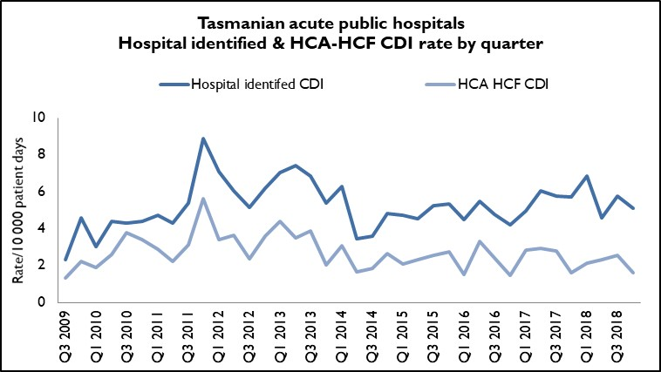
47 cases of hospital identified CDI in Q4 2018 corresponded to a rate of 5.1 per 10 000 patient days (95% CI 3.6 – 6.5); of these, 15 cases were HCA-HCF, a rate of 1.6 per10 000 patient days (95% CI 0.8 – 2.4). This is a decrease from Q3 2018 where there were 24 HCA-HCF which corresponded to a rate of 2.6 per 10 000 patient days.

Hospital rates – by quarter
Figure 4 and Figure 5 presents the individual acute public hospital rates of hospital identified CDI, and the healthcare associated – healthcare facility onset (HCA-HCF) CDI by quarter.
Figure 4 Hospital identified CDI by quarter
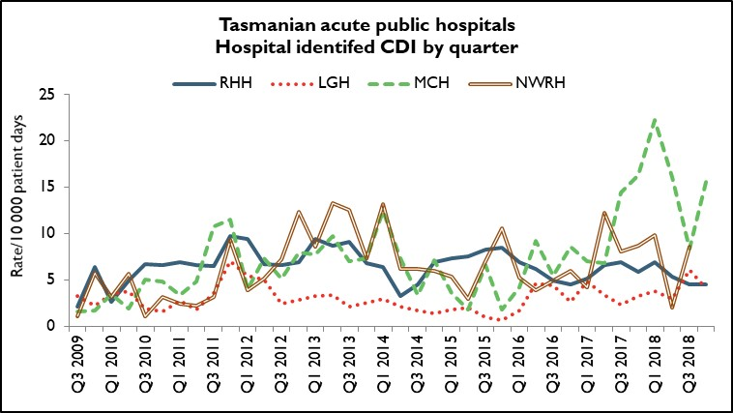
Figure 5 HCA-HCF by quarter
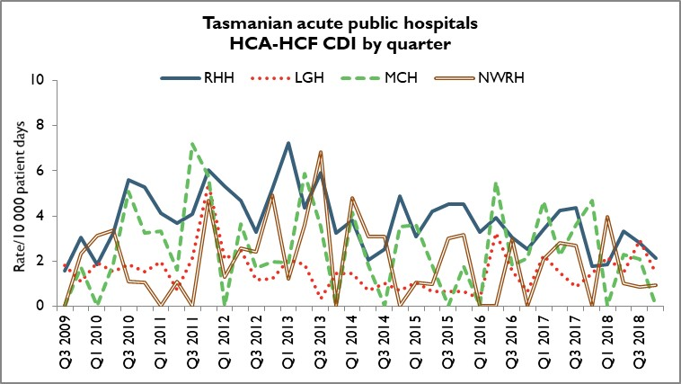
The rate of hospital identifed CDI varies considerably between hospitals and most likely reflects community associated CDI. The number and rate of HCA-HCF CDI at RHH, LGH MCH and NWRH decreased or remained the same in Q4 2018 compared to Q3 2018.

Vancomycin resistant enterococci
Enterococci are bacteria normally present in the human gastrointestinal and female genital tract and can cause infections of the urinary tract, bloodstream and wounds. Enterococci that have acquired resistance to the antibiotic vancomycin are called vancomycin-resistant enterococci or VRE. VRE infections can be more difficult to treat then those caused by vancomycin sensitive enterococci.
Factors that can contribute to the transmission of VRE in hospitals are inadequate infection control practices, overuse of antibiotics and suboptimal environmental cleanliness.
Identification of VRE is notifiable in Tasmania pursuant to the Public Health Act 1997.
Figure 6 presents all patients with a first VRE isolate identified within Tasmania by quarter. These numbers include all new patients identified within Tasmania from public and private hospitals, rural hospitals, GP clinics and long term and residential care facilities. A person’s first VRE isolate is classified according to whether it represents colonisation – an isolate from a non-sterile site with no targeted antibiotic treatment prescribed - or infection – a clinical isolate from a sterile site OR a non-sterile site clinical isolate where targeted antibiotic therapy was prescribed.
The number of people newly identified with VRE within hospitals does not necessarily reflect that VRE was acquired at that hospital. The numbers of VRE isolates identified can be affected by the amount of screening undertaken by hospitals and those that have an intensive screening program are likely to identify more VRE

Figure 6 First VRE isolates – classification by quarter
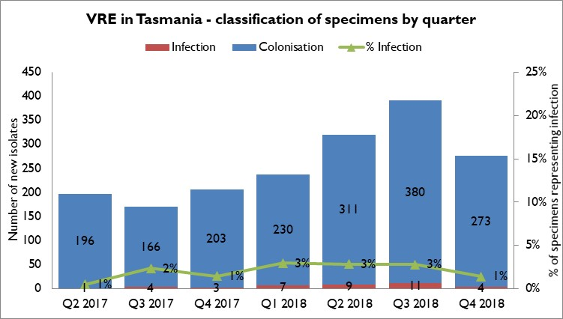

The number of new VRE identified in Q4 2018 decreased for the first time since Q3 2017.
Most first VRE isolates continue to reflect colonisation rather than infection. The proportion of first isolates that represent infections has remained stable over the last eight quarters with infections representing around between one and three per cent of total first VRE isolates. There were five isolates in Q4 2019 that were unable to be classified due to surveillance forms not being returned.

VRE genotypes
Figure 7 presents the genotypes of all new isolates identified within Tasmania by quarter.
Figure 7 First VRE isolates - genotype by quarter
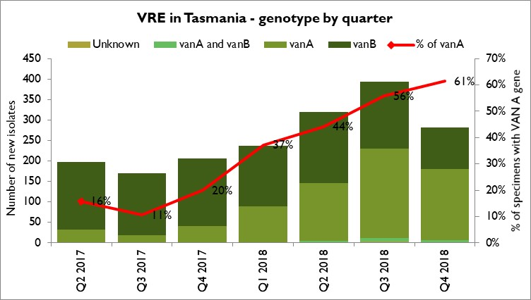
The number and proportion of isolates with the vanA genotype has increased substantially over the past three quarters and represents the majority (61%) of the total isolates for the current quarter.

Carbapenemase-producing Enterobacteriaceae
Carbapenem resistance in Enterobacteriaceae is an emerging clinical and public health problem that threatens the effectiveness of an important antibiotic group – carbapenems – that are highly active against multi-drug resistant Gram negative organisms.
The epidemiology of carbapenemase-producing Enterobacteriaceae (CPE) varies between countries and it is evident that without active surveillance and subsequent stringent infection control measures these organisms may rapidly become endemic.
In areas where few CPE cases have occurred, it is recommended that health departments take an aggressive approach to contain CPE.
With current low prevalence rates, surveillance through mandatory laboratory notification creates an opportunity for proactive measures to prevent, detect and contain CPE within Tasmania.
Identification of CPE was made notifiable in Tasmania pursuant to the Public Health Act 1997 in 2016.
There were two cases of CPE identified in Tasmania in Q4 2018. Both were identified in screening specimens that were taken when the patients were admitted to hospital in line with the recommended screening protocol. Neither of the patients acquired CPE in Tasmania. Both patients had appropriate infection control precautions in place from their admission to hospital thus no contact tracing or screening of other hospitals patients was required.
A total of seven cases have been identified in Tasmania from 2016 to the end of December 2018.

Acknowledgements
The production of this report is the culmination of data collection, analysis and input from several different organisations. In particular, we would like to acknowledge:
- Executive Director of Nursing North
- Executive Director of Nursing North West
- Nursing Director South – Critical Care, Clinical Support and Investigations
- Launceston General Hospital Infection Prevention and Control Unit
- North West Regional Hospital Infection Control Team
- Mersey Community Hospital Infection Control Team
- Royal Hobart Hospital Infection Prevention and Control Unit
- Microbiology Departments at the Royal Hobart Hospital, Launceston General Hospital and DSPL
- Hand Hygiene Australia
- Communicable Diseases Prevention Unit, Population Health Services
- Contributing Primary Health Sites

Appendix 1

Explanatory notes

What types of healthcare surveillance are done in Tasmania?
TIPCU undertakes surveillance of the following:
- Staphylococcus aureus bacteraemia (bloodstream infection).
- Clostridium difficile infection (CDI).
- Vancomycin resistant enterococci (VRE).
- Carbapenemase-producing Enterobacteriaceae.
- Hand hygiene compliance rates.
- Antibiotic utilisation – reported annually.

What do the rates mean?
The healthcare surveillance data are expressed as a rate or a raw number. SAB and CDI are expressed as a rate per 10 000 patient days, VRE is expressed as a raw number, hand hygiene compliance is expressed as a percentage and antibiotic utilisation is expressed as hospital use measured by defined daily doses, per 1 000 occupied bed days.

What are the definitions for Clostridium difficile infection (CDI)?
TIPCU use the national surveillance definitions published by the Australian Commission on Safety and Quality in Health Care (ACSQHC) to classify CDI. TIPCU reports on:
- Hospital identified CDI is defined as a case diagnosed in a patient attending an acute care facility. This includes positive specimens obtained from admitted patients and those attending the emergency department and outpatient departments. This definition excludes patients less than two years old and cases with a positive test within the previous eight weeks.
- Healthcare associated – healthcare facility onset CDI (HCA-HCF CDI) is defined as a patient with CDI symptom onset (or date and time of stool specimen collection if a laboratory system is used) more than 48 hours after admission to a healthcare facility. This definition excludes patients less than two years old and cases with a positive test within the previous eight weeks.

What are the definitions for healthcare associated Staphylococcus aureus bacteraemia (SAB)?
Criterion A the patient’s first SAB blood culture was collected more than 48 hours after hospital admission or less than 48 hours after discharge.
OR
Criterion B the patient’s first positive SAB blood culture was collected less than or equal to 48 hours after hospital admission and one or more of the following key clinical criteria was met for the patient-episode of SAB.
Key clinical criteria:
- SAB is a complication of the presence of an indwelling medical device (eg intravascular line, haemodialysis vascular access, CSF shunt, urinary catheter).
- SAB occurs within 30 days of a surgical procedure or 365 days for surgically implanted devices, where the SAB is related to the surgical site.
- SAB was diagnosed within 48 hours of a related invasive instrumentation or incision.
- SAB is associated with neutropenia (less 1 x 10⁹/L) contributed to by cytotoxic therapy.
What is the definition for vancomycin resistant enterococci (VRE)?
The definition for VRE is an isolate identified as VRE by an accredited laboratory.
TIPCU reports on the total number of people with new isolates of VRE identified in Tasmania per quarter and this number includes all people with new VRE isolates from public and private hospitals, rural hospitals, GP clinics and long term and residential care facilities.
What is the definition for carbapenemase-producing Enterobacteriaceae (CPE)?
The definition for CPE is an Enterobacteriaceae isolate with a carbapenemase gene identified by an accredited laboratory.
TIPCU reports on the total number of people with new isolates of CPE identified in Tasmania per annum and this number includes all people with new CPE isolates from public and private hospitals, rural hospitals, GP clinics and long term and residential care facilities.

Confidence intervals
Confidence intervals are used to calculate the range in which the true rate probably lies.
As an example, when looking at the hand hygiene compliance (HHC) data confidence intervals calculate the range in which the true compliance result lies, based on the data collected and the compliance measured, thus providing an indication of the reliability of the reported HHC level.
When only a small number of moments are collected, the confidence interval will be larger, as it is more difficult to establish the true compliance level from a small sample of moments.
If a large number of moments are collected the confidence interval will be smaller, meaning the reliability of the result is higher.
Hand Hygiene Australia (HHA) calculates 95 per cent confidence intervals, indicating the intervals in which 95 per cent of the time the true compliance level lies. (HHA 2011).
Patient care days
Patient days is the term to explain the total days patients are in hospital. In Tasmania’s four larger acute public hospitals there are around 330 000 patient care days a year.
When a rate is presented as a number per 10 000 patient days this presents the number of infections that occur for every 10 000 patient care days.

Can I compare Tasmanian hospital infection rates?
Each Tasmanian hospital provides different services and has patients with different levels of illness. This affects infection rates.
For example, very sick immuno-compromised patients may be more likely to get infections.
It is difficult to remove all of the factors outside the control of a hospital that can cause its infection rate to differ from other hospitals.
Other reasons for caution when comparing hospitals include:
- some hospitals may screen patients more than others. This can affect data for CDI and VRE in particular
- hospital laboratories may use different ways of identifying organisms. A laboratory that has a more sensitive way of looking for organisms may find more
- for hand hygiene, rural hospitals are not required to collect as many moments as the four acute public hospitals, which limits the comparability of data for rural and acute hospitals.

Appendix 2

Healthcare associated Staphylococcus aureus bacteraemia (SAB)
Table 1 Tasmanian public hospital numbers and rate per 10 000 patient days of HCA-SAB.
Quarter | Total HCA-SAB | Number MSSA | Number MRSA | HCA SAB Rate
Q3 2016 | 7 | 7 | 0 | 0.8
Q4 2016 | 11 | 10 | 1 | 1.3
Q1 2017 | 7 | 6 | 1 | 0.8
Q2 2017 | 12 | 10 | 2 | 1.3
Q3 2017 | 8 | 8 | 0 | 0.8
Q4 2017 | 11 | 8 | 3 | 1.2
Q1 2018 | 7 | 7 | 0 | 0.8
Q2 2018 | 10 | 8 | 2 | 1.1
Q3 2018 | 13 | 12 | 1 | 1.3
Q4 2018 | 7 | 7 | 0 | 0.7

Table 2 Royal Hobart Hospital numbers and rates per10 000 patient days of HCA-SAB
Quarter | Total HCA-SAB | Number MSSA | Number MRSA | HCA SAB Rate
Q3 2016 | 3 | 3 | 0 | 0.8
Q4 2016 | 7 | 7 | 0 | 1.8
Q1 2017 | 3 | 2 | 1 | 0.8
Q2 2017 | 5 | 5 | 0 | 1.2
Q3 2017 | 4 | 4 | 0 | 1.0
Q4 2017 | 4 | 3 | 1 | 0.9
Q1 2018 | 3 | 3 | 0 | 0.7
Q2 2018 | 4 | 3 | 1 | 0.9
Q3 2018 | 8 | 7 | 1 | 1.7
Q4 2018 | 3 | 3 | 0 | 0.7

Table 3 Launceston General Hospital numbers and rates per10 000 patient days of HCA-SAB
Quarter | Total HCA-SAB | Number MSSA | Number MRSA | HCA SAB Rate
Q3 2016 | 2 | 2 | 0 | 0.6
Q4 2016 | 1 | 0 | 1 | 0.3
Q1 2017 | 3 | 3 | 0 | 0.9
Q2 2017 | 5 | 3 | 2 | 1.4
Q3 2017 | 3 | 3 | 0 | 0.8
Q4 2017 | 7 | 5 | 2 | 2.0
Q1 2018 | 3 | 3 | 0 | 0.9
Q2 2018 | 5 | 4 | 1 | 1.4
Q3 2018 | 3 | 3 | 0 | 0.8
Q4 2018 | 2 | 2 | 0 | 0.5

Table 4 Mersey Community Hospital numbers and rates per10 000 patient days of HCA-SAB
Quarter | Total HCA-SAB | Number MSSA | Number MRSA | HCA SAB Rate
Q3 2016 | 0 | 0 | 0 | 0.0
Q4 2016 | 2 | 2 | 0 | 4.2
Q1 2017 | 0 | 0 | 0 | 0.0
Q2 2017 | 1 | 1 | 0 | 2.3
Q3 2017 | 1 | 1 | 0 | 1.8
Q4 2017 | 0 | 0 | 0 | 0.0
Q1 2018 | 0 | 0 | 0 | 0.0
Q2 2018 | 0 | 0 | 0 | 0.0
Q3 2018 | 1 | 1 | 0 | 2.1
Q4 2018 | 1 | 1 | 0 | 1.9

Table 5 North West Regional Hospital numbers and rates per10 000 patient days of HCA-SAB.
Quarter | Total HCA-SAB | Number MSSA | Number MRSA | HCA SAB Rate
Q3 2016 | 2 | 2 | 0 | 1.8
Q4 2016 | 1 | 1 | 0 | 0.9
Q1 2017 | 1 | 1 | 0 | 1.0
Q2 2017 | 1 | 1 | 0 | 0.9
Q3 2017 | 0 | 0 | 0 | 0.0
Q4 2017 | 0 | 0 | 0 | 0.0
Q1 2018 | 1 | 1 | 0 | 0.9
Q2 2018 | 1 | 1 | 0 | 0.9
Q3 2018 | 1 | 1 | 0 | 0.8
Q4 2018 | 1 | 1 | 0 | 0.9

Clostridium difficile infection (CDI)
Table 6 Tasmanian numbers and rates per10 000 patient days of CDI
Quarter | Total hospital identified CDI | Hospital identified Rate | Total HCA HCF | HCA HCF Rate
Q3 2016 | 40 | 4.8 | 20 | 2.4
Q4 2016 | 34 | 4.2 | 12 | 1.5
Q1 2017 | 40 | 5.0 | 23 | 2.9
Q2 2017 | 52 | 6.1 | 25 | 2.9
Q3 2017 | 52 | 5.8 | 25 | 2.8
Q4 2017 | 50 | 5.7 | 14 | 1.6
Q1 2018 | 58 | 6.9 | 18 | 2.1
Q2 2018 | 40 | 4.6 | 20 | 2.3
Q3 2018 | 54* | 5.8* | 24* | 2.6*
Q4 2018 | 47 | 5.1 | 15 | 1.6
* rates and numbers include unvalidated date from RHH

Table 7 Hospital numbers and rates per10 000 patient days of hospital identified CDI
Quarter | RHH Total | RHH Rate | LGH Total | LGH Rate | MCH Total | MCH Rate | NWRH Total | NWRH Rate
Q3 2016 | 18 | 5.0 | 14 | 4.4 | 3 | 5.5 | 5 | 4.9
Q4 2016 | 16 | 4.5 | 8 | 2.6 | 4 | 8.6 | 6 | 5.9
Q1 2017 | 18 | 5.1 | 15 | 4.8 | 3 | 7.0 | 4 | 4.2
Q2 2017 | 25 | 6.6 | 11 | 3.3 | 3 | 6.8 | 13 | 12.3
Q3 2017 | 27 | 6.9 | 8 | 2.3 | 8 | 14.4 | 9 | 8.0
Q4 2017 | 23 | 5.9 | 11 | 3.2 | 7 | 16.4 | 9 | 8.7
Q1 2018 | 26 | 6.9 | 12 | 3.7 | 10 | 22.3 | 10 | 9.9
Q2 2018 | 21 | 5.4 | 10 | 3.0 | 7 | 16.1 | 2 | 2.0
Q3 2018 | 19* | 4.5* | 21 | 6.1 | 4 | 8.4 | 10 | 8.6
Q4 2018 | 19 | 4.5 | 14 | 4.0 | 8 | 15.6 | 6 | 5.6
* denotes unvalidated data
Table 8 Hospital numbers and rates per10 000 patient days of HCA-HCF CDI
Quarter | RHH Total | RHH Rate | LGH Total | LGH Rate | MCH Total | MCH Rate | NWRH Total | NWRH Rate
Q3 2016 | 11 | 3.0 | 5 | 1.6 | 1 | 1.8 | 3 | 3.0
Q4 2016 | 9 | 2.5 | 2 | 0.7 | 1 | 2.1 | 0 | 0.0
Q1 2017 | 12 | 3.4 | 7 | 2.2 | 2 | 4.7 | 2 | 2.1
Q2 2017 | 16 | 4.2 | 5 | 1.5 | 1 | 2.3 | 3 | 2.8
Q3 2017 | 17 | 4.4 | 3 | 0.9 | 2 | 3.6 | 3 | 2.7
Q4 2017 | 7 | 1.8 | 5 | 1.5 | 2 | 4.7 | 0 | 0.0
Q1 2018 | 7 | 1.9 | 7 | 2.2 | 0 | 0.0 | 4 | 3.9
Q2 2018 | 13 | 3.3 | 5 | 1.5 | 1 | 2.3 | 1 | 1.0
Q3 2018 | 12* | 2.8* | 10 | 2.9 | 1 | 2.1 | 1 | 0.9
Q4 2018 | 9 | 2.1 | 5 | 1.4 | 0 | 0.0 | 1 | 0.9
* denotes unvalidated data

Vancomycin resistant enterococci (VRE)
Table 9 First VRE isolates identified per quarter within acute public hospitals, and other healthcare settings (private hospitals, rural hospitals, GP clinics and long term and residential care facilities).
Quarter | RHH | LGH | MCH | NWRH | Other healthcare settings | TOTAL
Q3 2016 | 30 | 65 | 8 | 23 | 28 | 154
Q4 2016 | 51 | 67 | 5 | 15 | 26 | 164
Q1 2017 | 41 | 82 | 13 | 13 | 26 | 175
Q2 2017 | 70 | 78 | 9 | 12 | 28 | 197
Q3 2017 | 28 | 89 | 10 | 11 | 32 | 170
Q4 2017 | 58 | 85 | 10 | 21 | 32 | 206
Q1 2018 | 79 | 92 | 6 | 27 | 33 | 237
Q2 2018 | 113 | 137 | 12 | 22 | 36 | 320
Q3 2018 | 140 | 151 | 21 | 18 | 63 | 393
Q4 2018 | 77 | 130 | 14 | 23 | 37 | 282

Table 10 Classification of first VRE isolates – colonisation and infection
Quarter | Total VRE | Colonisation | Infection | Unknown | % infection
Q3 2016 | 154 | 147 | 7 |  | 5%
Q4 2016 | 164 | 158 | 6 |  | 4%
Q1 2017 | 175 | 170 | 5 |  | 3%
Q2 2017 | 197 | 196 | 1 |  | 1%
Q3 2017 | 170 | 166 | 4 |  | 2%
Q4 2017 | 206 | 203 | 3 |  | 1%
Q1 2018 | 237 | 230 | 7 |  | 3%
Q2 2018 | 320 | 311 | 9 |  | 3%
Q3 2018 | 393 | 382 | 11 | 2 | 3%
Q4 2018 | 282 | 273 | 4 | 5 | 1%

Table 11 First VRE isolates by genotype by quarter
Quarter | vanA | vanB | vanA and vanB | Unknown
Q3 2016 | 55 | 93 | 4 | 2
Q4 2016 | 46 | 111 | 7 | 0
Q1 2017 | 47 | 119 | 4 | 1
Q2 2017 | 31 | 164 | 1 | 1
Q3 2017 | 18 | 152 | 0 | 0
Q4 2017 | 41 | 165 | 0 | 0
Q1 2018 | 88 | 148 | 1 | 0
Q2 2018 | 141 | 177 | 4 | 0
Q3 2018 | 219 | 163 | 8 | 3
Q4 2018 | 173 | 102 | 5 | 2

