Tasmanian Acute Public Hospitals
Healthcare Associated Infection Surveillance Report 38 – Annual Report 2017 - 18

Tasmanian Acute public Hospital Healthcare Associated Infection Surveillance Report 38 – Annual Report 2017 - 18
Department of Health, Tasmania
Published 2018
Copyright—Department of Health, Tasmania
Permission to copy is granted provided the source is acknowledged
Authors
- Ms Fiona Wilson, Clinical Nurse Consultant, TIPCU
- Dr Tara Anderson, Specialist Medical Advisor, TIPCU
- Ms Anne Wells, Assistant Director of Nursing, TIPCU
Suggested reference: Wilson, F., Anderson, T., Wells, A. (2018). Tasmanian Acute Public Hospitals Healthcare Associated Infection Report No 38 – Annual Report 2017 – 18. Hobart: Department of Health.
Reviewed and approved by the:
- Tasmanian Health Service - Executive Director of Nursing North, Executive Director of Nursing North West, Nursing Director South – Critical Care, Clinical Support and Investigations
- Tasmanian Department of Health - Director of Public Health
Notes
Data are subject to ongoing revision so data from previous reports should not be relied upon. Use the most up to date report when citing data.

Contents
Index of figures and tables 5
Executive summary 6
Achievements 7
Staphylococcus aureus bacteraemia 8
Clostridium difficile infection 14
Vancomycin resistant enterococci 18
Carbapenemase-producing Enterobacteriaceae 23
Hand Hygiene 24
Antibiotic use surveillance 27
Acknowledgements 30
Appendix 1 31
Explanatory notes 31
Appendix 2 34
Healthcare associated Staphylococcus aureus bacteraemia (SAB) 34
Clostridium difficile infection (CDI) 36
Vancomycin resistant enterococci (VRE) 38
Hand hygiene compliance data - audit period 2, 2018 40

Index of figures and tables
Figure 1 Healthcare associated Staphylococcus aureus bacteraemia - Tasmanian rate by quarter 7
Figure 2 Healthcare associated Staphylococcus aureus bacteraemia rate by financial year 8
Figure 3 Healthcare associated Staphylococcus aureus bacteraemia - rate by quarter 9
Figure 4 Healthcare associated Staphylococcus aureus bacteraemia - rate by financial year 9
Figure 5 Healthcare associated MSSA and MRSA SAB – number by financial year 10
Figure 6 Total IV device related HCA SAB – number and percentage by financial year 11
Figure 7 Community associated CA-SAB – number and incidence/100 000 population 12
Figure 8 Community associated CA-SAB – number of MSSA and MRSA/financial year 13
Figure 9 Acute public hospital identified CDI and HCA-HCF CDI – rates by quarter 14
Figure 10 Hospital identified and HCA-HCF CDI - rate by financial year 15
Figure 11 Hospital identified CDI by quarter 16
Figure 12 HCA-HCF by quarter 16
Figure 13 Hospital identified CDI by financial year 17
Figure 14 HCA-HCF CDI by financial year 17
Figure 15 First VRE isolates – classification by quarter 18
Figure 16 First VRE isolates – classification by financial year 19
Figure 17 First VRE isolates - genotype by quarter 20
Figure 18 First VRE isolates – genotype by financial year 20
Figure 19 VRE at RHH – genotype by quarter 21
Figure 20 VRE at LGH – genotype by quarter 21
Figure 21 Hand hygiene compliance in Tasmanian public hospitals 24
Figure 22 Hand hygiene compliance by moment 25
Figure 23 Hand hygiene compliance by healthcare worker 26
Figure 24 Cephalosporin use 28
Figure 25 Fluoroquinolone use 28
Figure 26 Piperacillin - tazobactam use 29
Figure 27 Vancomycin use 29

Table 1 Proportion of VRE positives from screening specimens 22
Table 2 Healthcare worker categories 26
Table 3 Tasmanian public hospital numbers and rate per 10 000 patient days of HCA-SAB. 34
Table 4 Royal Hobart Hospital numbers and rates per10 000 patient days of HCA-SAB 34
Table 5 Launceston General Hospital numbers and rates per10 000 patient days of HCA-SAB 35
Table 6 Mersey Community Hospital numbers and rates per10 000 patient days of HCA-SAB 35
Table 7 North West Regional Hospital numbers and rates per10 000 patient days of HCA-SAB. 36
Table 8 Tasmanian numbers and rates per10 000 patient days of CDI 36
Table 9 Hospital numbers and rates per10 000 patient days of hospital identified CDI 37
Table 10 Hospital numbers and rates per10 000 patient days of HCA-HCF CDI 37
Table 11 First VRE isolates identified per quarter. 38
Table 12 Classification of first VRE isolates – colonisation and infection 38
Table 13 First VRE isolates by genotype by quarter 39
Table 14 Hand hygiene compliance rates by Tasmanian hospital and state level 40
Table 15 Tasmanian hand hygiene compliance rates by moment 40
Table 16 Tasmanian hand hygiene compliance rates by healthcare worker 41

Executive summary
This report provides an overview of the Tasmanian acute public hospitals’ healthcare associated infection surveillance for the financial year 2017 – 18 and also serves as the report for quarter 2, 2018.
Compared to the quarterly reports, this annual report contains additional detail, such as financial year infection rates and antibiotic use. Details of the surveillance program, including the rationale for the indicators measured and the methodologies used in data collection, validation and analysis are available at the TIPCU website.
Any form of comparison between hospitals should be done with caution because data are not adjusted for patient characteristics that vary between hospitals. Further, the relatively small Tasmanian population and small number of events can result in volatility of rates from time to time. The raw data in the appendices illustrate this.
This report contains the following findings:
- The rate of healthcare associated Staphylococcus aureus bacteraemia (HCA SAB) for 2017 – 2018 for each public hospital meet the National Healthcare Agreement target of no more than two HCA SAB per 10 000 patient days for each public hospital.
- The rate of ‘hospital identified Clostridium difficile infection (CDI)’ decreased while healthcare associated-healthcare facility onset (HCA-HCF) CDI’ increased slightly this quarter but the overall trend remains stable.
- The number of new isolates of vancomycin resistant enterococcus (VRE) continues to increase.
- There were no cases of carbapenemase-producing Enterobacteriaceae (CPE) notified in Q2 2018.
- The consolidated Tasmanian public hospital hand hygiene compliance rate is 81 per cent which is slightly above the National Hand Hygiene Benchmark (NHHB) of 80 per cent.
- There has been a decrease in use in some classes of antibiotics over the past 12 months.
Achievements
The activities in 2017-18 that focus on preventing infection include:
Governance
- Development of the Tasmanian Infection Prevention and Control Advisory Committee to guide and inform the strategic planning and evaluation of interventions to reduce HAI in Tasmania and contribute to infection control aspects of relevant broader public health threats. The inaugural meeting was held in December 2017.
- Continuation of a collaborative project with the Tasmania Health Service (THS) to develop a State-wide infection control policy and suite of protocols for the THS. To date, the state-wide policy and nine protocols have been endorsed for use in the THS with 14 protocols currently in draft.
- Participation in national committees under the aegis of Australian Commission of Safety & Quality in Health Care (ACSQHC). These are:
  - Healthcare Associated Infection Advisory Committee.
  - National Hand Hygiene Initiative Advisory Committee.
  - Antimicrobial Stewardship Committee.
- Participation in the Communicable Diseases Network Australia (CDNA) Multi-drug Resistant Organism Working Group.
- Providing infection control support to the Department of Health (DoH) Regulations and Licencing Unit and partnering with the Communicable Diseases Prevention Unit (CDPU) and Environmental Health Unit within Population Health Services (PHS).
Education and Training
- TIPCU and the Communicable Diseases Prevention Unit (CDPU) held an inaugural influenza preparedness workshop for the aged care sector in response to the 2017 influenza season. The workshop was attended by over 60 aged care staff and feedback received indicated increased awareness of influenza planning, management and key resources.
- Education provided to a range of groups including aged care facilities, aged care graduate nurses and Department of Education child support staff.
- A Multi-Resistant Organism (MRO) Screening and Clearance patient brochure was developed to support the state-wide MRO Screening and Clearance Protocol.
Surveillance
- Continuation of surveillance programs based on nationally agreed methodology and Tasmanian notifiable microorganisms including the development and commencement of a state-wide Central Line Associated Blood Stream Infection (CLABSI) Surveillance protocol.
- Participation in the National Alert System for Critical Antimicrobial Resistances (CAR Alert).
- Continued provision of an environmental cleaning assessment program.
- Continuation of a surveillance program for antimicrobial use in rural hospitals.
Staphylococcus aureus bacteraemia
Staphylococcus aureus, a common cause of serious healthcare associated bloodstream infection (bacteraemia), may cause significant patient morbidity and mortality.
Many healthcare associated Staphylococcus aureus bacteraemias (SAB) are preventable. SAB was made notifiable in Tasmania in 2008 pursuant to the Public Health Act 1997. Tasmania was the first Australian jurisdiction to introduce this measure to capture SAB data.
SAB surveillance is carried out in Tasmania using the national surveillance definitions published by the Australian Commission on Safety and Quality in Health Care (ACSQHC).
Under this definition a SAB is defined as healthcare associated (HCA) if the patient’s first SAB positive blood culture was collected either >48 hours after hospital admission or <48 hours after discharge (Criterion A) OR ≤48 hours after hospital admission and one or more of four key clinical healthcare related criteria was met (Criterion B).
The National Healthcare Agreement (2011) target is no more than two HCA SAB per10 000 patient days for each public hospital.

Tasmanian rates
Figure 1and Figure 2 presents the combined Tasmanian acute public hospital rates of HCA SAB by quarter, and by financial year.
Figure 1 Healthcare associated Staphylococcus aureus bacteraemia - Tasmanian rate by quarter
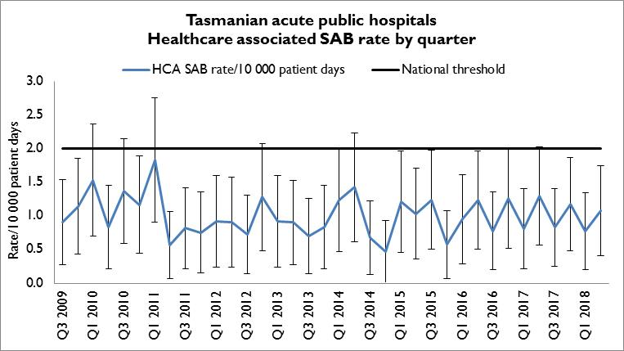
There were 10 cases of HCA SAB in all Tasmanian public hospitals in Q2 2018. This corresponded to a combined Tasmanian public hospital rate of HCA SAB for Q2 2018 of 1.1 per 10 000 patient days (95% CI 0.4 –1.8).

Figure 2 Healthcare associated Staphylococcus aureus bacteraemia rate by financial year
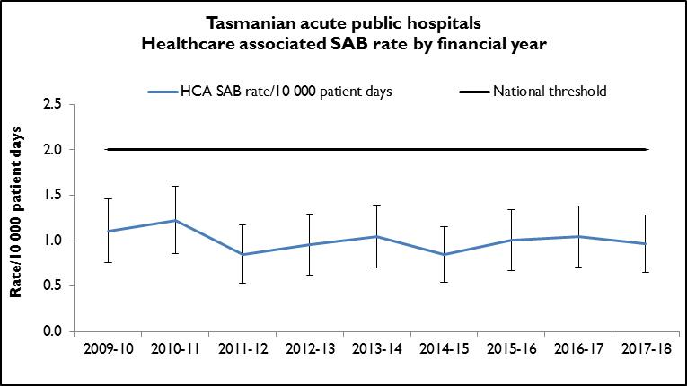
There were 36 cases of HCA SAB in all Tasmanian public hospitals in 2017 - 18. This corresponded to a combined Tasmanian public hospital rate of HCA SAB for 2017 – 18 of 1.0 per 10 000 patient days (95% CI 0.4 –1.8). The annual rate of HCA SAB has remained stable at around 1.0 per 10 000 patient days for the past five years.

Hospital rates
Figure 3 and Figure 4 presents the individual acute public hospitals rates of HCA SAB by quarter and, by financial year.
Figure 3 Healthcare associated Staphylococcus aureus bacteraemia - rate by quarter
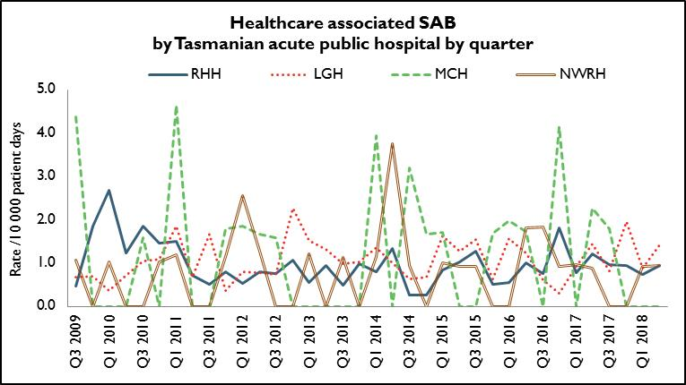
In Q2 2018, the rate of HCA SAB for each public hospital met the National Healthcare Agreement target of no more than two HCA SAB per10 000 patient days. Of note is that MCH has had no HCA SAB for three consecutive quarters
Figure 4 Healthcare associated Staphylococcus aureus bacteraemia - rate by financial year
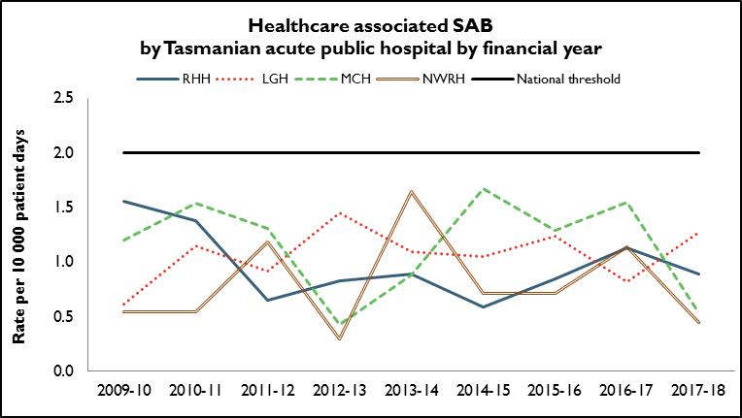
The annual HCA SAB rate for all public hospitals for 2017 - 18 was less than the National Healthcare Agreement target of no more than two HCA SAB per10 000 patient days.

HCA SAB according to methicillin susceptibility
Figure 5 presents HCA SAB according to susceptibility; methicillin sensitive Staphylococcus aureus (HCA-MSSA) and methicillin resistant Staphylococcus aureus (HCA-MRSA) by financial year.
Figure 5 Healthcare associated MSSA and MRSA SAB – number by financial year
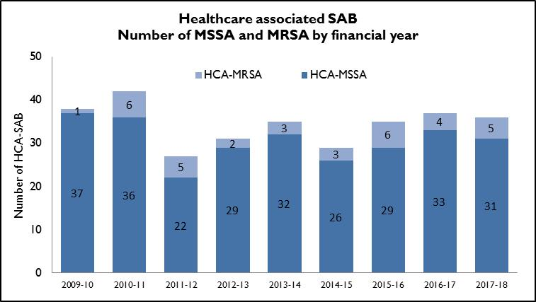
The majority of HCA SAB remains MSSA with the number of MRSA HCA SAB remaining stable over the past two years.

HCA SAB related to IV devices
Healthcare associated SAB are classified where possible into four categories: SAB related to an indwelling medical device, a surgical site, invasive instrumentation or cytotoxic therapy induced neutropenia. TIPCU reports annually on all HCA SAB related to one type of indwelling device – intravenous (IV) devices. Figure 6 presents the number and percentage of IV device related HCA SAB.
Figure 6 Total IV device related HCA SAB – number and percentage by financial year
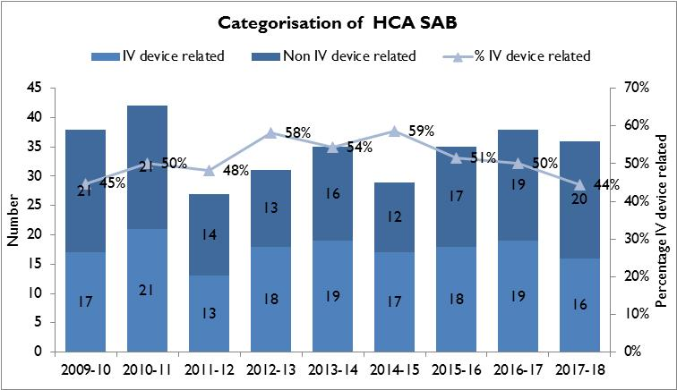
Just under half of HCA SAB were related to an IV device and the total number identified per financial year has not substantially changed over the past six years. Infection prevention strategies such as intravenous device management procedures and processes, in conjunction with adherence to aseptic technique principles, can reduce the risk of patients developing a SAB secondary to an IV device. These strategies should be implemented and evaluated in all healthcare settings where IV devices are used.

Community associated SAB
Figure 7 presents the Tasmanian number and incidence/100 000 population of community associated SAB (CA-SAB) by financial year. Figure 8 presents CA-SAB numbers according to antibiotic susceptibility; methicillin sensitive Staphylococcus aureus (CA-MSSA) and methicillin resistant Staphylococcus aureus (CA-MRSA).
Figure 7 Community associated CA-SAB – number and incidence/100 000 population
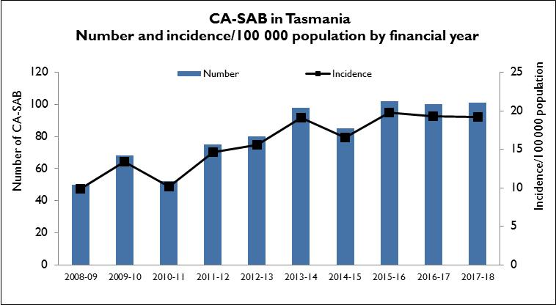

Figure 8 Community associated CA-SAB – number of MSSA and MRSA/financial year
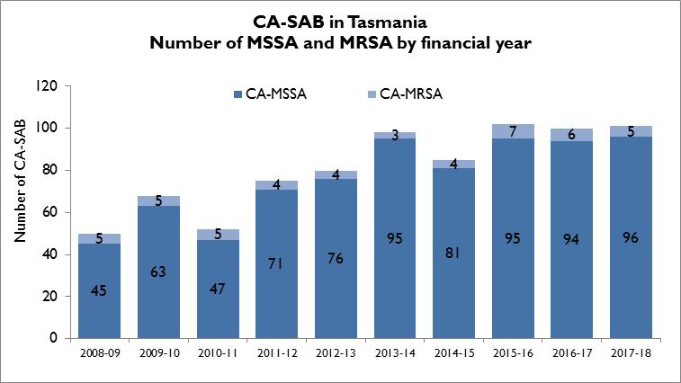
Figure 5 and Figure 8 show there are three times as many CA-SAB than HCA SAB with the majority being caused by MSSA. This has been the case for a number of years. Research is being undertaken to describe the epidemiology of all SAB in Tasmania between 2011 and 2017 to 1) describe the differing aetiologies of MSSA and MRSA SAB, and 2) to investigate the potential for misclassification of CA-SAB.

Clostridium difficile infection
Clostridium difficile infection (CDI) is a bowel infection caused by the bacterium Clostridium difficile and is a common cause of healthcare associated diarrhoea. CDI causes significant patient morbidity and mortality and can result in increased hospital stays and costs. Factors that may contribute to higher CDI rates include the overuse of antibiotics and ineffective infection control processes including suboptimal environmental cleanliness.
Surveillance of CDI in Tasmania uses the ACSQHC’s national surveillance definitions. There is no National benchmark for CDI and it is not a notifiable condition in Tasmania.
Hospital identified CDI are CDI infections identified in a hospital irrespective of attribution of infection.
Healthcare associated – healthcare facility onset (HCA-HCF) CDI are a sub-group of hospital identified cases. This category only includes infections that occurred 48 hours or more after a patient was admitted to hospital. The HCA – HCF rate excludes people who present to hospital with symptoms of CDI and/or develop symptoms within two days of admission.

Tasmanian rates
Figure 9 and Figure 10 presents the Tasmanian combined acute public hospital rates of hospital identified CDI and HCA-HCF CDI by quarter and financial year.
Figure 9 Acute public hospital identified CDI and HCA-HCF CDI – rates by quarter
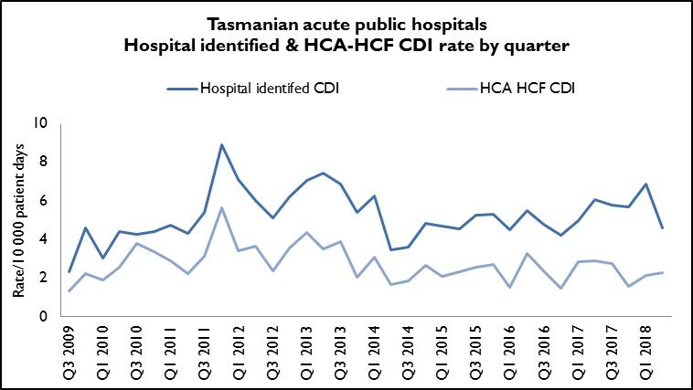
Forty cases of hospital identified CDI in Q2 2018 corresponded to a rate of 4.6 per 10 000 patient days (95%CI 3.2 – 6.0); of these, 20 cases were HCA-HCF, a rate of 2.3 per10 000 patient days (95% CI 1.3 – 3.3).
The rate of HCA-HCF in Q2 2018 is higher than in the previous two quarters – Q4 2017 and Q1 2018 - but remains lower than in the first three quarters of 2017.
Figure 10 Hospital identified and HCA-HCF CDI - rate by financial year
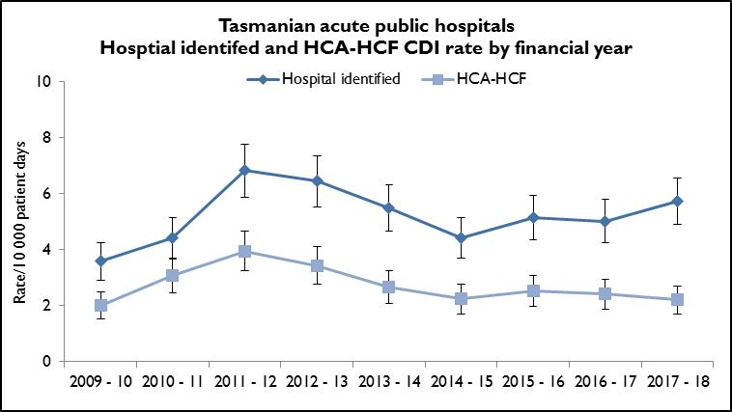
The mean (average) rate of hospital identified CDI for 2017 – 18 was 5.7 per 10 000 patient days (95% CI 4.9 – 6.5) and the mean rate of HCA-HCF CDI over the same period was 2.2 per 10 000 patient days (95% CI 1.7 – 2.7).
The number and rate of hospital identified CDI has increased slightly over the past four years. The annual number and rate of HCA-HCF CDI remains low and has decreased slightly over 2017 - 18.

Hospital rates – by quarter
Figure 11 and Figure 12 present the individual acute public hospital rates of hospital identified CDI, and the healthcare associated – healthcare facility onset (HCA-HCF) CDI by quarter.
Figure 11 Hospital identified CDI by quarter
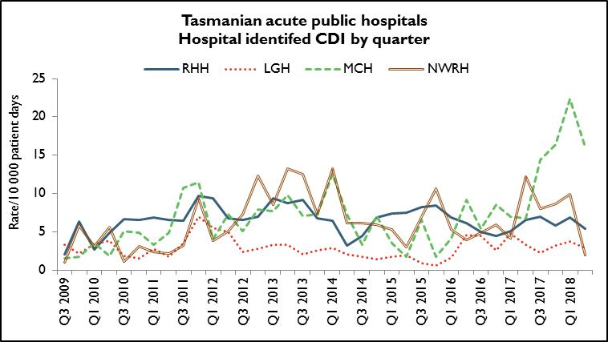
Figure 12 HCA-HCF by quarter
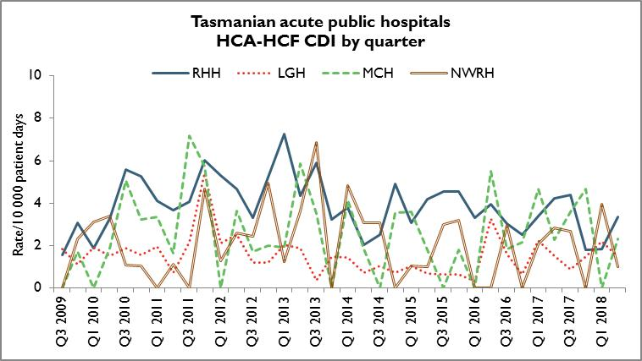
The rate of hospital identifed CDI varies considerably between hospitals. The rate of hospital identified CDI at MCH was high in Q2 2018 (which may reflect community associated cases) but there was only one case of HCA-HCF CDI at MCH over the same time period. The number and rate of HCA-HCF CDI at RHH increased in Q2 2018 but antimicrobial use patterns have not changed over this period and there were no ward based CDI outbreaks identified.

Hospital rates – by financial year
Figure 13 and Figure 14 presents the individual acute public hospital rates of hospital identified CDI, and healthcare associated – healthcare facility onset (HCA-HCF) CDI by financial year.
Figure 13 Hospital identified CDI by financial year
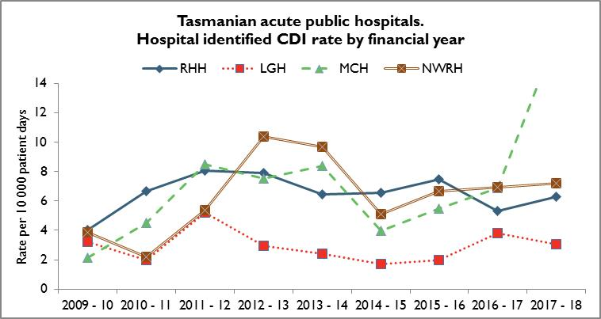
Figure 14 HCA-HCF CDI by financial year
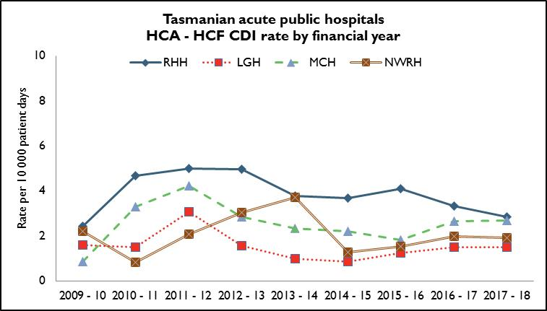
The MCH has demonstrated an upward trend in hospital identified CDI in 2017 – 2018 which can be largely explained by a tripling of community associated cases of CDI in 2017 – 2018 (19 cases) over the number of community associated cases identified in 2016 – 17 (6 cases).
The annual number and rates of HCA-HCF have remained stable at all public hospitals for 2017 – 18.

Vancomycin resistant enterococci
Enterococci are bacteria normally present in the human gastrointestinal and female genital tract and can cause infections of the urinary tract, bloodstream and wounds. Enterococci that have acquired resistance to the antibiotic vancomycin are called vancomycin-resistant enterococci or VRE. VRE infections can be more difficult to treat then those caused by vancomycin sensitive enterococci.
Factors that can contribute to the transmission of VRE in hospitals are inadequate infection control practices, overuse of antibiotics and suboptimal environmental cleanliness.
Identification of VRE is notifiable in Tasmania pursuant to the Public Health Act 1997.
Figure 15 and Figure 16presents all patients with a first VRE isolate identified within Tasmania by quarter and financial year respectively. These numbers include all new patients identified within Tasmania from public and private hospitals, rural hospitals, GP clinics and long term and residential care facilities. A person’s first VRE isolate is classified according to whether it represents colonisation – an isolate from a non-sterile site with no targeted antibiotic treatment prescribed - or infection – a clinical isolate from a sterile site OR a non-sterile site clinical isolate where targeted antibiotic therapy was prescribed.
The number of people newly identified with VRE within hospitals does not necessarily reflect that VRE was acquired at that hospital. The numbers of VRE isolates identified can be affected by the amount of screening undertaken by hospitals and those that have an intensive screening program are likely to identify more VRE

Figure 15 First VRE isolates – classification by quarter
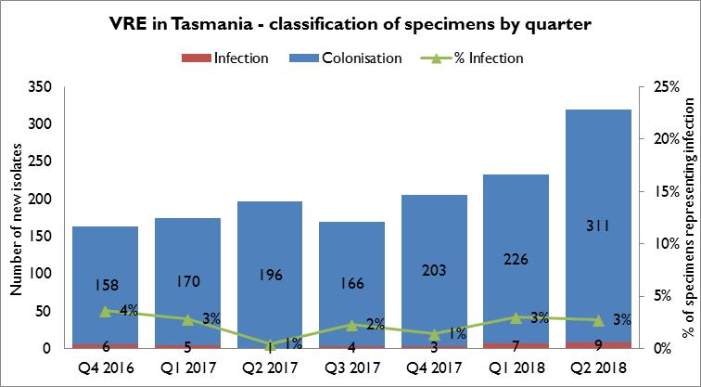
The number of new VRE identified in Q2 2018 is the highest since surveillance of VRE began in 2007 and there has been an increase in the proportion of these isolates which have the vanA gene. Infections caused by vanA VRE can be more difficult to treat than infections caused by vanB VRE.
Most first VRE isolates continue to reflect colonisation rather than infection. The proportion of isolates that represent infections has remained stable over the last seven quarters with infections representing around three per cent of total first VRE isolates.

Figure 16 First VRE isolates – classification by financial year
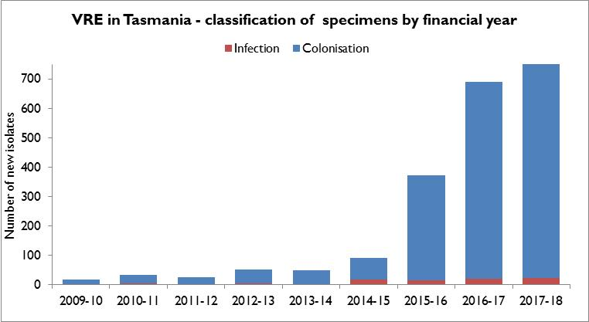
This figure illustrates the increase in new isolates that has occurred since 2014 – 15.

VRE genotypes
Figure 17 and Figure 18presents the genotypes of all new isolates identified within Tasmania by quarter and financial year respectively.
Figure 17 First VRE isolates - genotype by quarter
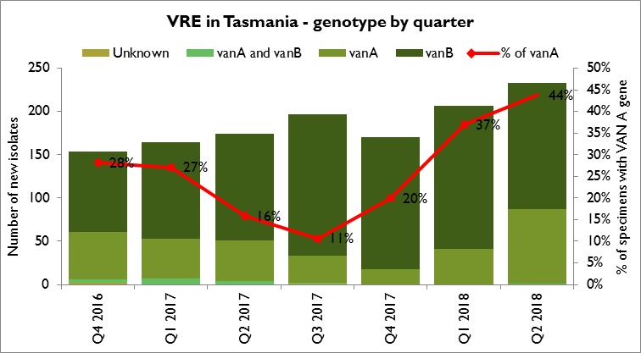
The majority of VRE within Tasmania remains vanB E. faecium. The number and proportion of isolates with the vanA genotype has increased substantially over the past two quarters and now represents nearly half (44%) of the total isolates for the current quarter.
Figure 18 First VRE isolates – genotype by financial year
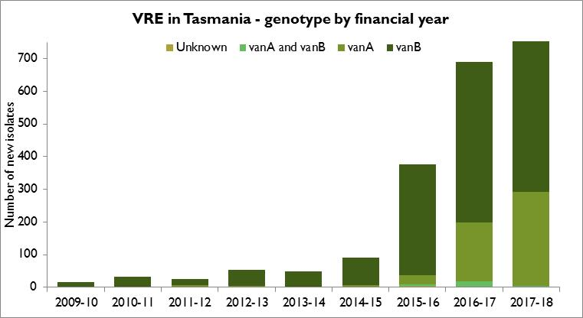
This figure illustrates the change in the epidemiology of VRE genotypes over the past two financial years with a marked increase in the number and proportion of van A genotype being identified. This change has also been identified in Victoria and New South Wales over a similar time period.
Figure 19 and Figure 20 presents the number of Van A or Van B genotype of new VRE isolates identified at RHH, and LGH per quarter.
Figure 19 VRE at RHH – genotype by quarter
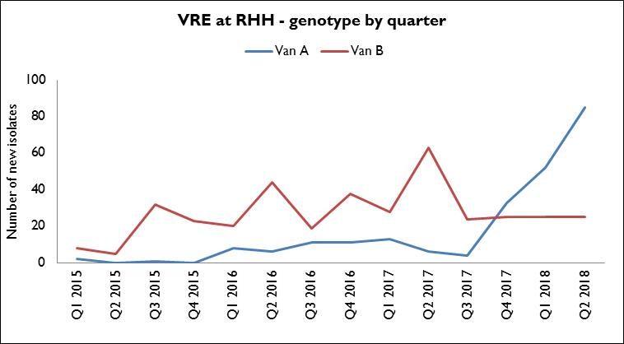
Figure 20 VRE at LGH – genotype by quarter
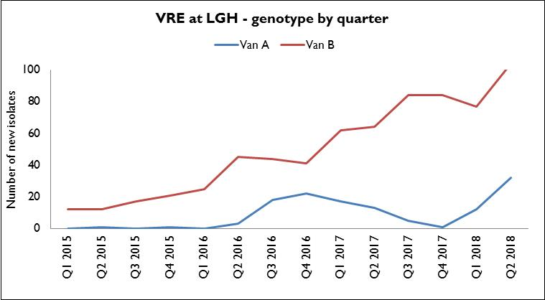

These figures illustrate the difference in epidemiology between the two hospitals with both hospitals experiencing an increase in cases identified per quarter, which commenced in 2016, but with RHH having a plateau in van B genotype but an increase in the number of van A genotype.

VRE screening effort
The volume of VRE screening has increased in Tasmania possibly in response to improved adherence to the THS Statewide screening protocol which includes both high risk patients and high risk clinical settings.
Table 1 presents the VRE screening effort across the four larger acute public hospitals, demonstrating the numbers of screening specimens tested, the number of specimens that have cultured VRE and the percentage of screening specimens that cultured VRE.

Table 1 Proportion of VRE positives from screening specimens
Year | RHH Screening specimens tested | RHH Positive specimens | LGH Screening specimens tested | LGH Positive specimens | MCH Screening specimens tested | MCH Positive specimens | NWRH Screening specimens tested | NWRH Positive specimens
2014 | 1962 | 12 (0.6%) | 353 | 25 (7%) | 544 | 8 (1%) | 893 | 11 (1%)
2015 | 2077 | 91 (4%) | 586 | 52 (9%) | 404 | 17 (4%) | 962 | 31 (3%)
2016 | 3863 | 182 (5%) | 1672 | 212 (13%) | 426 | 41 (10%) | 1094 | 66 (6%)
2017 | 4906 | 284 (6%) | 2564 | 289 (11%) | 571 | 66 (12%) | 1269 | 88 (7%)
2018* | 1214 | 86 (7%) | 954 | 95 (10%) | 127 | 11 (9%) | 452 | 45 (10%)
* 2018 - Quarter 1 data
This data shows that there has been an increase in VRE screening effort at RHH, LGH and NWRH and an increase in the proportion of positive specimens isolated across all four larger acute public hospitals since 2016. These data have not been de-duplicated so there may be a small number of repeat positive specimens on patients already known to have VRE included in this data set.

Carbapenemase-producing Enterobacteriaceae
Carbapenem resistance in Enterobacteriaceae is an emerging clinical and public health problem that threatens the effectiveness of an important antibiotic group – carbapenems – that are highly active against multi-drug resistant Gram negative organisms.
The epidemiology of carbapenemase-producing Enterobacteriaceae (CPE) varies between countries and it is evident that without active surveillance and subsequent stringent infection control measures these organisms may rapidly become endemic.
In areas where few CPE cases have occurred, it is recommended that health departments take an aggressive approach to contain CPE.
With current low prevalence rates, surveillance through mandatory laboratory notification creates an opportunity for proactive measures to prevent, detect and contain CPE within Tasmania.
Identification of CPE was made notifiable in Tasmania pursuant to the Public Health Act 1997 in 2016 and there have been three cases of CPE identified in Tasmania to June 30, 2018. None were locally acquired.
There was one case of CPE identified in Tasmania in 2017 – 18. The CPE was identified in a hospital inpatient and the CPE had been acquired overseas. The patient had the recommended infection prevention precautions in place whilst in hospital and no contact tracing or screening of other hospitals patients was required.

Hand Hygiene
The National Hand Hygiene Initiative (NHHI) was introduced in Tasmania in 2009 to increase healthcare workers hand hygiene compliance and monitor its effectiveness by measuring reductions in HCA SAB.
Hand hygiene compliance is monitored by direct observation of healthcare workers performing hand hygiene at the appropriate times. Hand Hygiene Australia (HHA) requires hand hygiene compliance data to be submitted three times per year with all acute care areas in a facility audited at least once per annum ideally every audit period.
The National Hand Hygiene Benchmark (NHHB) is ≥80 per cent for total moments, individual moments and each healthcare worker group.

Tasmanian rates
Figure 21 Hand hygiene compliance in Tasmanian public hospitals
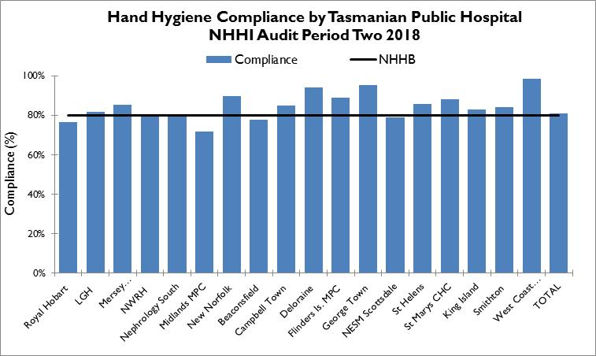
Audit period 2 2018 was from 1 April 2018 to 30 June 2018. For this period the overall Tasmanian public hospital compliance rate was 81 per cent which is one per cent higher than the NHHB.
There were five hospitals with compliance rates below the NHHB – RHH, NWRH, Midlands MPC, Beaconsfield and NESM Scottsdale. RHH was the only hospital of these to have an upper confidence interval below 80%. This indicates that the ‘true’ rate is below the NHHB. The RHH rate is a small (3%) decrease in the rate since the previous data collection period.
There are differences in the number of hand hygiene moments observed in the acute hospitals versus the rural hospitals and these numbers are presented in Table 13 in Appendix 2.

Figure 22 Hand hygiene compliance by moment
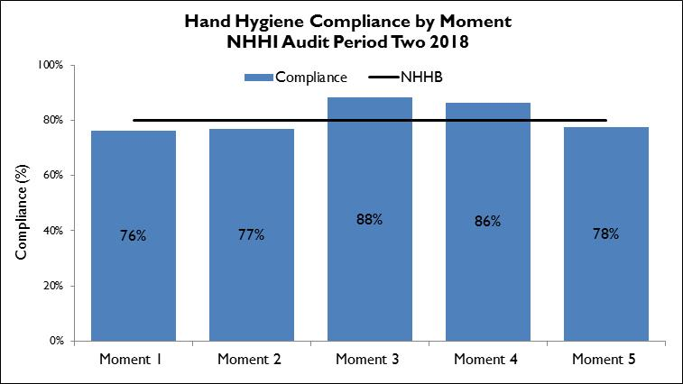
Hand hygiene compliance before touching a patient (Moment 1), before a procedure (Moment 2) and after touching patient surroundings (Moment 5) are lower than the NHHB and lower than those reported after undertaking a procedure (Moment 3) or after touching a patient (Moment 4).
Moment 1 and Moment 2 are key opportunities for hand hygiene that may have a direct effect on the risk of transmission of pathogens within the healthcare setting.
Moment 2, particularly relates to compliance with appropriate aseptic technique and procedural activity.

Figure 23 Hand hygiene compliance by healthcare worker
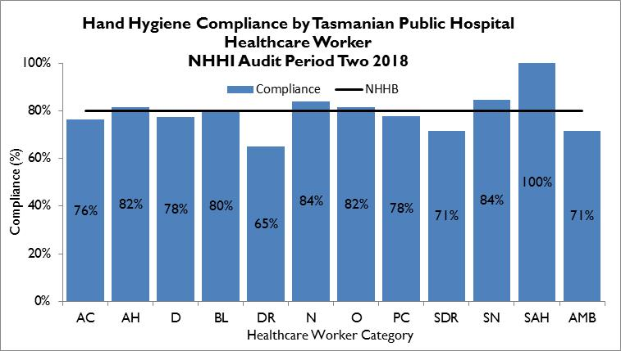
Table 2 Healthcare worker categories
Code | Healthcare worker | Code | Healthcare worker | Code | Healthcare worker
AC | Clerical | DR | Doctor | SDR | Student Doctor
AH | Allied Health | N | Nurse/Midwife | SN | Student Nurse/Midwife
D | Domestic | O | Other | SAH | Student Allied Health
BL | Invasive Technician | PC | Personal Care Staff | AMB | Ambulance worker

The number of hand hygiene moments observed between the different healthcare worker groups varies. Most (73 per cent in audit period 2, 2018) were collected from nursing activities with the next highest being medical activities (12 per cent).
There are a number of healthcare worker groups – clerical, invasive technician, student doctor, student allied healthcare worker, ambulance worker and other – that contribute one per cent or less of the total hand hygiene moments thus their results should be interpreted with caution.
Of the healthcare worker groups that contribute more than one per cent of the total moments, domestic staff, doctors and personal care staff are not meeting the NHHB. Doctor compliance at 65 per cent, is well below the benchmark and has decreased by one per cent since the last audit period. HHA is considering prioritising medical hand hygiene compliance for 2018/19.
TIPCU continue to work with and support the work of HHA and the NHHI.

Antibiotic use surveillance
Antimicrobial use is associated with the emergence of antimicrobial-resistant bacteria. Antimicrobial resistance is a significant and growing threat to public health worldwide. The National Antimicrobial Utilisation Surveillance Program (NAUSP) began in 2004 to conduct surveillance of hospital antimicrobials, principally antibiotic use. The program enables individual institutions to examine their own antimicrobial use rates and trends over time and provides peer group benchmarks for comparison. The data can be used to identify trends in antimicrobial use over time and develop local interventions to promote appropriate antimicrobial use.
The Royal Hobart Hospital has been contributing data to the NAUSP since July 2004 while Launceston General Hospital, North West Regional Hospital and Mersey Community Hospital have been contributing since January 2009. The data presented in this report shows use since January 2016 to June 2018.
Antimicrobial usage rates are calculated using the number of defined daily doses (DDDs) of specific antimicrobial agents or classes consumed each month per 1 000 occupied bed days (OBDs). This is a widely accepted method of measuring antimicrobial use in hospital settings both nationally and internationally. Tasmania has used ‘patient days’ rather than OBDs as the denominator and has done for a number of years. We changed the denominator to OBDs in January 2018 to achieve consistency with National data.
Rates presented in this report are for four antimicrobials or antimicrobial classes: third and fourth generation cephalosporins (ceftriaxone, cefotaxime, ceftazidime, cefepime); fluoroquinolones (ciprofloxacin, moxifloxacin, norfloxacin); piperacillin/tazobactam, and vancomycin. These were chosen for their relevance to other indicators in this report. Cephalosporin use has been linked with the emergence of MRSA while cephalosporins and fluoroquinolones have been identified as risk factors for Clostridium difficile infection, and all four classes have been associated with VRE acquisition.
The graphs show the use of the antimicrobial class or specific antimicrobial in each acute hospital. TIPCU use a three point rolling average to calculate the average rate of the current, and two previous months, and uses this to show trends over time. Because Tasmanian hospitals vary in services provided, comparisons between Tasmanian hospitals are not recommended. For example, a hospital that has a dedicated cancer service may use more antimicrobials to combat infections in this susceptible patient group.
Figure 24 Cephalosporin use
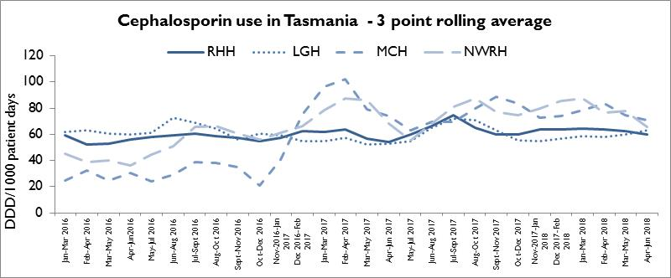
Cephalosporin usage in Tasmanian hospitals is comparable with the AURA 2017 data from NSW/ACT and Victoria but higher than the other states. Cephalosporin usage has been steady at the LGH and the RHH with the most recent usage being approximately 60 DDD per 1000 patient days, Use at the MCH and NWRH has decreased over the last 12 months, from approximately 102 per DDD per 1000 patient days to 70 DDD per 1000 patient days at MCH and from 87 DDD per 1000 patient days to 66 DDD per 1000 patient days at NWRH.
Figure 25 Fluoroquinolone use
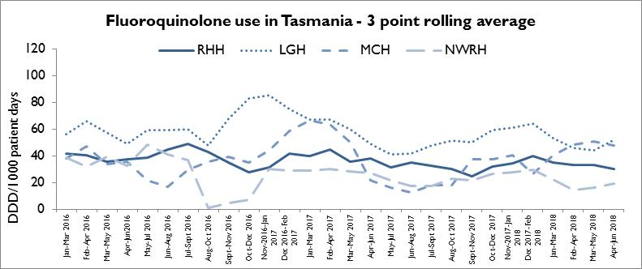
Fluoroquinolone use in Tasmanian hospitals is the highest of all of the states as seen in the AURA 2017 report but has decreased at RHH, MCH and NWRH over the past 12 months with the most recent usage being 27 DDD per1000 patient days (RHH), 43 DDD per1000 patient days (MCH) and 23 DDD per1000 patient days (NWRH). At LGH the use is higher than the other sites with the most recent usage data being approximately 75 DDD per1000 patient days.

Figure 26 Piperacillin - tazobactam use
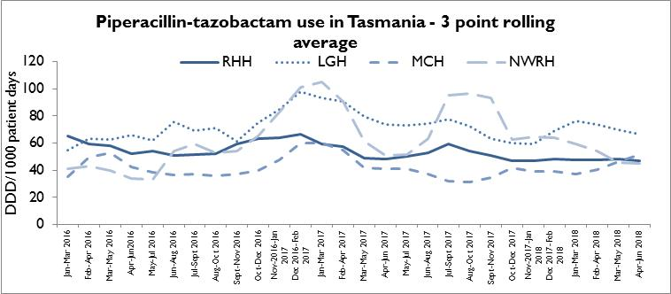
Piperacillin-tazobactam usage is similar at the RHH, MCH and the NWRH with the most recent usage being approximately 47 DDD per1000 patient days, 51 DDD per1000 patient days and 52 DDD per1000 patient days respectively. At the LGH, the usage is higher than the other sites with the most recent usage data being approximately 78 DDD per1000 patient days.
Figure 27 Vancomycin use
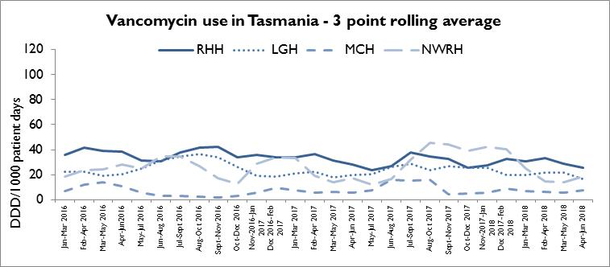
Vancomycin use has remained relatively stable across the RHH, LGH and MCH but useage has fluctuated at the NWRH. THE RHH usage was the highest of the four sites with approximately 20 DDD per 1000 patient days being the most recent usage figure.

Acknowledgements
The production of this report is the culmination of data collection, analysis and input from several different organisations. In particular, we would like to acknowledge:
- Executive Director of Nursing North
- Executive Director of Nursing North West
- Nursing Director South – Critical Care, Clinical Support and Investigations
- Launceston General Hospital Infection Prevention and Control Unit
- North West Regional Hospital Infection Control Team
- Mersey Community Hospital Infection Control Team
- Royal Hobart Hospital Infection Prevention and Control Unit
- Microbiology Departments at the Royal Hobart Hospital, Launceston General Hospital and DSPL
- Hand Hygiene Australia
- Communicable Diseases Prevention Unit, Population Health Services
- Contributing Primary Health Sites

Appendix 1

Explanatory notes

What types of healthcare surveillance are done in Tasmania?
TIPCU undertakes surveillance of the following:
- Staphylococcus aureus bacteraemia (bloodstream infection).
- Clostridium difficile infection (CDI).
- Vancomycin resistant enterococci (VRE).
- Carbapenemase-producing Enterobacteriaceae.
- Hand hygiene compliance rates.
- Antibiotic utilisation – reported annually.

What do the rates mean?
The healthcare surveillance data are expressed as a rate or a raw number. SAB and CDI are expressed as a rate per 10 000 patient days, VRE is expressed as a raw number, hand hygiene compliance is expressed as a percentage and antibiotic utilisation is expressed as hospital use measured by defined daily doses, per 1 000 occupied bed days.

What are the definitions for Clostridium difficile infection (CDI)?
TIPCU use the national surveillance definitions published by the Australian Commission on Safety and Quality in Health Care (ACSQHC) to classify CDI. TIPCU reports on:
- Hospital identified CDI is defined as a case diagnosed in a patient attending an acute care facility. This includes positive specimens obtained from admitted patients and those attending the emergency department and outpatient departments. This definition excludes patients less than two years old and cases with a positive test within the previous eight weeks.
- Healthcare associated – healthcare facility onset CDI (HCA-HCF CDI) is defined as a patient with CDI symptom onset (or date and time of stool specimen collection if a laboratory system is used) more than 48 hours after admission to a healthcare facility. This definition excludes patients less than two years old and cases with a positive test within the previous eight weeks.

What are the definitions for healthcare associated Staphylococcus aureus bacteraemia (SAB)?
Criterion A the patient’s first SAB blood culture was collected more than 48 hours after hospital admission or less than 48 hours after discharge.
OR
Criterion B the patient’s first positive SAB blood culture was collected less than or equal to 48 hours after hospital admission and one or more of the following key clinical criteria was met for the patient-episode of SAB.
Key clinical criteria:
- SAB is a complication of the presence of an indwelling medical device (eg intravascular line, haemodialysis vascular access, CSF shunt, urinary catheter).
- SAB occurs within 30 days of a surgical procedure or 365 days for surgically implanted devices, where the SAB is related to the surgical site.
- SAB was diagnosed within 48 hours of a related invasive instrumentation or incision.
- SAB is associated with neutropenia (less 1 x 10⁹/L) contributed to by cytotoxic therapy.
What is the definition for vancomycin resistant enterococci (VRE)?
The definition for VRE is an isolate identified as VRE by an accredited laboratory.
TIPCU reports on the total number of people with new isolates of VRE identified in Tasmania per quarter and this number includes all people with new VRE isolates from public and private hospitals, rural hospitals, GP clinics and long term and residential care facilities.
What is the definition for carbapenemase-producing Enterobacteriaceae (CPE)?
The definition for CPE is an Enterobacteriaceae isolate with a carbapenemase gene identified by an accredited laboratory.
TIPCU reports on the total number of people with new isolates of CPE identified in Tasmania per annum and this number includes all people with new CPE isolates from public and private hospitals, rural hospitals, GP clinics and long term and residential care facilities.

Confidence intervals
Confidence intervals are used to calculate the range in which the true rate probably lies.
As an example, when looking at the hand hygiene compliance (HHC) data confidence intervals calculate the range in which the true compliance result lies, based on the data collected and the compliance measured, thus providing an indication of the reliability of the reported HHC level.
When only a small number of moments are collected, the confidence interval will be larger, as it is more difficult to establish the true compliance level from a small sample of moments.
If a large number of moments are collected the confidence interval will be smaller, meaning the reliability of the result is higher.
Hand Hygiene Australia (HHA) calculates 95 per cent confidence intervals, indicating the intervals in which 95 per cent of the time the true compliance level lies. (HHA 2011).
Patient care days
Patient days is the term to explain the total days patients are in hospital. In Tasmania’s four larger acute public hospitals there are around 330 000 patient care days a year.
When a rate is presented as a number per 10 000 patient days this presents the number of infections that occur for every 10 000 patient care days.

Can I compare Tasmanian hospital infection rates?
Each Tasmanian hospital provides different services and has patients with different levels of illness. This affects infection rates.
For example, very sick immuno-compromised patients may be more likely to get infections.
It is difficult to remove all of the factors outside the control of a hospital that can cause its infection rate to differ from other hospitals.
Other reasons for caution when comparing hospitals include:
- some hospitals may screen patients more than others. This can affect data for CDI and VRE in particular
- hospital laboratories may use different ways of identifying organisms. A laboratory that has a more sensitive way of looking for organisms may find more
- for hand hygiene, rural hospitals are not required to collect as many moments as the four acute public hospitals, which limits the comparability of data for rural and acute hospitals.

Appendix 2

Healthcare associated Staphylococcus aureus bacteraemia (SAB)
Table 3 Tasmanian public hospital numbers and rate per 10 000 patient days of HCA-SAB.
Quarter | Total HCA-SAB | Number MSSA | Number MRSA | HCA SAB Rate
Q1 2016 | 8 | 6 | 2 | 1.0
Q2 2016 | 11 | 10 | 1 | 1.2
Q3 2016 | 7 | 7 | 0 | 0.8
Q4 2016 | 11 | 10 | 1 | 1.3
Q1 2017 | 7 | 6 | 1 | 0.8
Q2 2017 | 12 | 10 | 2 | 1.3
Q3 2017 | 8 | 8 | 0 | 0.8
Q4 2017 | 11 | 8 | 3 | 1.2
Q1 2018 | 7 | 7 | 0 | 0.8
Q2 2018 | 10 | 8 | 2 | 1.1

Table 4 Royal Hobart Hospital numbers and rates per10 000 patient days of HCA-SAB
Quarter | Total HCA-SAB | Number MSSA | Number MRSA | HCA SAB Rate
Q1 2016 | 2 | 2 | 0 | 0.5
Q2 2016 | 4 | 4 | 0 | 1.0
Q3 2016 | 3 | 3 | 0 | 0.8
Q4 2016 | 7 | 7 | 0 | 1.8
Q1 2017 | 3 | 2 | 1 | 0.8
Q2 2017 | 5 | 5 | 0 | 1.2
Q3 2017 | 4 | 4 | 0 | 1.0
Q4 2017 | 4 | 3 | 1 | 0.9
Q1 2018 | 3 | 3 | 0 | 0.7
Q2 2018 | 4 | 3 | 1 | 0.9

Table 5 Launceston General Hospital numbers and rates per10 000 patient days of HCA-SAB
Quarter | Total HCA-SAB | Number MSSA | Number MRSA | HCA SAB Rate
Q1 2016 | 5 | 3 | 2 | 1.6
Q2 2016 | 4 | 4 | 0 | 1.2
Q3 2016 | 2 | 2 | 0 | 0.6
Q4 2016 | 1 | 0 | 1 | 0.3
Q1 2017 | 3 | 3 | 0 | 0.9
Q2 2017 | 5 | 3 | 2 | 1.4
Q3 2017 | 3 | 3 | 0 | 0.8
Q4 2017 | 7 | 5 | 2 | 2.0
Q1 2018 | 3 | 3 | 0 | 0.9
Q2 2018 | 5 | 4 | 1 | 1.4

Table 6 Mersey Community Hospital numbers and rates per10 000 patient days of HCA-SAB
Quarter | Total HCA-SAB | Number MSSA | Number MRSA | HCA SAB Rate
Q1 2016 | 1 | 1 | 0 | 2.0
Q2 2016 | 1 | 1 | 0 | 1.7
Q3 2016 | 0 | 0 | 0 | 0.0
Q4 2016 | 2 | 2 | 0 | 4.2
Q1 2017 | 0 | 0 | 0 | 0.0
Q2 2017 | 1 | 1 | 0 | 2.3
Q3 2017 | 1 | 1 | 0 | 1.8
Q4 2017 | 0 | 0 | 0 | 0.0
Q1 2018 | 0 | 0 | 0 | 0.0
Q2 2018 | 0 | 0 | 0 | 0.0

Table 7 North West Regional Hospital numbers and rates per10 000 patient days of HCA-SAB.
Quarter | Total HCA-SAB | Number MSSA | Number MRSA | HCA SAB Rate
Q1 2016 | 0 | 0 | 0 | 0.0
Q2 2016 | 2 | 1 | 1 | 1.8
Q3 2016 | 2 | 2 | 0 | 1.8
Q4 2016 | 1 | 1 | 0 | 0.9
Q1 2017 | 1 | 1 | 0 | 1.0
Q2 2017 | 1 | 1 | 0 | 0.9
Q3 2017 | 0 | 0 | 0 | 0.0
Q4 2017 | 0 | 0 | 0 | 0.0
Q1 2018 | 1 | 1 | 0 | 0.9
Q2 2018 | 1 | 1 | 0 | 0.9

Clostridium difficile infection (CDI)
Table 8 Tasmanian numbers and rates per10 000 patient days of CDI
Quarter | Total hospital identified CDI | Hospital identified Rate | Total HCA HCF | HCA HCF Rate
Q1 2016 | 35 | 4.5 | 12 | 1.5
Q2 2016 | 45 | 5.5 | 17 | 2.1
Q3 2016 | 40 | 4.8 | 20 | 2.4
Q4 2016 | 34 | 4.2 | 12 | 1.5
Q1 2017 | 40 | 5.0 | 23 | 2.9
Q2 2017 | 52 | 6.1 | 25 | 2.9
Q3 2017 | 52 | 5.8 | 25 | 2.8
Q4 2017 | 50 | 5.7 | 14 | 1.6
Q1 2018 | 58 | 6.9 | 18 | 2.1
Q2 2018 | 40 | 4.6 | 20 | 2.3

Table 9 Hospital numbers and rates per10 000 patient days of hospital identified CDI
Quarter | RHH Total | RHH Rate | LGH Total | LGH Rate | MCH Total | MCH Rate | NWRH Total | NWRH Rate
Q1 2016 | 23 | 6.9 | 5 | 1.6 | 2 | 4.2 | 5 | 5.3
Q2 2016 | 22 | 6.2 | 14 | 4.6 | 5 | 9.2 | 4 | 3.9
Q3 2016 | 18 | 5.0 | 14 | 4.4 | 3 | 5.5 | 5 | 4.9
Q4 2016 | 16 | 4.5 | 8 | 2.6 | 4 | 8.6 | 6 | 5.9
Q1 2017 | 18 | 5.1 | 15 | 4.8 | 3 | 7.0 | 4 | 4.2
Q2 2017 | 25 | 6.6 | 11 | 3.3 | 3 | 6.8 | 13 | 12.3
Q3 2017 | 27 | 6.9 | 8 | 2.3 | 8 | 14.4 | 9 | 8.0
Q4 2017 | 23 | 5.9 | 11 | 3.2 | 7 | 16.4 | 9 | 8.7
Q1 2018 | 26 | 6.9 | 12 | 3.7 | 10 | 22.3 | 10 | 9.9
Q2 2018 | 21 | 5.4 | 10 | 3.0 | 7 | 16.1 | 2 | 2.0

Table 10 Hospital numbers and rates per10 000 patient days of HCA-HCF CDI
Quarter | RHH Total | RHH Rate | LGH Total | LGH Rate | MCH Total | MCH Rate | NWRH Total | NWRH Rate
Q1 2016 | 11 | 3.3 | 1 | 0.3 | 0 | 0.0 | 0 | 0.0
Q2 2016 | 14 | 3.9 | 10 | 3.3 | 3 | 5.5 | 0 | 0.0
Q3 2016 | 11 | 3.0 | 5 | 1.6 | 1 | 1.8 | 3 | 3.0
Q4 2016 | 9 | 2.5 | 2 | 0.7 | 1 | 2.1 | 0 | 0.0
Q1 2017 | 12 | 3.4 | 7 | 2.2 | 2 | 4.7 | 2 | 2.1
Q2 2017 | 16 | 4.2 | 5 | 1.5 | 1 | 2.3 | 3 | 2.8
Q3 2017 | 17 | 4.4 | 3 | 0.9 | 2 | 3.6 | 3 | 2.7
Q4 2017 | 7 | 1.8 | 5 | 1.5 | 2 | 4.7 | 0 | 0.0
Q1 2018 | 7 | 1.9 | 7 | 2.2 | 0 | 0.0 | 4 | 3.9
Q2 2018 | 13 | 3.3 | 5 | 1.5 | 1 | 2.3 | 1 | 1.0

Vancomycin resistant enterococci (VRE)
Table 11 First VRE isolates identified per quarter within acute public hospitals, and other healthcare settings (private hospitals, rural hospitals, GP clinics and long term and residential care facilities).
Quarter | RHH | LGH | MCH | NWRH | Other healthcare settings | TOTAL
Q1 2016 | 28 | 26 | 7 | 4 | 8 | 73
Q2 2016 | 51 | 48 | 12 | 14 | 12 | 138
Q3 2016 | 30 | 65 | 8 | 23 | 28 | 154
Q4 2016 | 51 | 67 | 5 | 15 | 26 | 164
Q1 2017 | 41 | 82 | 13 | 13 | 26 | 175
Q2 2017 | 70 | 78 | 9 | 12 | 28 | 197
Q3 2017 | 28 | 89 | 10 | 11 | 32 | 170
Q4 2017 | 58 | 85 | 10 | 21 | 32 | 206
Q1 2018 | 78 | 89 | 6 | 27 | 33 | 233
Q2 2018 | 113 | 137 | 12 | 22 | 36 | 320

Table 12 Classification of first VRE isolates – colonisation and infection
Quarter | Total VRE | Colonisation | Infection | % infection
Q1 2016 | 73 | 71 | 2 | 3%
Q2 2016 | 138 | 134 | 4 | 3%
Q3 2016 | 154 | 147 | 7 | 5%
Q4 2016 | 164 | 158 | 6 | 4%
Q1 2017 | 175 | 170 | 5 | 3%
Q2 2017 | 197 | 196 | 1 | 1%
Q3 2017 | 170 | 166 | 4 | 2%
Q4 2017 | 206 | 203 | 3 | 1%
Q1 2018 | 233 | 226 | 7 | 3%
Q2 2018 | 320 | 311 | 9 | 3%

Table 13 First VRE isolates by genotype by quarter
Quarter | vanA | vanB | vanA and vanB | Unknown
Q1 2016 | 10 | 61 | 1 | 1
Q2 2016 | 14 | 120 | 2 | 2
Q3 2016 | 55 | 93 | 4 | 2
Q4 2016 | 46 | 111 | 7 | 0
Q1 2017 | 47 | 119 | 4 | 1
Q2 2017 | 31 | 164 | 1 | 1
Q3 2017 | 18 | 152 | 0 | 0
Q4 2017 | 41 | 165 | 0 | 0
Q1 2018 | 86 | 146 | 1 | 0
Q2 2018 | 141 | 177 | 4 | 0

Hand hygiene compliance data - audit period 2, 2018
Table 14 Hand hygiene compliance rates by Tasmanian hospital and state level
Hospital Name | HH Correctly Performed | HH Moments | Compliance | Lower 95% confidence interval | Upper 95% confidence interval
RHH | 2029 | 2652 | 77% | 75% | 78%
LGH | 4911 | 6001 | 82% | 81% | 83%
MCH | 414 | 486 | 85% | 82% | 88%
NWRH | 810 | 1022 | 79% | 77% | 82%
Nephrology South | 179 | 223 | 80% | 80% | 80%
Midlands MPC | 43 | 60 | 72% | 59% | 81%
New Norfolk DH | 52 | 58 | 90% | 79% | 95%
Beaconsfield DHS | 155 | 199 | 78% | 72% | 83%
Campbell Town MPC | 51 | 60 | 85% | 74% | 92%
Deloraine DH | 153 | 163 | 94% | 89% | 97%
Flinders Is. MPC | 81 | 91 | 89% | 81% | 94%
George Town Hospital | 59 | 62 | 95% | 87% | 98%
NESM Scottsdale | 49 | 62 | 79% | 67% | 87%
St Helens DH | 96 | 112 | 86% | 78% | 91%
St Marys CHC | 60 | 68 | 88% | 78% | 94%
King Island Hospital | 43 | 52 | 83% | 70% | 91%
Smithton DH | 47 | 56 | 84% | 72% | 91%
West Coast DH | 132 | 134 | 99% | 95% | 100%
TOTAL | 9364 | 11561 | 81% | 80% | 82%

Table 15 Tasmanian hand hygiene compliance rates by moment
Moments | HH Correctly Performed | Total HH Moments | Compliance | Lower 95% confidence interval | Upper 95% confidence interval
Moment 1 | 2418 | 3177 | 76% | 75% | 78%
Moment 2 | 642 | 837 | 77% | 74% | 79%
Moment 3 | 1071 | 1214 | 88% | 86% | 90%
Moment 4 | 3134 | 3625 | 86% | 85% | 88%
Moment 5 | 2099 | 2708 | 78% | 76% | 79%
TOTAL | 9364 | 11561 | 81% | 80% | 82%

Table 16 Tasmanian hand hygiene compliance rates by healthcare worker
Staff Type | HH Correctly Performed | HH Moments | Compliance | Lower 95% confidence interval | Upper 95% confidence interval
Clerical | 32 | 42 | 76% | 61% | 87%
Allied Health | 307 | 376 | 82% | 77% | 85%
Domestic | 176 | 227 | 78% | 72% | 82%
Invasive Technician | 88 | 110 | 80% | 72% | 86%
Doctor | 908 | 1399 | 65% | 62% | 67%
Nurse/Midwife | 7025 | 8382 | 84% | 83% | 85%
Other | 31 | 38 | 82% | 67% | 91%
Personal care staff | 393 | 505 | 78% | 74% | 81%
Student Doctor | 25 | 35 | 71% | 55% | 84%
Student Nurse/Midwife | 359 | 425 | 84% | 81% | 88%
Student Allied Health | 15 | 15 | 100% | 80% | 100%
Ambulance Worker | 5 | 7 | 71% | 36% | 92%
TOTAL | 9364 | 11561 | 81% | 80% | 82%

