Contents
1 Introduction 3
2 Executive Summary 4
3 Context 5
3.1 Purpose 5
3.2 Scope 5
4 Purchasing Strategies 6
4.1 Activity 7
4.2 Chronic Disease Risk Factors 10
4.3 Complex Patients 11
4.4 Government Priorities 13
5 Future Purchasing Intentions and Strategies 14
6 Purchasing Actions 15
6.1 Purchase Activity 15
6.2 Government Priorities 18
Works Cited 20
Appendix A: Disease and Injury List 21
Appendix B: Chronic Disease – Mapping 23
Appendix C: List of Hospitals (purchase activity) 25

- Introduction
The objective of the State’s public sector health system is to deliver safe, high quality services to improve, promote, protect and maintain the health of Tasmanians. This objective supports the vision for Tasmania to have the healthiest population in Australia by 2025.
As per authority delegated by the Minister for Health, it is the responsibility of the Department of Health and Human Services (the Department), as System Manager, to purchase services (the Purchaser) on behalf of Tasmanians, using funds provided by the Tasmanian and Commonwealth Governments (the Funders) from suppliers of health services (the Service Provider/s).
The Department subsequently has a clear responsibility to the people of Tasmania to ensure that it is able to demonstrate that it is receiving the services it purchases and is obtaining value for money.
The Statement of Purchaser Intent (SoPI) serves a number of functions:
- It is a synthesis of Government priorities and a response to health trends across the State.
- It signals the Department’s intentions over the coming five years in order to assist the Provider/s with their forward planning.
- It creates the basis for the Service Agreement between Purchaser and Provider.
- It articulates purchasing intent in specific and measurable terms in order that the Department as Purchaser is able to clearly ascertain and account for what is being purchased.
A key mechanism for system management is through informed, appropriate purchasing. The nature and volume of services purchased will impact on the effectiveness and value-for-money of the Tasmanian health system. However, purchasing is a transactional process, and so must be contextualised to be effective as a mechanism to enact Government policy in health, and to ensure that purchasing decisions reflect the application of a longer term strategy. As part of this purchasing process, the Department must also signal as far as possible its future purchasing intentions to support service providers’ planning capacities.
SoPI (18-19) will drive the Service Agreement (SA) by articulating purchasing actions and intents derived from existing government priorities as stated in the White Paper, announcements and initiatives.
The priorities include those that are to be delivered by the Tasmanian Health Service (THS) consistent with the priorities outlined in SoPI (2017-18) and additional priorities that have been agreed between the Department and the THS as part of the 2017-18 SA development process for joint progression.
Consistent with the processes outlined in the Performance Framework, progress against the implementation of all priorities will be subject to regular monitoring and reporting throughout the year.

Michael Pervan
Secretary, DHHS

October 2017
- Executive Summary
The key developments in SoPI 18-19 constitute a more sophisticated and in depth analysis of conditions that provide the greatest burden of disease for Tasmanians. These include:
- Inclusion of Endocrine conditions, specifically Diabetes
- Study of risk factors linked to high burden of Chronic Disease
- Increased support for building capacity in the sub-acute sector
- Introduction of multimorbidity as a key challenge for health system design
Greater detail is provided in three supplementary papers that accompany this SoPI:
- Supplementary Paper I – Diabetes
- Supplementary Paper II – Chronic Disease Risk Factors
- Supplementary Paper III - Multimorbidity
Diabetes did not make the cumulative cut off for the burden of disease in SoPI 17-18 (80% of total burden). Diabetes accounted for 2.5% of non-fatal burden and 2.7% of fatal burden for Tasmanians. However, given the prevalence of Diabetes and the multi system nature of the condition, it was decided to include Diabetes in SoPI 18-19.
SoPI 17-18 focussed on acute activity represented by high burden of disease. In order to continue developing a whole of system response to high burden of disease an in-depth understanding of risk factors is required and the role they play in the development of these conditions in Tasmania.
This response is further supported in two ways; firstly by the ongoing Tasmanian Role Delineation Framework (TRDF) and Clinical Services Profile (CSP) expansion to include the Rural Inpatient Facilities (RIFs); and secondly the use of additional Australian Government: National Partnership Agreement (NPA) funding to support capacity building in the sub-acute sector.
This will take the form of numerous smaller projects and initiatives such as anticipatory care trials, provision of grants to develop and trial new models of care that allow for improved support such as Allied Health Rural Generalists, and outreach support for GPs from the acute sector for those patients addicted to analgesic medicines.
The introduction of multimorbidity marks an important developmental milestone for the SoPI. Patients with complex needs are increasingly acknowledged as presenting challenges for health systems and those who provide services to complex patients. By way of introduction, Supplementary Paper III proposes a methodology for describing and comparing multimorbidity and provides some directions for greater collaboration between services that provide support for patients with particular combinations of conditions. Further work is planned to develop a Multimorbidity Framework in conjunction with clinical providers and patients.
The SoPI 18-19 uses three strategies to actively manage and sustainably balance the elective surgery waitlist. These strategies are:
- Shared modelling and understanding of surgical demand
- Ensuring shorter time to treatment by ‘treating patients in turn’
- Addressing variation in five surgical interventions that appear to be higher in Tasmania than clinically evidenced nationally.

- Context
  - Purpose
The SoPI strategic importance to the health system and how it can be best used by the service provider/s is reflected in the table below:
Why is the SoPI important? | - Outlines System Manager five year purchasing intent plan  - Incorporates Government strategic directions and health system priorities (Including White Paper Health Reform – TRDF/CSP)  - Outlines the submissions into the Treasury budget input  - Informs Service Agreement
How is the SoPI used by Service Provider/s? | - Supports Health Service Policy and Planning (aligning with government health priorities)  - Assist in the development of the THS Corporate Plan  - Informs Statewide Models of Care development and implementation  - Enhances continuing care across all health sectors
What’s new in this version? | - Inclusion of Endocrine (specifically Diabetes)  - Additional focus on chronic disease risk factors  - Additional focus on multimorbid patients  - Additional Government Priorities
Monitoring and Reporting | - Monitor and measure purchasing activity, and regular reporting to service provider/s  - Progress reporting on purchaser intent by service provider/s to enable continuity of directed funding payments  - Additional Purchasing Strategies – agreed reporting process and progressive funding payments.
Performance and Audit | - Performance Framework progress against implementation of all purchasing priorities  - Review incentives and performance management funding  - Annual audit of Purchasing Strategies and Intentions

  - Scope
The scope of the SoPI relates to State Government funded services purchased by the Department. For services purchased from a provider but subsequently subcontracted to either Government or non-government organisations, broad intentions may be articulated but accountability for legislative and contractual requirements resides with the Provider. Linkages between service providers may be articulated where relevant, particularly where service integration is an objective.
- Purchasing Strategies
The evolution of SoPI Purchasing Strategies 2018-19 has the following key elements:-
- Activity: The first element builds upon SoPI (2017-18) Purchasing Activity through monitoring and THS, as service provider reporting on delivered chronic disease and surgery activity volumes.
- Chronic Disease Risk Factor Management: The second element brings together the SoPI (18-19) section on Chronic Disease Risk Factors and future purchasing strategies.
- Multimorbidity: The third element brings together the SoPI (18-19) section on multimorbidity and future purchasing strategies.
- Government Priorities: The fourth element evaluates and audits the SoPI (2017-18) Government Priorities purchaser intent, together with supporting the NPA funded proposed initiatives. 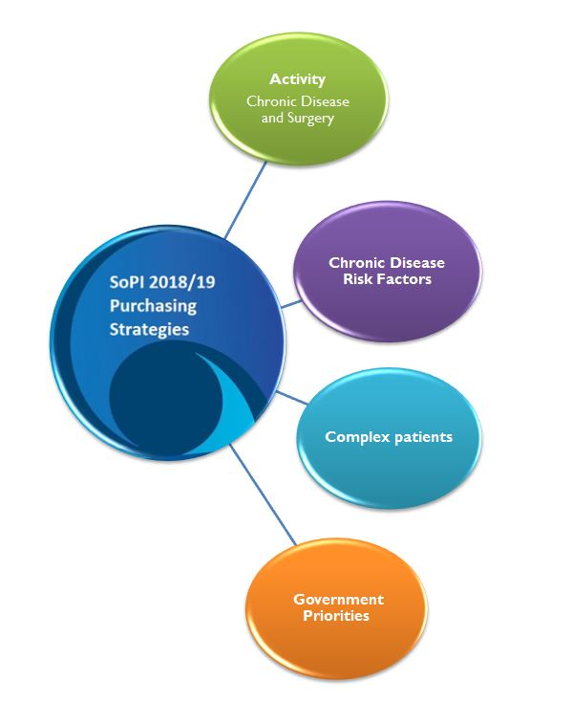

  - Activity

Chronic Disease Burden
The SoPI (2017-18) focused on the chronic conditions that provide the greatest burden of disease for Tasmanians.
The following groupings of health conditions account for eighty percent of the burden of disease for the Tasmanian population and purchasing actions will centre on these conditions:
In order to focus purchasing priorities, an analysis was undertaken to understand the Fatal and Non-Fatal burdens of each of the above diseases in Tasmania. The conditions that contribute to one or both are shown in the table below:
Fatal YLL | Cancer and Other Neoplasms | Respiratory disease | Musculoskeletal conditions | Non Fatal YLD
 | Injuries | Neurological conditions | Mental Health and Substance abuse
 |  | Cardiovascular disease | Oral disorders
 |  |  | Hearing and vision disorders
 |  |  | Endocrine disorders

The analysis revealed that respiratory diseases, neurological conditions and cardiovascular disease contribute significantly to both Fatal and Non-Fatal burdens of disease.

Endocrine Disorders: Diabetes
(c.f. Supplementary paper I)
The SoPI (2017-18) identified diabetes as a future priority to review and develop purchasing intentions and activity. The development of the DHHS: PPP - Acute Strategy “Diabetes Research and Discussion Paper” summarises and references the available national and Tasmanian prevalence, incidence, and burden of disease data trends, including the impact of co-morbidity, non-fatal and fatal burden, hospitalisations, mortality and associated risk factors.
The use of information and data on the health impacts and distribution of different diseases and risk factors is crucial in providing an evidence base to inform health policy, program and service delivery. In turn, this helps to ensure health resources are directed towards services that are cost-effective, equitable and optimise the health of Tasmanians.
Diabetes can result in a range of short- and long-term complications which are the major causes of associated co-morbidity and mortality in people with diabetes. The presence of complications also greatly increases the cost of managing diabetes. Improving the management and care of diabetes, particularly the early identification and reduction of risk factors, can delay the onset or slow the progression of complications.
Further monitoring and surveillance of diabetes is crucial for guiding preventive measures, determining clinical care and informing health policy and service planning. Diabetes has a significant impact on Australia’s health and productivity that research efforts need to be further focused on strengthening evidence-based practice for the prevention of diabetes and its complications, identifying a cure for diabetes, informing health policy decisions and potentially offering more timely access to newer and improved medications.
The figure below represents high level purchasing strategies that could be considered by the service provider/s and service delivery planner in collaboration with all health sectors, including acute, community and primary care:

Prevention | - Continue to implement community awareness and health literacy programs to enhance healthy eating, increase physical activity and improve knowledge of diabetes risk factors.  - Develop a strategy and set of diabetes guidelines for prevention of type 2 diabetes, including the reduction of hospitalisations for diabetes and related complications.  - Develop statewide integrated Models of Care to assist in reducing diabetes complications
Early Detection | - Promote awareness by establishing programs and information sessions to understand the early detection and symptoms of Diabetes and associated complications.  - Expand targeted risk assessment and screening opportunities in a range of healthcare settings.
Intervention | - Establishing specific interventions to assist in reducing complications for diabetes; including point-of-care testing for HbA1c, which has been suggested as a strategy to facilitate earlier diagnosis of diabetes.  - Developed guidelines to identify the early symptoms of type 2 diabetes, as it is often absent in the early stages and so people can go undiagnosed for a long period of time.
Self-management and Education | - Encourage and promote the management and care of diabetes through intensive self-management to prevent complications, by referring patients to health care pathways for diabetes.  - Continue to develop and implement accessible self-management and peer support programs for people with diabetes and their carers in various settings, in particular people living in rural and remote areas.  - Continue to implement coordinated, multidisciplinary and streamlined care for people with diabetes, particularly for those with chronic and complex conditions

Elective Surgery
There are three purchasing strategies for elective surgery:
- Maintenance of agreed existing activity volumes
- Ensuring accessibility to treatment
- Addressing variation of service delivery in targeted specialties

Volumes
The DHHS will undertake work to improve our understanding of real demand. Until a better understanding of “demand” and “capacity” is achieved and what the drivers are for demand in Tasmania, current volume expectations will remain.
Understanding “demand” is being confounded by low compliance with Treat in Turn and admission within recommended times. Surgical service providers should supply the volumes of activity as agreed in their Service Agreement. The DHHS as system manager will continue to work with service providers to better understand and model true demand.

Accessibility
A primary focus of the DHHS as system manager is accessibility to treatment. Treat in Turn rates will be monitored as a Key Performance Indicator (KPI) within the Service Agreement, in order to ensure standardisation and fairness in the management of the Elective Surgery Wait List (ESWL).
It is expected that 60% of patients will be treated in turn as per the Royal Australasian College Surgeons (RACS) endorsed project for ‘National Definitions for Elective Surgery Urgency Categorisation’ (AIHW, 2012).
The 2015 RACS National Elective Surgery ‘usual’ Urgency Categorisation Guideline supports the Treat in Turn principle and KPI. The purpose of the guideline is to promote national consistency and comparability in urgency categorisation and improve access for patients.
The DHHS as system manager will ask service providers to demonstrate how they are working with their clinicians to achieve the nationally agreed ‘Treat in Turn’ target and ‘usual’ Urgency Categorisation.

Variation
Tasmania is exhibiting significant variations in practice in five surgical interventions (ACSQHC, 2017):
- Lumbar spinal decompression
- Spinal Fusion (>18 year olds)
- Laparoscopic cholecystectomies
- Appendectomies
- Cataract surgeries (40 years and over)
These five surgical interventions represent higher than expected hospitalisations for these procedures.
The DHHS as system manager will work with service provider/s to address these variations.

  - Chronic Disease Risk Factors
(c.f. Supplementary paper II)
The SoPI (18-19) focuses on the outcomes of the key health drivers in Tasmania, including contributory health conditions, such as chronic disease risk factors. The development of the DHHS: PPP - Acute Strategy SoPI 2018-19 Supplementary Paper 11: “Chronic Disease and Risk Factors Research and Discussion Paper” summarises and references the available national and Tasmanian data.
Many factors influence people’s health. Some function on an individual level, for example, health behaviours or genetic make-up, while others function at a broader societal level, such as the availability of health services, vaccination programs or a clean and healthy environment.
All these factors are collectively known as determinants of health. Health determinants can influence our health in either a positive or negative way. Determinants affecting health in a negative way are commonly referred to as risk factors.
Risk factors carry different levels of burden for our health system. The benefits of reducing risk factors vary for individuals and the community. The DHHS recognises the benefit in systematically targeting a reduction in health risk factors that impact on the burden of chronic disease/s.
Some examples of risk factors that will be addressed are:
- Smoking
- Overweight and obesity
- Alcohol consumption
- Dietary risks
- Physical inactivity, and
- Environmental risks.
The diagram on page 11 represents high level purchasing strategies that could be considered by the service provider/s and service delivery planner in collaboration with all health sectors, including acute, community and primary care to reduce the greatest burden of disease for communities and individuals:
Prevention | - Implement population-based health programs to reduce lifestyle-related risk factors including obesity and increase physical activity levels and fruit & vegetable consumption.  - Support the development of statewide Models of Care to assist in reducing lifestyle related risk factors prevalent with the regions and/or Local Government Area.
Early Detection and Education | - Establish and promote risk factor related programs to understand the early detention and screening of chronic disease.  - Structured lifestyle education sessions in primary and secondary schools involving the family, local recreational, community and sporting organisations.  - Promote health literacy linking risk factors and chronic disease.
Chronic Disease Self-management | - Improve the management and care of chronic disease through self-management and peer support groups  - Support the transition from acute care to a culture that supports patient-centred care, hospital avoidance, self-management and increased primary and allied health care options.
Health Promotion Capacity Building | - Promote anticipatory care through cross-sector collaborations, data sharing and community involvement.  - Support the development of shared ‘continuity of care’ planning between DHHS, THS, Primary Health Tasmania, local Councils and service provider/s
Chronic Disease Purchasing | - Align Government strategic directions and health system purchasing priorities  - Report and evaluate the purchasing actions and intent.

  - Complex Patients
(c.f. Supplementary Paper III)
A significant challenge for healthcare systems is the increasing complexity presented by multimorbid patients. The prevalence of multimorbidity is well documented as are the impacts and high cost to the health system. Multimorbid patients experience increased health utilisation, higher rates of mortality, and greater difficulty managing their complex needs on an ongoing basis.
People with multimorbidity and complex healthcare needs often receive care that is fragmented, incomplete, inefficient and ineffective (Boyd, 2010). Whilst significant work is still required to build on the existing work, this SoPI opens the discussion on multimorbid patients by putting forward two proposals (1) identifying which conditions have the strongest relationships and (2) putting forward broad policy directions for multimorbidity.
Providers should create opportunities for increased collaboration to understand the following combinations of conditions as these conditions not only provide the highest burden of disease but also reflect the most common combinations of conditions across the State:
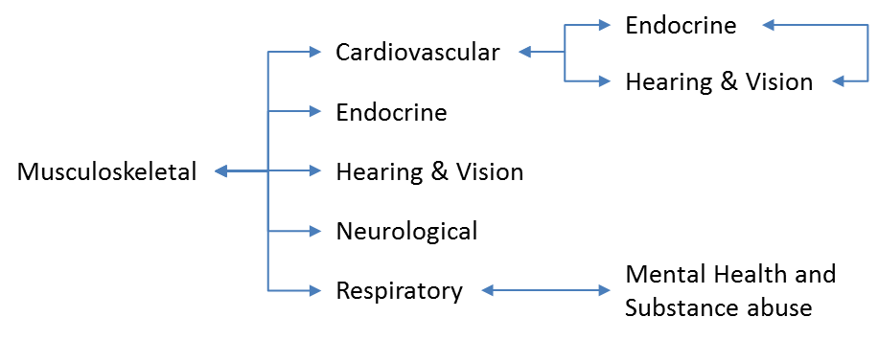
These conditions represent those conditions that provide the greatest burden of disease for Tasmanians and have been demonstrated as having the strongest (OR > 1.25) and statistically significant (p<0.05) co morbid relationships across the State in the acute sector. Further work will be undertaken to investigate the primary care sector and the development of a Multimorbidity Framework over the next two years.
Policy responses to multimorbidity could be articulated using the following model proposed by Rijken et al. (2017). These will be explored further in the development of the Framework.

Macro Level | - Education and Training  - Policy and Funding
Meso Level | - Care coordination  - Multiprofessional collaboration  - Inter-organisational collaboration  - Multi skill recruitment
Micro Level | - Periodic and comprehensive needs assessment  - Individual care planning  - Decision support and shared decision making

  - Government Priorities

Injuries – Suicide Reduction
As referenced in SoPI 17-18, ensuring deliberate self-harm or suicide attempt patients, when discharged from the acute hospital (either Emergency Department or inpatient setting), are assessed and referred for follow up in post discharge community care within 48 hours of discharge.

Musculoskeletal conditions – Pain Management and Rheumatology Services
As referenced in SoPI 17-18 and in accordance with TRDF and CSP to increase Pain Management and Rheumatology services in the North West Region from a no level service to a Level 4 service.
The Service Agreement 2017-18 states that by 30 June 2018 the THS will have established Level 4 Pain Management and Rheumatology services in the North West of the State.

Sub-Acute and Community based care capacity building
Building and maintaining capability along the continuum of care, especially in the sub-acute and community sectors is a high priority. In order to continue supporting capability building in the sub-acute sector, the DHHS will work collaboratively with service providers on a number of initiatives that will support the enhancement of existing capability. Examples of initiatives include (but are not limited to) the following:
- Anticipatory Care and complex patients
- Rural Inpatient Facilities
- Allied Health and Medical workforce capability development
- SoPI /TRDF focussed activities
- Collaboration and outreach support between service providers and/or health care sectors
- Operationalisation of Community Rapid Response Services (ComRRS)

Sector Purchasing: Tasmanian Role Delineation Framework and Clinical Service Plan
The expansion of the TRDF and CSP into the Rural Inpatient Facilities (RIFs) enables increased sophistication in the configuration and provision of health care. It provides a future planning foundation to articulate service delivery requirements between health sectors for each clinical specialty enabling a safer transition along the care spectrum. This provides the public health system with a structure to ensure alignment with the subsequent purchasing strategies which are articulated in this document as well as the SA.
Future planning and development of the TRDF and CSP will:
- articulate the full continuum of care to support cross sectoral (integrated) models of care
- create the opportunity to be more sophisticated in the purchasing intent and be able to purchase community and primary care based services, and
- delineate all clinical service provider/s of the Department of Health and Human Services in this framework.
- Future Purchasing Intentions and Strategies
Future SoPIs will consider the development of purchasing intentions and strategies in the following areas:
- Australian Commission on Safety and Quality in Healthcare “Australian Atlas of Healthcare Variation” to improve the quality, value and appropriateness of health care including:
- Identifying any specific and achievable purchasing actions for exploration and quality improvement;
- Additional priorities for investigation and action including hospitalisation rates for specific populations with chronic conditions.
- Additional Government Priorities integrating Australian Government funded initiatives and projects.
- Build on the further development of Elective Surgery Strategies.
- Chronic Disease Risk Factor Management to increase health promotion capacity building with service provider/s, as well as strategies to reduce lifestyle-related risk factors which align with the chronic diseases that contribute to 80% of the burden in Tasmania.
- Innovative mechanisms to address social determinants of health, such as educational programs and health literacy.
- New and emerging technologies – e.g. new cancer chemotherapy targeted treatment to reduce chemotherapy chair treatment time for patients and provide greater efficiency.
- Education, training and research as both costs of and drivers for health service delivery.

- Purchasing Actions
  - Purchase Activity
To provide acute admitted activity (medical only) (acute admitted RAW episodes – refer ‘Appendix B: Chronic Disease – Mapping’ definition) as specified below for the following chronic diseases that contribute to 80% of the burden in Tasmania.
NWAU projection values: based on Hardes projected numbers and costing NWAU values. Calculated on 2015-16 baseline date and using NWAU 2016 calculations.
The NWAU activity reflected by the Hardes projected modelling for the Rural Inpatient Facilities (RIFs) is block funded which is referenced in the Service Agreement.
Activity
Chronic Disease and Surgery
The full list of the Major Acute Hospitals and RIFs is provided at Appendix C.
Cardiovascular Disease
NWAU | 2017-18 | 2018-19 | 2019-20 | 2020-21 | 2021-22
Acute Hospitals | 6541 | 6773 | 7004 | 7236 | 7467
RIFs | 343 | 358 | 374 | 389 | 405
Neurological conditions
NWAU | 2017-18 | 2018-19 | 2019-20 | 2020-21 | 2021-22
Acute Hospitals | 5576 | 5753 | 5930 | 6107 | 6284
RIFs | 445 | 461 | 478 | 495 | 511
Respiratory Disease
NWAU | 2017-18 | 2018-19 | 2019-20 | 2020-21 | 2021-22
Acute Hospitals | 7275 | 7545 | 7815 | 8086 | 8356
RIFs | 613 | 635 | 657 | 679 | 701
Musculoskeletal conditions
NWAU | 2017-18 | 2018-19 | 2019-20 | 2020-21 | 2021-22
Acute Hospitals | 2473 | 2564 | 2655 | 2747 | 2838
RIFs | 246 | 257 | 267 | 278 | 289
Mental Health and Substance Abuse
NWAU | 2017-18 | 2018-19 | 2019-20 | 2020-21 | 2021-22
Acute Hospitals | 923 | 952 | 981 | 1011 | 1040
RIFs | 38 | 41 | 43 | 45 | 48
Cancer and other Neoplasms
NWAU | 2017-18 | 2018-19 | 2019-20 | 2020-21 | 2021-22
Acute Hospitals | 4898 | 5049 | 5200 | 5352 | 5503
RIFs | 656 | 697 | 738 | 779 | 820
Injuries
NWAU | 2017-18 | 2018-19 | 2019-20 | 2020-21 | 2021-22
Acute Hospitals | 1865 | 1918 | 1971 | 2024 | 2077
RIFs | 52 | 55 | 58 | 61 | 63
Oral Disorders
NWAU | 2017-18 | 2018-19 | 2019-20 | 2020-21 | 2021-22
Acute Hospitals | 570 | 586 | 603 | 620 | 636
RIFs | 3 | 3 | 3 | 3 | 3
Hearing and Vision Disorders
NWAU | 2017-18 | 2018-19 | 2019-20 | 2020-21 | 2021-22
Acute Hospitals | 130 | 135 | 140 | 144 | 149
RIFs | 3 | 4 | 4 | 4 | 4
Endocrine Disorders (Diabetes)
NWAU | 2017-18 | 2018-19 | 2019-20 | 2020-21 | 2021-22
Acute Hospitals | 618 | 626 | 634 | 641 | 649
RIFs | 36 | 38 | 39 | 41 | 43

Elective Surgery
Elective Surgery Volume
Purchase sufficient Elective surgery activity volume to maintain a stable waiting list, in accordance with supply stated activity.
2017-18 | 2018-19 | 2019-20 |  | 2020-21 |  | 2021-22
16 200 cases pa  (Baseline) | 16 200 Baseline  +  Pop growth to be agreed | 2018_19  +  Pop growth to be agreed |  | 2019_20  +  Pop growth to be agreed |  | 2020_21  +  Pop growth to be agreed
Treat in Turn and Categorisation
It is expected by the Purchaser that 60% of patients will be ‘treated in turn’ following the National Definitions for Elective Surgery Urgency Categories project ‘treat in turn’ principle.
It is expected by the Purchaser that all patients on the Elective Surgery Waiting List will be consistently categorised in accordance with the National Elective Surgery Urgency Categorisation Guideline.
The referenced Categorisation Guideline and Categorisation project were endorsed by AHMAC, RACS, 12 Australasian surgical colleges and the AIHW in 2015 and 2014 respectively..
Attain Treat in Turn KPI as below:
2017-18 | 2018-19 |  | 2019-20 |  | 2020-21 | 2021-22
60% | 60% |  | 60% |  | 60% | 60%

  - Government Priorities
Government
Priorities

Evaluate and audit the SoPI Government priorities.
Musculoskeletal conditions - Pain Management and Rheumatology Services
In accordance with TCSP/TRDF, increase Rheumatology services in the NW Region from a no level service to a Level 4 service. It is anticipated this service will be more cost effective, reduce waiting time and possibly eliminate the need for surgery.
Service Agreement states that by 30 June 2018 the THS will have established Level 4 Pain Management and Rheumatology services in the North West of the State.
2017-18 |  | 2018-19 |  | 2019-20 |  | 2020-21 |  | 2021-22
TRDF/CSP |  | TRDF/CSP - Audit |  | Service implementation and monitoring |  | Service monitoring and evaluation |  | Service monitoring and audit
Injuries – Suicide Reduction
Deliberate self-harm or suicide attempt patients, when discharged from the Acute Hospital (either Emergency Department or inpatient setting), are assessed and referred for follow up post discharge community care within 48 hours of discharge.
By 30 June 2018, ensure that a minimum of 90% of deliberate self-harm or suicide attempt patients, when discharged from the acute hospital (either Emergency Department or inpatient setting), are assessed and referred for follow up in post discharge community care within 48 hours of discharge.
2017-18 |  | 2018-19 |  | 2019-20 |  | 2020-21 |  | 2021-22
Monitoring & Reporting (existing SoPI 2017-18) |  | Audit a representative sample statewide patient records to ensure a minimum of 90% patients are referred for follow up 48 hours within discharge |  | Monitoring & Reporting |  | Monitoring & Reporting |  | Monitoring & Reporting
Injuries – Trauma (NPA funded initiative)
Provision of funding for resources to establish and implement a safe, high quality and evidence based state-wide Trauma Service and clinical governance framework, underpinned by major trauma criteria, guidelines and policies and supply of statewide training programs to build trauma capability along the full continuum of care for trauma patients.
As referenced in the Service Agreement (2017-18), in the years 2017-18 and 2018-19, $165 000 is provided for the development of Trauma related capacity along the full continuum of care from retrieval through to and including rehabilitation post discharge. This funding is to be used at the discretion of the Statewide Trauma Service to build capacity to improve care for trauma patients across the State and across all clinical disciplines that provide care to Trauma patients.
2017-18 | 2018-19 |  | 2019-20 |  | 2020-21 |  | 2021-22
Resource Funding - $165,000  (Capacity building) | Resource Funding - $165,000  (Capacity Building) |  | Achieve RACS – Trauma Accreditation |  | Maintain RACS – Trauma Accreditation |  | Maintain RACS – Trauma Accreditation
Sector Purchasing – TRDF and CSP
Connect our acute hospitals and health care services with the community by:
- Supporting people with chronic conditions to manage their condition at home and in their community.
- Fostering coordinated care and chronic condition management through developed coordinated care models for people with chronic conditions.
- Reducing likelihood of developing a chronic condition, disease or disorder.
2017-18 | 2018-19 |  | 2019-20 |  | 2020-21 |  | 2021-22
Policy Development | TRDF/CSP expansion into RIFs  Socialise TRDF/CSP  RIF activity data included in SoPI 18-19 |  | Facilitate acute hospital avoidance and TRDF/CSP continuity of care pathways  Audit TRDF/CSP for acute hospitals  Explore further expansion of TRDF/CSP to Community Health Sector |  | Audit TRDF/CSP for RIFs |  | Explore further expansion of TRDF/CSP to all clinical service providers of the DHHS

Works Cited
ACSQHC, 2017. The Second Australian Atlas of Healthcare Variation, s.l.: Australian Commission on Safety and Quality in Healthcare.
AIHW, 2012. National Definitions for Elective Surgery Urgency Categories, s.l.: AIHW.
Boyd, C., 2010. Future of Multimorbidity Research: How should understanding of multimorbidity inform health system design?. Public Health Reviews, 2(32), p. 451.
Rijken, M, Struckmann, V, van der Heide, I, Hujala, A, Barbabella, F, van Ginneken, E & Schellevis, F 2017, How to improve care for people with multimorbidity in Europe?, Health Systems and Policy Analysis, Policy Brief 23, ICARE4U, The Kings Fund, viewed 10 May 2017,

Appendix A: Disease and Injury List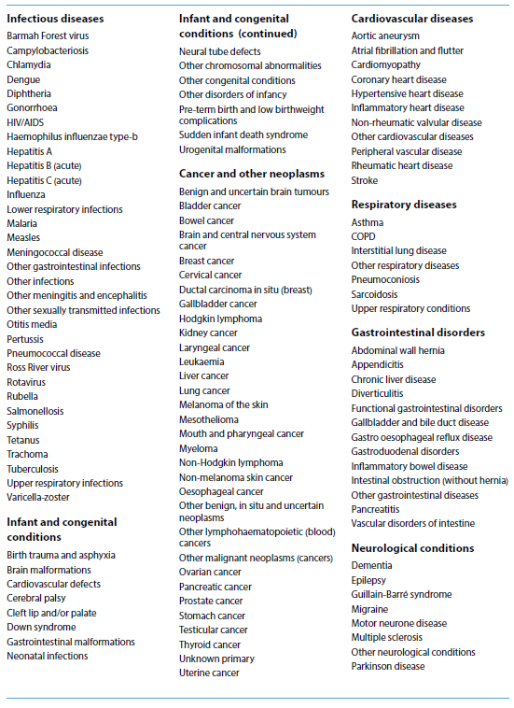

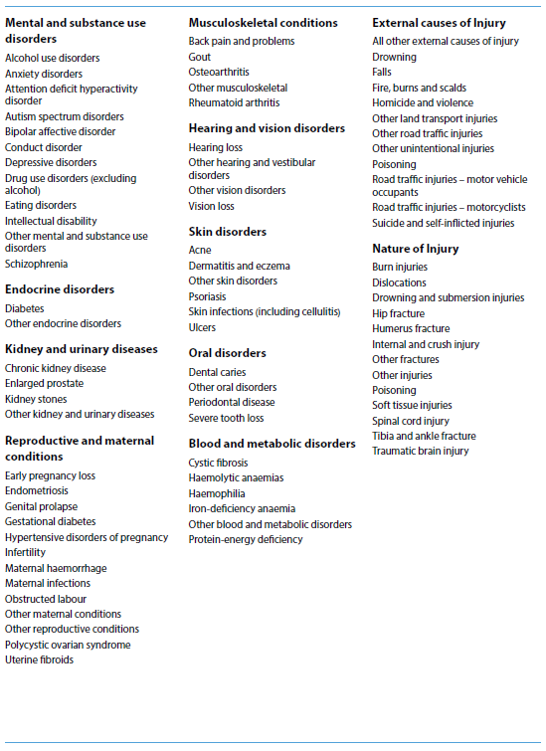

Appendix B: Chronic Disease – Mapping
Chronic Disease | SRG | Relevant ESRG
Cancer & Other Neoplasms | 12 Haematology | 039 Red Blood Cell Disorders
 |  | 040 Lymphoma and Non-Acute Leukaemia
 |  | 041 Haematological Surgery
 |  | 042 Other Haematology
 | 15 Medical Oncology | 050 Respiratory Neoplasms
 |  | 051 Digestive Malignancy
 |  | 052 Other Medical Oncology
 | 16 Chemotherapy & Radiotherapy | 053 Chemotherapy
Cardiovascular disease | 01 Cardiology | 001 Chest Pain
 |  | 002 Unstable Angina
 |  | 003 Heart Failure and Shock
 |  | 004 AMI W/O Invasive Cardiac Inves Proc
 |  | 005 Other Cardiology
 | 02 Interventional Cardiology | 006 Percutaneous Coronary Angioplasty W AMI
 |  | 007 Percutaneous Coronary Angioplasty W/O AMI
 |  | 008 Invasive Cardiac Inves Proc
 |  | 009 Other Interventional Cardiology
Hearing & Vision disorders | 14 Ophthalmology | 049 Non-procedural Ophthalmology
Injuries | 27 General Surgery | 090 OR Procedures for injuries
 |  | 091 Injuries - Non-surgical
 | 35 Burns | 117 Extensive Burns, Medical
 |  | 118 Extensive Burns, Surgical
Mental Health & Substance Abuse | 36 Psychiatry | 119 Major Psychiatric Disorder
 |  | 120 Other Psychiatry
 | 37 Drug & Alcohol | 121 Drug & Alcohol
Musculoskeletal conditions | 17 Rheumatology | 054 Rheumatology
 | 23 Orthopaedics | 069 Non-surgical Back and Neck Problems
 |  | 070 Other Orthopaedics - Non-Surgical
Chronic Disease | SRG | Relevant ESRG
Neurological conditions | 07 Neurology | 023 Dementia, Delirium and Non-traumatic Stupor/Coma
 |  | 024 Stroke
 |  | 025 TIA
 |  | 026 Seizures
 |  | 027 Headache
 |  | 028 Other Neurology
Oral disorders | 20 Dentistry | 058 Dental Extractions and Restorations
 |  | 059 Dental and Oral Disease excluding Extractions
Respiratory diseases | 04 Respiratory Medicine | 012 Bronchitis and Asthma
 |  | 013 Chronic Obstructive Airways Disease
 |  | 014 Respiratory Infections/Inflammations
 |  | 015 Sleep Apnoea
 |  | 016 Other Respiratory Medicine
Endocrine Conditions (Diabetes) | 09 Endocrinology | 034 Diabetes

Definition:
Chargeable_Status | (All)
Age_Group | (All)
Stay_Type | (All)
ComplexSurg | (All)
Hospital_Type | Public
Place_of_Treatment | (RHH, LGH, NWRH)
ED_Flag | (All)
SSU_Flag | (All)
Multiple_Morbidity | (All)
Place_of_Residence (SA3)  Rural Hospitals | (All)  (All)

Appendix C: List of Hospitals (purchase activity)
List of Major Acute Hospitals

Royal Hobart Hospital
Launceston General Hospital
North West Regional Hospital
Mersey Community Hospital
List of Rural Inpatient Facilities

St Helens District Hospital
St Mary’s Hospital
Smithton District Hospital
New Norfolk District Hospital
North Eastern Soldiers Memorial Hospital - Scottsdale
Flinders Island MPC
George Town Hospital
King Island MPC
Deloraine District Hospital
Campbell Town Hospital
Midlands MPC –Oatlands
HealthWest-West Coast District Hospital
Beaconsfield District Hospital

As reflected in the Tasmanian Health Organisations Act 2011, section 3 http://www.austlii.edu.au/au/legis/tas/num_act/thoa201151o2011346/s3.html

