Tasmanian Acute Public Hospitals
Healthcare Associated Infection Surveillance Annual Report 2020
Tasmanian Acute Public Hospitals Healthcare Associated Infection Surveillance Annual Report 2020
Department of Health, Tasmania
Published 2021
Copyright—Department of Health, Tasmania
Permission to copy is granted provided the source is acknowledged
Authors
- Ms Fiona Wilson, Nurse Manager, TIPCU
- Dr Alison Ratcliff, Specialist Medical Advisor, TIPCU
- Dr Tara Anderson, Infectious Diseases Physician and Clinical Microbiologist
- Ms Juanita Watson, Clinical Nurse Consultant, TIPCU
- Mr Raul Cox, Clinical Nurse Consultant, TIPCU
Suggested reference: Wilson, F., Ratcliff, A., Anderson, T., Watson, J., Cox, R. (2021). Tasmanian Acute Public Hospitals Healthcare Associated Infection Annual Report 2020. Hobart: Department of Health.
Reviewed and approved by the:
- Tasmanian Health Service - Executive Director of Nursing North, Executive Director of Nursing North West, Nursing Director South – Critical Care, Clinical Support and Investigations
- Tasmanian Department of Health - Director of Public Health
Notes
Data are subject to ongoing revision so data from previous reports should not be relied upon. Use the most up to date report when citing data.

Contents
Executive summary 6
Staphylococcus aureus bacteraemia 7
Tasmanian rates 7
Hospital rates 8
HCA SAB according to methicillin susceptibility 9
Categorisation of HCA SAB related to source 10
Community associated SAB 12
Clostridioides difficile infection 13
Tasmanian rates 13
Hospital rates – by calendar year 14
Vancomycin resistant enterococci 15
VRE genotypes 16
VRE screening effort 19
Critical Antimicrobial Resistances 20
Carbapenemase-producing Enterobacterales identified in Tasmania 2019 - 2020 20
Hand Hygiene 21
Tasmanian rates 21
Hand hygiene compliance 2020 22
Antibiotic use surveillance 27
Antimicrobial use in District and rural hospitals 31
AUTasRH 2020 results 31
Acknowledgements 32
Appendix 1 33
Explanatory notes 33
Appendix 2 36
Healthcare associated Staphylococcus aureus bacteraemia (SAB) 36
Clostridioides difficile infection (CDI) 38
Vancomycin resistant enterococci (VRE) 40
Appendix 3 42
AUTasRH 2020 results 42

Index of figures and tables
Figure 1 Healthcare associated Staphylococcus aureus bacteraemia rate calendar year 7
Figure 2 Healthcare associated Staphylococcus aureus bacteraemia – individual hospital rate 8
Figure 3 Healthcare associated MSSA and MRSA SAB – number by calendar year 9
Figure 4 Classification of HCA SAB by calendar year 10
Figure 5 Community associated CA-SAB - number and incidence by calendar year 12
Figure 6 Community associated CA-SAB – number of MSSA and MRSA by calendar year 12
Figure 7 Larger acute public hospital identified CDI and HCA-HCF CDI – rates by calendar year 13
Figure 8 Hospital identified CDI by calendar year 14
Figure 9 HCA-HCF CDI by calendar year 14
Figure 10 First VRE isolates – classification by calendar year 15
Figure 11 presents the genotypes of all new isolates identified within Tasmania by calendar year. 16
Figure 12 VRE at RHH – genotype by calendar year 16
Figure 13 VRE at LGH – genotype by calendar year 17
Figure 14 VRE at MCH – genotype by calendar year 17
Figure 15 VRE at NWRH – genotype by calendar year 18
Figure 16 Hand hygiene compliance 2010 – 2020 21
Figure 17 Hand hygiene compliance by moment – 2020 22
Figure 18 Hand hygiene compliance 2020 – larger Tasmanian acute public hospitals 24
Figure 19 Cephalosporin use 28
Figure 20 Fluoroquinolone use 28
Figure 21 Piperacillin - tazobactam use 29
Figure 22 Vancomycin use 29
Figure 23 Carbapenem use 30
Figure 24 Linezolid use 30

Table 1 Types of intravascular devices related to HCA SAB 10
Table 2 Proportion of VRE positives from screening specimens 19
Table 3 Characteristics of the cases of CPE identified in Tasmania in 2019 and 2020 20
Table 4 Compliance by healthcare worker category - 2020 23
Table 5 Hand hygiene compliance rates by Tasmanian public hospitals 25
Table 6 Hand hygiene compliance rates by Tasmanian satellite renal unit 2020 26
Table 7 Tasmanian public hospital numbers and rate per 10 000 patient days of HCA-SAB 36
Table 8 Royal Hobart Hospital numbers and rates per10 000 patient days of HCA-SAB 36
Table 9 Launceston General Hospital numbers and rates per10 000 patient days of HCA-SAB 37
Table 10 Mersey Community Hospital numbers and rates per10 000 patient days of HCA-SAB 37
Table 11 North West Regional Hospital numbers and rates per10 000 patient days of HCA-SAB 38
Table 12 Tasmanian numbers and rates per10 000 patient days of CDI 38
Table 13 Hospital numbers and rates per10 000 patient days of hospital identified CDI 39
Table 14 Hospital numbers and rates per10 000 patient days of HCA-HCF CDI 39
Table 15 First VRE isolates identified per quarter 40
Table 16 Classification of first VRE isolates – colonisation and infection 40
Table 17 First VRE isolates by genotype by quarter 41
Table 18 Comparison of the last 5 years of Tasmanian District and Rural Facility NAPS data 42
Table 19 Comparison of the last five years of indications for use 42
Table 20 Comparison of the last five years for commonest antimicrobials prescribed 43

Executive summary
This report provides an overview of the Tasmanian acute public hospitals’ healthcare associated infection surveillance for the calendar years 2016 – 2020 with a focus on 2019 and 2020. The report focuses on data for the four larger acute public hospitals – Royal Hobart Hospital (RHH), Launceston General Hospital (LGH), Mersey Community Hospital (MCH) and the North West Regional Hospital (NWRH) but also includes some District and rural hospital and community surveillance data.
Details of the surveillance program, including the rationale for the indicators measured and the methodologies used in data collection, validation and analysis are available at the TIPCU website (www.health.tas.gov.au/tipcu). Any form of comparison between hospitals should be done with caution because data are not adjusted for patient characteristics that vary between hospitals. Further, the relatively small Tasmanian population and small number of events can result in volatility of rates from time to time. The raw data in the appendices illustrate this.
This report contains the following findings for 2019 - 2020:
- The rate of healthcare associated Staphylococcus aureus bacteraemia (HCA SAB) to June 2020 for each of the larger acute public hospitals met the then National Healthcare Agreement target of no more than two HCA SAB per 10 000 patient days. The rate of HCA SAB for RHH, LGH and NWRH from June to December 2020 was less than the new National Healthcare Agreement target of no more than one HCA SAB per10 000 patient days while MCH slightly exceeded the new target with a rate of 1.1.
- The rate of ‘hospital identified Clostridioides difficile infection (CDI)’ for the larger acute public hospitals increased slightly in 2020 over 2019 while healthcare associated-healthcare facility onset (HCA-HCF) CDI remained stable over the same time period.
- The number of new isolates of vancomycin resistant enterococcus (VRE) in 2019 was significantly less than in 2018 with a further reduction occurring in 2020.
- There were three cases of carbapenemase-producing Enterobacterales (CPE) notified in 2019 and two in 2020.
- The consolidated Tasmanian public hospital hand hygiene compliance rate in 2019 and 2020 remains above the National Hand Hygiene Benchmark (NHHB) of 80 per cent.
- Antimicrobial use has been relatively stable amongst the larger acute public hospitals although the use of selected antimicrobial agents is higher than national comparator rates.
- Appropriate antimicrobial use in District and rural hospitals has improved.
Staphylococcus aureus bacteraemia
Staphylococcus aureus, a common cause of serious healthcare associated bloodstream infection (bacteraemia), may cause significant patient morbidity and mortality.
Many healthcare associated Staphylococcus aureus bacteraemias (SAB) are preventable. SAB was made notifiable in Tasmania in 2008 pursuant to the Public Health Act 1997. Tasmania was the first Australian jurisdiction to introduce this measure to capture SAB data.
SAB surveillance is carried out in Tasmania using the national surveillance definitions published by the Australian Commission on Safety and Quality in Health Care (ACSQHC).
Under this definition a SAB is defined as healthcare associated (HCA) if the patient’s first SAB positive blood culture was collected either >48 hours after hospital admission or <48 hours after discharge (Criterion A) OR ≤48 hours after hospital admission and one or more of four key clinical healthcare related criteria was met (Criterion B).
The National Healthcare Agreement (2019) target was no more than two HCA SAB per10 000 patient days for acute care public hospitals. The Australian Health Ministers’ Advisory Council (AHMAC) endorsed a new national benchmark of no more than 1.0 HCA SAB per 10 000 patient days and this has been implemented in Tasmania from 1 July 2020.

Tasmanian rates
Figure 1 presents the combined Tasmanian larger acute public hospital (RHH, LGH, NWRH and MCH combined) rate of HCA SAB by calendar year.
Figure 1 Healthcare associated Staphylococcus aureus bacteraemia rate by calendar year
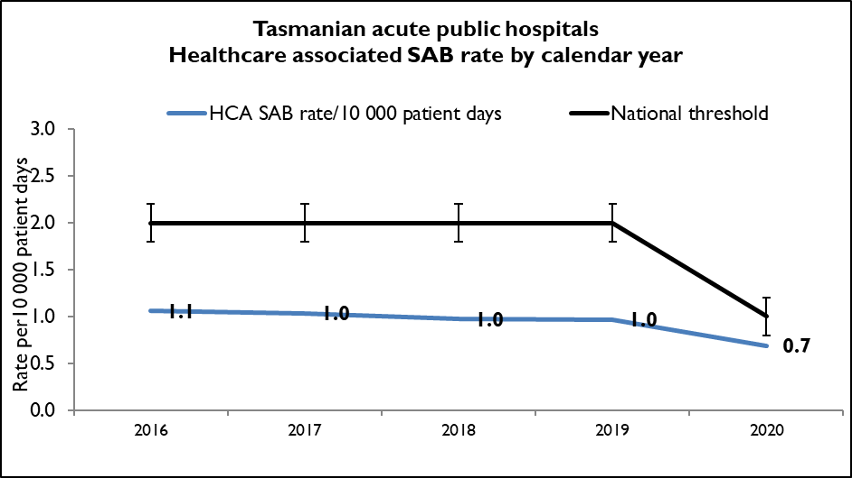
There were 27 cases of HCA SAB across the larger acute public hospitals in 2020. This corresponded to a combined Tasmanian larger acute public hospital rate of HCA SAB of 0.7 per 10 000 patient days (95% CI 0.4 –0.9). The annual rate of HCA SAB has remained stable at around 1.0 per 10 000 patient days for the past five years. This number and rate of HCA SAB in 2020 is the lowest since 2018 and a substantial decrease compared with the previous 5 years. This decrease may be related to the COVID-19 pandemic effects on hospital activity, improvements in hand hygiene, improvements in aseptic technique, or a combination of these factors.

Hospital rates
Figure 2 presents the individual larger acute public hospitals rates of HCA SAB by calendar year.
Figure 2 Healthcare associated Staphylococcus aureus bacteraemia – individual hospital rate by calendar year

The annual HCA SAB rate for all individual larger acute public hospitals up to June 2020 was less than the National Healthcare Agreement target of no more than two HCA SAB per10 000 patient days.
The rate of HCA SAB for RHH, LGH and NWRH from June to December 2020 was less than the new National Healthcare Agreement target of no more than one HCA SAB per10 000 patient days. MCH was just over the new target with a rate of 1.1which represents 2 HCA SAB for the six-month period.

HCA SAB according to methicillin susceptibility
Figure 3 presents the larger acute public hospitals HCA SAB according to methicillin susceptibility; methicillin sensitive Staphylococcus aureus (HCA MSSA) and methicillin resistant Staphylococcus aureus (HCA MRSA) by calendar year.
Figure 3 Healthcare associated MSSA and MRSA SAB – number by calendar year
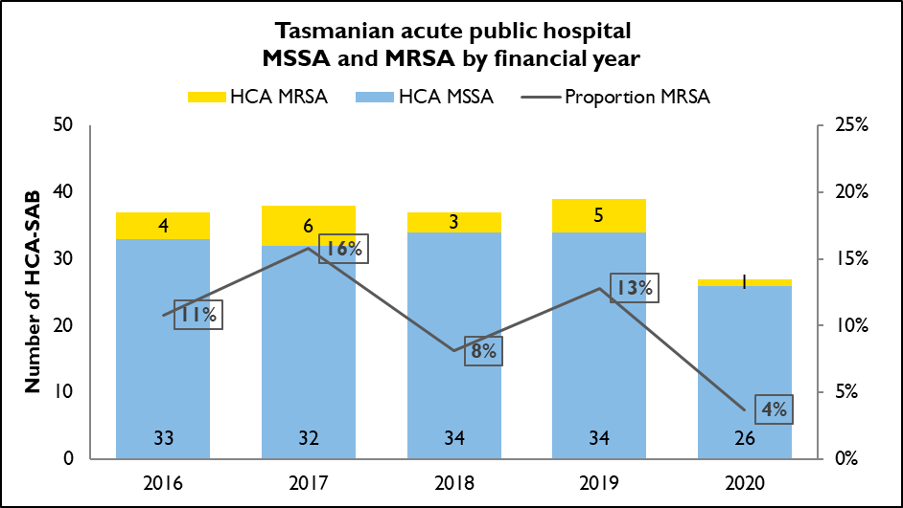
The majority of HCA SAB are methicillin sensitive with the total annual number of MRSA HCA SAB events remaining relatively stable over the past five years.

Categorisation of HCA SAB related to source
The larger acute public hospital HCA SABs are classified where possible into four categories: SAB related to an indwelling medical device, a surgical site, invasive instrumentation or cytotoxic therapy induced neutropenia. Indwelling medical devices are further classified into central venous catheter (CVC) related, other intravascular (IV) device related and non-IV device related. Figure 4 presents this data over the past five years and includes the total percentage of HCA SAB that are related to IV devices. Table 1 presents the different types of IV devices that have been identified as the source of the HCA SAB over the same time period.
Figure 4 Classification of HCA SAB by calendar year
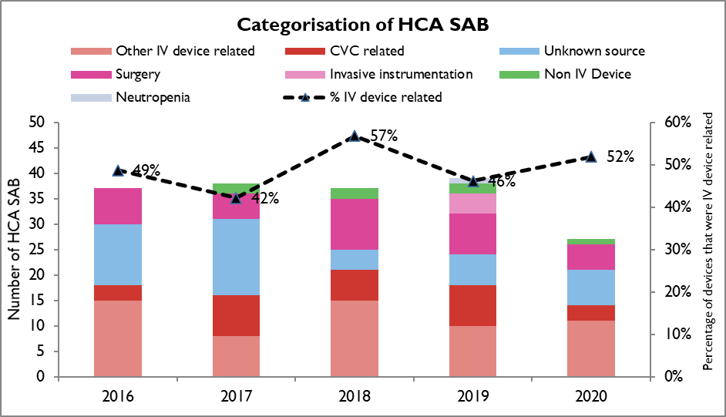
Table 1 Types of intravascular devices related to HCA SAB
 | Central venous catheter | Peripheral intravenous catheter | Intra-arterial catheter | Arterio-venous fistula | Not specified | TOTAL
2016 | 3 (17%) | 8 (44%) | - | 1 (6%) | 6 (33%) | 18
2017 | 8 (50%) | 5 (31%) | - | - | 3 (19%) | 16
2018 | 6 (28%) | 13 (62%) | 1 (5%) | - | 1 (5%) | 21
2019 | 8 (44%) | 9 (50%) | - | 1 (6%) |  | 18
2020 | 3 (21%) | 11 (79%) | - | - | - | 14

Fifty two percent of the larger acute public hospital HCA SAB were related to an IV device in 2020 which represents 14 IV device related HCA SAB. This is a decrease in number but a slight increase in the proportion over 2019. However, there has not been a sustained decrease in the number and rate of these infections over the past five years. Seventy nine percent of these IV device related HCA SAB were related to peripheral IV devices.
Data from the past three years is the most accurate in terms of the number of peripheral IV device related SAB given changes in surveillance processes. It is likely that many, if not all, of the ‘not specified IV devices in previous years were related to peripheral IV devices. In the past three years the majority of IV device related HCA SAB have been related to peripheral IVs.
Infection prevention strategies such as intravenous device management procedures and processes in conjunction with the ACSQHC ‘Management of Peripheral Intravenous Catheters Clinical Care Standard’, can reduce the risk of patients developing a SAB secondary to an IV device. These strategies should be implemented and evaluated in all healthcare settings where IV devices are used.

Community associated SAB
Figure 5 presents the Tasmanian number and incidence/100 000 population of community associated SAB (CA-SAB) by calendar year and Figure 6 presents CA SAB numbers according to antibiotic susceptibility - methicillin sensitive Staphylococcus aureus (MSSA) and methicillin resistant Staphylococcus aureus (MRSA).
Figure 5 Community associated CA-SAB - number and incidence by calendar year
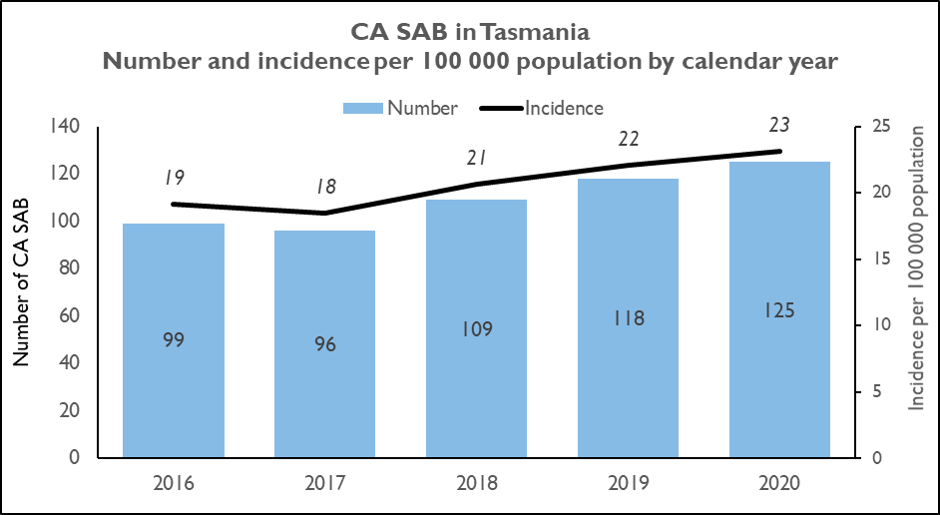
Figure 6 Community associated CA-SAB – number of MSSA and MRSA by calendar year
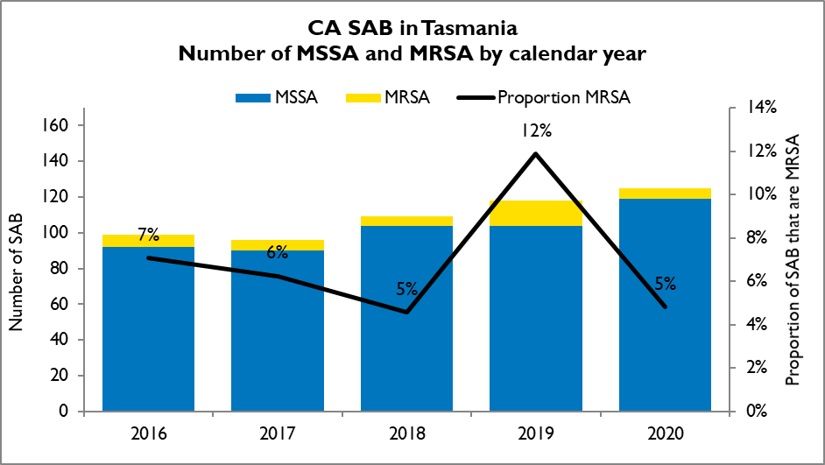
There were three times as many CA-SAB than HCA SAB reported in Tasmania, with the majority of CA-SAB being caused by MSSA.

Clostridioides difficile infection
Clostridioides difficile infection (CDI) is a bowel infection caused by the bacterium Clostridioides difficile and is a common cause of healthcare associated diarrhoea. CDI causes significant patient morbidity and mortality and can result in increased hospital stays and costs. Factors that may contribute to higher CDI rates include the overuse of antibiotics and ineffective infection control processes including suboptimal environmental cleanliness.
Surveillance of CDI in Tasmania uses the ACSQHC’s national surveillance definitions. There is no National benchmark for CDI and it is not a notifiable condition in Tasmania.
Hospital identified CDI are CDI infections identified in a hospital irrespective of attribution of infection.
Healthcare associated – healthcare facility onset (HCA-HCF) CDI are a sub-group of hospital identified cases. This category only includes infections that occurred 48 hours or more after a patient was admitted to hospital. The HCA-HCF rate excludes people who present to hospital with symptoms of CDI and/or develop symptoms within two days of admission.

Tasmanian rates
Figure 7 presents the Tasmanian combined larger acute public hospital rates of hospital identified CDI and HCA-HCF CDI by calendar year.
Figure 7 Larger acute public hospital identified CDI and HCA-HCF CDI – rates by calendar year
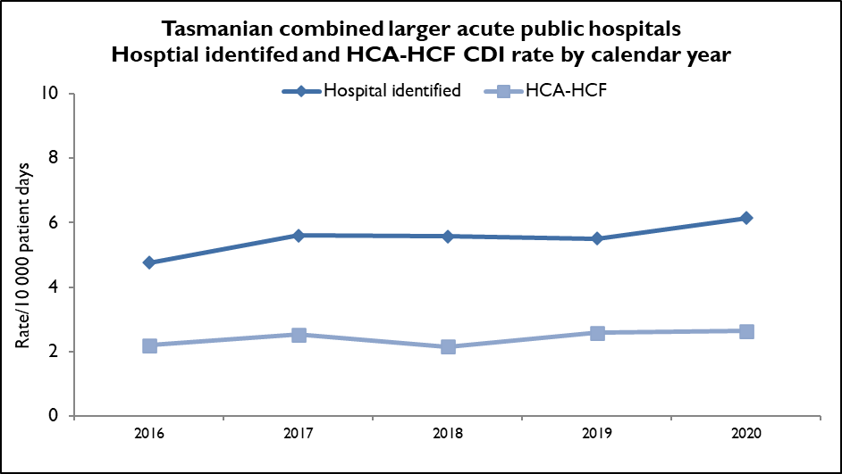
The mean (average) rate of hospital identified CDI for 2020 was 6.1 per 10 000 patient days (95% CI 5.3 – 6.9) and the mean rate of HCA-HCF CDI over the same period was 2.6 per 10 000 patient days (95% CI 2.1 – 3.2). The number and rate of hospital identified CDI has increased slightly over the past four years. The annual number and rate of HCA-HCF CDI has remained stable over the past two years after the slight decreases seen in 2018.

Hospital rates – by calendar year
Figure 8 and 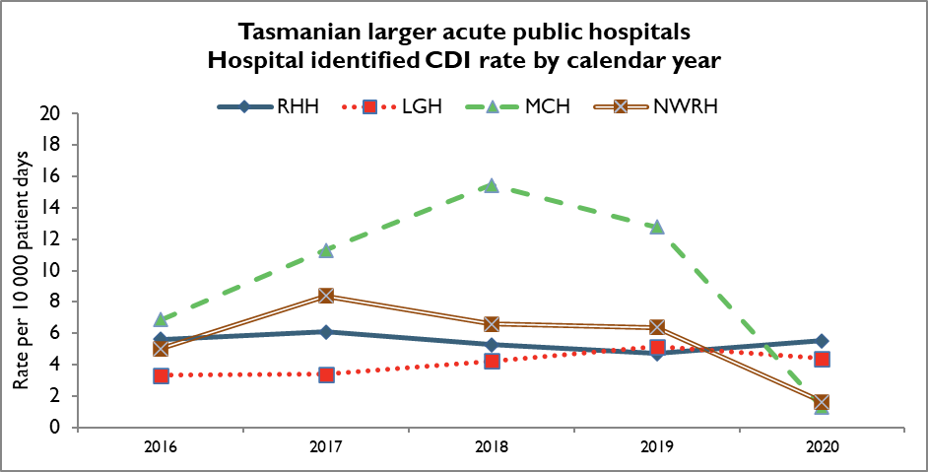
Figure 9 presents the individual larger acute public hospital rates of hospital identified CDI, and healthcare associated – healthcare facility onset (HCA-HCF) CDI by calendar year.
Figure 8 Hospital identified CDI by calendar year
Figure 9 HCA-HCF CDI by calendar year
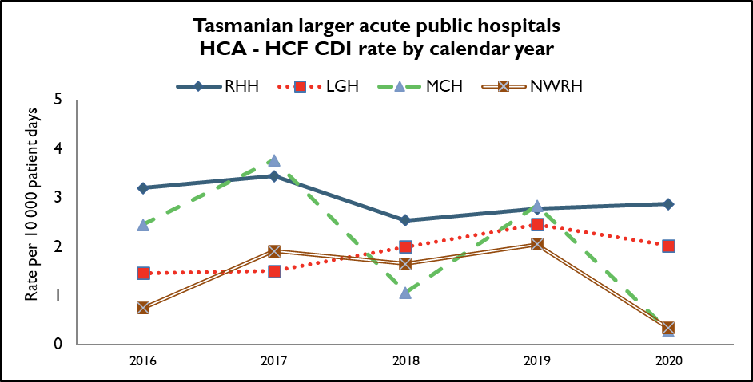
LGH, MCH and NWRH demonstrated a downward trend in hospital identified CDI in 2019 – 20. MCH and NWRH experienced a particularly sharp downward trend in 2020 which can possibly be explained by the closure of the hospital (NWRH) and the MCH Emergency Department for a period of time in 2020 related to the COVID-19 outbreak in the NW of the State. The annual number and rates of HCA-HCF have remained stable at RHH and LGH while MCH and NWRH experienced large decreases, again possibly due to the hospital closures for a period in 2020.

Vancomycin resistant enterococci
Enterococci are bacteria normally present in the human gastrointestinal and female genital tract and can cause infections of the urinary tract, bloodstream and wounds. Enterococci that have acquired resistance to the antibiotic vancomycin are called vancomycin-resistant enterococci or VRE. VRE infections can be more difficult to treat then those caused by vancomycin sensitive enterococci.
Factors that can contribute to the transmission of VRE in hospitals are inadequate infection control practices including suboptimal environmental cleanliness and overuse of antibiotics.
Identification of VRE is notifiable in Tasmania pursuant to the Public Health Act 1997.
Figure 10 presents all patients with a first VRE isolate identified within Tasmania by calendar year for the past five years. These numbers include all new patients identified within Tasmania from public and private hospitals, District and rural hospitals, GP clinics and long term and residential care facilities. A person’s first VRE isolate is classified according to whether it is a screening or a clinical specimen.
The identification of VRE colonisation or infection in particular hospitals does not necessarily reflect that VRE was acquired at that hospital. The numbers of VRE isolates identified can be affected by the amount of screening undertaken by hospitals and those that have an intensive screening program are likely to identify more VRE

Figure 10 First VRE isolates – classification by calendar year
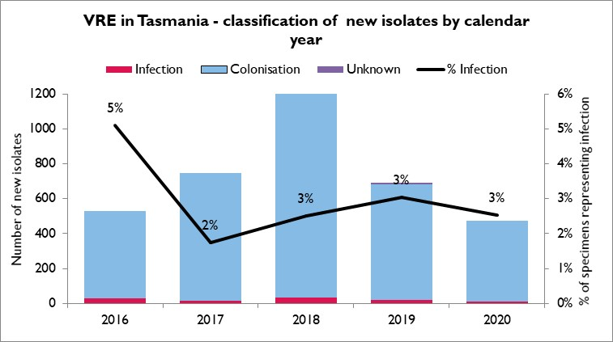
The number of new VRE identified in 2019 were around half the number identified in 2018 and the decrease continued in 2020. Most first VRE isolates continue to reflect colonisation rather than infection. The proportion of isolates that represent infections has remained stable over the last four years with infections representing around three per cent of total first VRE isolates.

VRE genotypes
Figure 11 presents the genotypes of all new isolates identified within Tasmania by calendar year.
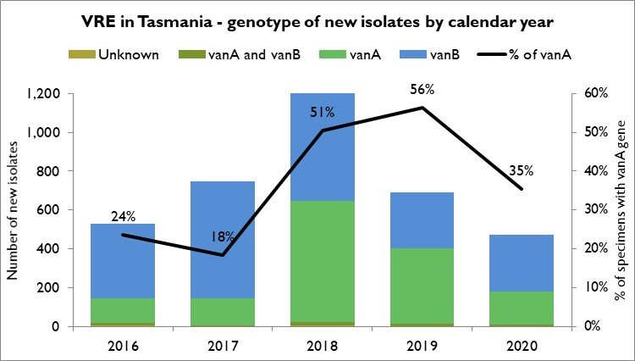
This figure illustrates the change in the epidemiology of VRE genotypes over the past three calendar years with a marked increase in the proportion of vanA genotype being identified with this genotype representing more than half of the total new isolates in 2018 and 2019. The proportion of vanA genotype decreased in 2020.
Figure 12 - Figure 15 inclusive presents the number of new VRE isolates identified at RHH, LGH, MCH and NWRH per calendar year according to genotype.
Figure 12 VRE at RHH – genotype by calendar year
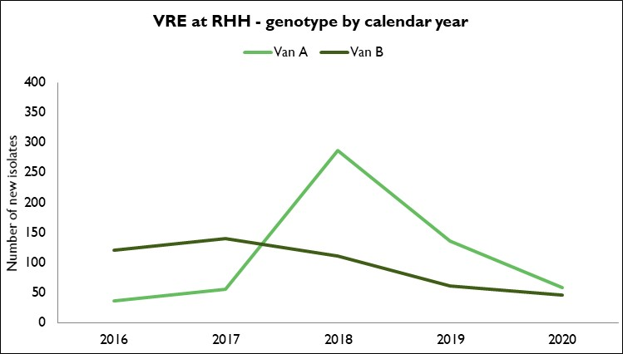
Figure 13 VRE at LGH – genotype by calendar year
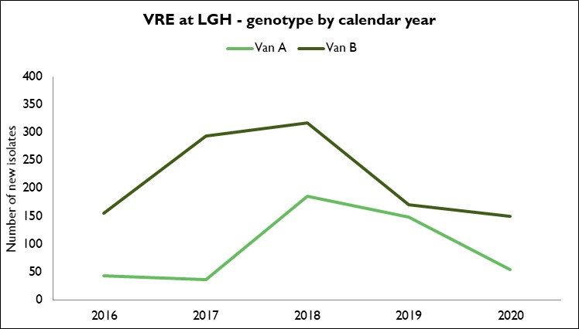

Figure 14 VRE at MCH – genotype by calendar year
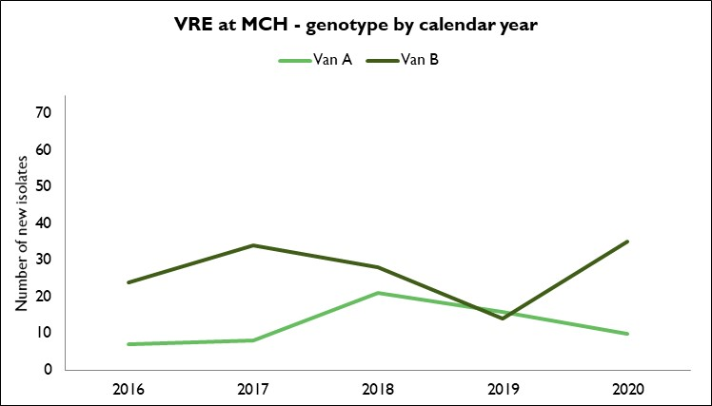

Figure 15 VRE at NWRH – genotype by calendar year
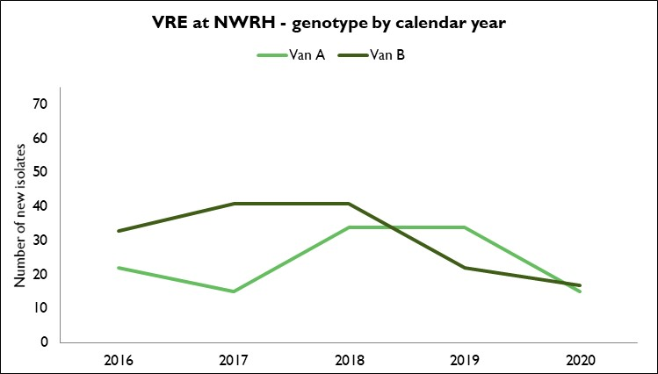
These figures illustrate the difference in epidemiology between the four larger acute public hospitals. All hospitals had an increase in vanA genotype commencing in 2017 with this genotype becoming the dominant genotype at RHH and NWRH during 2018 and 2019 although the number of patients with the vanA genotype has decreased at both these sites in 2020.

VRE screening effort
Table 2 presents the VRE screening effort across the four larger acute public hospitals, demonstrating the numbers of screening specimens tested, the number and percentage of these specimens that have cultured VRE.
Table 2 Proportion of VRE positives from screening specimens
 | RHH |  | LGH |  | MCH |  | NWRH
 | Screening specimens tested | Positive specimens | Screening specimens tested | Positive specimens | Screening specimens tested | Positive specimens | Screening specimens tested | Positive specimens
2014 | 1962 | 12 (0.6%) | 353 | 25 (7%) | 544 | 8 (1%) | 893 | 11 (1%)
2015 | 2077 | 91 (4%) | 586 | 52 (9%) | 404 | 17 (4%) | 962 | 31 (3%)
2016 | 3863 | 182 (5%) | 1672 | 212 (13%) | 426 | 41 (10%) | 1094 | 66 (6%)
2017 | 4906 | 284 (6%) | 2564 | 289 (11%) | 571 | 66 (12%) | 1269 | 88 (7%)
2018 | 6641 | 738 (11%) | 4091 | 576 (14%) | 622 | 90 (14%) | 2015 | 195 (10%)
2019 | 7532 | 507 (7%) | 3831 | 274 (7%) | 733 | 80 (11%) | 1964 | 124 (6%)
2020 | 5942 | 225 (4%) | 3105 | 308 (10%) | 846 | 81 (9%) | 1726 | 85 (5%)

The volume of VRE screening decreased in 2020 at the RHH, LGH and NWRH while it continued to increase at MCH. The proportion of positives from the screening specimens reduced across all four sites in 2019 with only LGH having a small increase in 2020. This suggests that there is an ongoing, true reduction of VRE burden within the facilities.
These data have not been de-duplicated so there are repeat positive specimens on patients already known to have VRE included in this data set.

Critical Antimicrobial Resistances
The Antimicrobial Use and Resistance in Australia (AURA) Surveillance System integrates surveillance of antimicrobial use and antimicrobial resistance, monitoring trends and measuring the effects of interventions over time. An important element of this project is the National Alert System for Critical Antimicrobial Resistances (CARAlert). The definition (www.safetyandquality.gov.au/our-work/antimicrobial-resistance/antimicrobial-use-and-resistance-australia-surveillance-system/national-alert-system-critical-antimicrobial-resistances-caralert) of critical antimicrobial resistances (CARs) are ‘a resistance mechanism, or profile, known to be a serious threat to the effectiveness of last-line antimicrobial agents’. This alert system allows early recognition and communication of critical antimicrobial resistances (CARs) to all jurisdictions across Australia.
Please refer to the 2019 CARAlert Annual Report and the 2020 CARAlert Annual Report for further details (www.safetyandquality.gov.au/publications-and-resources/resource-library?resource_search=CARAlert+Annual+Report).

Carbapenemase-producing Enterobacterales identified in Tasmania 2019 - 2020
Carbapenem resistance in Enterobacterales is an emerging clinical and public health problem that threatens the effectiveness of an important antibiotic group – carbapenems – that are highly active against multi-drug resistant Gram-negative organisms.
The epidemiology of carbapenemase-producing Enterobacterales (CPE) varies between countries and it is evident that without active surveillance and subsequent stringent infection control measures these organisms may rapidly become endemic. In areas where few CPE cases have occurred, it is recommended that health departments take an aggressive approach to contain CPE.
With current low prevalence rates, surveillance through mandatory laboratory notification creates an opportunity for proactive measures to prevent, detect and contain CPE within Tasmania.
Identification of CPE was made notifiable in Tasmania pursuant to the Public Health Act 1997 in 2016. CPE are also captured within the National Alert System for Critical Antimicrobial Resistances (CARAlert).
Table 3 Characteristics of the cases of CPE identified in Tasmania in 2019 and 2020
Year | Organism | CAR | Specimen type | Risk factors
2019 | K. pneumoniae | KPC producer | Screening - colonisation | Inpatient in overseas healthcare facility within the previous 12 months
2019 | K. pneumoniae | OXA-48-like | Clinical - infection | Inpatient in overseas healthcare facility within the previous 12 months
2019 | K. pneumoniae | KPC producer | Clinical – colonisation | Non identified
2020 | P. aeruginosa | NDM | Clinical – colonisation | Overseas travel and antimicrobial treatment within the previous 12 months
2020 | K. pneumoniae | IMP | Screening – colonisation | Unknown
2020 | K. pneumoniae | NDM | Clinical - colonisation | Had K. pneumoniae OXA-48 like identified in 2019 but new resistance gene identified so new CARalert generated
The three patients identified in 2019 were public hospital inpatients and the two in 2020 were public hospital outpatients. All had the recommended infection prevention precautions in place either from admission to hospital or when the CPE was identified. No transmission of CPE from these patients to other hospital patients has been identified.

Hand Hygiene
The National Hand Hygiene Initiative (NHHI) was introduced in Tasmania in 2009 to increase healthcare workers’ hand hygiene compliance and monitor its effectiveness by measuring reductions in HCA SAB.
Following a review of the NHHI in 2019, the ACSQHC took over the coordination and support of the program from Hand Hygiene Australia who had been contracted since 2008. The ACSQHC is continuing to review and refine aspects of the NHHI.
Hand hygiene compliance is the established outcome for assessing the effectiveness of a hand hygiene program within facilities participating in the NHHI. Compliance auditing is conducted by direct observation of healthcare workers performing hand hygiene at the appropriate times. Auditing occurs continuously across three audit periods per year. The NHHI benchmark (NHHB) is ≥80 per cent for total moments, individual moments and each healthcare worker group.
In 2020, data submission for Audit 2 2020 was not required by the NHHI due to the need for health services to direct significant resources in response to the COVID-19 pandemic. Facilities were able to submit data if they wished and the results of the audits were available to inform improvements in compliance.

Tasmanian rates
Figure 16 illustrates the compliance rate of all Tasmanian public healthcare facilities over time.
Figure 16 Hand hygiene compliance 2010 – 2020
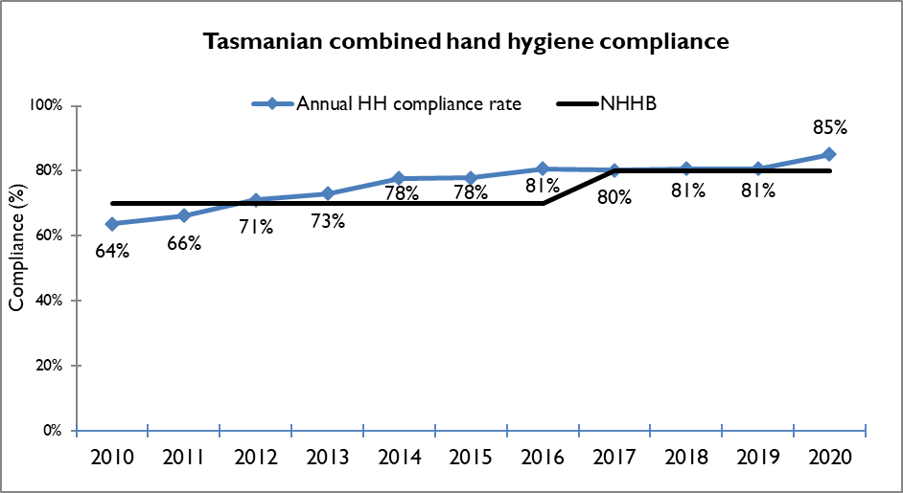
This graph presents the combined hand hygiene compliance rate of all Tasmanian public healthcare facilities participating in the NHHI. Eleven facilities submitted data for the non-mandatory Audit 2, 2020. The number of hand hygiene moments collected was approximately two and half times less than the previous audit period. Nationally, less than two-thirds of hospitals supplied hand hygiene compliance data for this audit period. The Tasmanian hand hygiene compliance rate has remained stable since 2017, with an increase to 85 per cent in 2020.

Hand hygiene compliance 2020
The following figures and tables present hand hygiene compliance data for each of the three audit periods in 2020.
Figure 17 Hand hygiene compliance by moment – 2020
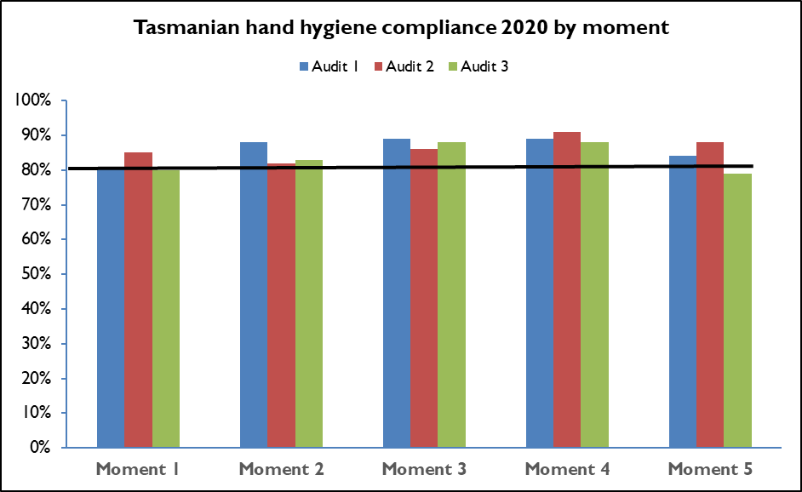
Moment 1 and Moment 2 are key opportunities for hand hygiene that may have a direct effect on the risk of transmission of pathogens within the healthcare setting. Moment 2, particularly relates to compliance with appropriate aseptic technique and procedural activity.
In 2020, compliance with Moments 1, 4 and 5 increased during Audit 2 (April to June 2020) while it decreased for Moments 2 and 3. This period coincides with the COVID-19 outbreak in the North West of Tasmania, when the health system was under considerable stress. In Audit 3 2020, compliance across all Moments returned to their previous levels from Audit 1 2020, or below. This suggests that health care worker hand hygiene behaviour during Audit 2 may have been influenced by the COVID - 19 pandemic. Interestingly, an increase across all Moments was not observed during 2020 despite the need for greater infection prevention behaviours while the health system and community responded to the pandemic.

Table 4 Compliance by healthcare worker category - 2020

 | Audit 1 |  |  | Audit 2 |  |  | Audit 3
 | HH performed correctly | HH Moments | Compliance | HH performed correctly | HH Moments | Compliance | HH performed correctly | HH Moments | Compliance
Clerical | 11 | 11 | 100% | 3 | 3 | 100% | 8 | 12 | 67%
Allied Health | 186 | 223 | 83% | 73 | 84 | 87% | 222 | 275 | 81%
Domestic | 156 | 172 | 91% | 71 | 81 | 88% | 132 | 185 | 71%
Invasive Technician | 76 | 92 | 83% | 43 | 48 | 90% | 94 | 116 | 81%
Doctor | 707 | 912 | 78% | 305 | 386 | 79% | 728 | 950 | 77%
Nurse/Midwife | 5032 | 5742 | 88% | 2021 | 2272 | 89% | 4989 | 5847 | 85%
Other | 13 | 13 | 100% | 1 | 2 | 50% | 10 | 11 | 91%
Personal Care Staff | 292 | 352 | 83% | 111 | 133 | 83% | 273 | 328 | 83%
Student Doctor | 30 | 35 | 86% | 12 | 12 | 100% | 41 | 51 | 80%
Student Nurse/Midwife | 221 | 270 | 82% | 24 | 31 | 77% | 274 | 340 | 81%
Student Allied Health | 0 | 0 | 0% | 0 | 0 | 0% | 1 | 1 | 100%
Ambulance Worker | 12 | 21 | 57% | 0 | 0 | 0% | 0 | 7 | 0%
TOTAL | 6736 | 7843 | 86% | 2664 | 3052 | 87% | 6772 | 8123 | 83%

The number of hand hygiene moments observed between the different healthcare worker groups varies. Most are collected from nurses/midwives with the next highest being from medical practitioners.
There are a number of healthcare worker groups – clerical, invasive technician, student doctor, student allied healthcare worker, ambulance worker and other – that contribute one per cent or less of the total hand hygiene moments per audit period thus their results should be interpreted with caution.
Despite not meeting the NHHB for any audit period in 2020, doctors hand hygiene compliance remains stable with no dramatic decrease. Domestic staff did not meet the NHHB in Audit period 3.

Figure 18 Hand hygiene compliance 2020 – larger Tasmanian acute public hospitals
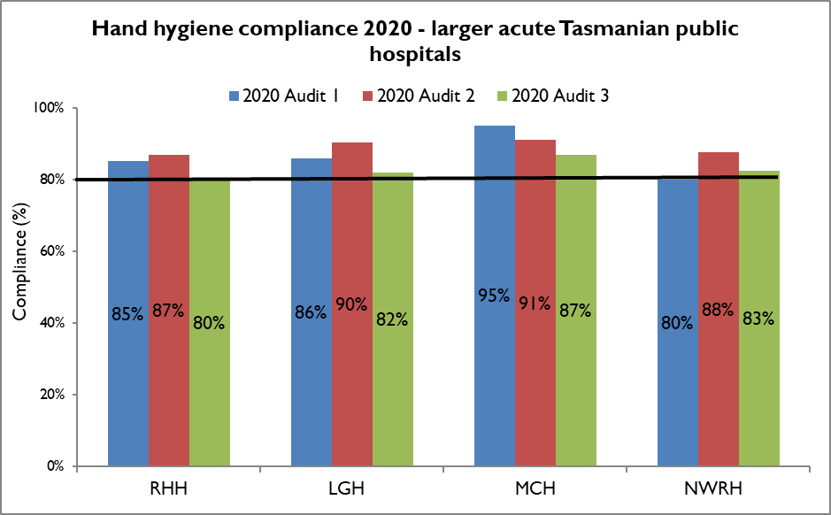
The Tasmanian combined compliance rate for 2020 was 85% and all four larger acute public hospitals consistently met or exceeded the national benchmark of 80%. This is an improvement on 2019 compliance rates where no larger acute public hospital met the national benchmark across all three audit periods.

Table 5 Hand hygiene compliance rates by Tasmanian public hospitals excluding the larger acute public hospitals 2020

 | Audit 1 |  |  | Audit 2 |  |  | Audit 3
 | HH performed correctly | HH Moments | Compliance | HH performed correctly | HH Moments | Compliance | HH performed correctly | HH Moments | Compliance
Midlands MPC | 53 | 57 | 93% | 50 | 55 | 91% | 50 | 52 | 96%
New Norfolk | 0 | 0 | 0% | 49 | 56 | 88% | 47 | 53 | 89%
Beaconsfield | 106 | 116 | 91% | 0 | 0 | 0% | 97 | 107 | 91%
Campbell Town | 99 | 103 | 96% | 0 | 0 | 0% | 109 | 114 | 96%
Deloraine | 85 | 96 | 89% | 0 | 0 | 0% | 109 | 121 | 90%
Flinders Is. MPC | 100 | 111 | 90% | 0 | 0 | 0% | 51 | 56 | 91%
George Town Hospital | 90 | 103 | 87% | 0 | 0 | 0% | 114 | 126 | 90%
NESM Scottsdale | 92 | 105 | 88% | 0 | 0 | 0% | 41 | 51 | 80%
St Helens | 144 | 157 | 92% | 0 | 0 | 0% | 25 | 27 | 93%
St Marys CHC | 61 | 64 | 95% | 0 | 0 | 0% | 64 | 68 | 94%
King Island Hospital | 92 | 109 | 84% | 50 | 69 | 72% | 101 | 119 | 85%
Smithton | 0 | 0 | 0% | 8 | 9 | 89% | 47 | 51 | 92%
Healthwest | 48 | 51 | 94% | 0 | 0 | 0% | 0 | 0 | 0%
Repatriation Centre | 136 | 154 | 88% | 194 | 216 | 90% | 186 | 231 | 81%

This table presents the hand hygiene compliance at the 13 Tasmanian District and rural hospitals and the Repatriation Centre. These smaller sites are required to audit a minimum of 50 moments per audit period.
Most District and rural hospitals met the NHHB in all required audit periods in 2020, however the confidence intervals are large due to the low number of moments collected in these facilities. Two District hospitals did not meet the benchmark in audit period 1 but exceeded the benchmark in the subsequent required audit period (Audit Period 3 2020).

Table 6 Hand hygiene compliance rates by Tasmanian satellite renal unit 2020

 | Audit 1 |  |  | Audit 2 |  |  | Audit 3
 | HH performed correctly | HH Moments | Compliance | HH performed correctly | HH Moments | Compliance | HH performed correctly | HH Moments | Compliance
Nephrology South | 175 | 208 | 84% | 54 | 59 | 92% | 180 | 212 | 85%
North West Renal Unit | 188 | 202 | 93% | 12 | 25 | 48% | 185 | 200 | 93%
Kings Meadows Renal Unit | 345 | 420 | 82% | 0 | 0 | 0% | 187 | 200 | 94%

The NHHI acknowledges the high-risk nature in the dialysis setting due to repetitive invasive procedures and blood handling and recommends minimum audit requirements according to the number of procedures performed per annum. In Tasmania there are three stand-alone satellite dialysis units who are required to collect 200 moments per audit period as they perform >5000 procedures per annum.
Table 6 presents the satellite dialysis units’ compliance by audit period in 2020. All sites exceeded the benchmark in the two required audit periods.

Antibiotic use surveillance
Antimicrobial use is associated with the emergence of antimicrobial resistant bacteria. Antimicrobial resistance is a significant and growing threat to public health worldwide. The National Antimicrobial Utilisation Surveillance Program (NAUSP) began in 2004 to conduct surveillance of hospital antimicrobials, principally antibiotic use. The program enables individual institutions to examine their own antimicrobial use rates and trends over time and provides peer group benchmarks for comparison. The data can be used to identify trends in antimicrobial use over time and develop local interventions to promote appropriate antimicrobial use.
The RHH has been contributing data to the NAUSP since July 2004 while LGH, MCH and NWRH have been contributing since January 2009. The data presented in this report shows use over a two-year period until December 2020.
Antimicrobial usage rates are calculated using the number of defined daily doses (DDDs) of specific antimicrobial agents or classes consumed each month per 1000 occupied bed days (OBDs). This is a widely accepted method of measuring antimicrobial use in hospital settings both nationally and internationally.
Rates presented in this report are for six antimicrobials or antimicrobial classes: third and fourth generation cephalosporins (ceftriaxone, cefotaxime, ceftazidime, cefepime); fluoroquinolones (ciprofloxacin, moxifloxacin, norfloxacin); carbapenems (ertapenem, imipenem, meropenem); linezolid, piperacillin/tazobactam, and vancomycin. These were chosen for their relevance to other indicators in this report.
To ensure that antimicrobials remain effective for treating important infections, it is critical that antimicrobials are prescribed appropriately with consideration for antimicrobial stewardship principles to minimise overuse of certain antimicrobials or antimicrobial classes, in particular cephalosporins, fluoroquinolones, carbapenems, beta-lactamase inhibitor combinations (e.g. piperacillin/tazobactam) and vancomycin.
The graphs show the use of the antimicrobial class or specific antimicrobial in each of the larger acute public hospitals. TIPCU use a three-point rolling average to calculate the average rate of the current, and two previous months, and uses this to show trends over time. Tasmanian hospitals vary in services provided so comparisons between Tasmanian hospitals are not recommended. For example, a hospital that has a dedicated cancer service may use more antimicrobials to combat infections in this susceptible patient group than another hospital without such a service.
However total antibacterial use in Australian hospitals increased annually from 2016 to 2019 following sustained reductions in total use between 2010 and 2016. The overall appropriateness of antimicrobial use in Australian public and private hospitals contributors has remained static since 2013 and was 75.7% in 2019.
The largest increase in total hospital use of 4.2% was in Tasmania in 2019. Tasmania however had the highest proportionate use in the access category which includes antimicrobials recommended as first line treatment for common infections with a low antimicrobial resistance (AMR) or Hospital Attributable Infection (HAI) potential, which may be appropriate use of the antimicrobials.
Total hospital antibacterial usage rates by state and territory for 2020 has not yet been released by NAUSP at the time of writing this report.
The dramatic drop in use during March-May 2020 for NWRH and MCH can be explained by the closure of the NWRH during an outbreak of COVID-19 and a diversion of patients from these two hospitals to LGH.
Figure 19 Cephalosporin use
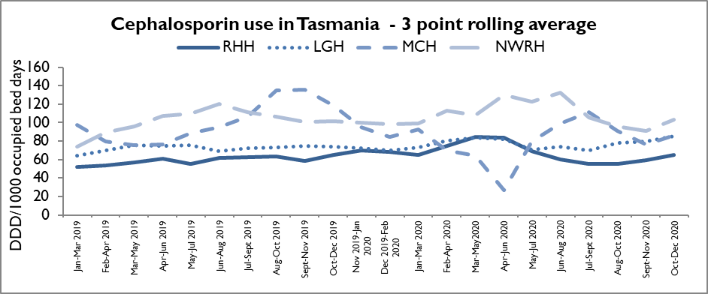
Third and fourth generation cephalosporin usage has remained stable at the LGH and the RHH with the average recent usage being approximately 63 DDD per 1000 OBDs at the RHH and 74 DDD per 1000 OBDs at the LGH.
The use at both the NWRH and the MCH increased during 2019, peaking up to 136 DDD per OBDs at the MCH and 120 DDD per OBDs at the NWRH, which was significantly higher than the 2019 national comparator rate (using the whole NAUSP contributor peer group) for total hospital use of third and fourth generation cephalosporin of approximately 60-65 DDD per 1000 OBDs. Encouragingly a sustained reduction in use has been maintained since August 2020 in NWRH and MCH, possibly in conjunction with recruitment of a dedicated ID Physician for the NW region.
Figure 20 Fluoroquinolone use
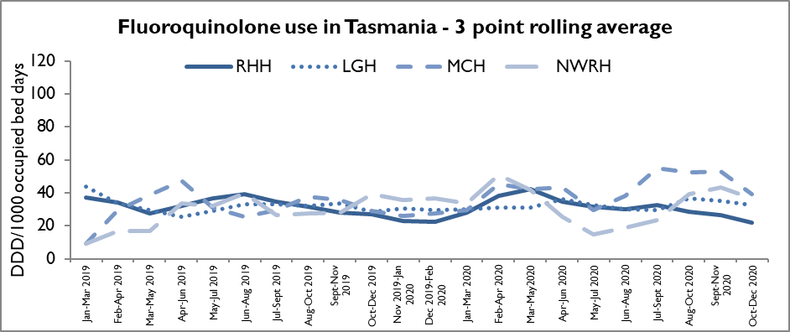
Fluoroquinolone use has decreased in most states and Territories including Tasmania which had the second largest decrease of 7.3% in 2019 to 31.8 DDD per 1000 OBDs; although this was still higher than the average for Australia in 2019 at 27.3 DDD per1,000 OBDs.
Recent use at the RHH was lower than the other sites with the most recent use data being approximately 22 DDD per1000 OBDs. However, the peak usage for RHH was high at 42 DDD per1000 OBDs in mid-2020. The average use was around 32 DDD per 1000 OBDs. MCH had a higher than normal peak in 2020 with up to 54.8 DDD per 1000 OBDs. However, this rate did fall towards the end of the year. LGH used on average 33 DDD per 1000 OBDs in 2019 which is also near the average use for Australia.

Figure 21 Piperacillin - tazobactam use

Tasmanian piperacillin-tazobactam usage has remained relatively stable over 2019 - 20 and is similar between the four larger acute public hospitals with use ranging from 45-65 DDD per OBDs. This is higher than the 2019 national comparator rate (using the whole NAUSP contributor peer group) for total hospital use of piperacillin-tazobactam of approximately 42 DDD per 1000 OBDs.
The cause for the peak at MCH of 90.7 DDD per 1000 OBDs remains unclear; but use by the end of year was comparable to the other sites.
Figure 22 Vancomycin use
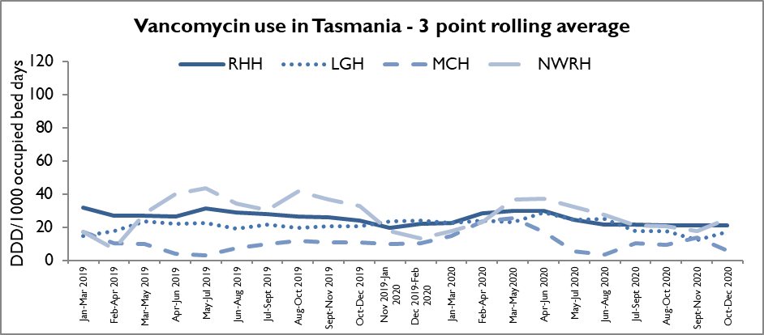
Vancomycin use has remained relatively stable at the RHH (average 27 DDD per 1000 OBDs) and LGH (average 21 DDD per 1000 OBDs), but use has fluctuated at the NWRH and MCH.
The most recent use across all sites ranged from 3.6 - 37.5 DDD per OBDs due to patient acuity between hospitals.
The 2019 national comparator rate (using the whole NAUSP contributor peer group) for total hospital usage of glycopeptides (combining vancomycin and teicoplanin) was approximately 26 DDD per 1000 OBDs.

Figure 23 Carbapenem use
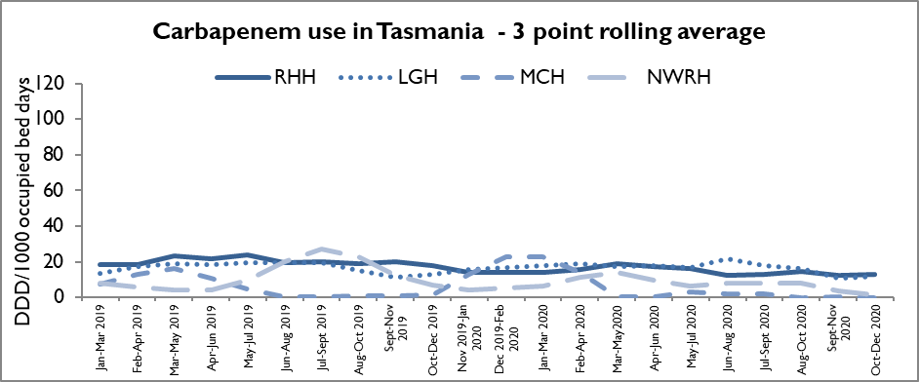
In 2019, carbapenem use in Australia increased 32% in the larger acute public hospitals from approximately 11 DDD per1000 OBDs to 15 DDD/1000 OBDs. Carbapenem use has been relatively similar at the RHH (average use 17 DDD per 1000 OBDs) and the LGH (average use 16 DDD per 1000 OBDs) over the last 24 months which is slightly higher than the 2019 national comparator rate of 14.8 DDD per1000 OBDs.
Carbapenem use fluctuated considerably at the MCH and NWRH but there has been minimal use at both hospitals more recently. A few individual patients can make a large proportional difference to use in Tasmania where prolonged directed therapy can possibly account for the variation in use between hospitals.
Figure 24 Linezolid use
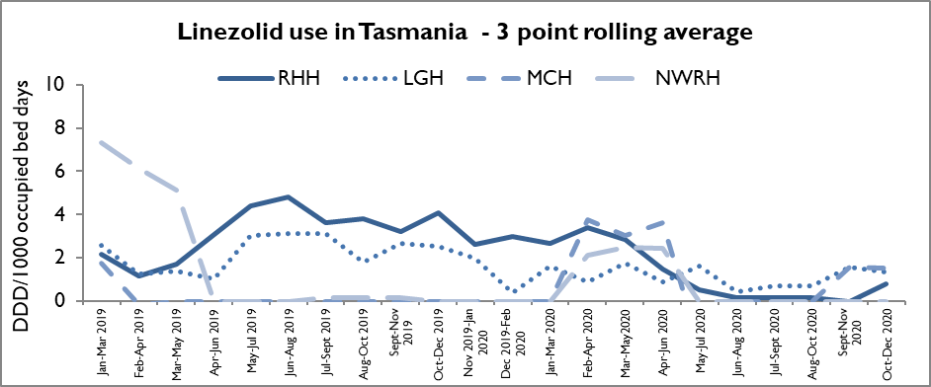
Linezolid usage has been relatively similar between the RHH and the LGH over the last 2 years, although there was greater use at the RHH in 2019 than at the LGH. Use has been similar at both hospitals in 2020. There has been minimal use at both the NWRH and the MCH over the preceding 6 months.

Antimicrobial use in District and rural hospitals
The Tasmanian Infection Prevention and Control Unit (TIPCU) antimicrobial use surveillance module for District and rural hospitals (AUTasRH) has been performed annually in all 13 Tasmanian District and rural hospitals since 2015. The aims of this surveillance are to quantify antimicrobial use within these hospitals over a defined audit period and to assess the appropriateness of this antimicrobial use in accordance with Therapeutic Guidelines: Antibiotic Guidelines (TG). The methodology and definitions of appropriateness have been based upon the National Antimicrobial Prevalence Survey (NAPS) methodology since 2016 and the method for surveillance is outlined in the ‘TIPCU Antimicrobial use surveillance protocol’ (www.health.tas.gov.au/publichealth/tasmanian_infection_prevention_and_control_unit/infection_control_assessment_non acute_settings/antimicrobial_use_surveillance_module_for_rural_hospitals_autasrh)

AUTasRH 2020 results
There was a reduction in the number of antimicrobials prescribed in 2020 with 142 prescriptions compared with 181 prescriptions in 2019 although there were four less facilities involved in 2020.
The four commonest antimicrobials prescribed were, cefalexin, amoxycillin-clavulanic acid, flucloxacillin and ceftriaxone and these accounted for nearly half of the total prescriptions.
The overall appropriateness of antimicrobial prescribing was 70% which was an improvement over 2019 when it was 64%.
Six facilities demonstrated appropriate prescribing of ≥ 70% (range 71% to 94%) which is one more facility than in 2019.
Three facilities had prescribing appropriateness < 60%, but two of these facilities have improved their prescribing compared with 2019.
Documentation improved with 99% of prescriptions having an indication documented.
Skin and soft tissue infections were the most common indicator for antimicrobial prescribing accounting for 37% of prescriptions. This is in contest to the previous four years where respiratory tract infection were the most common indication.
Further results can be found in Appendix 3.

Acknowledgements
The production of this report is the culmination of data collection, analysis and input from several different organisations. In particular, we would like to acknowledge:
- Executive Director of Nursing North
- Executive Director of Nursing North West
- Nursing Director South – Critical Care, Clinical Support and Investigations
- Launceston General Hospital Infection Prevention and Control Unit
- North West Regional Hospital Infection Control Team
- Mersey Community Hospital Infection Control Team
- Royal Hobart Hospital Infection Prevention and Control Unit
- Microbiology Departments at the Royal Hobart Hospital, Launceston General Hospital and DSPL
- Hand Hygiene Australia
- Australian Commission on Safety and Quality in Health Care
- Communicable Diseases Prevention Unit, Public Health Services
- Contributing Primary Health Sites

Appendix 1

Explanatory notes

What types of healthcare surveillance are done in Tasmania?
TIPCU undertakes surveillance of the following:
- Staphylococcus aureus bacteraemia (bloodstream infection).
- Clostridioides (Clostridium) Clostridium difficile infection (CDI).
- Vancomycin resistant enterococci (VRE).
- CARs including Carbapenemase-producing Enterobacterales (CPE).
- Hand hygiene compliance rates.
- Antibiotic utilisation – reported annually.
- Antimicrobial surveillance within District and rural inpatient facilities.

What do the rates mean?
The healthcare surveillance data are expressed as a rate or a raw number. SAB and CDI are expressed as a rate per 10 000 patient days, VRE is expressed as a raw number, hand hygiene compliance is expressed as a percentage and antibiotic utilisation is expressed as hospital use measured by defined daily doses, per 1 000 occupied bed days.

What are the definitions for Clostridioides difficile infection (CDI)?
TIPCU use the national surveillance definitions published by the ACSQHC to classify CDI. TIPCU reports on:
- Hospital identified CDI is defined as a case diagnosed in a patient attending an acute care facility. This includes positive specimens obtained from admitted patients and those attending the emergency department and outpatient departments. This definition excludes patients less than two years old and cases with a positive test within the previous eight weeks.
- Healthcare associated – healthcare facility onset CDI (HCA-HCF CDI) is defined as a patient with CDI symptom onset (or date and time of stool specimen collection if a laboratory system is used) more than 48 hours after admission to a healthcare facility. This definition excludes patients less than two years old and cases with a positive test within the previous eight weeks.

What are the definitions for healthcare associated Staphylococcus aureus bacteraemia (SAB)?
Criterion A the patient’s first SAB blood culture was collected more than 48 hours after hospital admission or less than 48 hours after discharge.
OR
Criterion B the patient’s first positive SAB blood culture was collected less than or equal to 48 hours after hospital admission and one or more of the following key clinical criteria was met for the patient-episode of SAB.
Key clinical criteria:
- SAB is a complication of the presence of an indwelling medical device (eg intravascular line, haemodialysis vascular access, CSF shunt, urinary catheter).
- SAB occurs within 30 days of a surgical procedure or 365 days for surgically implanted devices, where the SAB is related to the surgical site.
- SAB was diagnosed within 48 hours of a related invasive instrumentation or incision.
- SAB is associated with neutropenia (less 1 x 10⁹/L) contributed to by cytotoxic therapy.

What is the definition for vancomycin resistant enterococci (VRE)?
The definition for VRE is an isolate identified as VRE by an accredited laboratory.
TIPCU reports on the total number of people with new isolates of VRE identified in Tasmania per quarter and this number includes all people with new VRE isolates from public and private hospitals, District and rural hospitals, GP clinics and long term and residential care facilities.

What is the definition for carbapenemase-producing Enterobacterales (CPE)?
The definition for CPE is an Enterobacterales isolate with a carbapenemase gene identified by an accredited laboratory.
TIPCU reports on the total number of people with new isolates of CPE identified in Tasmania per annum and this number includes all people with new CPE isolates from public and private hospitals, District and rural hospitals, GP clinics and long term and residential care facilities.

Confidence intervals
Confidence intervals are used to calculate the range in which the true rate probably lies.
As an example, when looking at the hand hygiene compliance (HHC) data confidence intervals calculate the range in which the true compliance result lies, based on the data collected and the compliance measured, thus providing an indication of the reliability of the reported HHC level.
When only a small number of moments are collected, the confidence interval will be larger, as it is more difficult to establish the true compliance level from a small sample of moments.
If a large number of moments are collected the confidence interval will be smaller, meaning the reliability of the result is higher.

Patient care days
Patient days is the term to explain the total days patients are in hospital. In Tasmania’s four larger acute public hospitals there are around 330 000 patient care days a year.
When a rate is presented as a number per 10 000 patient days this presents the number of infections that occur for every 10 000 patient care days.

Can I compare Tasmanian hospital infection rates?
Each Tasmanian hospital provides different services and has patients with different levels of illness. This affects infection rates.
For example, very sick immuno-compromised patients may be more likely to get infections.
It is difficult to remove all of the factors outside the control of a hospital that can cause its infection rate to differ from other hospitals.
Other reasons for caution when comparing hospitals include:
- some hospitals may screen patients more than others. This can affect data for CDI and VRE in particular
- hospital laboratories may use different ways of identifying organisms. A laboratory that has a more sensitive way of looking for organisms may find more
- for hand hygiene, District and rural hospitals are not required to collect as many moments as the four larger acute public hospitals, which limits the comparability of data for District and rural hospitals and the larger acute hospitals.

What are the ‘5 Moments for Hand Hygiene’?
The 5 Moments for Hand Hygiene are the critical times in clinical situations when hand hygiene should be performed. Hand hygiene performed in accordance with the ‘5 Moments for Hand Hygiene’ protects patients and clients from acquiring infectious agents from the hands of the healthcare worker; protects patients and clients from infectious agents entering their bodies during procedures; and protects healthcare workers and the healthcare surroundings from acquiring patients’ and clients’ infectious agents.
The 5 moments for hand hygiene are:
Moment 1 – before touching a patient/client
Moment 2 – before a procedure
Moment 3 – after a procedure or body fluid exposure risk
Moment 4 – after touching a patient/client
Moment 5 – after touching a patient’s/client’s immediate environment

Appendix 2

Healthcare associated Staphylococcus aureus bacteraemia (SAB)
Table 7 Tasmanian public hospital numbers and rate per 10 000 patient days of HCA-SAB
Quarter | Total HCA-SAB | Number MSSA | Number MRSA | HCA SAB Rate
Q1 2018 | 7 | 7 | 0 | 0.8
Q2 2018 | 10 | 8 | 2 | 1.1
Q3 2018 | 13 | 12 | 1 | 1.3
Q4 2018 | 7 | 7 | 0 | 0.7
Q1 2019 | 8 | 7 | 1 | 0.8
Q2 2019 | 9 | 7 | 2 | 0.9
Q3 2019 | 7 | 5 | 2 | 0.7
Q4 2019 | 15 | 16 | 0 | 1.6
Q1 2020 | 9 | 9 | 0 | 0.9
Q2 2020 | 4 | 4 | 0 | 0.5
Q3 2020 | 10 | 9 | 1 | 1.0
Q4 2020 | 4 | 4 | 0 | 0.4

Table 8 Royal Hobart Hospital numbers and rates per10 000 patient days of HCA-SAB
Quarter | Total HCA-SAB | Number MSSA | Number MRSA | HCA SAB Rate
Q1 2018 | 3 | 3 | 0 | 0.7
Q2 2018 | 4 | 3 | 1 | 0.9
Q3 2018 | 8 | 7 | 1 | 1.7
Q4 2018 | 3 | 3 | 0 | 0.7
Q1 2019 | 1 | 1 | 0 | 0.2
Q2 2019 | 6 | 5 | 1 | 1.3
Q3 2019 | 4 | 3 | 1 | 0.8
Q4 2019 | 10 | 10 | 0 | 2.1
Q1 2020 | 4 | 4 | 0 | 0.9
Q2 2020 | 3 | 3 | 0 | 0.7
Q3 2020 | 4 | 4 | 0 | 0.8
Q4 2020 | 2 | 2 | 0 | 0.4
Table 9 Launceston General Hospital numbers and rates per10 000 patient days of HCA-SAB
Quarter | Total HCA-SAB | Number MSSA | Number MRSA | HCA SAB Rate
Q1 2018 | 3 | 3 | 0 | 0.9
Q2 2018 | 5 | 4 | 1 | 1.4
Q3 2018 | 3 | 3 | 0 | 0.8
Q4 2018 | 2 | 2 | 0 | 0.5
Q1 2019 | 4 | 3 | 1 | 1.2
Q2 2019 | 3 | 2 | 1 | 0.8
Q3 2019 | 2 | 1 | 1 | 0.5
Q4 2019 | 5 | 5 | 0 | 1.6
Q1 2020 | 3 | 3 | 0 | 0.9
Q2 2020 | 1 | 1 | 0 | 0.7
Q3 2020 | 3 | 2 | 1 | 0.8
Q4 2020 | 2 | 2 | 0 | 0.4

Table 10 Mersey Community Hospital numbers and rates per10 000 patient days of HCA-SAB
Quarter | Total HCA-SAB | Number MSSA | Number MRSA | HCA SAB Rate
Q1 2018 | 0 | 0 | 0 | 0.0
Q2 2018 | 0 | 0 | 0 | 0.0
Q3 2018 | 1 | 1 | 0 | 2.1
Q4 2018 | 1 | 1 | 0 | 1.9
Q1 2019 | 2 | 2 | 0 | 4.1
Q2 2019 | 0 | 0 | 0 | 0.0
Q3 2019 | 0 | 0 | 0 | 0.0
Q4 2019 | 0 | 0 | 0 | 0.0
Q1 2020 | 2 | 2 | 0 | 3.4
Q2 2020 | 0 | 0 | 0 | 0.0
Q3 2020 | 0 | 0 | 0 | 0.0
Q4 2020 | 0 | 0 | 0 | 0.0

Table 11 North West Regional Hospital numbers and rates per10 000 patient days of HCA-SAB
Quarter | Total HCA-SAB | Number MSSA | Number MRSA | HCA SAB Rate
Q1 2018 | 1 | 1 | 0 | 0.9
Q2 2018 | 1 | 1 | 0 | 0.9
Q3 2018 | 1 | 1 | 0 | 0.9
Q4 2018 | 1 | 1 | 0 | 0.9
Q1 2019 | 1 | 1 | 0 | 0.8
Q2 2019 | 0 | 0 | 0 | 0.0
Q3 2019 | 1 | 1 | 0 | 0.9
Q4 2019 | 0 | 0 | 0 | 0.0
Q1 2020 | 0 | 0 | 0 | 0.0
Q2 2020 | 0 | 0 | 0 | 0.0
Q3 2020 | 3 | 3 | 0 | 2.6
Q4 2020 | 0 | 0 | 0 | 0.0

Clostridioides difficile infection (CDI)
Table 12 Tasmanian numbers and rates per10 000 patient days of CDI
Quarter | Total hospital identified CDI | Hospital identified Rate | Total HCA HCF | HCA HCF Rate
Q1 2018 | 58 | 6.9 | 18 | 2.1
Q2 2018 | 40 | 4.6 | 20 | 2.3
Q3 2018 | 54 | 5.8 | 24 | 2.6
Q4 2018 | 47 | 5.1 | 15 | 1.6
Q1 2019 | 52 | 5.8 | 22 | 2.4
Q2 2019 | 46 | 4.8 | 23 | 2.4
Q3 2019 | 62 | 6.4 | 27 | 2.8
Q4 2019 | 49 | 5.1 | 26 | 2.7
Q1 2020 | 50 | 5.3 | 18 | 1.9
Q2 2020 | 41 | 5.1 | 17 | 2.1
Q3 2020 | 71 | 7.1 | 34 | 3.4
Q4 2020 | 66 | 6.8 | 27 | 2.8

Table 13 Hospital numbers and rates per10 000 patient days of hospital identified CDI
Quarter | RHH Total | RHH Rate | LGH Total | LGH Rate | MCH Total | MCH Rate | NWRH Total | NWRH Rate
Q1 2018 | 26 | 6.9 | 12 | 3.7 | 10 | 22.3 | 10 | 9.9
Q2 2018 | 21 | 5.4 | 10 | 3.0 | 7 | 16.1 | 2 | 2.0
Q3 3018 | 19 | 4.5 | 21 | 6.1 | 4 | 8.4 | 10 | 8.6
Q4 2018 | 19 | 4.5 | 14 | 4.0 | 8 | 15.6 | 6 | 5.6
Q1 2019 | 24 | 5.8 | 15 | 4.6 | 6 | 12.4 | 7 | 6.3
Q2 2019 | 20 | 4.6 | 18 | 5.1 | 6 | 11.9 | 2 | 1.8
Q3 2019 | 24 | 5.2 | 24 | 7.0 | 5 | 9.0 | 9 | 8.3
Q4 2019 | 15 | 3.3 | 15 | 3.9 | 10 | 17.7 | 10 | 9.6
Q1 2020 | 18 | 4.1 | 12 | 3.6 | 11 | 18.6 | 9 | 8.3
Q2 2020 | 22 | 5.7 | 13 | 4.0 | 0 | 0.0 | 6 | 9.0
Q3 2020 | 31 | 6.4 | 31 | 8.5 | 3 | 5.9 | 6 | 5.6
Q4 2020 | 27 | 5.8 | 23 | 6.7 | 9 | 17.0 | 7 | 6.5

Table 14 Hospital numbers and rates per10 000 patient days of HCA-HCF CDI
Quarter | RHH Total | RHH Rate | LGH Total | LGH Rate | MCH Total | MCH Rate | NWRH Total | NWRH Rate
Q1 2018 | 7 | 1.9 | 7 | 2.2 | 0 | 0.0 | 4 | 3.9
Q2 2018 | 13 | 3.3 | 5 | 1.5 | 1 | 2.3 | 1 | 1.0
Q3 3018 | 12 | 2.8 | 10 | 2.9 | 1 | 2.1 | 1 | 0.9
Q4 2018 | 9 | 2.1 | 5 | 1.4 | 0 | 0.0 | 1 | 0.9
Q1 2019 | 11 | 2.7 | 7 | 2.1 | 2 | 4.1 | 2 | 1.8
Q2 2019 | 15 | 3.4 | 6 | 1.7 | 1 | 2.0 | 1 | 0.9
Q3 2019 | 12 | 2.6 | 12 | 3.5 | 0 | 0.0 | 3 | 2.8
Q4 2019 | 11 | 2.4 | 9 | 2.5 | 3 | 5.3 | 3 | 2.9
Q1 2020 | 9 | 2.0 | 4 | 1.2 | 4 | 6.8 | 1 | 0.9
Q2 2020 | 12 | 3.1 | 4 | 1.2 | 0 | 0.0 | 1 | 1.5
Q3 2020 | 17 | 3.5 | 14 | 4.0 | 1 | 2.0 | 2 | 1.9
Q4 2020 | 13 | 2.8 | 12 | 3.5 | 0 | 0.0 | 2 | 1.9

Vancomycin resistant enterococci (VRE)
Table 15 First VRE isolates identified per quarter within larger acute public hospitals, and other healthcare settings (private hospitals, District and rural hospitals, GP clinics and long term and residential care facilities)
Quarter | RHH | LGH | MCH | NWRH | Other healthcare settings | TOTAL
Q1 2018 | 78 | 89 | 6 | 27 | 33 | 233
Q2 2018 | 113 | 137 | 12 | 22 | 36 | 320
Q3 2018 | 141 | 151 | 21 | 18 | 62 | 393
Q4 2018 | 78 | 130 | 14 | 23 | 37 | 282
Q1 2019 | 47 | 81 | 9 | 19 | 18 | 174
Q2 2019 | 38 | 85 | 7 | 10 | 23 | 163
Q3 2019 | 71 | 87 | 6 | 17 | 27 | 208
Q4 2019 | 45 | 75 | 9 | 11 | 5 | 145
Q1 2020 | 37 | 52 | 5 | 10 | 18 | 122
Q2 2020 | 24 | 29 | 7 | 6 | 19 | 85
Q3 2020 | 21 | 65 | 15 | 10 | 12 | 122
Q4 2020 | 25 | 66 | 20 | 7 | 27 | 145

Table 16 Classification of first VRE isolates – colonisation and infection
Quarter | Total VRE | Colonisation | Infection | % infection
Q1 2018 | 233 | 226 | 7 | 3%
Q2 2018 | 320 | 311 | 9 | 3%
Q3 2018 | 393 | 381 | 10 | 3%
Q4 2018 | 282 | 274 | 5 | 2%
Q1 2019 | 174 | 165 | 7 | 4%
Q2 2019 | 163 | 154 | 8 | 5%
Q3 2019 | 208 | 199 | 5 | 2%
Q4 2019 | 145 | 143 | 1 | 1%
Q1 2020 | 122 | 119 | 3 | 2%
Q2 2020 | 85 | 84 | 1 | 1%
Q3 2020 | 122 | 116 | 6 | 5%
Q4 2020 | 145 | 143 | 2 | 1%

Table 17 First VRE isolates by genotype by quarter
Quarter | vanA | vanB | vanA and vanB | Unknown
Q1 2018 | 91 | 148 | 1 | 0
Q2 2018 | 141 | 175 | 4 | 0
Q3 2018 | 219 | 163 | 8 | 3
Q4 2018 | 173 | 102 | 5 | 2
Q1 2019 | 107 | 66 | 1 | 0
Q2 2019 | 111 | 48 | 3 | 1
Q3 2019 | 101 | 102 | 5 | 0
Q4 2019 | 70 | 71 | 3 | 1
Q1 2020 | 49 | 73 | 0 | 0
Q2 2020 | 40 | 42 | 3 | 0
Q3 2020 | 47 | 71 | 3 | 1
Q4 2020 | 32 | 110 | 3 | 0

Appendix 3

AUTasRH 2020 results
Table 18 Comparison of the last 5 years of Tasmanian District and Rural Facility NAPS data
 | TAS Rural NAPS 2016 | TAS Rural NAPS 2017 | TAS Rural NAPS 2018 | TAS Rural NAPS 2019 | TAS Rural NAPS 2020 | Australian NAPS 2017 data (AURA 2019 report)
Appropriate | 62% | 74% | 62% | 64% | 70% | 73%
Optimal | 40% | 41% | 37% | 47% | 47%
Adequate | 22% | 33% | 26% | 17% | 24%
Inappropriate | 23% | 17% | 30% | 32% | 29% | 22%
Suboptimal | 19% | 16% | 23% | 30% | 25%
Inadequate | 4% | 2% | 8% | 2% | 4%
Not assessable | 15% | 9% | 7% | 4% | 0.7% | 5%
Indication documented | 90% | 88% | 93% | 96% | 99% | 78%
Total antimicrobials | 225 | 244 | 199 | 181 | 142 | N/A

Table 19 Comparison of the last five years of indications for use
Site | 2016 | 2017 | 2018 | 2019 | 2020
Respiratory tract | 45% | 43% | 40% | 38% | 22%
Skin and soft tissue | 12% | 19% | 14% | 26% | 37%
Urinary tract | 12% | 14% | 13% | 13% | 11%
Miscellaneous | 31% | 24% | 33% | 23% | 30%

Table 20 Comparison of the last five years for commonest antimicrobials prescribed
Rank | 2016  (n = 225) | 2017  (n = 244) | 2018  (n = 199) | 2019  (n = 181) | 2020  (n = 142)
1st | Cefalexin (36) | Cefalexin (34)  Doxycycline (34) | Doxycycline (29) | Flucloxacillin (25) | Cefalexin (20)
2nd | Ceftriaxone (30) | Amoxycillin (24) | Amoxycillin (19) | Cefalexin (21) | Amoxycillin-clavulanate (16)
3rd | Doxycycline (25) | Ceftriaxone (23) | Cefalexin (18)  Ceftriaxone (18) | Amoxicillin (20)  Doxycycline (20) | Flucloxacillin (14)
4th | Amoxycillin-clavulanate (20) | Amoxycillin-clavulanate (17)  Flucloxacillin (17) | Amoxycillin-clavulanate (16) | Ceftriaxone (17) | Ceftriaxone (13)
5th | Amoxicillin (13) | Metronidazole (11) | Flucloxacillin (13) | Ciprofloxacin (9) | Amoxicillin (8)

