Tasmanian Acute Public Hospitals
Healthcare Associated Infection Surveillance Report 39 – Quarter 3 2018
Tasmanian Acute public Hospital Healthcare Associated Infection Surveillance Report 39 – Quarter 3 2018
Department of Health, Tasmania
Published 2018
Copyright—Department of Health, Tasmania
Permission to copy is granted provided the source is acknowledged
Authors
- Ms Fiona Wilson, Clinical Nurse Consultant, TIPCU
- Dr Tara Anderson, Specialist Medical Advisor, TIPCU
- Ms Anne Wells, Assistant Director of Nursing, TIPCU
Suggested reference: Wilson, F., Anderson, T., Wells, A. (2018). Tasmanian Acute Public Hospitals Healthcare Associated Infection Report No 39 Quarter 3, 2018. Hobart: Department of Health.
Reviewed and approved by the:
- Tasmanian Health Service - Executive Director of Nursing North, Executive Director of Nursing North West, Nursing Director South – Critical Care, Clinical Support and Investigations
- Tasmanian Department of Health - Director of Public Health
Notes
Data are subject to ongoing revision so data from previous reports should not be relied upon. Use the most up to date report when citing data.

Contents
Index of figures and tables 4
Executive summary 5
Staphylococcus aureus bacteraemia 6
Tasmanian rates 6
Hospital rates 7
Clostridium difficile infection 8
Tasmanian rates 8
Hospital rates – by quarter 9
Vancomycin resistant enterococci 10
VRE genotypes 11
Carbapenemase-producing Enterobacteriaceae 12
Hand Hygiene 13
Tasmanian rates 13
Acknowledgements 16
Appendix 1 17
Explanatory notes 17
Appendix 2 20
Healthcare associated Staphylococcus aureus bacteraemia (SAB) 20
Clostridium difficile infection (CDI) 22
Vancomycin resistant enterococci (VRE) 24
Hand hygiene compliance data - audit period 3, 2018 26

Index of figures and tables
Figure 1 Healthcare associated Staphylococcus aureus bacteraemia - Tasmanian rate by quarter 6
Figure 2 Healthcare associated Staphylococcus aureus bacteraemia - rate by quarter 7
Figure 3 Acute public hospital identified CDI and HCA-HCF CDI – rates by quarter 8
Figure 4 Hospital identified CDI by quarter 9
Figure 5 HCA-HCF by quarter 9
Figure 6 First VRE isolates – classification by quarter 10
Figure 7 First VRE isolates - genotype by quarter 11
Figure 8 Hand hygiene compliance in Tasmanian public hospitals 13
Figure 9 Hand hygiene compliance by moment 14
Figure 10 Hand hygiene compliance by healthcare worker 15

Table 1 Healthcare worker categories 15
Table 2 Tasmanian public hospital numbers and rate per 10 000 patient days of HCA-SAB. 20
Table 3 Royal Hobart Hospital numbers and rates per10 000 patient days of HCA-SAB 20
Table 4 Launceston General Hospital numbers and rates per10 000 patient days of HCA-SAB 21
Table 5 Mersey Community Hospital numbers and rates per10 000 patient days of HCA-SAB 21
Table 6 North West Regional Hospital numbers and rates per10 000 patient days of HCA-SAB. 22
Table 7 Tasmanian numbers and rates per10 000 patient days of CDI 22
Table 8 Hospital numbers and rates per10 000 patient days of hospital identified CDI 23
Table 9 Hospital numbers and rates per10 000 patient days of HCA-HCF CDI 23
Table 10 First VRE isolates identified per quarter. 24
Table 11 Classification of first VRE isolates – colonisation and infection 24
Table 12 First VRE isolates by genotype by quarter 25
Table 13 Hand hygiene compliance rates by Tasmanian hospital and state level 26
Table 14 Tasmanian hand hygiene compliance rates by moment 26
Table 15 Tasmanian hand hygiene compliance rates by healthcare worker 27

Executive summary
This report provides an overview of the Tasmanian acute public hospitals’ healthcare associated infection surveillance for the third quarter (Q3) of 2018.
Details of the surveillance program, including the rationale for the indicators measured and the methodologies used in data collection, validation and analysis are available at the TIPCU website.
Any form of comparison between hospitals should be done with caution because data are not adjusted for patient characteristics that vary between hospitals. Further, the relatively small Tasmanian population and small number of events can result in volatility of rates from time to time. The raw data in the appendices illustrate this.
This report contains the following findings:
- The Tasmanian rate of healthcare associated Staphylococcus aureus bacteraemia (SAB) remains low and below the National Benchmark.
- The rate of ‘hospital identified Clostridium difficile infection (CDI)’ and ‘hospital identified, healthcare associated-healthcare facility onset (HCA-HCF) CDI’ increased slightly this quarter.
- The number of new isolates of vancomycin resistant enterococcus (VRE) continues to increase and vanA is the most common genotype identified.
- There was one case of Carbapenemase-producing Enterobacteriaceae (CPE) notified.
- The consolidated Tasmanian public hospital hand hygiene compliance rate is 81 per cent which is one percent above the National Hand Hygiene Benchmark (NHHB).
Please note that counts of VRE and CDI identified at the Royal Hobart Hospital (RHH) in Q3 2018 and reported in this HAI report, have not been validated by RHH.

Staphylococcus aureus bacteraemia
Staphylococcus aureus, a common cause of serious healthcare associated bloodstream infection (bacteraemia), may cause significant patient morbidity and mortality.
Many healthcare associated Staphylococcus aureus bacteraemias (SAB) are preventable. SAB was made notifiable in Tasmania in 2008 pursuant to the Public Health Act 1997. Tasmania was the first Australian jurisdiction to introduce this measure to capture SAB data.
SAB surveillance is carried out in Tasmania using the national surveillance definitions published by the Australian Commission on Safety and Quality in Health Care (ACSQHC).
Under this definition a SAB is defined as healthcare associated (HCA) if the patient’s first SAB positive blood culture was collected either >48 hours after hospital admission or <48 hours after discharge (Criterion A) OR ≤48 hours after hospital admission and one or more of four key clinical healthcare related criteria was met (Criterion B).
The National Healthcare Agreement (2011) target is no more than two HCA SAB per10 000 patient days for each public hospital.

Tasmanian rates
Figure 1 presents the combined Tasmanian acute public hospital rates of HCA SAB by quarter.
Figure 1 Healthcare associated Staphylococcus aureus bacteraemia - Tasmanian rate by quarter
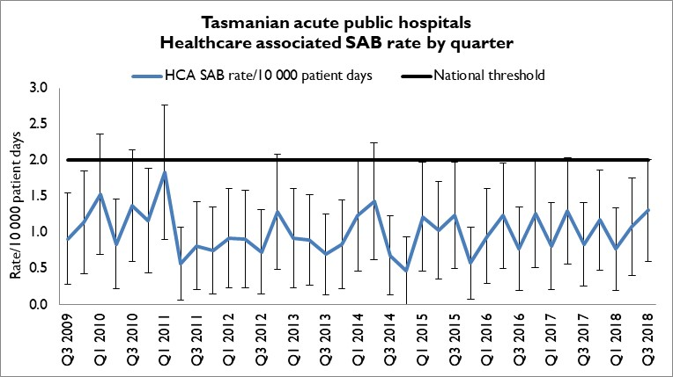
There were 13 cases of HCA SAB in all Tasmanian public hospitals in Q3 2018. This corresponded to a combined Tasmanian public hospital rate of HCA SAB for Q3 2018 of 1.3 per 10 000 patient days (95% CI 0.6 –2.0).

Hospital rates
Figure 2 presents the individual acute public hospitals rates of HCA SAB by quarter.
Figure 2 Healthcare associated Staphylococcus aureus bacteraemia - rate by quarter
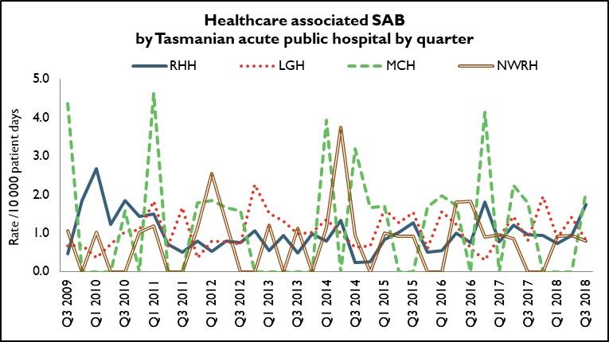
In Q3 2018, the rate of HCA SAB for RHH, LGH and NWRH met the National Healthcare Agreement target of no more than two HCA SAB per10 000 patient days. The MCH exceeded the target with a rate of 2.1/10 000 patient days as a result of a single HCA-SAB for MCH in Q3 2018.

Clostridium difficile infection
Clostridium difficile infection (CDI) is a bowel infection caused by the bacterium Clostridium difficile and is a common cause of healthcare associated diarrhoea. CDI causes significant patient morbidity and mortality and can result in increased hospital stays and costs. Factors that may contribute to higher CDI rates include the overuse of antibiotics and ineffective infection control processes including suboptimal environmental cleanliness.
Surveillance of CDI in Tasmania uses the ACSQHC’s national surveillance definitions. There is no National benchmark for CDI and it is not a notifiable condition in Tasmania.
Hospital identified CDI are CDI infections identified in a hospital irrespective of attribution of infection.
Healthcare associated – healthcare facility onset (HCA-HCF) CDI are a sub-group of hospital identified cases. This category only includes infections that occurred 48 hours or more after a patient was admitted to hospital. The HCA – HCF rate excludes people who present to hospital with symptoms of CDI and/or develop symptoms within two days of admission.

Tasmanian rates
Figure 3 presents the Tasmanian combined acute public hospital rates of hospital identified CDI and HCA-HCF CDI by quarter.
Figure 3 Acute public hospital identified CDI and HCA-HCF CDI – rates by quarter
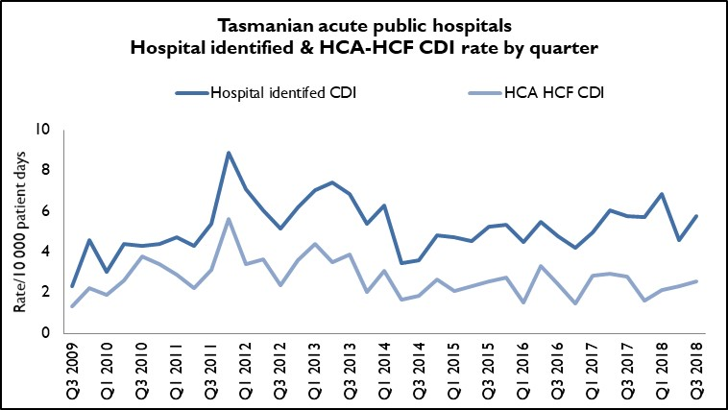
Fifty-four cases of hospital identified CDI in Q3 2018 corresponded to a rate of 5.8 per 10 000 patient days (95%CI 4.2 – 7.3); of these, 24 cases were HCA-HCF, a rate of 2.6 per10 000 patient days (95% CI 1.5 – 3.6). This is a slight increase from Q2 2018 where there were 20 HCA-HCF which corresponded to a rate of 2.3 per 10 000 patient days. The HCA-HCF rate in Q3 2018 is higher than in the previous three quarters – Q4 2017, Q1 2018 and Q2 2018 - but remains lower than in the first three quarters of 2017.

Hospital rates – by quarter
Figure 4 and Figure 5 presents the individual acute public hospital rates of hospital identified CDI, and the healthcare associated – healthcare facility onset (HCA-HCF) CDI by quarter.
Figure 4 Hospital identified CDI by quarter
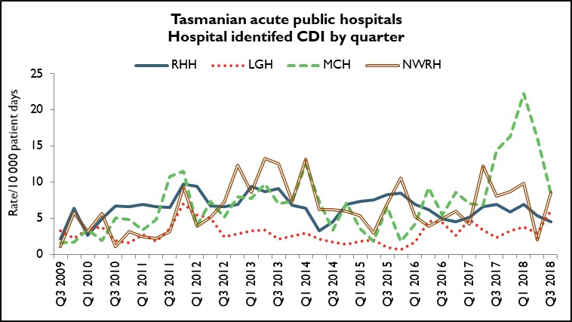
Figure 5 HCA-HCF by quarter
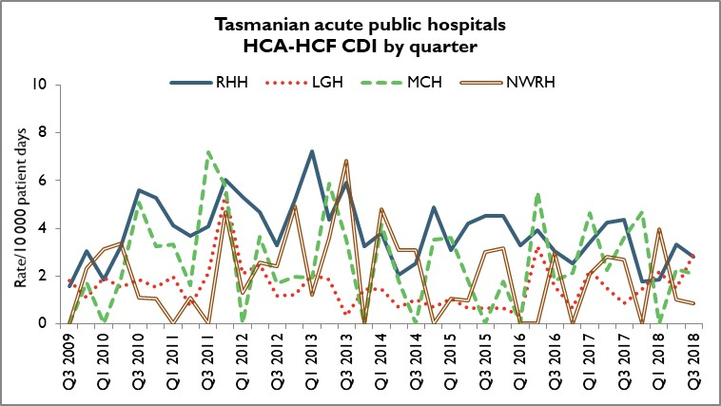
The rate of hospital identifed CDI varies considerably between hospitals and most likely reflects community associated CDI. The number and rate of HCA-HCF CDI at RHH, MCH and NWRH decreased or remained the same in Q3 2018 compared to Q2 2018, while it increased slightly at LGH.

Vancomycin resistant enterococci
Enterococci are bacteria normally present in the human gastrointestinal and female genital tract and can cause infections of the urinary tract, bloodstream and wounds. Enterococci that have acquired resistance to the antibiotic vancomycin are called vancomycin-resistant enterococci or VRE. VRE infections can be more difficult to treat then those caused by vancomycin sensitive enterococci.
Factors that can contribute to the transmission of VRE in hospitals are inadequate infection control practices, overuse of antibiotics and suboptimal environmental cleanliness.
Identification of VRE is notifiable in Tasmania pursuant to the Public Health Act 1997.
Figure 6 and presents all patients with a first VRE isolate identified within Tasmania by quarter and financial year respectively. These numbers include all new patients identified within Tasmania from public and private hospitals, rural hospitals, GP clinics and long term and residential care facilities. A person’s first VRE isolate is classified according to whether it represents colonisation – an isolate from a non-sterile site with no targeted antibiotic treatment prescribed - or infection – a clinical isolate from a sterile site OR a non-sterile site clinical isolate where targeted antibiotic therapy was prescribed.
The number of people newly identified with VRE within hospitals does not necessarily reflect that VRE was acquired at that hospital. The numbers of VRE isolates identified can be affected by the amount of screening undertaken by hospitals and those that have an intensive screening program are likely to identify more VRE

Figure 6 First VRE isolates – classification by quarter
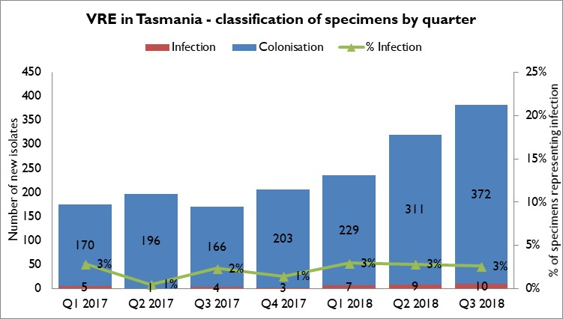

The number of new VRE identified in Q3 2018 is the highest since surveillance of VRE began in 2007.
Most first VRE isolates continue to reflect colonisation rather than infection. The proportion of isolates that represent infections has remained stable over the last seven quarters with infections representing around two to three per cent of total first VRE isolates.

VRE genotypes
Figure 7 presents the genotypes of all new isolates identified within Tasmania by quarter.
Figure 7 First VRE isolates - genotype by quarter
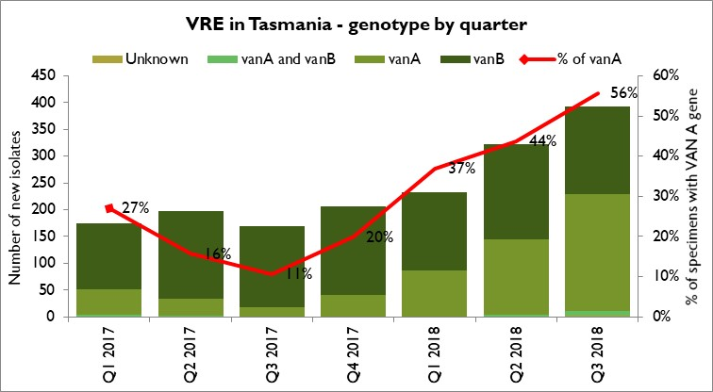
The number and proportion of isolates with the vanA genotype has increased substantially over the past two quarters and now, for the first time, represents the majority (56%) of the total isolates for the current quarter.
Infections caused by vanA VRE can be more difficult to treat than infections caused by vanB VRE.

Carbapenemase-producing Enterobacteriaceae
Carbapenem resistance in Enterobacteriaceae is an emerging clinical and public health problem that threatens the effectiveness of an important antibiotic group – carbapenems – that are highly active against multi-drug resistant Gram negative organisms.
The epidemiology of carbapenemase-producing Enterobacteriaceae (CPE) varies between countries and it is evident that without active surveillance and subsequent stringent infection control measures these organisms may rapidly become endemic.
In areas where few CPE cases have occurred, it is recommended that health departments take an aggressive approach to contain CPE.
With current low prevalence rates, surveillance through mandatory laboratory notification creates an opportunity for proactive measures to prevent, detect and contain CPE within Tasmania.
Identification of CPE was made notifiable in Tasmania pursuant to the Public Health Act 1997 in 2016 and of the three cases of CPE identified in Tasmania to June 30, 2018, none were locally acquired.
There was one case of CPE identified in Tasmania in Q3 2018. The CPE was identified in a hospital inpatient. The patient had had several short (1 – 2 days) hospital admissions along with antibiotic therapy in the 12 months prior to the CPE being identified but had no overseas travel or residential care in the same time frame. No contact tracing or screening of other hospitals patients was required.

Hand Hygiene
The National Hand Hygiene Initiative (NHHI) was introduced in Tasmania in 2009 to increase healthcare workers hand hygiene compliance and monitor its effectiveness by measuring reductions in HCA SAB.
Hand hygiene compliance is monitored by direct observation of healthcare workers performing hand hygiene at the appropriate times. Hand Hygiene Australia (HHA) requires hand hygiene compliance data to be submitted three times per year with all acute care areas in a facility audited at least once per annum ideally every audit period.
The National Hand Hygiene Benchmark (NHHB) is ≥80 per cent for total moments, individual moments and each healthcare worker group.

Tasmanian rates
Figure 8 Hand hygiene compliance in Tasmanian public hospitals
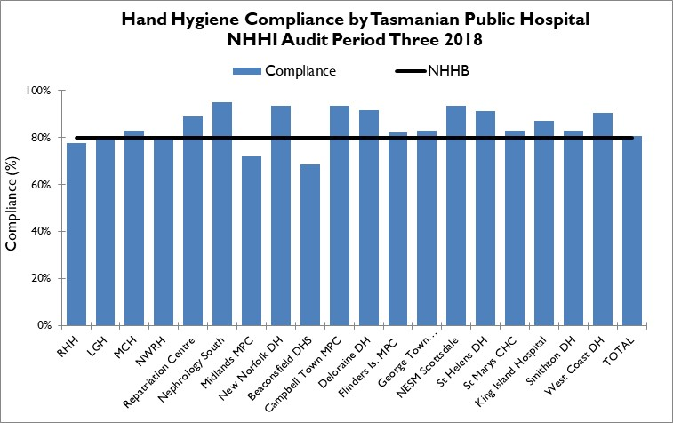
Audit period 3 2018 was from 1 July 2018 to 31 October 2018 with 20 facilities contributing to the national audit, with the Repatriation Centre auditing and submitting national data for the first time. For this period the overall Tasmanian public hospital compliance rate was 81 per cent which is one per cent above the NHHB and the same as in audit period 2 2018.
There were three hospitals with compliance rates below the NHHB – Royal Hobart Hospital (RHH), Midlands Multipurpose Centre and Beaconsfield District Hospital. RHH and Beaconsfield both had upper confidence intervals below 80 per cent, at 79 and 77 per cent respectively. This indicates that the ‘true’ rate is below the NHHB. The RHH rate has a small (one per cent) increase in the rate since the previous data collection period.
There are differences in the number of hand hygiene moments observed in the acute hospitals versus the rural hospitals and these numbers are presented in Table 13 in Appendix 2.
Figure 9 Hand hygiene compliance by moment
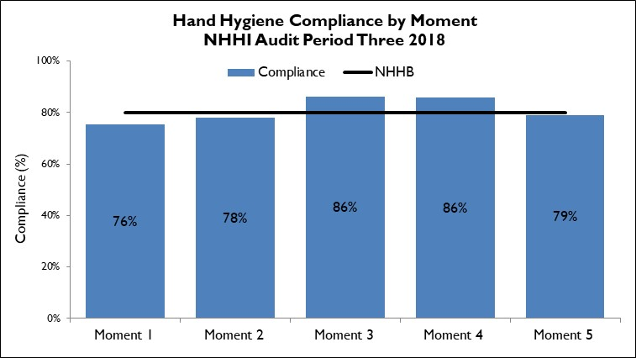
Hand hygiene compliance before touching a patient (Moment 1), before a procedure (Moment 2) and after touching patient surroundings (Moment 5) are lower than the NHHB and lower than those reported after undertaking a procedure (Moment 3) or after touching a patient (Moment 4).
Moment 1 and Moment 2 are key opportunities for hand hygiene that may have a direct effect on the risk of transmission of pathogens within the healthcare setting.
Moment 2, particularly relates to compliance with appropriate aseptic technique and procedural activity.

Figure 10 Hand hygiene compliance by healthcare worker
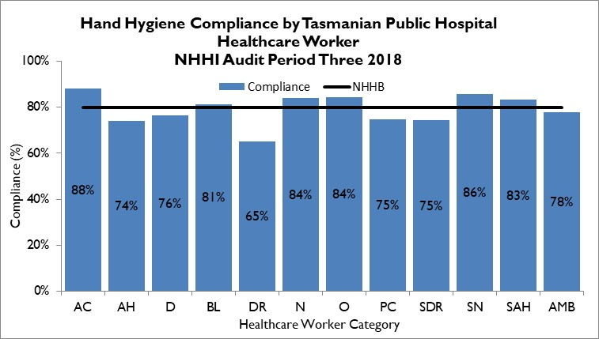
Table 1 Healthcare worker categories
Code | Healthcare worker | Code | Healthcare worker | Code | Healthcare worker
AC | Clerical | DR | Doctor | SDR | Student Doctor
AH | Allied Health | N | Nurse/Midwife | SN | Student Nurse/Midwife
D | Domestic | O | Other | SAH | Student Allied Health
BL | Invasive Technician | PC | Personal Care Staff | AMB | Ambulance worker

The number of hand hygiene moments observed between the different healthcare worker groups varies. Most (71 per cent in audit period 2018) were collected from nursing activities with the next highest being medical activities (13 per cent).
There are several healthcare worker groups – clerical, invasive technician, student doctor, student allied healthcare worker, ambulance worker and other – that contribute one per cent or less of the total hand hygiene moments thus their results should be interpreted with caution.
Of the healthcare worker groups that contribute more than one per cent of the total moments, allied health staff, domestic staff, doctors and personal care staff are not meeting the NHHB. Doctor compliance at 65 per cent, is well below the benchmark and is unchanged since the last audit period. HHA is considering prioritising medical hand hygiene compliance for 2018/19.
TIPCU continue to work with and support the work of HHA and the NHHI.

Acknowledgements
The production of this report is the culmination of data collection, analysis and input from several different organisations. In particular, we would like to acknowledge:
- Executive Director of Nursing North
- Executive Director of Nursing North West
- Nursing Director South – Critical Care, Clinical Support and Investigations
- Launceston General Hospital Infection Prevention and Control Unit
- North West Regional Hospital Infection Control Team
- Mersey Community Hospital Infection Control Team
- Royal Hobart Hospital Infection Prevention and Control Unit
- Microbiology Departments at the Royal Hobart Hospital, Launceston General Hospital and DSPL
- Hand Hygiene Australia
- Communicable Diseases Prevention Unit, Population Health Services
- Contributing Primary Health Sites

Appendix 1

Explanatory notes

What types of healthcare surveillance are done in Tasmania?
TIPCU undertakes surveillance of the following:
- Staphylococcus aureus bacteraemia (bloodstream infection).
- Clostridium difficile infection (CDI).
- Vancomycin resistant enterococci (VRE).
- Carbapenemase-producing Enterobacteriaceae.
- Hand hygiene compliance rates.
- Antibiotic utilisation – reported annually.

What do the rates mean?
The healthcare surveillance data are expressed as a rate or a raw number. SAB and CDI are expressed as a rate per 10 000 patient days, VRE is expressed as a raw number, hand hygiene compliance is expressed as a percentage and antibiotic utilisation is expressed as hospital use measured by defined daily doses, per 1 000 occupied bed days.

What are the definitions for Clostridium difficile infection (CDI)?
TIPCU use the national surveillance definitions published by the Australian Commission on Safety and Quality in Health Care (ACSQHC) to classify CDI. TIPCU reports on:
- Hospital identified CDI is defined as a case diagnosed in a patient attending an acute care facility. This includes positive specimens obtained from admitted patients and those attending the emergency department and outpatient departments. This definition excludes patients less than two years old and cases with a positive test within the previous eight weeks.
- Healthcare associated – healthcare facility onset CDI (HCA-HCF CDI) is defined as a patient with CDI symptom onset (or date and time of stool specimen collection if a laboratory system is used) more than 48 hours after admission to a healthcare facility. This definition excludes patients less than two years old and cases with a positive test within the previous eight weeks.

What are the definitions for healthcare associated Staphylococcus aureus bacteraemia (SAB)?
Criterion A the patient’s first SAB blood culture was collected more than 48 hours after hospital admission or less than 48 hours after discharge.
OR
Criterion B the patient’s first positive SAB blood culture was collected less than or equal to 48 hours after hospital admission and one or more of the following key clinical criteria was met for the patient-episode of SAB.
Key clinical criteria:
- SAB is a complication of the presence of an indwelling medical device (eg intravascular line, haemodialysis vascular access, CSF shunt, urinary catheter).
- SAB occurs within 30 days of a surgical procedure or 365 days for surgically implanted devices, where the SAB is related to the surgical site.
- SAB was diagnosed within 48 hours of a related invasive instrumentation or incision.
- SAB is associated with neutropenia (less 1 x 10⁹/L) contributed to by cytotoxic therapy.
What is the definition for vancomycin resistant enterococci (VRE)?
The definition for VRE is an isolate identified as VRE by an accredited laboratory.
TIPCU reports on the total number of people with new isolates of VRE identified in Tasmania per quarter and this number includes all people with new VRE isolates from public and private hospitals, rural hospitals, GP clinics and long term and residential care facilities.
What is the definition for carbapenemase-producing Enterobacteriaceae (CPE)?
The definition for CPE is an Enterobacteriaceae isolate with a carbapenemase gene identified by an accredited laboratory.
TIPCU reports on the total number of people with new isolates of CPE identified in Tasmania per annum and this number includes all people with new CPE isolates from public and private hospitals, rural hospitals, GP clinics and long term and residential care facilities.

Confidence intervals
Confidence intervals are used to calculate the range in which the true rate probably lies.
As an example, when looking at the hand hygiene compliance (HHC) data confidence intervals calculate the range in which the true compliance result lies, based on the data collected and the compliance measured, thus providing an indication of the reliability of the reported HHC level.
When only a small number of moments are collected, the confidence interval will be larger, as it is more difficult to establish the true compliance level from a small sample of moments.
If a large number of moments are collected the confidence interval will be smaller, meaning the reliability of the result is higher.
Hand Hygiene Australia (HHA) calculates 95 per cent confidence intervals, indicating the intervals in which 95 per cent of the time the true compliance level lies. (HHA 2011).
Patient care days
Patient days is the term to explain the total days patients are in hospital. In Tasmania’s four larger acute public hospitals there are around 330 000 patient care days a year.
When a rate is presented as a number per 10 000 patient days this presents the number of infections that occur for every 10 000 patient care days.

Can I compare Tasmanian hospital infection rates?
Each Tasmanian hospital provides different services and has patients with different levels of illness. This affects infection rates.
For example, very sick immuno-compromised patients may be more likely to get infections.
It is difficult to remove all of the factors outside the control of a hospital that can cause its infection rate to differ from other hospitals.
Other reasons for caution when comparing hospitals include:
- some hospitals may screen patients more than others. This can affect data for CDI and VRE in particular
- hospital laboratories may use different ways of identifying organisms. A laboratory that has a more sensitive way of looking for organisms may find more
- for hand hygiene, rural hospitals are not required to collect as many moments as the four acute public hospitals, which limits the comparability of data for rural and acute hospitals.

Appendix 2

Healthcare associated Staphylococcus aureus bacteraemia (SAB)
Table 2 Tasmanian public hospital numbers and rate per 10 000 patient days of HCA-SAB.
Quarter | Total HCA-SAB | Number MSSA | Number MRSA | HCA SAB Rate
Q1 2016 | 8 | 6 | 2 | 1.0
Q2 2016 | 11 | 10 | 1 | 1.2
Q3 2016 | 7 | 7 | 0 | 0.8
Q4 2016 | 11 | 10 | 1 | 1.3
Q1 2017 | 7 | 6 | 1 | 0.8
Q2 2017 | 12 | 10 | 2 | 1.3
Q3 2017 | 8 | 8 | 0 | 0.8
Q4 2017 | 11 | 8 | 3 | 1.2
Q1 2018 | 7 | 7 | 0 | 0.8
Q2 2018 | 10 | 8 | 2 | 1.1
Q3 2018 | 13 | 12 | 1 | 1.3

Table 3 Royal Hobart Hospital numbers and rates per10 000 patient days of HCA-SAB
Quarter | Total HCA-SAB | Number MSSA | Number MRSA | HCA SAB Rate
Q1 2016 | 2 | 2 | 0 | 0.5
Q2 2016 | 4 | 4 | 0 | 1.0
Q3 2016 | 3 | 3 | 0 | 0.8
Q4 2016 | 7 | 7 | 0 | 1.8
Q1 2017 | 3 | 2 | 1 | 0.8
Q2 2017 | 5 | 5 | 0 | 1.2
Q3 2017 | 4 | 4 | 0 | 1.0
Q4 2017 | 4 | 3 | 1 | 0.9
Q1 2018 | 3 | 3 | 0 | 0.7
Q2 2018 | 4 | 3 | 1 | 0.9
Q3 2018 | 8 | 7 | 1 | 1.7

Table 4 Launceston General Hospital numbers and rates per10 000 patient days of HCA-SAB
Quarter | Total HCA-SAB | Number MSSA | Number MRSA | HCA SAB Rate
Q1 2016 | 5 | 3 | 2 | 1.6
Q2 2016 | 4 | 4 | 0 | 1.2
Q3 2016 | 2 | 2 | 0 | 0.6
Q4 2016 | 1 | 0 | 1 | 0.3
Q1 2017 | 3 | 3 | 0 | 0.9
Q2 2017 | 5 | 3 | 2 | 1.4
Q3 2017 | 3 | 3 | 0 | 0.8
Q4 2017 | 7 | 5 | 2 | 2.0
Q1 2018 | 3 | 3 | 0 | 0.9
Q2 2018 | 5 | 4 | 1 | 1.4
Q3 2018 | 3 | 3 | 0 | 0.8

Table 5 Mersey Community Hospital numbers and rates per10 000 patient days of HCA-SAB
Quarter | Total HCA-SAB | Number MSSA | Number MRSA | HCA SAB Rate
Q1 2016 | 1 | 1 | 0 | 2.0
Q2 2016 | 1 | 1 | 0 | 1.7
Q3 2016 | 0 | 0 | 0 | 0.0
Q4 2016 | 2 | 2 | 0 | 4.2
Q1 2017 | 0 | 0 | 0 | 0.0
Q2 2017 | 1 | 1 | 0 | 2.3
Q3 2017 | 1 | 1 | 0 | 1.8
Q4 2017 | 0 | 0 | 0 | 0.0
Q1 2018 | 0 | 0 | 0 | 0.0
Q2 2018 | 0 | 0 | 0 | 0.0
Q3 2018 | 1 | 1 | 0 | 2.1

Table 6 North West Regional Hospital numbers and rates per10 000 patient days of HCA-SAB.
Quarter | Total HCA-SAB | Number MSSA | Number MRSA | HCA SAB Rate
Q1 2016 | 0 | 0 | 0 | 0.0
Q2 2016 | 2 | 1 | 1 | 1.8
Q3 2016 | 2 | 2 | 0 | 1.8
Q4 2016 | 1 | 1 | 0 | 0.9
Q1 2017 | 1 | 1 | 0 | 1.0
Q2 2017 | 1 | 1 | 0 | 0.9
Q3 2017 | 0 | 0 | 0 | 0.0
Q4 2017 | 0 | 0 | 0 | 0.0
Q1 2018 | 1 | 1 | 0 | 0.9
Q2 2018 | 1 | 1 | 0 | 0.9
Q3 2018 | 1 | 1 | 0 | 0.8

Clostridium difficile infection (CDI)
Table 7 Tasmanian numbers and rates per10 000 patient days of CDI
Quarter | Total hospital identified CDI | Hospital identified Rate | Total HCA HCF | HCA HCF Rate
Q1 2016 | 35 | 4.5 | 12 | 1.5
Q2 2016 | 45 | 5.5 | 17 | 2.1
Q3 2016 | 40 | 4.8 | 20 | 2.4
Q4 2016 | 34 | 4.2 | 12 | 1.5
Q1 2017 | 40 | 5.0 | 23 | 2.9
Q2 2017 | 52 | 6.1 | 25 | 2.9
Q3 2017 | 52 | 5.8 | 25 | 2.8
Q4 2017 | 50 | 5.7 | 14 | 1.6
Q1 2018 | 58 | 6.9 | 18 | 2.1
Q2 2018 | 40 | 4.6 | 20 | 2.3
Q3 2018 | 54* | 5.8* | 24* | 2.6*
* rates and numbers include unvalidated date from RHH

Table 8 Hospital numbers and rates per10 000 patient days of hospital identified CDI
Quarter | RHH Total | RHH Rate | LGH Total | LGH Rate | MCH Total | MCH Rate | NWRH Total | NWRH Rate
Q1 2016 | 23 | 6.9 | 5 | 1.6 | 2 | 4.2 | 5 | 5.3
Q2 2016 | 22 | 6.2 | 14 | 4.6 | 5 | 9.2 | 4 | 3.9
Q3 2016 | 18 | 5.0 | 14 | 4.4 | 3 | 5.5 | 5 | 4.9
Q4 2016 | 16 | 4.5 | 8 | 2.6 | 4 | 8.6 | 6 | 5.9
Q1 2017 | 18 | 5.1 | 15 | 4.8 | 3 | 7.0 | 4 | 4.2
Q2 2017 | 25 | 6.6 | 11 | 3.3 | 3 | 6.8 | 13 | 12.3
Q3 2017 | 27 | 6.9 | 8 | 2.3 | 8 | 14.4 | 9 | 8.0
Q4 2017 | 23 | 5.9 | 11 | 3.2 | 7 | 16.4 | 9 | 8.7
Q1 2018 | 26 | 6.9 | 12 | 3.7 | 10 | 22.3 | 10 | 9.9
Q2 2018 | 21 | 5.4 | 10 | 3.0 | 7 | 16.1 | 2 | 2.0
Q3 2018 | 19* | 4.5* | 21 | 6.1 | 4 | 8.4 | 10 | 8.6
* denotes unvalidated data
Table 9 Hospital numbers and rates per10 000 patient days of HCA-HCF CDI
Quarter | RHH Total | RHH Rate | LGH Total | LGH Rate | MCH Total | MCH Rate | NWRH Total | NWRH Rate
Q1 2016 | 11 | 3.3 | 1 | 0.3 | 0 | 0.0 | 0 | 0.0
Q2 2016 | 14 | 3.9 | 10 | 3.3 | 3 | 5.5 | 0 | 0.0
Q3 2016 | 11 | 3.0 | 5 | 1.6 | 1 | 1.8 | 3 | 3.0
Q4 2016 | 9 | 2.5 | 2 | 0.7 | 1 | 2.1 | 0 | 0.0
Q1 2017 | 12 | 3.4 | 7 | 2.2 | 2 | 4.7 | 2 | 2.1
Q2 2017 | 16 | 4.2 | 5 | 1.5 | 1 | 2.3 | 3 | 2.8
Q3 2017 | 17 | 4.4 | 3 | 0.9 | 2 | 3.6 | 3 | 2.7
Q4 2017 | 7 | 1.8 | 5 | 1.5 | 2 | 4.7 | 0 | 0.0
Q1 2018 | 7 | 1.9 | 7 | 2.2 | 0 | 0.0 | 4 | 3.9
Q2 2018 | 13 | 3.3 | 5 | 1.5 | 1 | 2.3 | 1 | 1.0
Q3 2018 | 12* | 2.8* | 10 | 2.9 | 1 | 2.1 | 1 | 0.9
* denotes unvalidated data

Vancomycin resistant enterococci (VRE)
Table 10 First VRE isolates identified per quarter within acute public hospitals, and other healthcare settings (private hospitals, rural hospitals, GP clinics and long term and residential care facilities).
Quarter | RHH | LGH | MCH | NWRH | Other healthcare settings | TOTAL
Q1 2016 | 28 | 26 | 7 | 4 | 8 | 73
Q2 2016 | 51 | 48 | 12 | 14 | 12 | 138
Q3 2016 | 30 | 65 | 8 | 23 | 28 | 154
Q4 2016 | 51 | 67 | 5 | 15 | 26 | 164
Q1 2017 | 41 | 82 | 13 | 13 | 26 | 175
Q2 2017 | 70 | 78 | 9 | 12 | 28 | 197
Q3 2017 | 28 | 89 | 10 | 11 | 32 | 170
Q4 2017 | 58 | 85 | 10 | 21 | 32 | 206
Q1 2018 | 79 | 91 | 6 | 27 | 33 | 233
Q2 2018 | 113 | 137 | 12 | 22 | 36 | 320
Q3 2018 | 140* | 151 | 21 | 18 | 63 | 393
* denotes unvalidated data
Table 11 Classification of first VRE isolates – colonisation and infection
Quarter | Total VRE | Colonisation | Infection | Unknown | % infection
Q1 2016 | 73 | 71 | 2 |  | 3%
Q2 2016 | 138 | 134 | 4 |  | 3%
Q3 2016 | 154 | 147 | 7 |  | 5%
Q4 2016 | 164 | 158 | 6 |  | 4%
Q1 2017 | 175 | 170 | 5 |  | 3%
Q2 2017 | 197 | 196 | 1 |  | 1%
Q3 2017 | 170 | 166 | 4 |  | 2%
Q4 2017 | 206 | 203 | 3 |  | 1%
Q1 2018 | 236 | 229 | 7 |  | 3%
Q2 2018 | 320 | 311 | 9 |  | 3%
Q3 2018 | 393 | 382 | 10 | 11 | 3%

Table 12 First VRE isolates by genotype by quarter
Quarter | vanA | vanB | vanA and vanB | Unknown
Q1 2016 | 10 | 61 | 1 | 1
Q2 2016 | 14 | 120 | 2 | 2
Q3 2016 | 55 | 93 | 4 | 2
Q4 2016 | 46 | 111 | 7 | 0
Q1 2017 | 47 | 119 | 4 | 1
Q2 2017 | 31 | 164 | 1 | 1
Q3 2017 | 18 | 152 | 0 | 0
Q4 2017 | 41 | 165 | 0 | 0
Q1 2018 | 87 | 148 | 1 | 0
Q2 2018 | 141 | 177 | 4 | 0
Q3 2018 | 219 | 163 | 8 | 3

Hand hygiene compliance data - audit period 3, 2018
Table 13 Hand hygiene compliance rates by Tasmanian hospital and state level
Hospital Name | HH Correctly Performed | HH Moments | Compliance | Lower 95% confidence interval | Upper 95% confidence interval
RHH | 2199 | 2830 | 78% | 76% | 79%
LGH | 4601 | 5727 | 80% | 79% | 81%
MCH | 436 | 525 | 83% | 80% | 86%
NWRH | 593 | 741 | 80% | 77% | 83%
Repatriation Centre | 194 | 218 | 89% | 84% | 92%
Nephrology South | 191 | 201 | 95% | 95% | 95%
Midlands MPC | 44 | 61 | 72% | 60% | 82%
New Norfolk DH | 59 | 63 | 94% | 85% | 98%
Beaconsfield DHS | 61 | 89 | 69% | 58% | 77%
Campbell Town MPC | 99 | 106 | 93% | 87% | 97%
Deloraine DH | 101 | 110 | 92% | 85% | 96%
Flinders Is. MPC | 74 | 90 | 82% | 73% | 89%
George Town Hospital | 83 | 100 | 83% | 74% | 89%
NESM Scottsdale | 58 | 62 | 94% | 85% | 97%
St Helens DH | 96 | 105 | 91% | 85% | 95%
St Marys CHC | 78 | 94 | 83% | 74% | 89%
King Island Hospital | 60 | 69 | 87% | 77% | 93%
Smithton DH | 39 | 47 | 83% | 70% | 91%
West Coast DH | 141 | 156 | 90% | 85% | 94%
TOTAL | 9207 | 11394 | 81% | 80% | 82%

Table 14 Tasmanian hand hygiene compliance rates by moment
Moments | HH Correctly Performed | Total HH Moments | Compliance | Lower 95% confidence interval | Upper 95% confidence interval
Moment 1 | 2323 | 3076 | 76% | 74% | 77%
Moment 2 | 640 | 820 | 78% | 75% | 81%
Moment 3 | 1059 | 1230 | 86% | 84% | 88%
Moment 4 | 2904 | 3383 | 86% | 85% | 87%
Moment 5 | 2281 | 2885 | 79% | 78% | 81%
TOTAL | 9207 | 11394 | 81% | 80% | 82%

Table 15 Tasmanian hand hygiene compliance rates by healthcare worker
Staff Type | HH Correctly Performed | HH Moments | Compliance | Lower 95% confidence interval | Upper 95% confidence interval
Clerical | 22 | 25 | 88% | 70% | 96%
Allied Health | 262 | 354 | 74% | 69% | 78%
Domestic | 165 | 216 | 76% | 70% | 82%
Invasive Technician | 118 | 145 | 81% | 74% | 87%
Doctor | 956 | 1466 | 65% | 63% | 68%
Nurse/Midwife | 6758 | 8038 | 84% | 83% | 85%
Other | 16 | 19 | 84% | 62% | 94%
Personal care staff | 369 | 493 | 75% | 71% | 78%
Student Doctor | 38 | 51 | 75% | 61% | 84%
Student Nurse/Midwife | 491 | 572 | 86% | 83% | 88%
Student Allied Health | 5 | 6 | 83% | 44% | 97%
Ambulance Worker | 7 | 9 | 78% | 45% | 94%
TOTAL | 9207 | 11394 | 81% | 80% | 82%

