Tasmanian Acute Public Hospitals
Healthcare Associated Infection Surveillance Report 32 – Quarter 4 2016
Tasmanian Acute Public Hospitals Healthcare Associated Infection Surveillance Report
Department of Health and Human Services, Tasmania
Published 2017
Copyright—Department of Health and Human Services
Permission to copy is granted provided the source is acknowledged

Authors
- Ms Fiona Wilson, Clinical Nurse Consultant, TIPCU
- Dr Tara Anderson, Specialist Medical Advisor, TIPCU
- Ms Anne Wells, Assistant Director of Nursing, TIPCU
Suggested reference: Wilson, F., Anderson, T., Wells, A. (2017). Tasmanian Acute Public Hospitals Healthcare Associated Infection Report No 32 – Quarter 4 2016. Hobart: Department of Health and Human Services.
Peer reviewed and approved by the Tasmanian Healthcare Associated Infection Advisory Committee and the Acting Director of Public Health, DHHS Tasmania.

Notes
Data are subject to ongoing revision so data from previous reports should not be relied upon. Use the most up to date report when citing data.

Contents
Index of figures and tables 4
Executive summary 5
Staphylococcus aureus bacteraemia 6
Tasmanian rates 6
Hospital rates 7
Clostridium difficile infection 8
Tasmanian rates 8
Hospital rates – by quarter 9
Vancomycin resistant enterococci 10
Acknowledgements 12
Appendix 1 13
Explanatory notes 13
Appendix 2 16
Staphylococcus aureus bacteraemia (SAB) 16
Clostridium difficile infection (CDI) 21
Vancomycin resistant enterococci (VRE) 24

Index of figures and tables
Figure 1 Healthcare associated Staphylococcus aureus bacteraemia - Tasmanian rate by quarter 6
Figure 2 Healthcare associated Staphylococcus aureus bacteraemia 7
Figure 3 Acute public hospital identified CDI and HCA-HCF CDI – rates by quarter. 8
Figure 4 Hospital identified CDI by quarter 9
Figure 5 HCA-HCF CDI by quarter 9
Figure 6 New VRE isolates by quarter 10
Figure 7 New VRE isolates – classification 11
Figure 8 New VRE isolates by genotype by quarter 11

Table 1 Tasmanian numbers and rate per 10 000 patient days of HCA-SAB. 16
Table 2 Royal Hobart Hospital numbers and rates per10 000 patient days of HCA-SAB 17
Table 3 Launceston General Hospital numbers and rates per10 000 patient days of HCA-SAB 18
Table 4 Mersey Community Hospital numbers and rates per10 000 patient days of HCA-SAB 19
Table 5 North West Regional Hospital numbers and rates per10 000 patient days of HCA-SAB. 20
Table 6 Tasmanian numbers and rates per10 000 patient days of CDI 21
Table 7 Hospital numbers and rates per10 000 patient days of hospital identified CDI 22
Table 8 Hospital numbers and rates per10 000 patient days of HCA-HCF CDI 23
Table 9 VRE isolates identified per quarter. 24
Table 10 Classification of first VRE isolates – number of screening and clinical specimens; and of clinical specimens that indicate an infection 25
Table 11 Classification of first VRE isolates – colonisation and infection 26

Executive summary
This quarterly report provides an overview of the Tasmanian acute public hospitals’ healthcare associated infection surveillance for quarter four, 2016. Details of the surveillance program, including the rationale for the indicators measured and the methodologies used in data collection, validation and analysis are available at TIPCU website.
Any form of comparison between hospitals should be done with caution because data are not adjusted for patient characteristics that vary between hospitals. Further, the relatively small Tasmanian population and small number of events can result in volatility of rates from time to time. The raw data in the appendices illustrate this.
This report contains the following findings:
- The rate of healthcare associated Staphylococcus aureus bacteraemia (SAB) remains low.
- The number and rate of both ‘hospital identified Clostridium difficile infection (CDI)’and ‘healthcare associated-healthcare facility onset (HCA-HCF) CDI’ has decreased over the previous two quarters.
- The number of new isolates of VRE remains high with an increase in the number and proportion of Van A genotype being isolated.
- The overall Tasmanian public hospital hand hygiene compliance rate is above the National Benchmark.
Staphylococcus aureus bacteraemia
Staphylococcus aureus, a common cause of serious healthcare associated bloodstream infection (bacteraemia), causes significant patient morbidity and has an estimated 30 day mortality of a 25-30 per cent. Many healthcare associated Staphylococcus aureus bacteraemias (SAB) are preventable. SAB was made notifiable in Tasmania in 2008 pursuant to the Public Health Act 1997. Tasmania was the first and remains the only Australian jurisdiction to introduce this measure.
SAB surveillance is carried out in Tasmania using the national surveillance definitions published by the Australian Commission on Safety and Quality in Health Care (ACSQHC). Under this definition a SAB is defined as healthcare associated if the patient’s first SAB positive blood culture was collected either >48 hours after hospital admission or <48 hours after discharge (Criterion A) OR ≤48 hours after hospital admission and one of four key clinical healthcare related criteria was met (Criterion B).
The National Healthcare Agreement (2011) target is no more than two HCA SAB per10 000 patient days.

Tasmanian rates
Figure 1 presents the Tasmanian combined acute public hospital rates of healthcare associated Staphylococcus aureus bacteraemia (HCA SAB) by quarter.
Figure 1 Healthcare associated Staphylococcus aureus bacteraemia - Tasmanian rate by quarter
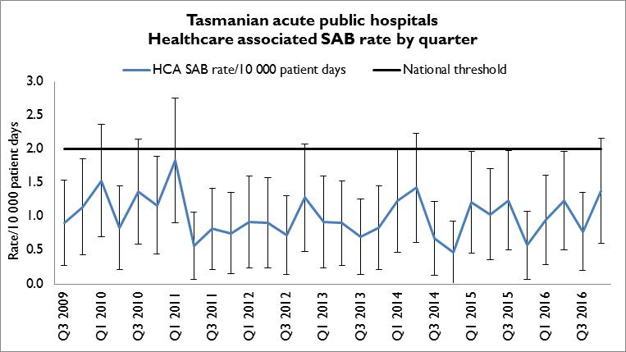

The rate of HCA SAB for Q4 2016 was 1.4 per 10 000 patient days (95% CI 0.6-2.2) which met the National Healthcare Agreement target of no more than two HCA SAB per10 000 patient days.

Hospital rates
Figure 2 presents the individual acute public hospitals rates of HCA SAB by quarter. This information is also contained in tables within the appendix.
Figure 2 Healthcare associated Staphylococcus aureus bacteraemia – individual hospital rate by quarter
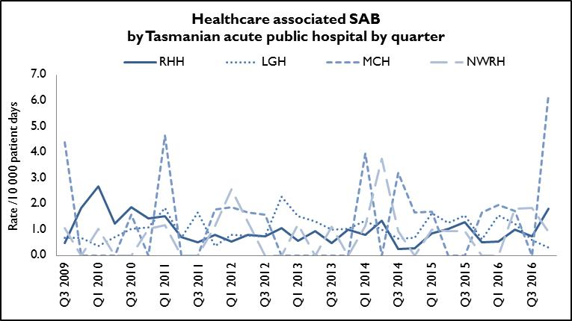

In Q4 2016, there were three HCA SAB identified at the MCH for Q4 2016. Based on the small number of patient days at MCH, the HCA SAB rate for MCH is more than the National Healthcare Agreement target of no more than two HCA SAB per10 000 patient days.
The HCA SAB rate for RHH, LGH and NWRH was less than the National Healthcare Agreement target of no more than two HCA SAB per10 000 patient days.

Clostridium difficile infection
Clostridium difficile infection (CDI) is a bowel infection caused by the bacterium Clostridium difficile and is a common cause of healthcare associated diarrhoea. CDI causes significant patient morbidity and mortality and can result in increased hospital stays and costs. Factors that may contribute to higher CDI rates include the overuse of antibiotics, ineffective infection control processes and suboptimal environmental cleanliness.
Surveillance of CDI in Tasmania uses the ACSQHC’s national surveillance definitions. There is no National benchmark for CDI.
Hospital identified CDI are CDI infections identified in a hospital; this category includes healthcare facility and community associated infections.
Healthcare associated – healthcare facility onset (HCA-HCF) CDI are a sub-group of hospital identified cases. This category only includes infections that occurred 48 hours or more after a patient was admitted to hospital. The HCA – HCF rate excludes people who present to hospital with symptoms of CDI and/or develop symptoms within two days of admission.

Tasmanian rates
Figure 3 Acute public hospital identified CDI and HCA-HCF CDI – rates by quarter.
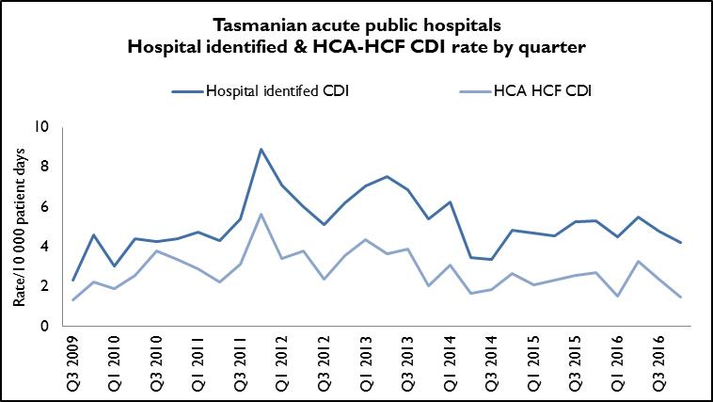
The rate of hospital identified CDI for Q4 2016 was 4.2 per 10 000 patient days (95%
CI 2.8 – 5.6) and the rate of HCA-HCF over the same period was 1.5 per10 000 patient days (95% CI 0.6 – 2.3).

Hospital rates – by quarter
The following figures presents the individual acute public hospital rates of ‘hospital identified CDI’ and ‘healthcare associated – healthcare facility onset (HCA-HCF)’ CDI by quarter.
Figure 4 Hospital identified CDI by quarter
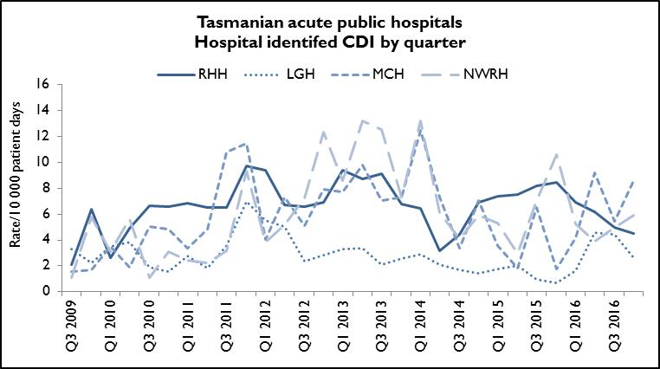

Figure 5 HCA-HCF CDI by quarter
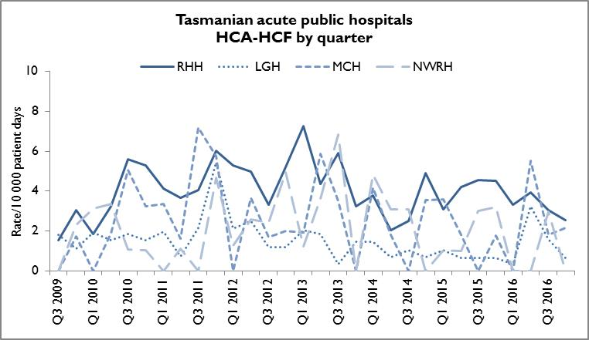

Vancomycin resistant enterococci
Enterococci are bacteria normally present in the human gastrointestinal and female genital tract and can cause infections of the urinary tract, bloodstream and wounds. Enterococci that have acquired resistance to the antibiotic vancomycin are called vancomycin-resistant enterococci or VRE. VRE infections can be more difficult to treat then those caused by vancomycin sensitive enterococci. Factors that can contribute to the transmission of VRE in hospitals are ineffective infection control practices, overuse of antibiotics and suboptimal environmental cleanliness.
Identification of VRE is notifiable in Tasmania pursuant to the Public Health Act 1997.
Figure 6 presents the total of all new VRE screening and clinical isolates identified within Tasmania by quarter. These numbers include all new cases identified within Tasmania from public and private hospitals, rural hospitals, GP clinics and long term and residential care facilities. A person’s first VRE isolate is classified according to whether it was from a screening or clinical specimen.

Figure 6 New VRE isolates by quarter
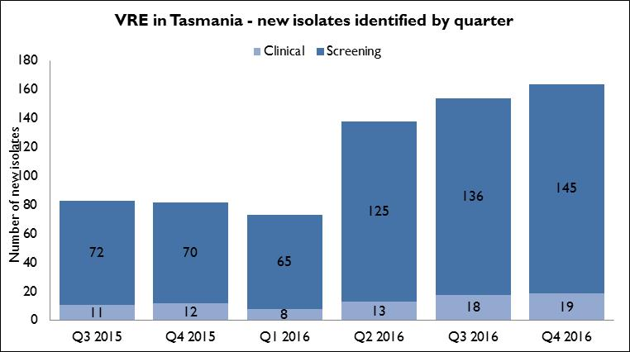

The number of people newly identified with VRE within hospitals does not necessarily reflect that VRE was acquired at that hospital. The numbers of VRE isolates identified can be affected by the amount of screening undertaken by hospitals. Hospitals that have an intensive screening program are likely to identify more VRE. During the past two years there has been an increase in identification of VRE. The majority of isolates over that time have been, and continue to be, screening specimens. In Q4 2016, there were 19 specimens (12%) that were clinical specimens, which is a similar proportion to the last four quarters.

Figure 7 New VRE isolates – classification
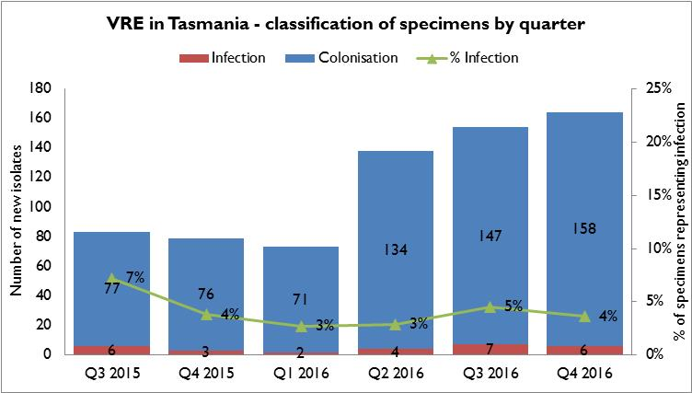
VRE isolates are also classified as to whether they represent colonisation or infection. The proportion of isolates that represent infections has remained stable over the last six quarters with infections representing around 4% of total isolates.
Figure 8 New VRE isolates by genotype by quarter
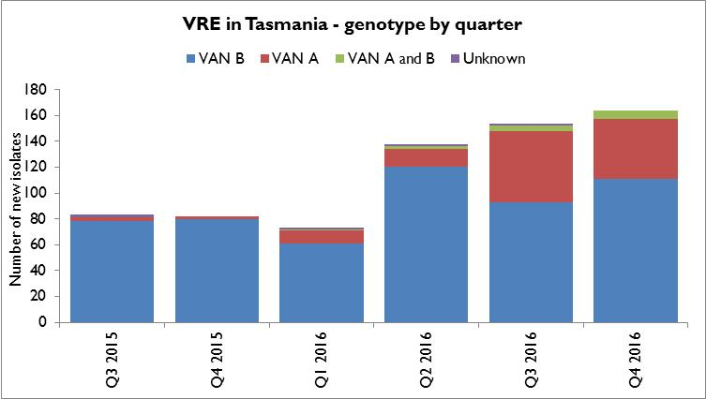
The majority of VRE within Tasmania remains vanB E. faecium but there has been a recent increase in the number and proportion of isolates with the vanA genotype. This is a concern as there are limited antimicrobial choices for treatment of infection with this organism.

Acknowledgements
The production of this report is the culmination of data collection, analysis and input from a number of different organisations. In particular, we would like to acknowledge:
- Executive Director of Nursing THS North
- Executive Director of Nursing THS North West
- Executive Director of Nursing THS South
- Launceston General Hospital Infection Prevention and Control Unit
- North West Regional Hospital Infection Control Team
- Mersey Community Hospital Infection Control Team
- Royal Hobart Hospital Infection Prevention and Control Unit
- Microbiology Departments at the Royal Hobart Hospital, Launceston General Hospital and DSPL
- Hand Hygiene Australia
- Communicable Diseases Prevention Unit, Public Health Services
- Contributing Primary Health Sites

Appendix 1

Explanatory notes

What types of healthcare surveillance are done in Tasmania?
TIPCU undertakes surveillance of the following:
- Staphylococcus aureus bacteraemia (bloodstream infection).
- Clostridium difficile infection (CDI).
- Vancomycin resistant enterococci (VRE).
- Hand hygiene compliance rates.
- Antibiotic utilisation.

What do the rates mean?
The healthcare surveillance data are expressed as a rate or a raw number. SAB and CDI are expressed as a rate per 10 000 patient days, VRE is expressed as a raw number, hand hygiene compliance is expressed as a percentage and antibiotic utilisation is expressed as hospital use measured by defined daily doses, per 1 000 occupied bed days.

What are the definitions for Clostridium difficile infection (CDI)?
TIPCU use the national surveillance definitions published by the Australian Commission on Safety and Quality in Health Care (ACSQHC) to classify CDI. TIPCU reports on:
- Hospital identified CDI is defined as a case diagnosed in a patient attending an acute care facility. This includes positive specimens obtained from admitted patients and those attending the emergency department and outpatient departments. This definition excludes patients less than two years old and cases with a positive test within the previous eight weeks.
- Healthcare associated – healthcare facility onset CDI (HCA-HCF CDI) is defined as a patient with CDI symptom onset (or date and time of stool specimen collection if a laboratory system is used) more than 48 hours after admission to a healthcare facility. This definition excludes patients less than two years old and cases with a positive test within the previous eight weeks.

What are the definitions for healthcare associated Staphylococcus aureus bacteraemia (SAB)?
Criterion A the patient’s first SAB blood culture was collected more than 48 hours after hospital admission or less than 48 hours after discharge.
OR
Criterion B the patient’s first positive SAB blood culture was collected less than or equal to 48 hours after hospital admission and one or more of the following key clinical criteria was met for the patient-episode of SAB.
Key clinical criteria:
- SAB is a complication of the presence of an indwelling medical device (eg intravascular line, haemodialysis vascular access, CSF shunt, urinary catheter).
- SAB occurs within 30 days of a surgical procedure or 365 days for surgically implanted devices, where the SAB is related to the surgical site.
- SAB was diagnosed within 48 hours of a related invasive instrumentation or incision.
- SAB is associated with neutropenia (less 1 x 10⁹/L) contributed to by cytotoxic therapy.
What are the definitions for vancomycin resistant enterococci (VRE)?
The definition for VRE is an isolate identified as VRE by an accredited laboratory. TIPCU reports on the total number of people with new isolates of VRE identified in Tasmania per quarter and this number includes all people with new VRE isolates from public and private hospitals, rural hospitals, GP clinics and long term and residential care facilities.

Confidence intervals
Confidence intervals are used to calculate the range in which the true rate probably lies. As an example, when looking at the hand hygiene compliance (HHC) data “confidence intervals calculate the range in which the true compliance result lies, based on the data collected and the compliance measured, thus providing an indication of the reliability of the reported HHC level. When only a small number of moments are collected, the confidence interval will be larger, as it is more difficult to establish the true compliance level from a small sample of moments. If a large number of moments are collected the confidence interval will be smaller, meaning the reliability of the result is higher. Hand Hygiene Australia (HHA) calculates 95 per cent confidence intervals, indicating the intervals in which 95 per cent of the time the true compliance level lies.” (HHA 2011)
Patient care days
Patient days is the term to explain the total days patients are in hospital. In each of Tasmania’s four larger acute public hospitals there are around 330 000 patient care days a year. When a rate is presented as a number per 10 000 patient days this presents the number of infections that occur for every 10 000 patient care days.

Can I compare Tasmanian hospital infection rates?
Each Tasmanian hospital provides different services and has patients with different levels of illness. This affects infection rates. For example, very sick immuno-compromised patients may be more likely to get infections. It is difficult to remove all of the factors outside the control of a hospital that can cause its infection rate to differ from other hospitals.
Other reasons for caution when comparing hospitals include:
- some hospitals may screen patients more than others. This can affect data for CDI and VRE in particular
- hospital laboratories may use different ways of identifying organisms. A laboratory that has a more sensitive way of looking for organisms may find more
- for hand hygiene, rural hospitals are not required to collect as many moments as the four acute public hospitals, so comparisons between rural and acute hospitals are not recommended.

Appendix 2

Staphylococcus aureus bacteraemia (SAB)
Table 1 Tasmanian numbers and rate per 10 000 patient days of HCA-SAB.
Quarter | Total HCA-SAB | Number MSSA | Number MRSA | HCA SAB Rate
Q1 2012 | 7 | 6 | 1 | 0.9
Q2 2012 | 7 | 6 | 1 | 0.9
Q3 2012 | 6 | 6 | 0 | 0.7
Q4 2012 | 10 | 9 | 1 | 1.3
Q1 2013 | 7 | 7 | 0 | 0.9
Q2 2013 | 8 | 7 | 1 | 0.9
Q3 2013 | 6 | 6 | 0 | 0.7
Q4 2013 | 7 | 7 | 0 | 0.8
Q1 2014 | 10 | 9 | 1 | 1.2
Q2 2014 | 12 | 10 | 2 | 1.4
Q3 2014 | 6 | 6 | 0 | 0.7
Q4 2014 | 4 | 4 | 0 | 0.5
Q1 2015 | 10 | 9 | 1 | 1.2
Q2 2015 | 9 | 7 | 2 | 1.0
Q3 2015 | 12 | 10 | 2 | 1.4
Q4 2015 | 5 | 4 | 1 | 0.6
Q1 2016 | 8 | 6 | 2 | 1.0
Q2 2016 | 11 | 10 | 1 | 1.2
Q3 2016 | 7 | 7 | 0 | 0.8
Q4 2016 | 11 | 10 | 1 | 1.3

Table 2 Royal Hobart Hospital numbers and rates per10 000 patient days of HCA-SAB
Quarter | Total HCA-SAB | Number MSSA | Number MRSA | HCA SAB Rate
Q1 2012 | 2 | 2 | 0 | 0.5
Q2 2012 | 3 | 3 | 0 | 0.8
Q3 2012 | 3 | 3 | 0 | 0.8
Q4 2012 | 4 | 4 | 0 | 1.1
Q1 2013 | 2 | 2 | 0 | 0.6
Q2 2013 | 4 | 4 | 0 | 0.9
Q3 2013 | 2 | 2 | 0 | 0.5
Q4 2013 | 4 | 4 | 0 | 1.0
Q1 2014 | 3 | 3 | 0 | 0.8
Q2 2014 | 5 | 4 | 1 | 1.3
Q3 2014 | 1 | 1 | 0 | 0.3
Q4 2014 | 1 | 0 | 0 | 0.3
Q1 2015 | 3 | 2 | 1 | 0.8
Q2 2015 | 4 | 4 | 0 | 1.0
Q3 2015 | 5 | 5 | 0 | 1.3
Q4 2015 | 2 | 2 | 0 | 0.5
Q1 2016 | 2 | 2 | 0 | 0.5
Q2 2016 | 4 | 4 | 0 | 1.0
Q3 2016 | 3 | 3 | 0 | 0.8
Q4 2016 | 7 | 7 | 0 | 1.8

Table 3 Launceston General Hospital numbers and rates per10 000 patient days of HCA-SAB
Quarter | Total HCA-SAB | Number MSSA | Number MRSA | HCA SAB Rate
Q1 2012 | 2 | 1 | 1 | 0.8
Q2 2012 | 2 | 2 | 0 | 0.8
Q3 2012 | 2 | 2 | 0 | 0.7
Q4 2012 | 6 | 5 | 1 | 2.3
Q1 2013 | 4 | 4 | 0 | 1.5
Q2 2013 | 4 | 3 | 1 | 1.3
Q3 2013 | 3 | 3 | 0 | 1.0
Q4 2013 | 3 | 3 | 0 | 1.0
Q1 2014 | 4 | 4 | 0 | 1.4
Q2 2014 | 3 | 2 | 1 | 1.0
Q3 2014 | 2 | 2 | 0 | 0.6
Q4 2014 | 2 | 2 | 0 | 0.7
Q1 2015 | 5 | 5 | 0 | 1.6
Q2 2015 | 4 | 2 | 2 | 1.3
Q3 2015 | 5 | 3 | 2 | 1.5
Q4 2015 | 2 | 1 | 1 | 0.6
Q1 2016 | 5 | 3 | 2 | 1.6
Q2 2016 | 4 | 4 | 0 | 1.2
Q3 2016 | 2 | 2 | 0 | 0.6
Q4 2016 | 1 | 0 | 1 | 0.3

Table 4 Mersey Community Hospital numbers and rates per10 000 patient days of HCA-SAB
Quarter | Total HCA-SAB | Number MSSA | Number MRSA | HCA SAB Rate
Q1 2012 | 1 | 1 | 0 | 1.9
Q2 2012 | 1 | 1 | 0 | 1.7
Q3 2012 | 1 | 1 | 0 | 1.6
Q4 2012 | 0 | 0 | 0 | 0.0
Q1 2013 | 0 | 0 | 0 | 0.0
Q2 2013 | 0 | 0 | 0 | 0.0
Q3 2013 | 0 | 0 | 0 | 0.0
Q4 2013 | 0 | 0 | 0 | 0.0
Q1 2014 | 2 | 2 | 0 | 3.9
Q2 2014 | 0 | 0 | 0 | 0.0
Q3 2014 | 2 | 2 | 0 | 3.2
Q4 2014 | 1 | 1 | 0 | 1.7
Q1 2015 | 1 | 1 | 0 | 1.7
Q2 2015 | 0 | 0 | 0 | 0.0
Q3 2015 | 1 | 1 | 0 | 1.5
Q4 2015 | 1 | 1 | 0 | 1.7
Q1 2016 | 1 | 1 | 0 | 2.0
Q2 2016 | 1 | 1 | 0 | 1.7
Q3 2016 | 0 | 0 | 0 | 0.0
Q4 2016 | 3 | 3 | 0 | 6.2

Table 5 North West Regional Hospital numbers and rates per10 000 patient days of HCA-SAB.
Quarter | Total HCA-SAB | Number MSSA | Number MRSA | HCA SAB Rate
Q1 2012 | 2 | 2 | 0 | 2.6
Q2 2012 | 1 | 0 | 1 | 1.3
Q3 2012 | 0 | 0 | 0 | 0.0
Q4 2012 | 0 | 0 | 0 | 0.0
Q1 2013 | 1 | 1 | 0 | 1.2
Q2 2013 | 0 | 0 | 0 | 0.0
Q3 2013 | 1 | 1 | 0 | 1.1
Q4 2013 | 0 | 0 | 0 | 0.0
Q1 2014 | 1 | 0 | 1 | 1.2
Q2 2014 | 4 | 4 | 0 | 3.7
Q3 2014 | 1 | 1 | 0 | 1.0
Q4 2014 | 0 | 0 | 0 | 0.0
Q1 2015 | 1 | 1 | 0 | 1.0
Q2 2015 | 1 | 1 | 0 | 0.9
Q3 2015 | 1 | 1 | 0 | 0.9
Q4 2015 | 0 | 0 | 0 | 0.0
Q1 2016 | 0 | 0 | 0 | 0.0
Q2 2016 | 2 | 1 | 1 | 1.8
Q3 2016 | 2 | 2 | 0 | 1.8
Q4 2016 | 1 | 1 | 0 | 0.9

Clostridium difficile infection (CDI)
Table 6 Tasmanian numbers and rates per10 000 patient days of CDI
Quarter | Total hospital identified CDI | Hospital identified Rate | Total HCA HCF | HCA HCF Rate
Q1 2012 | 50 | 7.1 | 24 | 3.4
Q2 2012 | 43 | 6.0 | 27 | 3.8
Q3 2012 | 39 | 5.1 | 18 | 2.4
Q4 2012 | 45 | 6.2 | 26 | 3.6
Q1 2013 | 50 | 7.1 | 31 | 4.4
Q2 2013 | 57 | 7.5 | 27 | 3.6
Q3 2013 | 55 | 6.9 | 31 | 3.9
Q4 2013 | 42 | 5.4 | 16 | 2.1
Q1 2014 | 47 | 6.3 | 23 | 3.1
Q2 2014 | 27 | 3.5 | 13 | 1.7
Q3 2014 | 27 | 3.4 | 15 | 1.9
Q4 2014 | 38 | 4.8 | 21 | 2.7
Q1 2015 | 36 | 4.7 | 16 | 2.1
Q2 2015 | 37 | 4.6 | 19 | 2.3
Q3 2015 | 43 | 5.2 | 21 | 2.6
Q4 2015 | 43 | 5.3 | 22 | 2.7
Q1 2016 | 35 | 4.5 | 12 | 1.5
Q2 2016 | 45 | 5.5 | 17 | 2.1
Q3 2016 | 40 | 4.8 | 20 | 2.4
Q4 2016 | 34 | 4.2 | 12 | 1.5

Table 7 Hospital numbers and rates per10 000 patient days of hospital identified CDI
Quarter | Royal Hobart |  | Launceston General |  | Mersey Community |  | NW Regional
 | Total | Rate | Total | Rate | Total | Rate | Total | Rate
Q1 2012 | 32 | 9.4 | 13 | 5.5 | 2 | 4.0 | 3 | 3.9
Q2 2012 | 23 | 6.7 | 12 | 5.0 | 4 | 7.3 | 4 | 5.2
Q3 2012 | 24 | 6.6 | 6 | 2.4 | 3 | 5.1 | 6 | 7.3
Q4 2012 | 24 | 6.9 | 7 | 2.8 | 4 | 7.9 | 10 | 12.3
Q1 2013 | 31 | 9.4 | 8 | 3.3 | 4 | 7.7 | 7 | 8.6
Q2 2013 | 32 | 8.7 | 9 | 3.4 | 5 | 9.8 | 11 | 13.2
Q3 2013 | 34 | 9.1 | 6 | 2.1 | 4 | 7.0 | 11 | 12.5
Q4 2013 | 25 | 6.8 | 7 | 2.6 | 4 | 7.3 | 6 | 7.3
Q1 2014 | 22 | 6.4 | 8 | 2.9 | 6 | 12.5 | 11 | 13.2
Q2 2014 | 11 | 3.2 | 6 | 2.1 | 4 | 7.3 | 6 | 6.1
Q3 2014 | 16 | 4.5 | 5 | 1.7 | 2 | 3.4 | 4 | 4.1
Q4 2014 | 24 | 6.9 | 4 | 1.4 | 4 | 7.1 | 6 | 5.9
Q1 2015 | 24 | 7.4 | 5 | 1.7 | 2 | 3.6 | 5 | 5.3
Q2 2015 | 27 | 7.5 | 6 | 2.0 | 1 | 1.8 | 3 | 3.0
Q3 2015 | 29 | 8.2 | 3 | 1.0 | 4 | 6.5 | 7 | 7.0
Q4 2015 | 30 | 8.5 | 2 | 0.7 | 1 | 1.8 | 10 | 10.6
Q1 2016 | 23 | 6.9 | 5 | 1.6 | 2 | 4.2 | 5 | 5.3
Q2 2016 | 22 | 6.2 | 14 | 4.6 | 5 | 9.2 | 4 | 3.9
Q3 2016 | 18 | 5.0 | 14 | 4.4 | 3 | 5.5 | 5 | 4.9
Q4 2016 | 16 | 4.5 | 8 | 2.6 | 4 | 8.6 | 6 | 5.9

Table 8 Hospital numbers and rates per10 000 patient days of HCA-HCF CDI
Quarter | Royal Hobart |  | Launceston General |  | Mersey Community |  | NW Regional
 | Total | Rate | Total | Rate | Total | Rate | Total | Rate
Q1 2012 | 18 | 5.3 | 5 | 2.1 | 0 | 0.0 | 1 | 1.3
Q2 2012 | 17 | 5.0 | 6 | 2.5 | 2 | 3.6 | 2 | 2.6
Q3 2012 | 12 | 3.3 | 3 | 1.2 | 1 | 1.7 | 2 | 2.4
Q4 2012 | 18 | 5.2 | 3 | 1.2 | 1 | 2.0 | 4 | 4.9
Q1 2013 | 24 | 7.2 | 5 | 2.1 | 1 | 1.9 | 1 | 1.2
Q2 2013 | 16 | 4.4 | 5 | 1.9 | 3 | 5.9 | 3 | 3.6
Q3 2013 | 22 | 5.9 | 1 | 0.4 | 2 | 3.5 | 6 | 6.8
Q4 2013 | 12 | 3.2 | 4 | 1.5 | 0 | 0.0 | 0 | 0.0
Q1 2014 | 13 | 3.8 | 4 | 1.4 | 2 | 4.2 | 4 | 4.8
Q2 2014 | 7 | 2.0 | 2 | 0.7 | 1 | 1.8 | 3 | 3.1
Q3 2014 | 9 | 2.5 | 3 | 1.0 | 0 | 0.0 | 3 | 3.1
Q4 2014 | 17 | 4.9 | 2 | 0.7 | 2 | 3.5 | 0 | 0.0
Q1 2015 | 10 | 3.1 | 3 | 1.0 | 2 | 3.6 | 1 | 1.1
Q2 2015 | 15 | 4.2 | 2 | 0.7 | 1 | 1.8 | 1 | 1.0
Q3 2015 | 16 | 4.5 | 2 | 0.7 | 0 | 0.0 | 3 | 3.0
Q4 2015 | 16 | 4.5 | 2 | 0.7 | 1 | 1.8 | 3 | 3.2
Q1 2016 | 11 | 3.3 | 1 | 0.3 | 0 | 0.0 | 0 | 0.0
Q2 2016 | 14 | 3.9 | 10 | 3.3 | 3 | 5.5 | 0 | 0.0
Q3 2016 | 11 | 3.0 | 5 | 1.6 | 1 | 1.8 | 3 | 3.0
Q4 2016 | 9 | 2.5 | 2 | 0.7 | 1 | 2.1 | 0 | 0.0

Vancomycin resistant enterococci (VRE)
Table 9 VRE isolates identified per quarter within a) acute public hospitals, b) other healthcare settings (private hospitals, rural hospitals, GP clinics and long term and residential care facilities) and c) total Tasmanian isolates.
 | RHH | LGH | MCH | NWRH | Other healthcare settings | Total
Q1 2012 | 3 | 2 | 2 | 2 | 1 | 10
Q2 2012 | 4 | 2 | - | 1 | - | 7
Q3 2012 | 3 | 2 | 2 | - | 1 | 8
Q4 2012 | 1 | 7 | 1 | 1 | 2 | 12
Q1 2013 | 13 | 0 | 3 | - | 2 | 18
Q2 2013 | 8 | 3 | - | 1 | 3 | 15
Q 3 2013 | 8 | 1 | - | 2 | 1 | 12
Q4 2013 | 5 | 3 | - | 3 | 5 | 16
Q1 2014 | 5 | - | 1 | 1 | 1 | 8
Q2 2014 | 3 | 6 | 1 | 1 | 2 | 13
Q3 2014 | 1 | 2 | 3 | 2 | - | 8
Q4 2014 | 1 | 5 | 1 | 5 | 7 | 19
Q1 2015 | 10 | 12 | 2 | 5 | 7 | 36
Q2 2015 | 5 | 13 | 2 | 1 | 8 | 29
Q3 2015 | 33 | 17 | 9 | 5 | 19 | 83
Q4 2015 | 36 | 22 | 0 | 11 | 13 | 82
Q1 2016 | 28 | 26 | 7 | 4 | 8 | 73
Q2 2016 | 51 | 48 | 12 | 14 | 12 | 138
Q3 2016 | 30 | 65 | 8 | 23 | 28 | 154
Q4 2016 | 51 | 67 | 5 | 15 | 26 | 164

Table 10 Classification of first VRE isolates – number of screening and clinical specimens; and of clinical specimens that indicate an infection
Quarter | Total VRE | Screening specimens | Clinical specimens
Q1 2012 | 10 | 8 | 2
Q2 2012 | 7 | 7 | 0
Q3 2012 | 8 | 8 | 0
Q4 2012 | 12 | 9 | 3
Q1 2013 | 18 | 17 | 1
Q2 2013 | 15 | 13 | 2
Q3 2013 | 12 | 10 | 2
Q4 2013 | 16 | 14 | 2
Q1 2014 | 8 | 6 | 2
Q2 2014 | 13 | 11 | 2
Q3 2014 | 8 | 8 | 0
Q4 2014 | 19 | 19 | 0
Q1 2015 | 36 | 27 | 9
Q2 2015 | 29 | 16 | 13
Q3 2015 | 83 | 72 | 11
Q4 2015 | 82 | 70 | 12
Q1 2016 | 73 | 65 | 8
Q2 2016 | 138 | 125 | 13
Q3 2016 | 154 | 136 | 18
Q4 2016 | 164 | 145 | 19

Table 11 Classification of first VRE isolates – colonisation and infection
Quarter | Total VRE | Colonisation | Infection | % infection
Q1 2012 | 10 | 8 | 2 | 20%
Q2 2012 | 7 | 7 | 0 | 0%
Q3 2012 | 8 | 8 | 0 | 0%
Q4 2012 | 12 | 9 | 3 | 25%
Q1 2013 | 18 | 18 | 0 | 0%
Q2 2013 | 15 | 13 | 2 | 13%
Q3 2013 | 12 | 11 | 1 | 8%
Q4 2013 | 16 | 16 | 0 | 0%
Q1 2014 | 8 | 7 | 1 | 13%
Q2 2014 | 13 | 13 | 0 | 0%
Q3 2014 | 8 | 8 | 0 | 0%
Q4 2014 | 19 | 19 | 0 | 0%
Q1 2015 | 36 | 29 | 7 | 19%
Q2 2015 | 29 | 18 | 11 | 38%
Q3 2015 | 83 | 77 | 6 | 7%
Q4 2015* | 82 | 76 | 3 | 4%
Q1 2016 | 73 | 71 | 2 | 3%
Q2 2016 | 138 | 134 | 4 | 3%
Q3 2016 | 154 | 147 | 17 | 5%
Q4 2016 | 164 | 158 | 6 | 4%

* 3 specimens unknown if represented colonisation or infection.

