Staphylococcus aureus bloodstream infection surveillance.
Report, 2010 to 2018
Staphylococcus aureus bloodstream infection surveillance. Report, 2010 to 2018
Department of Health, Tasmania
Published 2019
Copyright—Department of Health, Tasmania
Permission to copy is granted provided the source is acknowledged
Authors
- Ms Fiona Wilson, Clinical Nurse Consultant, TIPCU
- Dr Tara Anderson, Specialist Medical Advisor, TIPCU
- Ms Anne Wells, Assistant Director of Nursing, PHS
Suggested reference: Wilson, F., Anderson, T., Wells, A. (2019). Staphylococcus aureus bloodstream infection surveillance. Report, 2010 to 2018. Hobart: Department of Health.
Reviewed and approved by the:
- Tasmanian Health Service - Executive Director of Nursing North, Executive Director of Nursing North West, Nursing Director South – Critical Care, Clinical Support and Investigations
- Tasmanian Department of Health - Director of Public Health

Contents

Contents 3
Background 4
Definitions 5
Surveillance definitions 6
Rate calculations 6
Staphylococcus aureus bacteraemia in Tasmania 7
SAB and methicillin susceptibility 8
Community associated SAB 9
Healthcare associated SAB 10
Individual hospital HCA SAB rate comparisons with National peer group average 12
Device related HCA SAB 15
Key findings 16
References 17

Figure 1 SAB - Tasmanian number and incidence per year 7
Figure 2 SAB classification - Tasmanian number per year 7
Figure 3 Number of MSSA and MRSA SAB 8
Figure 4 Community associated CA-SAB – number and incidence per100 000 population 9
Figure 5 Total acute public hospital HCA SAB number 10
Figure 6 Total acute public hospital HCA SAB rate per 10 000 patient days 10
Figure 7 Individual acute public hospitals HCA SAB rate per 10 000 patient days 11
Figure 8 HCA SAB - State and Territory combined public hospital rates 12
Figure 9 Royal Hobart Hospital compared with National peer group (Major Hospitals) 13
Figure 10 Launceston General Hospital compared with National peer group (Large Hospitals) 13
Figure 11 Mersey Community Hospital compared with National peer group (Medium Hospitals) 14
Figure 12 North West Regional Hospital compared with National peer group (Large Hospitals) 14
Figure 13 Classification of HCA SAB – number and percentage by calendar year 15

Background
Staphylococcus aureus is a common pathogen which causes a wide range of community and health-care associated infections including bloodstream infections (bacteraemia). Staphylococcus aureus bacteraemia (SAB) is associated with significant morbidity and a 30-day mortality of 15-30% (ACSQHC 2019). The overall 30-day all-cause mortality is reported to be 14.8% with a significant difference in all-cause mortality between community (13.7%) and hospital-onset (18.3%) SAB (AGAR 2018).
The Tasmanian Infection and Prevention and Control Unit (TIPCU) coordinates the collection, analysis and reporting of SAB surveillance data in Tasmania using the national surveillance definitions published by the Australian Commission on Safety and Quality in Health Care (ACSQHC) (2013) and the TIPCU ‘SAB surveillance protocol’ (Wilson, Hughson, Wells and Anderson, 2016).
Staphylococcus aureus bacteraemia is a notifiable condition in Tasmania under the Public Health Act 1997 (Tasmanian Government 2017) so all cases of SAB are required to be notified to Public Health Services. Public hospital healthcare associated SAB (HCA SAB) are an Australian National Healthcare Agreement performance indicator (Australian Institute of Health and Welfare 2018) and are reported publicly on the MyHospitals website. In addition, all SAB identified at the Royal Hobart Hospital (RHH) and Launceston General Hospital (LGH) microbiology laboratories are reported to the Australian Group on Antimicrobial Resistance (AGAR). These data are published by the Australian Staphylococcal Sepsis Outcome Program and the Antimicrobial Use and Resistance in Australia (AURA) Surveillance System reports (AGAR 2018, ACSQHC 2019).
This report provides cumulative data of all Staphylococcus aureus bacteraemia (SAB) notified in Tasmania from 2010 to 2018 with a focus on public hospital healthcare associated SAB; comparisons where possible with AGAR data; and comparisons of individual Tasmanian public hospital associated SAB with their hospital peer groups.
Data sourced from the MyHospitals website is reported by financial year as per their on-line reports. All other SAB data in this report is reported by calendar year.

Definitions
Inpatient healthcare facility – facility where patients can be admitted for overnight stay and includes acute private or public hospitals, rural hospital, sub-acute facility, long term care facility, nursing home.
Inpatient – patient who has a minimum of an overnight stay in a healthcare facility.
Outpatient – patient who visits a healthcare facility for a medical, allied health or similar appointment.
Day case – a patient who attends a healthcare facility for a full or part day for a course of treatment.
Patient days – the total number of days for all patients who were admitted for an episode of care and who separated during a specific reference period.
MSSA – methicillin sensitive Staphylococcus aureus
MRSA - methicillin resistant Staphylococcus aureus
Hospital peer groups – categorisation and grouping of Australian public and private hospitals into peer groups of facilities with shared characteristics that allows for comparisons between similar hospitals (AIHW 2015).
The peer groups on MyHospitals that are relevant to this report are:
- Major Hospitals group - Royal Hobart Hospital (RHH).
- Large Hospitals group - Launceston General Hospital (LGH) and North West Regional Hospital (NWRH).
- Medium Hospitals group - Mersey Community Hospital (MCH).

Surveillance definitions
These definitions have been maintained throughout the period of this report.
All SAB notified in Tasmania are classified according to the following surveillance definitions:
Healthcare associated SAB (HCA – SAB) – a SAB that meets either Criterion A or Criterion B of the surveillance definitions
Criterion A - the patient’s first positive SAB blood culture was collected more than 48 hours after hospital admission or within 48 hours of discharge.
OR
Criterion B - the patient’s first positive SAB blood culture was collected less than or equal to 48 hours after hospital admission and one or more of the following key clinical criteria was met for the patient-episode of SAB.
Key clinical criteria:
- SAB is a complication of the presence of an indwelling medical device (eg intravascular line, haemodialysis vascular access, CSF shunt, urinary catheter).
- SAB occurs within 30 days of a surgical procedure or 365 days for surgically implanted devices, where the SAB is related to the surgical site.
- SAB was diagnosed within 48 hours of a related invasive instrumentation or incision.
- SAB is associated with neutropenia (less 1 x 10⁹/L) contributed to by cytotoxic therapy.
Community associated SAB - the patients first positive SAB blood culture was collected less than or equal to 48 hours after admission and none of the key clinical criteria were met.
Contaminant – the clinical picture does not support infection AND either a repeat blood culture is negative, AND/OR no S. aureus targeted antibiotic treatment is given.
Unknown – the place of acquisition is not known.
Excluded data – any Staphylococcus aureus isolated from a blood culture specimen that:
- Is the second or more Staphylococcus aureus isolate from blood culture specimen/s for the same individual within 14 days; or
- Is a contaminant; or
- Was identified from a blood culture taken post mortem.

Rate calculations
$HCA SAB rate=\frac{number of HCA SAB}{number of patient days}$ X 10 000

$Community associated SAB rate=\frac{number of CA SAB}{Tasmanian population}$ X 100 000

Staphylococcus aureus bacteraemia in Tasmania
Figure 1 presents the total number and incidence of all reported SAB in Tasmania per year between 2010 and 2018 and Figure 2 presents the classification of SAB into community or healthcare associated events.
Figure 1 SAB - Tasmanian number and incidence per year
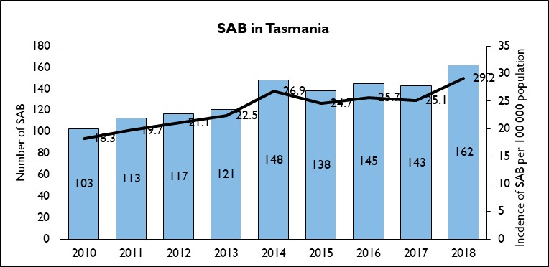
Figure 2 SAB classification - Tasmanian number per year
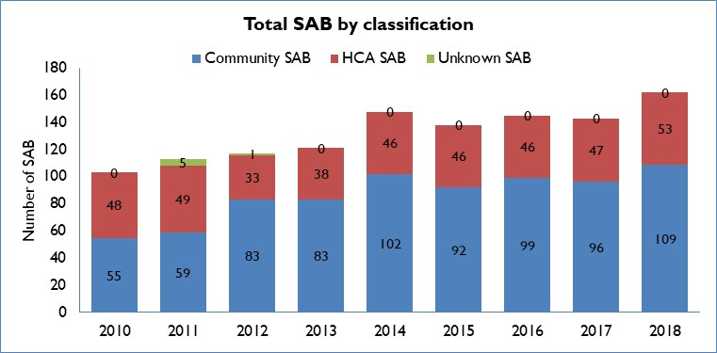
The total annual number and incidence of SAB reported in Tasmania has gradually increased each year since 2010 due to an increase in community associated SAB. There were approximately twice as many CA SAB than HCA SAB from 2010 to 2018 which is similar to reports in other Australian States (Imam N, Tempone S, Armstrong PK, McCann R, Johnson S, Worth LJ and Richards MJ. 2019). Community associated SAB in 2018 accounts for just over two thirds of all SAB which, although not directly comparable, is similar to the national proportion of 77% (AGAR 2018) of SAB being community onset events.

SAB and methicillin susceptibility
Methicillin (flucloxacillin) susceptibility is reported for all Tasmanian SABs. This allows measurement of the proportion of SAB episodes with methicillin (flucloxacillin) resistance, and for identifying trends in resistance over time.
Figure 3 Number of MSSA and MRSA SAB
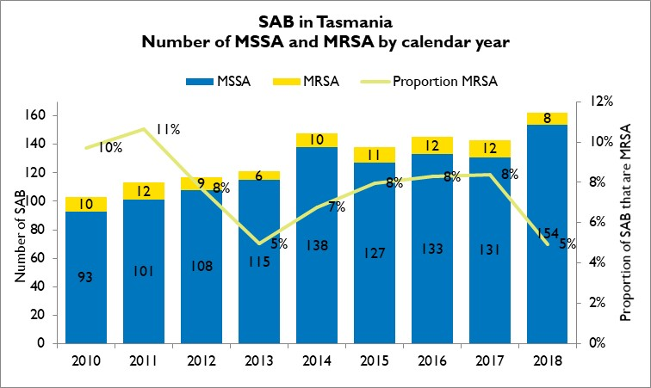
The average proportion of SAB that were MRSA was 8% between 2010 to 2018. This is less than the reported National proportion of 19% (ACSQHC 2019, AGAR 2018). Tasmania and the Australian Capital Territory had the lowest proportions of methicillin resistant SAB of all Australian States and Territories with the highest proportions reported in the Northern Territory (44%) (ACSQHC 2019, AGAR 2018).
Methicillin resistance has historically been regarded as an issue related to healthcare but MRSA bloodstream infections do occur in the community, albeit in lesser numbers than within healthcare. The average proportion of Tasmanian community MRSA SAB between 2010 and 2018 was 6% while the average proportion of HCA MRSA SAB was 12% over the same time.

Community associated SAB
Figure 4 presents the Tasmanian number and incidence per100 000 population of community associated SAB (CA-SAB) by year.
Figure 4 Community associated CA-SAB – number and incidence per100 000 population
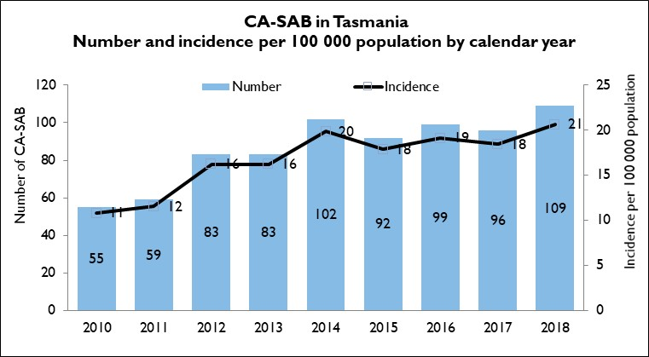
The number and incidence of community associated SAB has doubled between 2010 and 2018. Research is being undertaken in Tasmania to better understand the epidemiology of all SAB in Tasmania between 2011 and 2017 and to describe the differing aetiologies of MSSA and MRSA SAB, and to investigate the potential for under-recognition of the contribution of healthcare to SAB events currently reported as community associated SAB events.

Healthcare associated SAB
Figure 5 presents the number of healthcare associated SAB (HCA SAB) associated with the four larger Tasmanian public hospitals per annum between 2010 and 2018, Figure 6 presents the rate per 10 000 patient beds days over the same time and Figure 7 presents the individual acute public hospitals HCA SAB rate per 10 000 patient days per year.
Figure 5 Total acute public hospital HCA SAB number
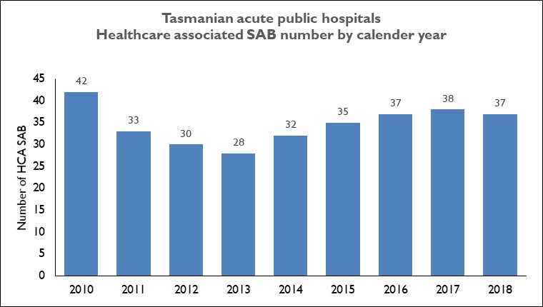
Figure 6 Total acute public hospital HCA SAB rate per 10 000 patient days
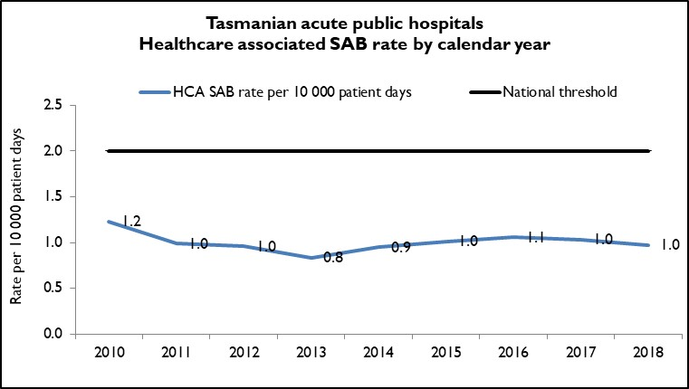
The number and rate of HCA SAB declined between 2010 and 2013, increased in 2014 and 2015 but has remined stable since then. The average number of HCA SAB per year is 35 and the average rate of HCA SAB is one per 10 000 patient days per year.

Figure 7 Individual acute public hospitals HCA SAB rate per 10 000 patient days
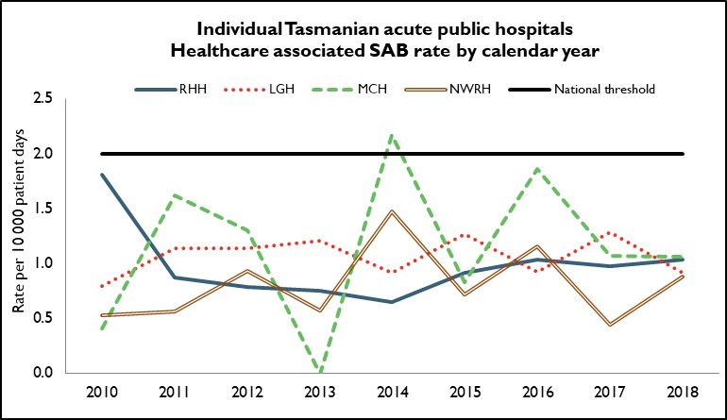
The rate for each individual hospital has been below the National Healthcare Agreement (2011) target of no more than two HCA SAB per10 000 patient days for each public hospital since 2015.
Mersey Community Hospital exceeded the rate threshold in 2014 when they had five HCA SAB but have remained under the threshold since then.
The mean annual number of cases and range for each hospital were as follows: RHH (16, 10 – 30). LGH (13, 9 – 18), MCH 3, (0 – 5), NWRH (3, 2 – 6).

Individual hospital HCA SAB rate comparisons with National peer group average
Healthcare associated SABs associated with public hospitals are an Australian National Healthcare Agreement performance indicator (AIHW 2015). All Tasmanian hospitals provide HCA SAB data annually to the Australian Institute of Health and Welfare (AIHW) who publish aggregated State and Territory data (AIHW 2019) and individual hospital data published on the MyHospitals website (AIHW 2019). Data on MyHospitals allow for rate comparisons to be made between an individual hospital and its peer group.
The peer groups that are relevant to this report are:
- Principal referral hospitals (‘Major hospitals’ on MyHospitals) - Royal Hobart Hospital (RHH).
- Public acute group A hospitals (‘Large hospitals’ on MyHospitals) - Launceston General Hospital (LGH) and North West Regional Hospital (NWRH).
- Public acute group B hospitals (‘Medium hospitals’ on MyHospitals) - Mersey Community Hospital (MCH).
The following graphs use financial year HCA SAB data sourced from the MyHospitals website.
Figure 8 HCA SAB - State and Territory combined public hospital rates
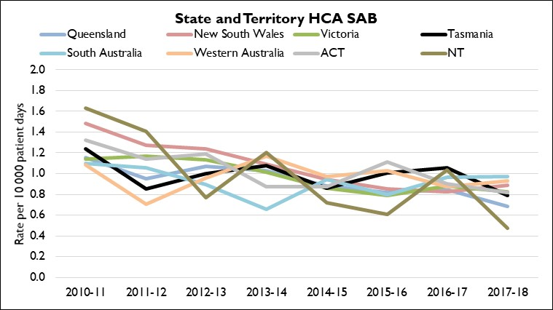
There has been a decrease in rates of HCA SAB across all States and Territories since 2010-11 with Tasmania decreasing from 1.2 HCA SAB per 10 000 patient days in 2010-11 to 0.8 cases per 10 000 patient days in 2017-18. One factor that has contributed to this decrease is improved hand hygiene in healthcare following the implementation of the National Hand Hygiene Initiative.

Figures 9 – 12 illustrate the individual public hospitals HCA SAB rates compared with their peer group.
Figure 9 Royal Hobart Hospital compared with National peer group (Major Hospitals)
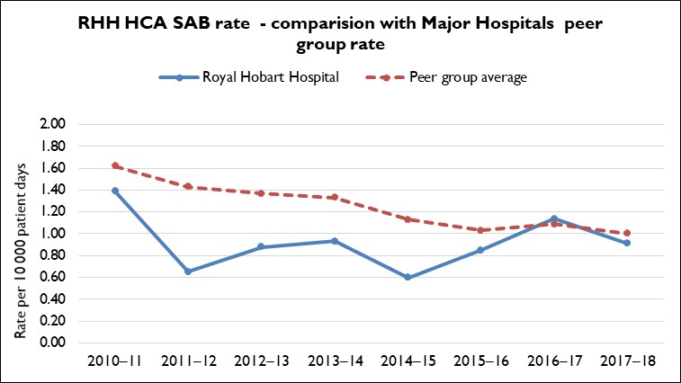
Figure 10 Launceston General Hospital compared with National peer group (Large Hospitals)
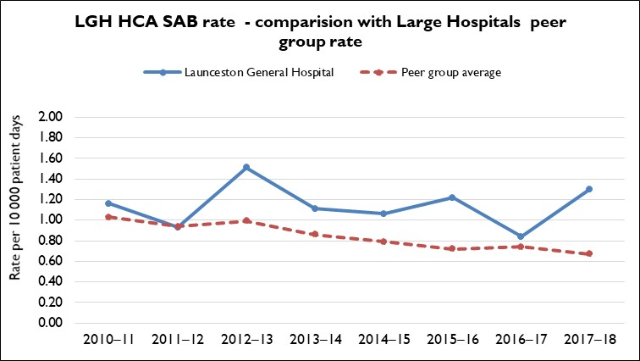

Figure 11 Mersey Community Hospital compared with National peer group (Medium Hospitals)
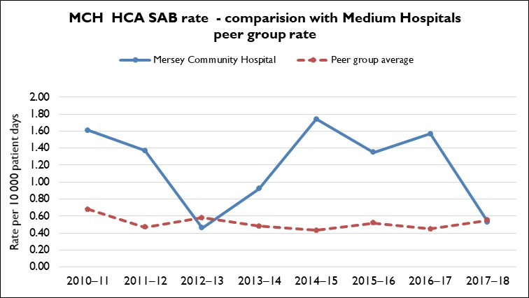
Figure 12 North West Regional Hospital compared with National peer group (Large Hospitals)
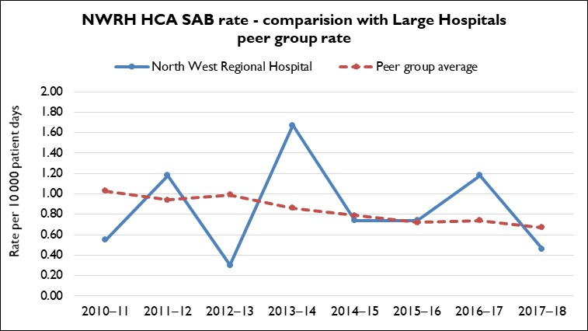
These graphs illustrate that RHH is the only hospital that consistently has an HCA SAB rate less than its peer group average.
Mersey Community Hospital (MCH) has had HCA SAB rates much higher than its peer group average from July 2013 to June 2017. In response, MCH implemented a range of strategies with a focus on intravenous device related HCA SAB. These included a best practice IV device insertion and maintenance protocol, on-going education around hand hygiene, aseptic technique and appropriate documentation, a biannual cannulation course, and a review of skin antisepsis. In 2017 to 2018 the rate decreased to be comparable to their peer group rate.

Device related HCA SAB
Healthcare associated SAB are classified, where possible, by the source of the infection whether that is a medical device (intravenous device and non-intravenous devices), a procedure (surgery and invasive instrumentation), a medical condition (neutropenia) or unknown. Figure 13 presents the number of HCA SAB related to these categories.

Figure 13 Classification of HCA SAB – number and percentage by calendar year
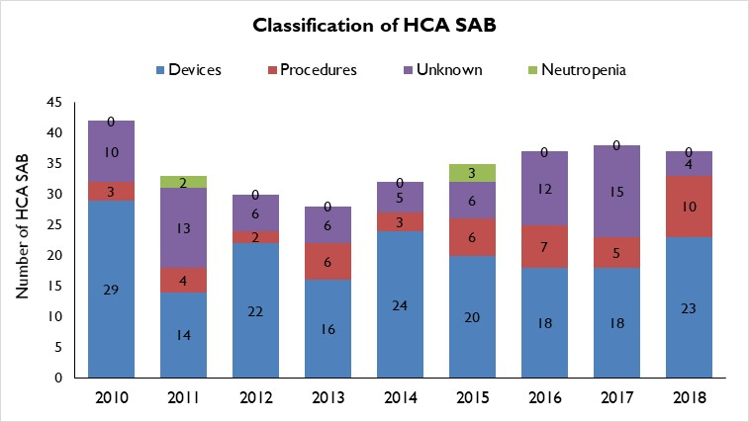
Of the 184 medical device related HCA SABs from 2010 to 2018, 164 (89%) were related to intravenous (IV) devices. In 2018 there were 21 IV device related HCA SAB with 13 (62%) of these related to peripheral IV devices.
Infection prevention strategies such as IV device management procedures and processes, in conjunction with adherence to aseptic technique principles, can reduce the risk of patients developing a SAB secondary to an IV device. These strategies have been implemented in Tasmanian public hospitals but require constant monitoring and ongoing staff education to ensure that they are sustained.

Key findings
The key findings of this report are that from 2010 to 2018:
- The number of SAB reported in Tasmania increased over time, attributable to an increase in community associated SAB.
- The proportion of SAB episodes caused by methicillin resistant Staphylococcus aureus (MRSA) is higher in healthcare associated SAB than in community associated SAB but is lower than that reported nationally.
  - The number and rate of healthcare associated SAB remained stable.
  - All major acute public hospitals in Tasmania have HCA SAB rates less than the National Benchmark of 2.0 per 10 000 patient days
  - Royal Hobart Hospital is the only facility with HCA SAB rates consistently less than their hospital peer group average.
  - The proportion of intravenous device related HCA SAB in public hospitals decreased slightly since 2014 but in 2018 still represented 44% of all HCA SAB. IV device related SAB are potentially preventable events.

References
- Australian Bureau of Statistics. Retrieved from https://www.abs.gov.au/ausstats/abs@.nsf/second+level+view?ReadForm&prodno=3218.0&viewtitle=Regional%20Population%20Growth,%20Australia~2009-10~Previous~31/03/2011&&tabname=Related%20Products&prodno=3218.0&issue=2009-10&num=&view=&; https://www.abs.gov.au/AUSSTATS/abs@.nsf/allprimarymainfeatures/30125843DE7F366ECA2582570013F5FE?opendocument and https://www.abs.gov.au/AUSSTATS/abs@.nsf/allprimarymainfeatures/E18EA7BE5701F459CA2583C3000C53C8?opendocument
- Australian Commission on Safety and Quality in Health Care (ACSQHC) (2019). AURA 2019: third Australian report on antimicrobial use and resistance in human health. Sydney: ACSQHC. Retrieved from https://www.safetyandquality.gov.au/wp-content/uploads/2019/05/AURA-2019-Report.pdf
- The Australian Group on Antimicrobial Resistance (AGAR) (2018). Australian Staphylococcal Sepsis Outcome Program (ASSOP) 2017. Retrieved from http://agargroup.org.au/agar-surveys#Staphylococcus-aureus
- Australian Institute of Health and Welfare (AIHW) (2015). National Healthcare Agreement: PB g–Better health services: the rate of Staphylococcus aureus (including MRSA) bacteraemia is no more than 2.0 per 10,000 occupied bed days for acute care public hospitals by 2011–12 in each state and territory, 2018. Retrieved from https://meteor.aihw.gov.au/content/index.phtml/itemId/658536
- Tasmanian Government (2017). Public Health Act 1997. Retrieved from https://www.legislation.tas.gov.au/view/html/inforce/current/act-1997-086
- Australian Commission on Safety and Quality in Healthcare (2013). Implementation guide for surveillance of Staphylococcus aureus bacteraemia. Sydney, NSW.; ACSQHC
- Wilson, F, Hughson, L, Anderson, T and Wells, A. (2016). Staphylococcus aureus bacteraemia (SAB) surveillance protocol. Hobart: Department of Health and Human Services.
- AIHW (2015). Australian hospital peer groups. Health services series no. 66. Cat. no. HSE 170. Canberra, ACT.: AIHW. Retrieved from https://www.aihw.gov.au/reports/hospitals/australian-hospital-peer-groups/contents/table-of-contents
- AIHW (2019). Bloodstream infections associated with hospital care 2017/18: Australian hospital statistics. Retrieved from https://www.aihw.gov.au/reports/health-care-quality-performance/bloodstream-infections-hospital-care-17-18/contents/introduction
- AIHW (2019). MyHospitals. Retrieved from https://www.myhospitals.gov.au/our-reports/healthcare-staphylococcus-aureus-bloodstream/february-2019/overview
- Imam N, Tempone S, Armstrong PK , McCann R, Johnson S, Worth LJ and Richards MJ. Increased incidence of community-associated Staphylococcus aureus bloodstream infections in Victoria and Western Australia, 2011–2016. Med J Aust 2019; 210 (2): 87-88.

